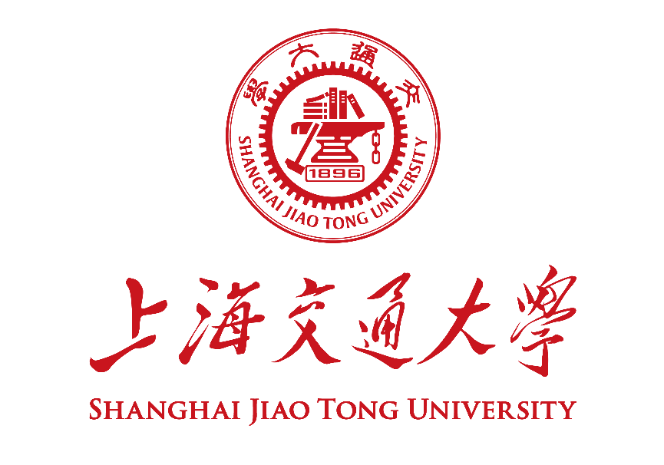

**硕士研究生学位论文中期检查报告**

**Mid-term Examination Report for SJTU Master Student**

|  |  |
| --- | --- |
| **学号 Student ID** |  |
| **姓名 Name** |  |
| **学生类别 Degree Program** | 专业型硕士生 Professional Master |
| **学习形式 Study Mode** | 全日制 Full-time |
| **导师 Supervisor(s)** |  |
| **专业 Major** | 机械/能源动力/电子信息 |
| **学院 School** | 巴黎卓越工程师学院 |
| **考核日期 Date** | 2024年9月 |

填报说明 **Instruction**

1. 硕士研究生学位论文中期检查应通过[数字交大](http://my.sjtu.edu.cn/)在线提交申请，填写本表并上传系统。特殊情况下经研究生院事先同意，可不上传系统，并使用《上海交通大学硕士论文中期检查评审表》完成评审。

The application for thesis mid-term examination should be submitted online through [My SJTU](http://my.sjtu.edu.cn/). The student shall filled this form and upload it in the system. Under special circumstance, this form does not need to be uploaded and the review can be proceeded with the review form with prior consent from the graduate school.

1. 本报告请用A4纸双面打印，于左侧订在一起。各栏空格不够时，请自行加页。考核前提前一周送交导师、评审专家审阅。

This report should be printed with A4 papers and bound together on the left. If the space left is not enough, please feel free to add extra pages. The print version shall be sent to the supervisor, and the review committee members for review at least one week before the oral presentation.

1. 中期检查报告通过后，定稿版报告由研究生、导师各存档一份，无需上传系统。

Upon passing the review, the final version of this report shall be archived by the graduate student and his/her supervisors for future reference.

**中期检查报告 Mid-term Examination Report**

|  |  |
| --- | --- |
| 论文题目  Thesis Title |  |
| 研究课题来源  Source of Research Project | 请在合适选项前画√ Please select the proper options by “√”.  国家自然科学基金课题 NSFC Research Grants  国家社会科学基金 National Social Science Fund of China  国家重大科研专项 National Key Research Projects  其它纵向科研课题 Other Governmental Research Grants  企业横向课题 R&D Projects from Industry  自拟课题 Self-proposed Project |
| 论文开题日期  Thesis Proposal Date |  |

1. **报告正文 Report。**请阐述开题报告以来学位论文研究工作的进展情况及所取得的阶段性成果，并简述下一阶段研究计划，不少于4000汉字。Please summarize your research progress and achievements since your thesis proposal as well as your plan for next step. No less than 3200 words if written in English.
2. **成果清单 List of Achievements。**请列出开题报告以来或上次年度进展报告以来新发表的学术论文、授权专利、国际会议论文、专著等成果清单。作者、标题、杂志、卷、期、页码等信息请填写完整。Please provide a list of academic publications (papers, patents, international academic conference talks/presentations, monographs, etc.) since your thesis proposal. Information on author list, title, journal name, volume, number, and pages shall be complete.

**本人承诺：报告中的内容真实无误，若有不实，愿承担相应的责任和后果。** **I hereby declare and confirm that the details provided in this Form are valid and accurate.** **If anything untruthful found, I will bear the corresponding liabilities and consequences.**

**学生签字/Signature of Student： 日期/Date：** 2024-07-02