Open Ears

Project Overview
The intention of this project is to provide a platform for owners of organisations to gather suggestions and feedback about measures that they are currently implementing, as well as conduct polls to gather information about the opinions of the general public. The motivation of this project is to facilitate more active communication between leaders of an organisation and its members, so as to bridge the divide that so often appears in such circumstances, and which the leaders themselves are frequently unable to effectively bridge, despite their claims of frequent attempts. To that end, this app is a cross between a traditional social media platform, with its upvotes and downvotes, and a feedback system, in an attempt to get the best of both worlds.

I would like to thank the candidates for Senior Council 2020. Without inspiration from their speeches about feedback, I never would have considered this app idea. Without that, perhaps I would have actually needed to code something that more people would be interested in that isn’t just a channel for people to get ignored.

Code Explanation of Key Algorithms and Features
Perhaps the most relevant algorithm to be mentioned here is the contribution algorithm. There are actually three relevant contribution scores, called the Public Score, Secret Score and Total Score respectively. The Public Score is gained through interactions with other users, the Secret Score is determined by administrators and the Total Score is given by the maximum of 0 and the sum of the Public and Secret Scores.

The Total Score determines how much contribution you can give others by upvoting their posts. To prevent rapid rating inflation due to echo chambers, the Total Score increases very slowly with upvotes on posts. One needs to gather up to 170 upvotes from other users in order for their vote to be worth double of a vote from a user who has 0 upvotes.

Each post has an individual rating which is determined by the votes on it from other users, as well as the Total Score of the poster when the post was made. Posts are sorted by rating when displayed, which helps to demonstrate which ideas are most popular among users.

The posts follow a strict hierarchy, being part of either “suggestions” or “feedback”. Each of these categories can be modelled as a rooted tree. In order to store this data in a space-efficient manner, and to avoid Firebase’s limit of 16 layers of nested data, we may elect to store the parent and children of each node in this tree of posts. This allows us to efficiently return to the parent from a post, as well as visit any of its children (comments).

It may surprise you to learn this, but the polls are actually implemented almost the same way as the posts were. If one visualises the similarity between having the poll question as a parent and the poll options as its children and having one post as a parent and multiple as its children, the similarities become clear. However, poll options are not sorted by order, and they count number of votes, unlike posts which have a rating system.

Another point of interest is the implementation of poll options/post images (both are similar). We model the list of poll options and post images using a Last-In First-Out data structure, commonly known as a stack. This allows us to add an image or option to the end of the list, as well as remove the last one. The downside is that it is very difficult to remove something in the middle of the list.

Internally, items are identified with a custom generated 26-digit alphanumeric id. As there are 62 alphanumeric characters, this yields upwards of forty quattuordecillion possible strings to be used per organisation. If for all of human history we were to force people to slave away in front of their keyboards, dedicating their life to generating content, it is quite possible that this system would not have generated a single collision by the death of the last stars.

Finally, although it is not of any algorithmic importance, I would like to give passing mention to the way administrative permissions are handled in my application. There are three levels of administrative permissions, Owner, Admin and Member. Owners are the only ones allowed to promote and demote other users (except for other owners), while admins are able to remove members and “consider suggestions”. Note that “consider suggestions” is an admin-only feature that marks if a suggestion is under consideration by an admin.

Project Screenshots
Screenshot | Explanation | Accessed From
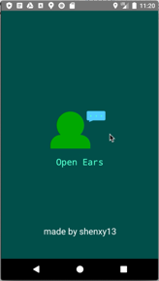 | StartScreenActivity  This activity shows at the start of the app and displays a splash screen. One of the main functionalities of this activity is the display of a permission request for storage, which is needed to access load image features later on. | Launch
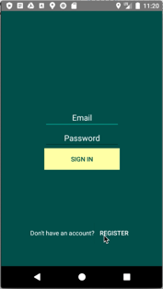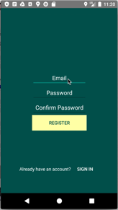 | SignInActivity/RegisterActivity  These activities display allow the user to sign in or register a new account respectively. | StartScreenActivity  RegisterActivity/SignInActivity
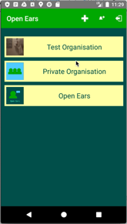 | OrganisationListActivity  Lists all organisations that the user is currently a part of. Also implements accessibility for creating organisations, joining organisations and signing out. | StartScreenActivity  RegisterActivity  SignInActivity
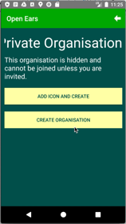 | CreateOrganisationActivity  This activity allows the user to create an organisation with a name and a description, as well as an icon if they so desire. If there is no icon selected, the default icon will be used. | OrganisationListActivity
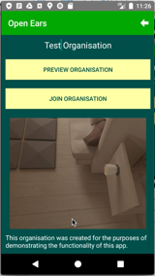 | JoinOrganisationActivity  This activity allows the user to find an organisation by name and join it. It also offers a preview of the organisation, showing the icon and description. Organisations can only be found on this list if they are set to public. | OrganisationListActivity
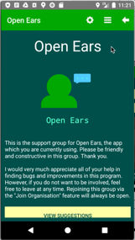 | HomeActivity  This is the hub for an organisation. Every single organisation-related feature is accessed from this activity. It displays the organisation name, icon and description clearly. | OrganisationListActivity
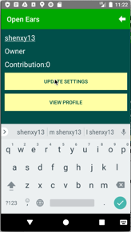 | SettingsActivity  This activity allows the user to change their displayed name in the organisation. It also contains a link to the user’s profile. | HomeActivity
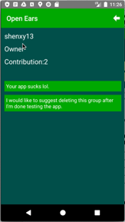 | ViewUserActivity  This activity shows the user’s name, permissions and contribution score, as well as links to every post which they have ever made. | ListUsersActivity  SettingsActivity  SuggestionActivity/FeedbackActivity
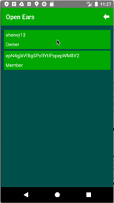 | ListUsersActivity  This activity lists all users in the current organisation, sorted first by permissions then by contribution. | HomeActivity
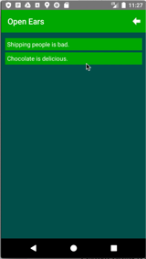 | ListPollsActivity  This activity lists all polls in the current organisation. | HomeActivity
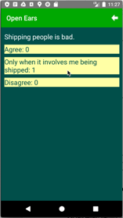 | ViewPollActivity  This activity allows the user to view and vote on polls. | ListPollsActivity
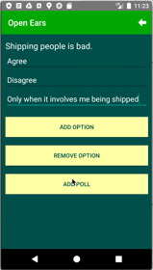 | AddPollActivity  This activity is only accessible by admins. It allows them to add polls to the current organisation. | ListPollsActivity
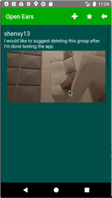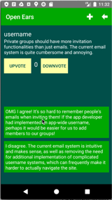 | SuggestionActivity/FeedbackActivity  Displays a feedback/suggestion post and all of the direct comments on that post. Allows upvoting and downvoting (and marking suggestions for consideration for admins). | HomeActivity  ViewUserActivity  AdminSuggestionsActivity
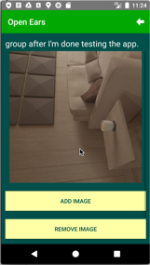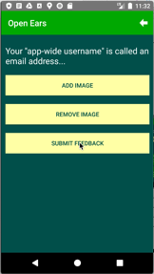 | AddSuggestionActivity/  AddFeedbackActivity  Allows user to add a suggestion or feedback post with text and images. | SuggestionActivity/FeedbackActivity
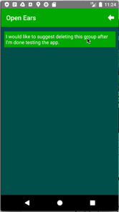 | AdminSuggestionsActivity  This view lists all suggestions currently marked for consideration by the admins. | SuggestionActivity
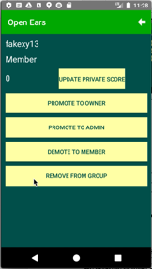 | AdminUserActivity  This activity allows admins to modify the Secret Score of users, as well as change their permissions or remove them from the organisation. | ViewUserActivity
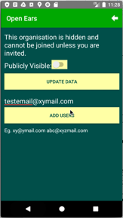 | AdminViewActivity  This view allows admins to change the organisation settings, as well as invite users to the organisation. | HomeActivity
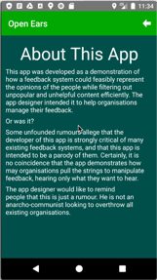 | AboutAppActivity  This view shows a short essay about the application. Come to think of it, I should have just copied this into the report. The method of accessing this view is unknown. | ???
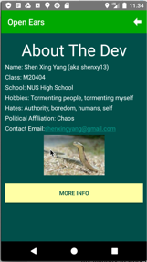 | AboutDeveloperActivity  This view gives more information about the developer of the app. It also links to a page with more information (yeah, right). The method of accessing this view is unknown. | ???

Usability Survey (To Be Gathered)
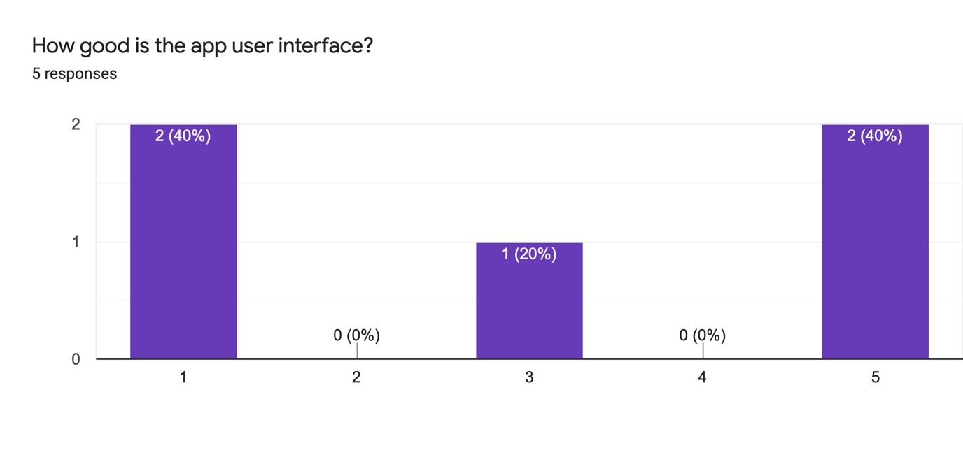
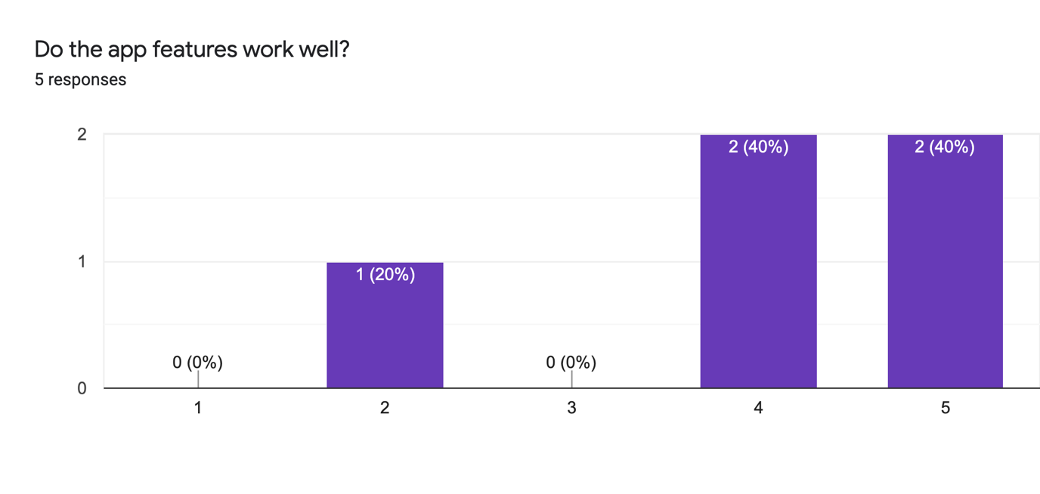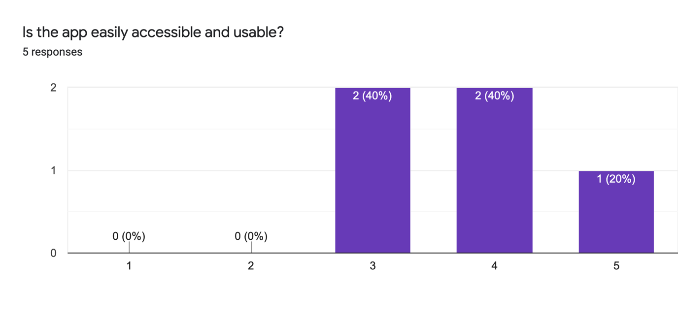
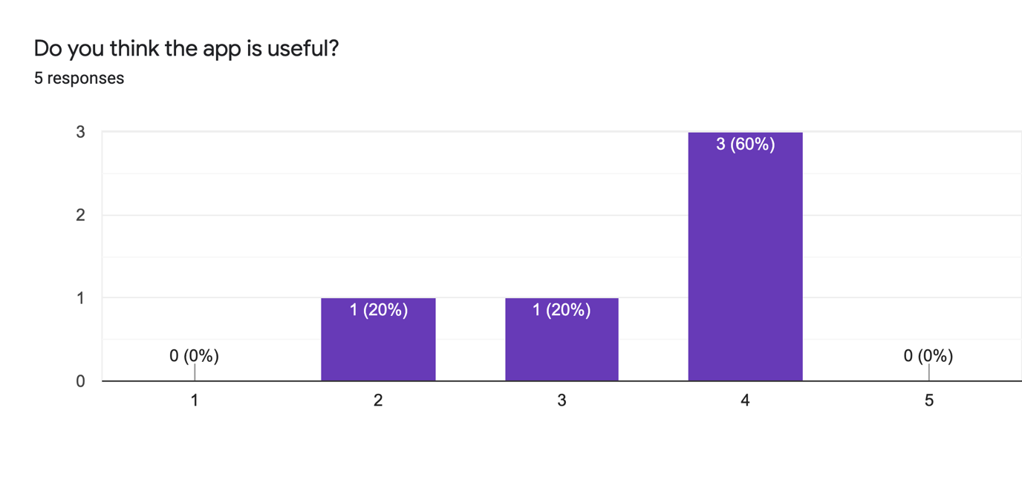
As can be seen, the general opinion among people who filled up the survey was that the app features worked really well, while the app usability and usefulness were decent. However, opinions seem divided about the (new and improved) user interface, with some thinking that it is acceptable and others vehemently declaring that they would sooner tear their eyes out than look at it.

Reflection
Of the many obstacles I faced along the way when doing this project, the greatest is my own continued lack of productivity (as usual). This is not to say that I did not face many other difficulties (as documented below), but my inability to work hard without tangible deadlines is still the most crippling blow to my project. In particular, I was unable to fully utilise my weekends as I was too frequently distracted by other work or just my own studies to truly focus on finishing my project. This likely stopped me from implementing some things I would very much have liked to implement.

Another factor arguably more deadly than the first was my impatience. During the March holidays, I had coded a sizeable amount of backend code. However, when I discovered that my backend code did not match my frontend design well, instead of carefully rewriting certain parts, I elected to discard both and start over, losing well over a week of progress. This time could have been much better utilised to implement more features, once again, which I may come to sorely regret not implementing.

Of course, I faced a fair share of difficulty in the implementation of various parts of my app as well. For example, it took me a few days to come up with the idea of generating alphanumeric ids to identify content in the app. A similarly problematic issue was the use of a stack for poll options, which also took two days to think of. However, perhaps the most problematic piece of code over the course of this entire project was the contribution and rating system, the core selling point of this app over existing feedback systems.

Firstly, a major roadblock I hit right at the start was the newfound knowledge that ValueEventListeners are not automatically removed from DatabaseReferences, and that a specific function call was needed to remove them to prevent the UI from bugging. After that, I realised that my database structure was not equipped to handle the rating system. After fixing both of those issues, I was finally confronted with the fact that I could not perform the very basic task of adding one million to Total Score in the backend.

This project has taught me a lot about Android app development, although the one lesson I would really remember is how painful it was. At many points in the development of this project, I was tempted to give up, and it is hard to imagine how much harder it must be for programmers to make those everyday apps we take for granted. The other takeaway from this, thankfully a much less cliché one, would be that I should probably stay away from Android app development.

Another important lesson is the importance of good user interface. I spent quite a long time working on my project, making sure every little detail in the code was perfect and that every feature worked exactly as intended. The first thing that happened when I opened my app for review was that I immediately got flamed by several different people about my colour choices and had to change up much of my colour palette to make the app even presentable. This shows just how important a good UI is to a good app, and also how bad I am at UI design.

If more time was given, or rather if I had squandered less of the time given to me, one of the first things I would have introduced would be more customisability in the contribution algorithm. While the current one is decent, it may not have much of an influence in smaller organisations (where it is hard to gather enough votes for the rise of contribution to mean anything) or larger organisations (where it is very possible that a contribution arms race may ensure, with users getting increasingly ludicrous contributions due to the ultimately exponential nature of the algorithm). This proposed feature would allow administrators to modify the specific numbers used in the contribution algorithm to better tailor it to the needs of their organisation.

A smaller but no less relevant change would have been to allow administrators to modify the organisation’s icon. Currently, the owner selects the icon on creating the organisation, and there is no way to modify it other than spamming me with emails. It would have been useful to implement a feature that allows admins to change the organisation icon, but ultimately it was on the list of features that just weren’t important enough to make the cut for v1.0.

There are of course many other miscellaneous features that I want to work on, for example images for polls and poll options, better UI for upvoting and downvoting, better display of nested comments, et cetera. However, I recognise that even had I not wasted what little time I had, there was no way I could have implemented all of these features, so I must say that these features were never likely to be implemented in the app in the first place.

Notably, there were two features in my original proposal that are nowhere to be seen in the current app, those being the Event and Mute User functions. I realised swiftly that events could be implemented through “emergent gameplay”, where an admin with artificially boosted Total Score posts a root level post asking for discussion on a certain event. As for Mute User, its higher implementation cost and low difference from the other function Kick User ultimately resulted in it being skipped over, although it could return in a future update.

Finally, I would like to suggest something for future iterations of this task. Right now, many students are waiting until the last minute to perform their usability survey, making the feedback they receive not that useful. Instead, I propose that the usability survey should be due before the main body of the project itself, such that the student is actually required to have finished the project by the due date of the usability survey, and can then use the results to further improve on what they have created.

