DESCRIPTION:// This a simple chatbot project that is built upon and implemented in python that allows users to have a conversation by prompting questions and answering them through a premade response dataset.

HOW TO COMPILE & RUN:// Make sure python is installed in the computer. Click run button to compile and run the code. To run the code, you have to say hi and your name to program. After this, you can just ask questions to program depend on keys which has been implemented in program.

CLASS:// “chatBot”: Store dataset, prompt questions and give responses, users’ inputs validity check, help.

HELP:// typing “help” if you need help

Assignment 3 Feature Introduction://

- Make a simple GUI

So that the user is typing into a nicer interface

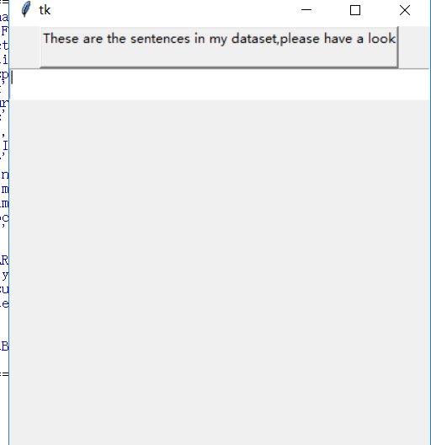

- Add an extra topic to my agent's repertoire. （professor）
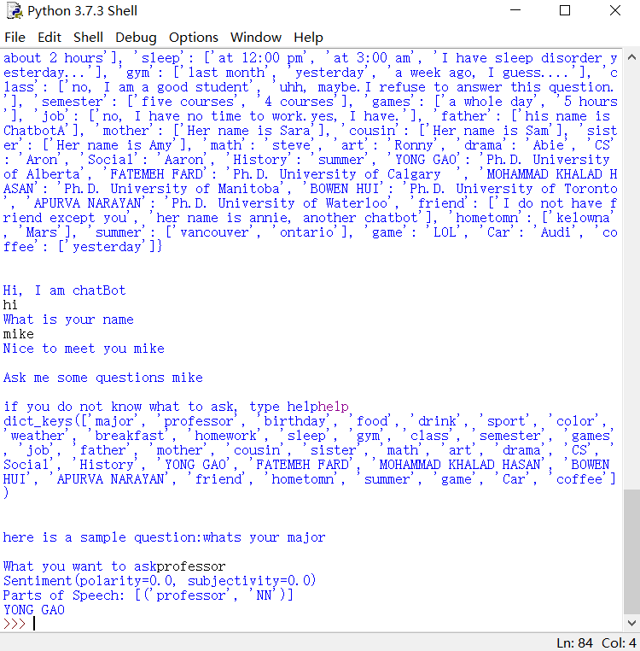

- Add a feature that enables your agent to handle spelling mistakes of the words
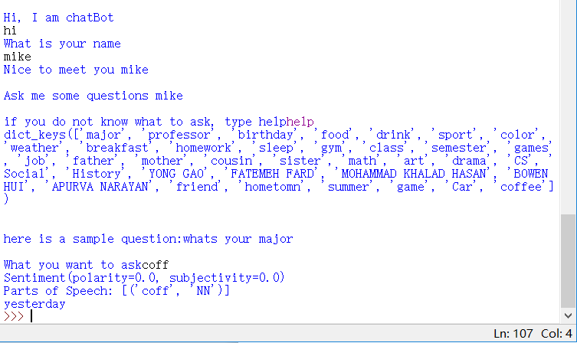

- Synonym recognition，
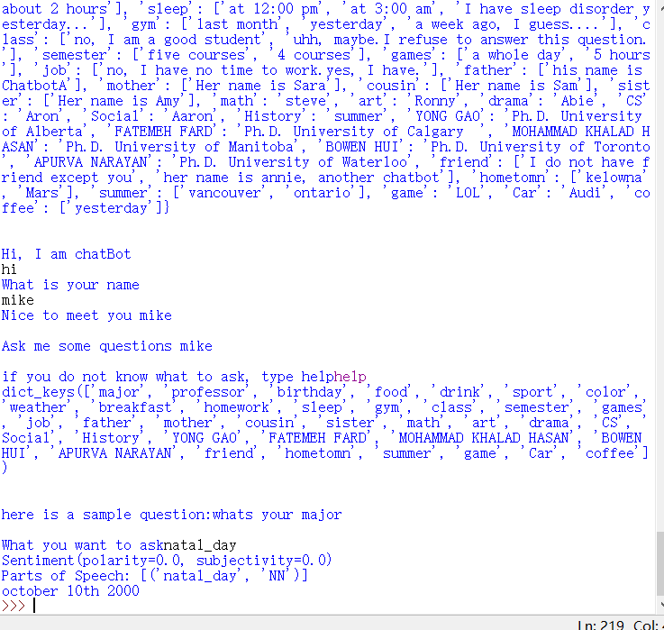

- POS tagging it shows the pos tag for the words
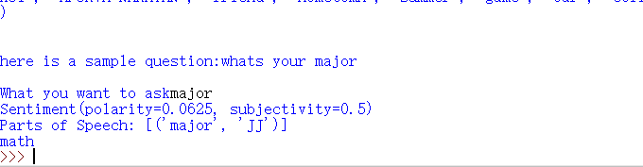

- Named entity recognition
If you enter the sentence that does not contain noun
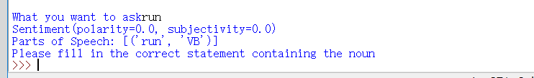

- Sentiment analysis tools
If you enter some word that shows good or bad feeling of you, the it will show the polarity of you, positive number means positive feeling, negative means opposite way,
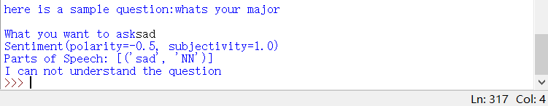

Level 0 DFD:
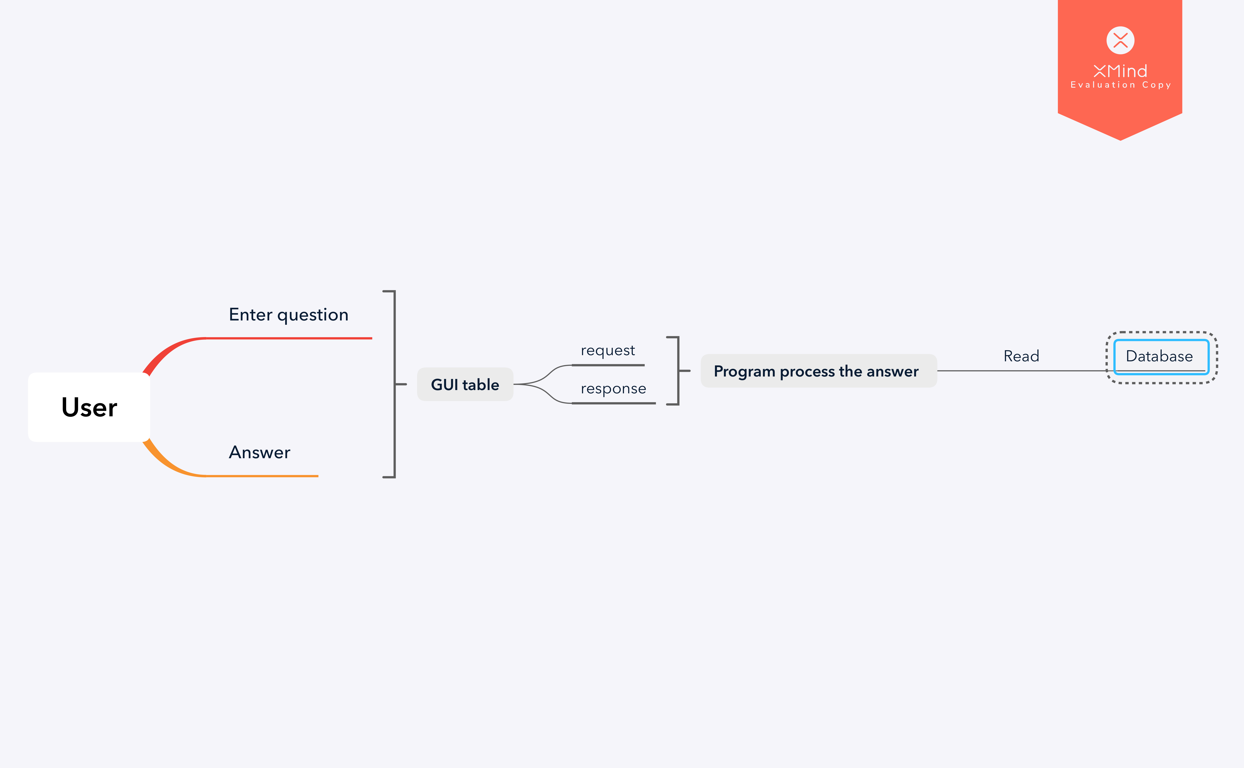

Level 1 DFD:
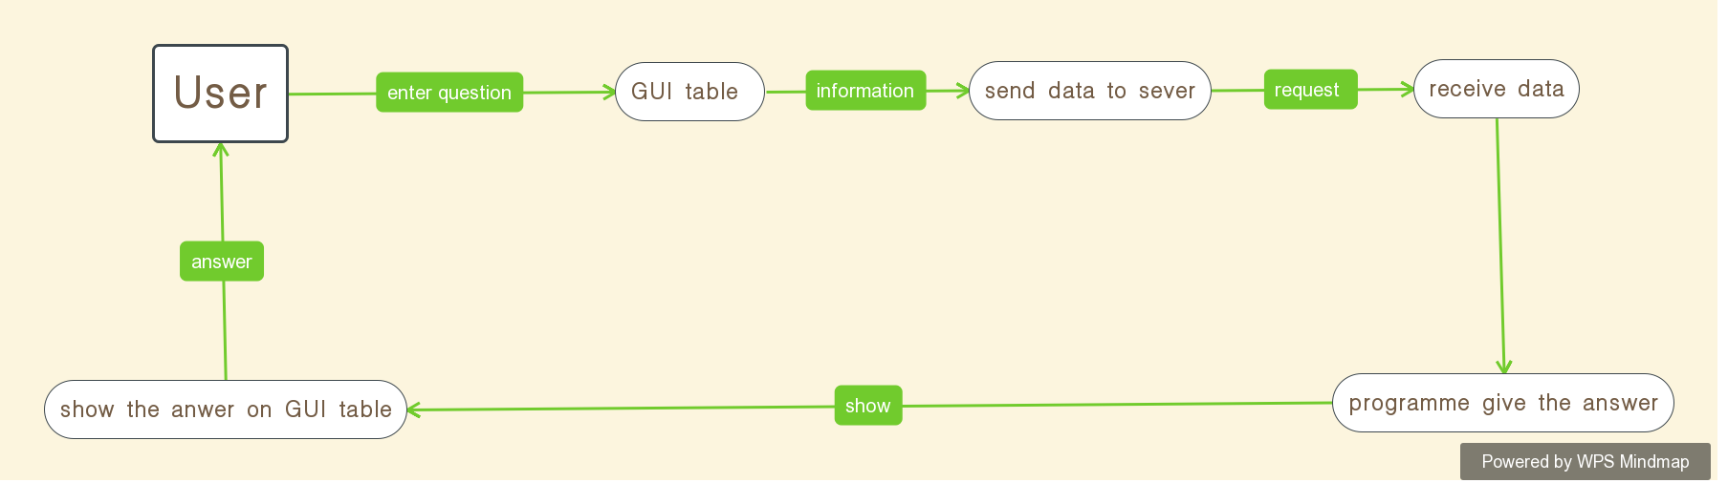

Sample run:
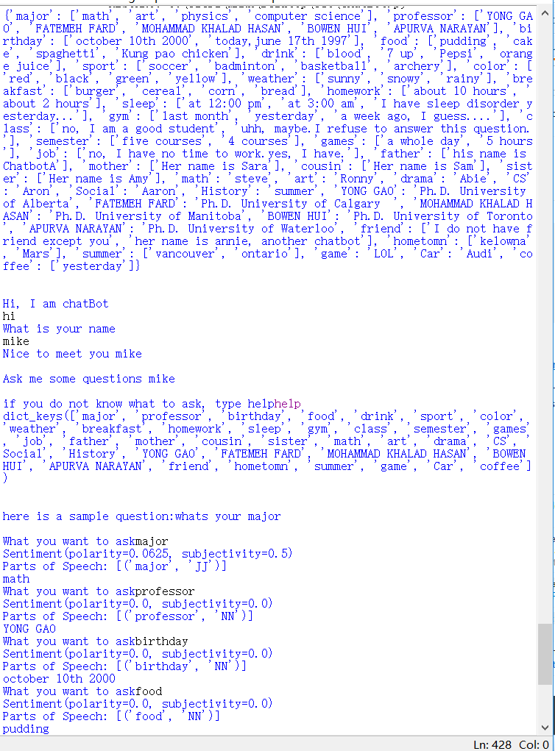
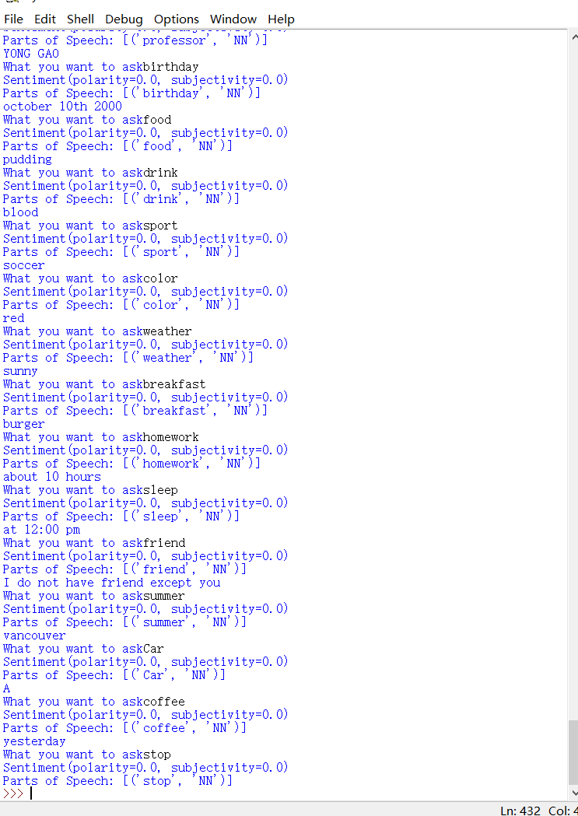

a list of limitations:
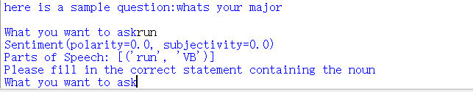

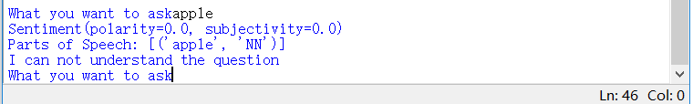

Five features that can be extracted as API:
- The tkinter model can be used as an API, because everyone can use that to create their own GUI.
- The textblob model can be used as an API, because everyone can use that to let their programme to distinguish user’s feeling.
- The nltk model can be used as an API, because everyone can use that to add Synonym recognition features to their programme.
- The nltk.word_tokenize can be used as an API, because everyone can use that to add Named entity recognition features to their programme.
- nltk.stem.lancaster can be used as an API, because everyone can use that to add LancasterStemmer features to their programme.

