1. Introduction

Super-resolution microscopy is a fast-evolving area with enormous potential for impacting biological vivo imaging. Many super-resolution methods have developed to overcome the diffraction limit of light. The quantum correlation fluorescence of m-th order create a PSF with a $\frac{1}{√m}$ FWHM. Structural illumination microscopy can also improve the resolution by principle of moire fringes in the order of m. By combing these two methods, it's possible to further improve the resolution by m + $\frac{1}{√m}$, fully depending on the correlation order m. The main goal for this work is to proof experimentally the structural illumination quantum correlation microscopy (SI-QCM) will work and achieve expected resolution improvement.

1. Setup

Fig. 1. Experiment setup. L1-L5 are lens, with focus length 1000mm, 75mm, 150mm, 150 mm and 200mm respectively. Tube lens is 200mm concave lens. Mask is a customized mask to block zero-order and orders higher than +1/-1. DM is a short pass dichroic mirror, 505 nm cutoff. LP500 is a 500nm long pass filter.

As shown is Fig. 1, 405nm diode laser coupled to a multi-mode fiber and then collimated by L1. After going though Ronchi grading (50.0 cy/mm), the diffraction beams are focused by L2 and filtered by customized mask to block out the zero-order line for increasing the contrast. The +1 and -1 order of beams collimated by L3 and transmitted through 505nm short pass dichroic mirror (Fig.1 DM), focused by tube lens to the back-focus plane of objectives and then achieve structured illumination at the sample. The excited fluorescence is collected by same objective, focus by tube lens and reflected by dichroic mirror. After passing another 4-f system (L4& L5), the image is collected by the CCD camera.

1. Current result

The microscopy setup is finished with the several different magnification rate by changing the focus lengths of L4&L5 (Fig2. (a)(b)). Two types of objectives with magnification rate 40X and 100X are also tested (Fig2. (b)(c)). The net magnification rates of the microscopy system are 17, 59.2 and 148 respectively. The additional bright spot in Fig. 2 (c) is due to the auto-fluorescence of immersion oil, which can be improved later.

(a)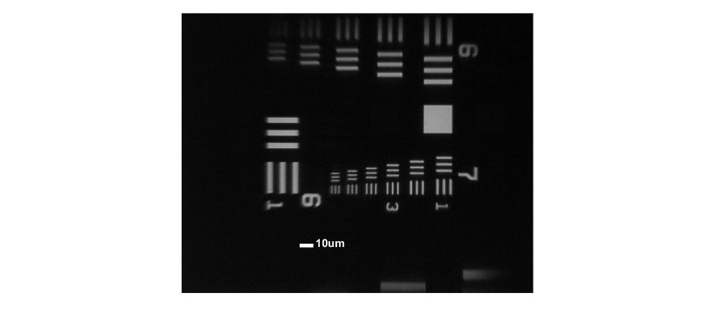(B) (c)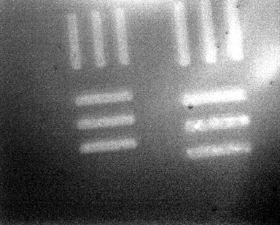

5um

5um

Fig. 2. Images of USAF mask.

(a)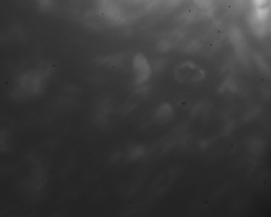

Fig. 3. Images of quantum dots with structured illumination.

To further test the system, we image the sample of CdSeS/ZnS alloyed quantum dots (QDs). The size of QDs are 6 nm. The solution is 0.1mg/mL in toluene and fluorescence wavelength is 540nm. The grading is attached to a rotation stage and rotating at three different angles (0°, 15°, 30°) to show the angular changes of the strip pattern (Fig.3(a)-(c)). However, the QDs are too dense in current sample, so no single QD has been founded. Also, the auto-fluorescence by oil further blur this image, which makes it harder to see blinking phenomena of QDs.