TCP (Transmission Control Protocol):

TCP is a connection-oriented protocol that requires establishing a connection before transmitting data and closing it afterward. This connection is reliable, ensuring data arrives at the destination in the correct order without loss or damage.

TCP ensures data reliability through acknowledgment, retransmission of lost packets, and flow control mechanisms. If data packets are lost or corrupted, TCP retransmits them until the receiving end confirms correct reception.

UDP (User Datagram Protocol)

UDP is a connectionless protocol, meaning it doesn't require a connection setup before data transmission. Senders directly transmit data packets to receivers without handshakes or acknowledgments.

UDP does not guarantee data reliability; packets may be lost, corrupted, or arrive out of order. It lacks retransmission and flow control mechanisms, making it faster but less reliable.

Wi-Fi 5 (802.11ac):

Bandwidth: 20 MHz, 40 MHz, 80 MHz, and 160 MHz (5G frequency band).

Throughput: At a maximum channel width of 160 MHz, Wi-Fi 5 can provide a theoretical throughput of up to 3.5 Gbps.

Wi-Fi 6 (802.11ax):

Bandwidth: 20 MHz, 40 MHz, 80 MHz, and 160 MHz channels (2.4G and 5G frequency band).

Throughput: At a maximum channel width of 160 MHz, Wi-Fi 6 can deliver up to 9.6 Gbps theoretical throughput.

Wi-Fi 6e (802.11ax extension):

Bandwidth: 20 MHz, 40 MHz, 80 MHz, and 160 MHz, but it introduces more available spectrum on the 6 GHz band, without being affected by congestion and interference on the 2.4 GHz and 5 GHz frequency bands.

Throughput: In theory, Wi-Fi 6e can provide 18Gbps throughput.

Wi-Fi 7 (802.11be)

Bandwidth: 320 MHz bandwidth with three bands (2.4 GHz, 5 GHz, and 6 GHz)

Throughput: 46Gbps

* LTE and 5G (frequency used) - normal throughput for UL and DL
* LTE

Frequency used:

1. FDD LTE Bands (Frequency Division Duplex):

Low bands (e.g., 700 MHz, 800 MHz): Such as Band 12, Band 13, Band 17, Band 20, etc.

Mid bands (e.g., 1800 MHz, 2100 MHz): Such as Band 1, Band 3, Band 7, etc.

High bands (e.g., 2600 MHz): Such as Band 7, Band 38, etc.

1. TDD LTE Bands (Time Division Duplex):

Mid bands (e.g., 2300 MHz, 2600 MHz): Such as Band 38, Band 40, Band 41, etc.

1. Special Bands:

Band 14: Specifically used for public safety networks.

Band 46: Used for unlicensed LTE operations (LAA).

1. Emerging Bands:

With the advancement of 5G, some bands are beginning to be used for both LTE and 5G NR (New Radio) coexistence, such as n78 band, etc.

Normal throughput for UL and DL:

1. LTE Category 4: This is an early form of LTE technology. Downlink: Real-world speeds typically range from 10 to 30 Mbps, but can peak at 150 Mbps under ideal conditions. Uplink: Usually around 5 to 15 Mbps, with a maximum of 50 Mbps.
2. LTE-Advanced (LTE-A): An upgrade of LTE, LTE-A supports carrier aggregation (CA), which increases throughput by using multiple frequency bands simultaneously. Downlink: Users can often see speeds between 30 and 100 Mbps, with peaks potentially reaching up to 300 Mbps or more in very good conditions. Uplink: Speeds might range from 10 to 50 Mbps, with potential peaks of up to 150 Mbps or more.
3. LTE-Advanced Pro (LTE-A Pro): This is a further enhancement of LTE, introducing more advanced features such as 256 QAM and 4x4 MIMO. Downlink: In real-world scenarios, speeds might range from 100 Mbps to several hundred Mbps. Under ideal conditions, it can theoretically go as high as 1 Gbps or more. Uplink: Real-world speeds can be significantly higher than LTE-A, potentially ranging from 50 to 200 Mbps.

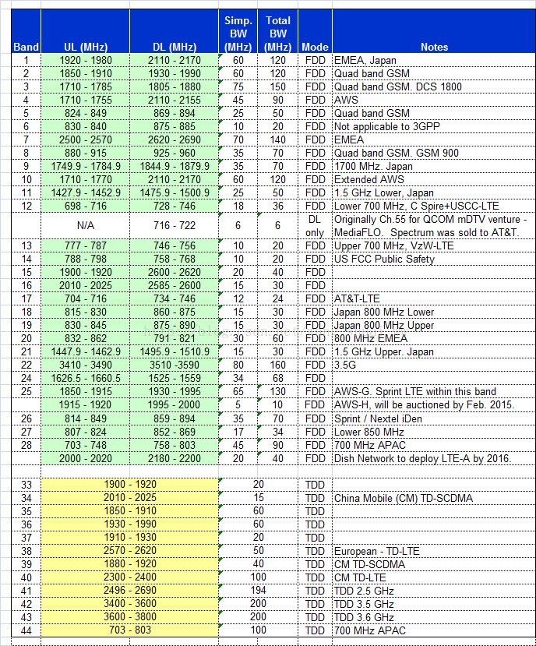

* 5G

Frequency used:

1. Low-Band (Sub-1 GHz): These bands are typically used for wide coverage and penetration capabilities, such as 700 MHz, 800 MHz, and 900 MHz. Low-bands offer good coverage range and strong building penetration but have lower data transmission rates compared to higher frequency bands.
2. Mid-Band (C-Band, approximately 1 GHz - 6 GHz): This is the most commonly used spectrum in 5G networks, including frequencies like 3.5 GHz (n78), 2.6 GHz (n41), and 3.7-4.2 GHz (n77). Mid-bands provide a balanced choice with higher data transmission rates while maintaining reasonable coverage and penetration.
3. High-Band (Millimeter Wave, above 24 GHz): Includes bands like 24 GHz, 28 GHz, 39 GHz, etc. These high-frequency bands offer very high data transmission rates, suitable for high-bandwidth applications, but have limited coverage and penetration capabilities, typically used in urban centers, stadiums, or other densely populated areas.

Normal throughput for UL and DL:

1. Low-Band 5G (Sub-6 GHz): Downlink: Often in the range of 50-250 Mbps, but it can be higher in some cases. Uplink: Typically ranges from 10-100 Mbps.
2. Mid-Band 5G (C-Band, around 1-6 GHz): Downlink: Commonly sees speeds between 100-900 Mbps, with potential peaks reaching 1 Gbps or more in ideal conditions. Uplink: Usually falls between 10-100 Mbps, but can exceed these figures under optimal circumstances.
3. High-Band 5G (Millimeter Wave, above 24 GHz): Downlink: Can exceed 1 Gbps, with peaks often reaching 2 Gbps or more in optimal conditions. Uplink: Speeds can be significantly higher than lower bands, often ranging from 100 Mbps to 1 Gbps.

* Jitter measurement in networks

1. Measuring Jitter with Ping:

Although primarily used to measure network latency (i.e., round-trip time, RTT), ping can also be indirectly used to observe jitter. By running ping continuously and observing the variation in the return times of the packets, one can get a rough estimate of jitter. For example, significant variation in RTT values over consecutive ping attempts could indicate the presence of some level of jitter in the network.

1. Measuring Jitter with Iperf:

When using iperf to measure jitter, it's typically done in UDP mode. This is because UDP, unlike TCP, does not have congestion control mechanisms, making it more suitable for jitter measurement. In iperf's UDP tests, the server side reports the jitter statistics for the received packets, providing a direct measurement of jitter. For example, you can start iperf as a server on one end (using the command iperf -s) and as a client on the other (using the command iperf -c [server address] -u) to initiate a UDP test. After the test, iperf will display average jitter values and other relevant statistics.

Reference

1. Wikipedia contributors. (2024, January 24). LTE (telecommunication). In Wikipedia, The Free Encyclopedia. Retrieved 12:56, January 27, 2024, from https://en.wikipedia.org/w/index.php?title=LTE_(telecommunication)&oldid=1198407942
2. LTE; Evolved Universal Terrestrial Radio Access (E-UTRA); LTE physical layer; General description (3GPP TS 36.201 version 17.0.0 Release 17)
3. <https://blog.csdn.net/huxyc/article/details/124977574>
4. Wikipedia contributors. (2024, January 23). 5G. In Wikipedia, The Free Encyclopedia. Retrieved 12:51, January 27, 2024, from <https://en.wikipedia.org/w/index.php?title=5G&oldid=1198212742>
5. 5G; NR; Physical layer; General description (3GPP TS 38.201 version 17.0.0 Release 17)