Pilot test case descriptions: (not tested yet)

* 3 plants, 5 items, 6 time periods
* Production:
* Capacity has single set 1
* All plants can produce all items, except that plant 2 cannot produce item 5, plant 3 cannot produce item 2
* Capacity of plants:

|  |  |  |
| --- | --- | --- |
| Plant 1 | Plant 2 | Plant 3 |
| 30 | 15 | 20 |

* Unit capacity consumption: all production takes 2 time periods

|  |  |
| --- | --- |
| Item 1 | Item 2-5 |
| 2 | 1 |

* Lot size: 5 in a batch, min production 1, max production 20 for all items
* Production cost and component cost currently set as 0
* Demands: see dm_df_demand.csv
* Transit: transit time on arcs

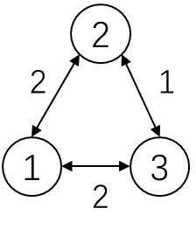

* Initial inventory: 20 at plant 1 and plant 3, 30 at plant 2, for all items
* Parts assembly relationship: every plant can assemble

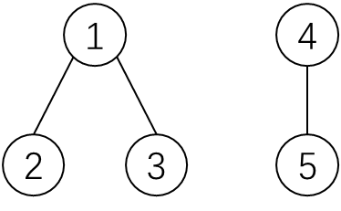

* One unit of item 1 requires two units of item 2 and three units of item 3
* One unit of item 4 requires two units of item 5
* Item replacement:
* Holidays/weeks/workday ignored for now, no dummy po period, twip, sr relationship, paired production relationship, fixed component proportions, or line relationships