Pro-Choice vs. Pro-Life: Tweets Exploratory Data Analysis

Xingyu Chen   
 Department of Data Science  
University of Colorado at Boulder  
Boulder, CO 80309 USA   
xich9921@colorado.edu

***Abstract*—TBA**

***Keywords—Seaborn, Data Visualization, Data Model, Neural Nets, ANN, CNN, RNN, LSTM, NLP***

# Introduction

The 1973 Roe vs. Wade decision, legalizing abortion in all fifty states, seems to solve one of the most controversial issues in terms of abortion. However, on June 24, 2022, the Supreme Court issued a bill prohibiting women's access to out-of-state abortion services. Additionally, the Court banned abortions nationwide after 15 weeks of pregnancy, which overturned the Roe v. Wade case.

The Congress's decision has drawn much attention on social media, especially from females. The argument divides into two opinions: Pro-Choice vs. Pro-Life. People who support pro-choice believe everyone has the fundamental human right to decide when and whether to have children. They think it is OK for them to have the ability to choose abortion as an option for an unplanned pregnancy – even if they would not choose abortion for themselves. The view is that a woman should have the legal right to an elective abortion, meaning the right to terminate her pregnancy.

People who support pro-life believe that the life of the fertilized egg, embryo, or fetus is much more critical. They despise children's welfare after birth and oppose child welfare legislation. The controversial issues pit people against each other like they are on two teams. Most Americans believe abortion should be legal because it is the human right to access abortion.

This paper presents an exploratory data analysis on tweets about pro-choice vs. pro-life. It is helpful for people who want to have a general idea about how people react to the bill that bans abortion in certain states, especially for females. The neural network model helps them to grasp a pragmatic understanding of the whole event timeline.

More specifically, the model should provide a decent result so people can learn primary online users' opinions behind the case. In addition, this model should facilitate decision-makers in Congress to pass bills involving controversial issues because it generates local and global impacts at a certain level.

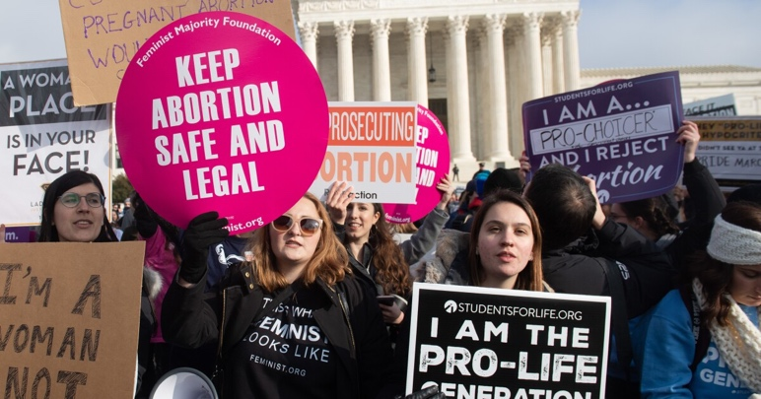

Fig 1. Abortion-rights movements

# Data Gather

The dataset of 56,040 tweets was collected in the wake of the Roe vs. Wade cancellation sentence and analyzed the influence operations. The dataset is available to download from the Kaggle website, which lists in the reference.

The tweets are collected containing either the #prochoice or the #prolife hashtag, reflecting the two opposite poles of the discussion. The tweets with #prochoice have a target variable of 0, and the tweet with the #prolife has a target variable of 1.Table

Fig 2. Original dataset

Other columns, such as ‘created_at’, ‘retweet_count’, and ‘like_count’, can be valuable features for the data model. On the other hand, the ‘author_name’, ‘author_username’, and other columns are irrelevant to this paper and will be omitted during the data preprocessing.

In addition to the original dataset, newsapi.org provide API to gather unlabeled news titles related to Pro-Choice vs. Pro-Life. Registered a free account on newsapi.org to get the API key and set up an endpoint for the servers and the location on the server where data will be retrieved. The newspaper servers will query for all the topic names in the list: 'abortion' and 'antiabortion.'

The server will respond in JSON format with the date, title, headline, and source. Then the JSON format transforms into a large CSV file where each article is in a row. Adding one column that either abortion or antiabortion to convert this data into a labeled data frame so model train and test with the data.A picture containing text

Fig3. Dataset retrieved from API

# Data Prep

Preprocessing is a crucial step in the processing of text, especially for tweets. This paper is not focus on text preprocessing (Natural language programming) but focus on neural network, so I include essential steps about text preprocessing instead of detailed step-by-step explanation.

Fig 3. Preprocess Datetime using strptime library.

I use datetime module to fix the formatting of the date column. I will also be using regular expressions to fix the structure of the text and remove unnecessary ascii symbols because tweets can contain a lot of things such as mentions, hashtags, links, punctuations, and etc. Here is the list of text preprocessing tasks:

1. Lowercasing all the letters
2. Remove mentions ‘@’
3. Remove hash tags ‘#’
4. Remove URLs, start with ‘http’ or ‘www’
5. Remove punctuations
6. Remove non-alphanumeric characters
7. Remove stop words

Fig 4. Preprocess tweets based on tasks

Fig 5. Preprocess text into numerical values

Fig 6. Train set

Fig 7. Test set

# NN w/ BP Architecture and Design

Fig 8. Neural Net structure

Iteration 1000

Total Loss: 4840.214395017918

Average Loss: 0.12891424905497037

The confusion matrix is:

[[10232 8087]

[ 16 19211]]

The accuracy score is:

0.7841847333937038

Fig 9. Total loss

Fig 10. Average Loss

# Sample Execution

For Analyses and Technical Results, all projects should use, explore, describe, discuss, and illustrate appropriate neural network models. If using a website, have one or more TABS as appropriate for your models and results, etc. If using a document, have sections and subsections appropriate to your models and results. There is an infinite number of ways to complete this part. The key is to show that you applied NN's to a significant problem, modeled the problem, and then discussed and illustrated the results.

# Conclusion

This dataset is not intended to be used to take a position on the discussion on the right to abortion. I focus on the ethical arguments and underlying issues rather than on political considerations that might also be involved. This dataset takes its cue from this discussion to create a corpus of tweets that can be tagged a priori.

I use neural networks intended to answer following questions:

1. How is people reaction changes between dates?

2. Can we use the neural net to predict tweets opinion?

3. What is the frequency of tweets during the whole timeline?

4. What are the words that contribute to pro-life/pro-choice

For now, the epoch is 1000 and learning rate 0.01 with sample size 37,546, we get 78% accuracy. Parameter tuning will be used during next tasks.

The network intended to predict the tweets is supporting pro-life or pro-choice, the input vector is retweet_count, like_count, words_count, sentence_length, and hour.

All projects must be submitted with a 5 paragraph CONCLUSIONS that clearly describes how the exploration, prediction(s), modeling, and/or other project methods support, clarify, or assist with the topic, Conclusions are 100% non-technical and should contain images that help the reader to understand the "take-home" and key messages, discoveries, and/or predictions. Each project will have a different conclusion based on the topic and goals.

##### References

[1]