Real work is the best way to improve myself, I have learned a lot from school. But Only after I using them in real work so that I could have a deeper understanding. (like why I need to use this, but not this, How to face problem and solve problem, more efficiency) The challenges in real work are more various and complicate than class. By handling this questions, I absolutely could get huge improvement.

And I need to let the knowledge I learned make value. So I think have a job is the best way.

I think the work position was perfect fit to me. I want to be a web developer in the future, this is my career direction. and the skill stack your company using. Like Java, js and React.Spring Boot. There are just my interested and study field and I was very familiar with them. I always use them to build the web project. So I thought this position was very fit to me.

Exploration

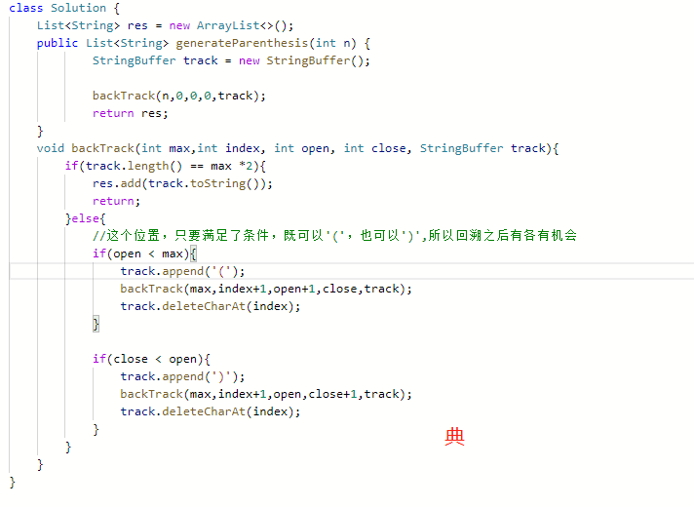

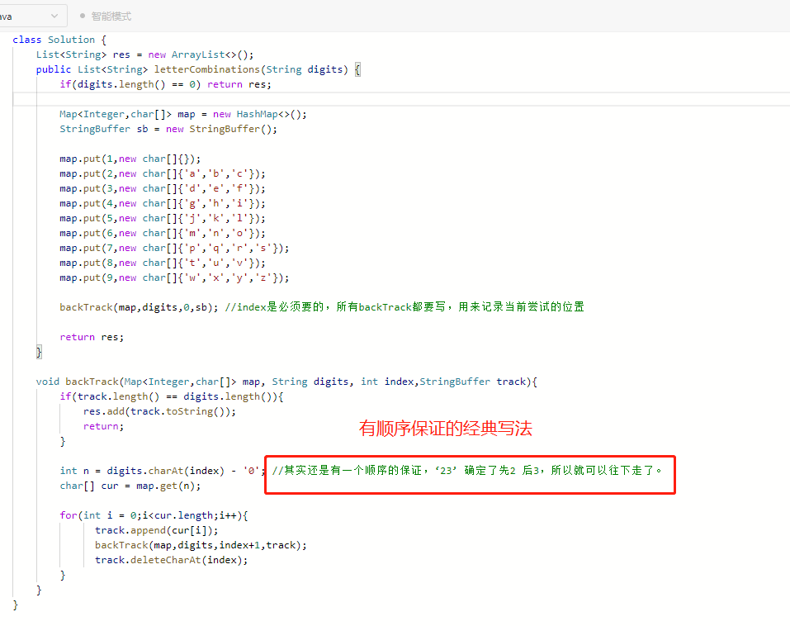

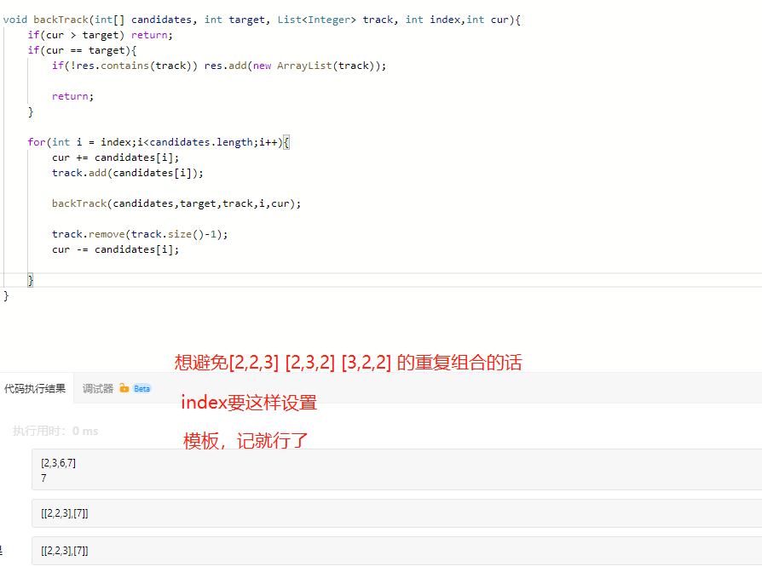

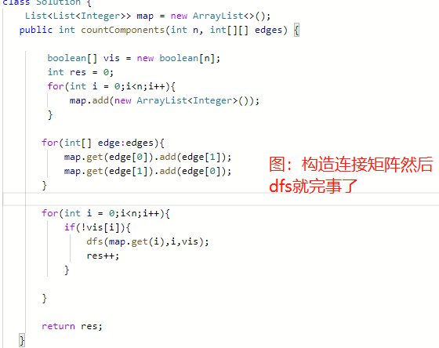

树图的bfs:主要用来检查是否有环。

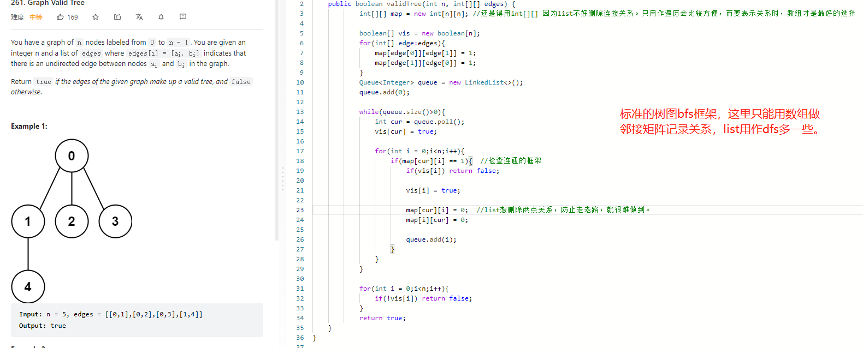
而且是，需要表示连通关系时，最好用数组而不是list，只是单纯的dfs可以list，
而bfs中需要删除关系，这样用list就很难了。

总结就是数组注重关系记录，而list用于dfs的快速遍历。

