Lab Homework1

Xingyu Wang

**Task 3: Create a new folder in Hadoop (not in the local filesystem)**

Create a new folder called hw1 in Hadoop:

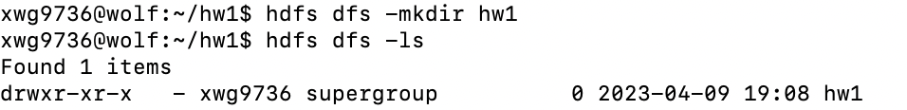

**Task 4: Move one file that you have just uploaded to Wolf to the new folder in Hadoop**

List all files uploaded to Wolf under hw1 directory:



Move hw1_file1.txt to the new folder in Hadoop:

**Task5: Rename this file in Hadoop**

Rename *hw1_file1.txt* to *hw1_file1_Newname.txt* in Hadoop:



**Task6: Copy this file from Hadoop to the local filesystem**

Copy *hw1_file1_Newname.txt* from Hadoop to the local filesystem

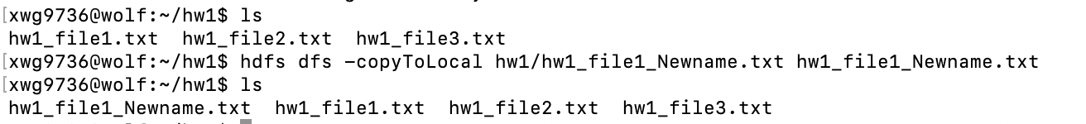

**Task7: Create a second folder in Hadoop. Copy two small text files to it. Then extract from Hadoop a single file that is going to be the concatenation of the two files, i.e., appending one file to the other one. (use getmerge)**

Create a second folder in Hadoop:

Copy *hw1_file2.txt* and *hw1_file3.txt* to the new folder *hw1_second* in Hadoop



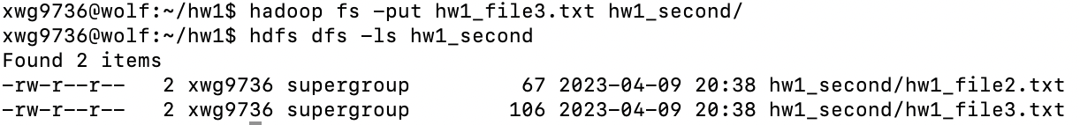

Merge *hw1_file2.txt* and *hw1_file3.txt and* save the concatenate file to Wolf.



Show the content of concatenate file:

**Task 8: Take a different file on your local filesystem, move it to Hadoop, and then within Hadoop copy the same file to Tucker’s folder (/user/tlewis).**

Move *hw1_task8_by_Xingyu.txt* from local file system to Hadoop under the hw1 directory:

Copy the file to Tucker’s folder:

