Saurabh Sinha

saurabhsinha1420@gmail.com

Abstract

In accordance with the aforementioned title, the present analysis aims to examine the user interfaces of two prominent Indian colleges. The primary objective of this analysis is to identify and highlight design flaws that hinder the optimal user experience. Furthermore, comprehensive recommendations will be provided regarding the methods through which these identified errors can be rectified and enhanced to achieve superior performance. Additionally, visual aid in the form of screenshots will be employed to specifically pinpoint the errors, accompanied by detailed descriptions and suggested improvements.

Analysis on design errors commitTed on educational institutes’ webPAGES

(Cogoport Training Assessment 1- UI/UX Design Error Analysis)

1. NIT SILCHAR

* Too many “Menu” options

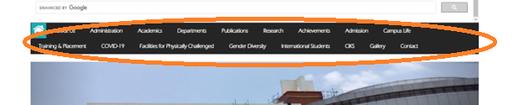

As illustrated in the provided image, the array of options positioned to the right of the home icon is significantly excessive. This surplus of options often results in an overwhelming display, which may not hold relevance or capture the interest of users attempting to navigate through the available choices. Hence, it is crucial to carefully reassess and curate the selection of options presented in this section. By eliminating extraneous and unrelated choices, the user interface can be optimized to provide a more focused and engaging experience for users seeking to toggle between options.

Potential improvement: Several of the existing options can be reorganized and incorporated as submenus for improved navigational efficiency. For instance, options such as "COVID-19," "Training and Placement," and even the "International Student" section could be nested under corresponding parent sections such as Academics or Gallery. This restructuring approach ensures that the options are appropriately categorized and seamlessly integrated within relevant sections of the website. By adopting this strategy, the user interface can provide a more streamlined and intuitive experience, allowing users to easily access specific information without unnecessary clutter or confusion.

* Almost negligible contrasting colors in some areas

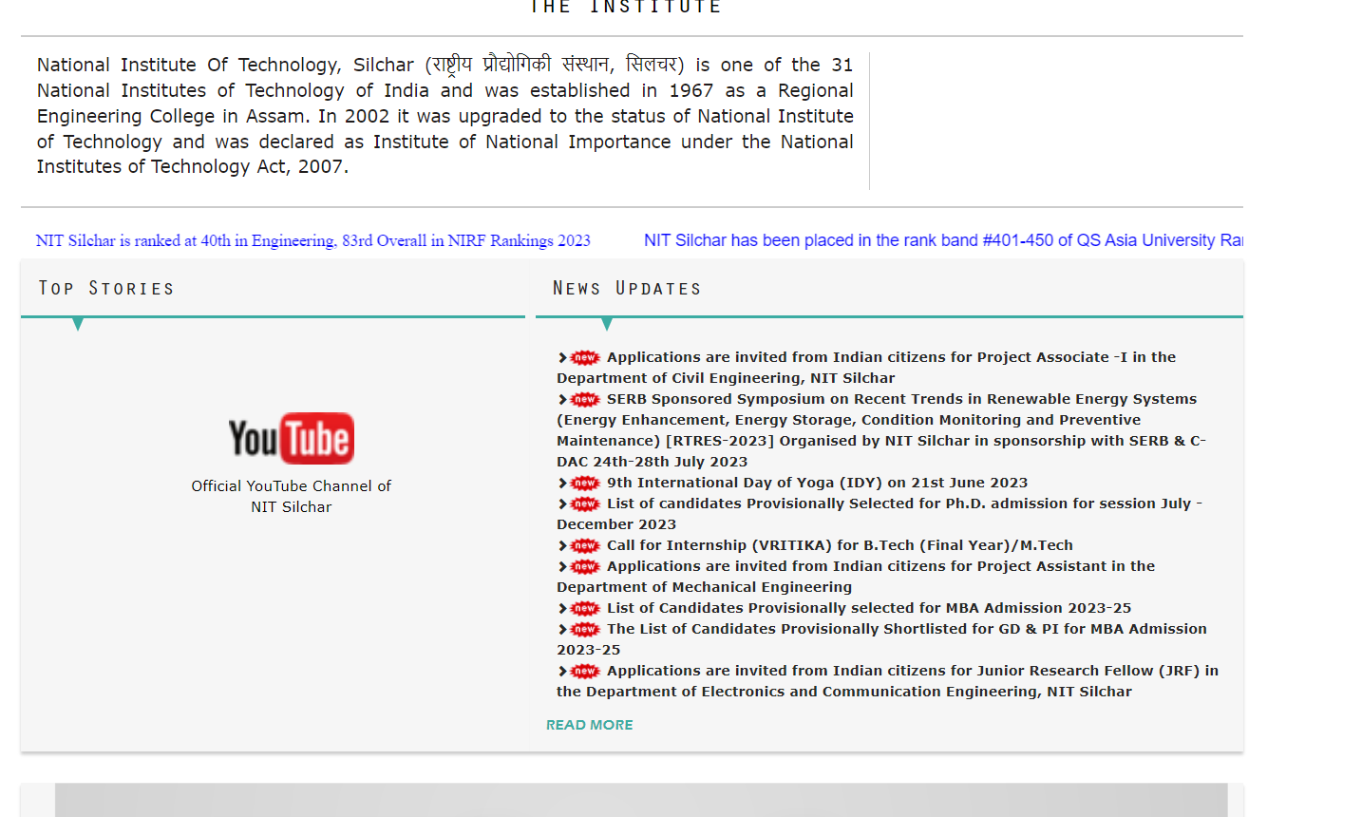

To introduce visual contrast and alleviate the overall plainness of the webpage, certain sections have been accentuated with a black background color. The strategic use of contrasting colors serves a dual purpose: enhancing the user experience for individuals with visual impairments and improving the overall visual appeal for all users accessing the content. By incorporating distinct color differentiations, users with vision difficulties can more easily perceive and navigate through the webpage's various sections. Simultaneously, this approach contributes to a more engaging and visually stimulating experience for all users, enriching their interaction with the content presented.

Potential improvement: In order to enhance the visual aesthetics and improve user experience, it is recommended to introduce additional colors to the server that exhibit moderate contrast with each other. For instance, shades of blue or even gold can be employed to highlight the most significant sections of the webpage. By selecting colors with longer wavelengths, such as those towards the red end of the spectrum, important features can be effectively emphasized. Furthermore, if users utilize the provided search bar to locate specific content, and if the search results are present on the home page, it is advisable to highlight the searched keywords using a high-wavelength color, such as red. This visual cue serves as a clear indicator to users, signaling that the highlighted content corresponds to their desired search query.

* Complex quick link section with readability issues

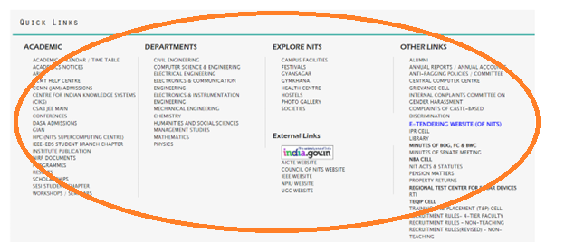

As depicted in the provided image, the quick link section contains an excessive number of options presented in a smaller font size. This arrangement may not be visually appealing to many viewers and could result in overlooking important sections within the quick link menu. To address this issue, it is advisable to reconsider the design by employing a more user-friendly approach. This can involve reducing the number of options to prioritize the most prominent ones and increasing the font size to enhance readability. By implementing these modifications, viewers will be more likely to engage with and explore the quick link section, ensuring that crucial sections are not overlooked or disregarded.

Potential improvement: Building upon previous improvements, it is recommended to introduce subsections within the quick link section. This can be achieved by implementing a hover effect where links appear when the cursor is positioned over the main section content. By doing so, the number of visible quick links can be reduced, resulting in a more streamlined and accessible interface. Additionally, to enhance both accessibility and user experience, consider grouping together similar content from different links into a single link.

* Using texts and graphs as images

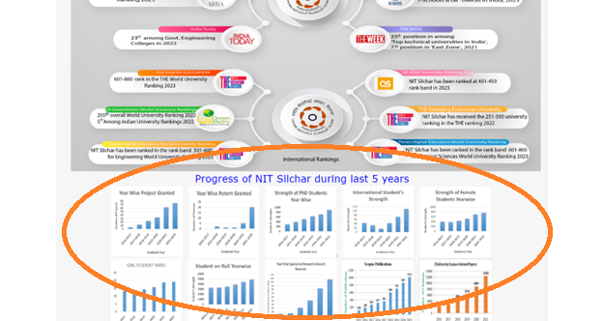

Regarding the specific section of the webpage, the images and the graphs having important data can be observed as individual screenshots or sourced screenshots. However, it is worth noting that the images currently exhibit low resolution and lack clarity. As a result, it becomes challenging to discern the details within the images. To address this issue, it is recommended to enhance the resolution and clarity of the images. This can be achieved by obtaining higher-quality screenshots or by improving the existing images to ensure they accurately represent the intended content with clear visibility and distinctiveness.

Potential improvement: Instead of relying on a single image as the source of rankings, it is preferable to incorporate distinct images that are linked to their respective sources in a similar manner. This approach ensures transparency and facilitates easy access to the relevant information for users. Additionally, when dealing with graphs or charts, it is advantageous to plot them directly on the webpage. By doing so, the webpage becomes more responsive and interactive, allowing users to interact with the visual data and gain a better understanding of the rankings being presented. This not only enhances the user experience but also adds value to the overall usability and engagement of the webpage.

* Language dropdown can be swapped with toggle as only one language is included

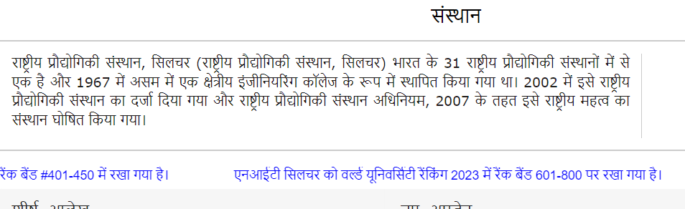

As depicted below, the website currently incorporates only one language, Hindi, in addition to English. However, relying solely on automated translation tools like Google Translate can result in inaccurate phrasing and inconsistencies in meaning. To address this issue, it is advisable to implement professional human translation services for other languages. By utilizing qualified translators, the website can ensure accurate and contextually appropriate translations, maintaining consistency in the intended message across different languages. This approach guarantees a higher quality user experience by avoiding potential errors or misinterpretations that may arise from machine translations.

Potential improvement: It is highly recommended to incorporate additional languages, such as Bengali and Kannada, into the website. This inclusion offers significant advantages by introducing subjectivity to an otherwise objective website and enhancing its overall user-friendliness. By providing content in multiple languages, the website becomes more accessible to a broader range of users, accommodating diverse linguistic preferences and increasing user engagement. This expansion ensures that a wider audience can fully understand and connect with the information presented, resulting in a more inclusive and user-centric experience.

1. NIT MANIPUR

* Absence of a Search Bar

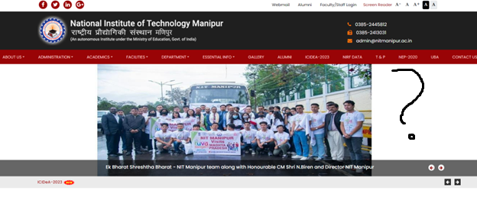

In any website that encompasses a significant volume of content, the inclusion of a search bar is essential. This feature plays a vital role in facilitating user navigation by swiftly directing them to their desired page or location, thereby enhancing the overall user experience and saving valuable time.

Potential Improvement: To further improve the website's usability, it is recommended to incorporate a search bar either on the top right-hand side of the page or as a separate section positioned between the logo and the menu section. This strategic placement ensures easy visibility and accessibility for users, allowing them to quickly locate and utilize the search functionality to find relevant information within the website.

* Too many white spaces between content

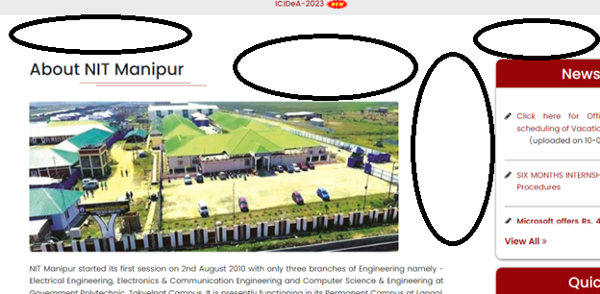

During the process of scrolling down the webpage, a notable presence of excessive white spaces becomes apparent. This design inefficiency has the potential to diminish a viewer's interest in the visited webpage.

Potential Improvement: To address this concern, it is recommended to reduce the amount of white spaces by incorporating additional content that is likely to engage and captivate the viewers. This can be achieved by carefully identifying and including relevant information, images, or interactive elements in the vacant areas. Another approach to enhance the design is through reorganization or restructuring of the existing content, ensuring a more balanced and visually appealing layout. By optimizing the use of white spaces and offering compelling content, the webpage can sustain viewer interest and encourage them to explore further.

* Lack of accessibility

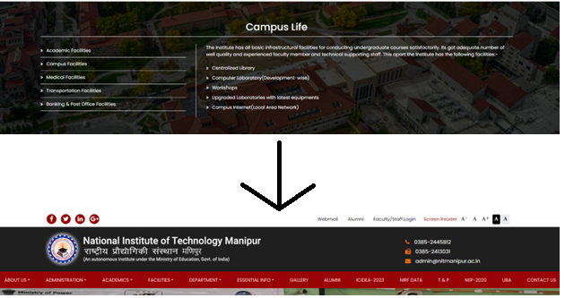

As depicted in the images above, a particular section of the webpage presents an issue where, upon scrolling and attempting to click on any link, the page redirects back to the top. This redirection occurs because the content linked within this section mirrors the content available in the main menu of the webpage, resulting in a lack of accessibility. Consequently, viewers may encounter difficulty accessing specific sections of the webpage that they require.

Potential Improvement: To address this issue, it is recommended to improve the user experience by redirecting viewers to the actual link or page they intend to access, rather than redirecting them to the top of the webpage. For instance, if a viewer clicks on "Campus Facilities," it would greatly enhance the user experience if they are redirected to the page containing the essential information related to campus facilities, rather than being redirected to the top of the webpage. By implementing this improvement, the accessibility and ease of navigation within the webpage will be significantly enhanced, providing a more satisfying user experience.

* Website images are unresponsive

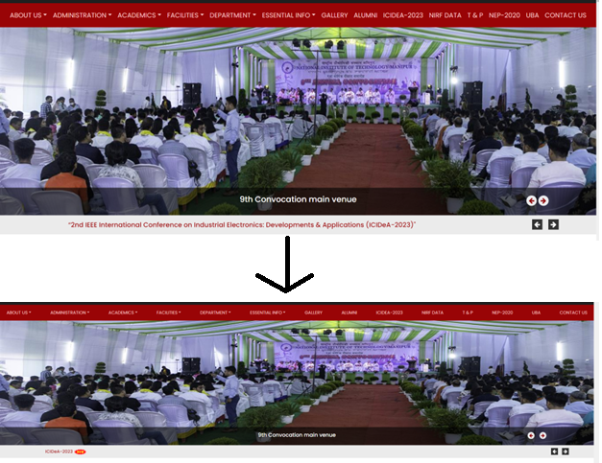

Upon the first visit to the website, a noticeable issue arises when attempting to zoom in or out on the initial images. These images appear to lack responsiveness to the user's control, resulting in an inconsistent and unappealing experience for the viewer.

Potential Improvement: To improve this situation, it is crucial to introduce responsiveness to the images. By enhancing the responsiveness, the user experience will be significantly enhanced, as the images will adapt and adjust accordingly to accommodate the viewer's preferences and actions. This adaptive behavior ensures a seamless and visually pleasing experience for users, regardless of their preferred zoom level. Incorporating this improvement will contribute to a more engaging and user-friendly website.

* Inconsistency in layout and outdated design:

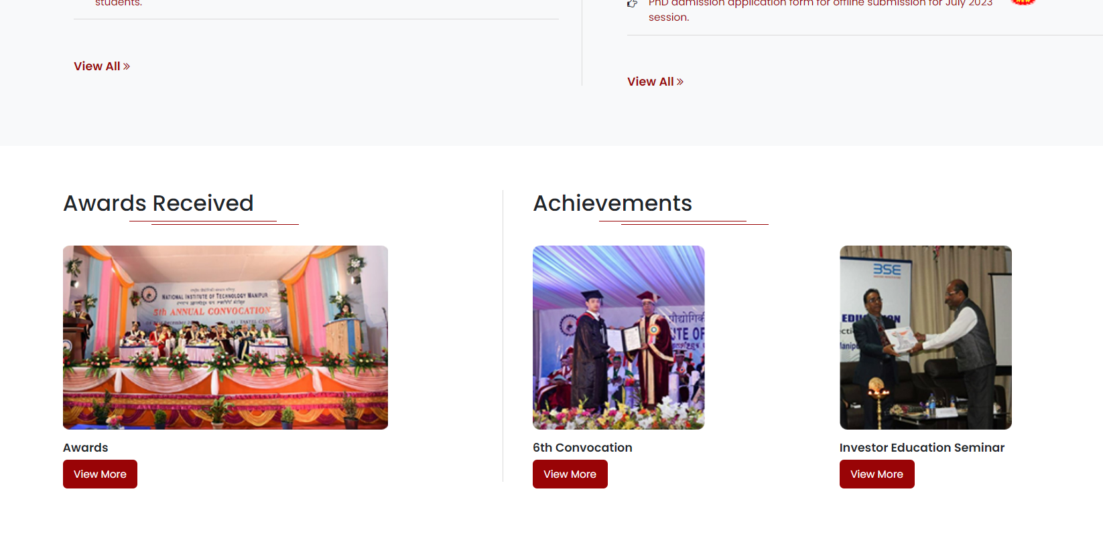

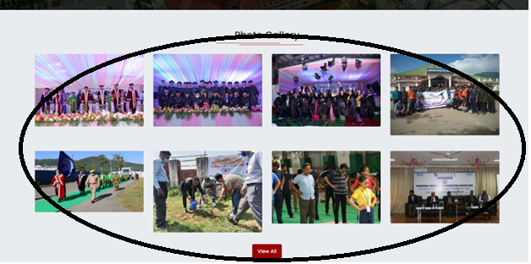

The website itself demonstrates certain shortcomings in terms of accessing specific sections, such as the gallery or achievements, which often require scrolling down the webpage to view the content. Moreover, numerous images suffer from low resolution, and certain areas of the layout exhibit inconsistency. For instance, the photo gallery at the bottom of the page solely comprises photos without any accompanying background information.

Potential Improvement: To address these issues and enhance the overall user experience, several improvements can be implemented. Firstly, the images should have better resolution to make them more visually appealing. Secondly, the achievement section can be prominently included in the main menu, allowing easier access for users. Additionally, important images accompanied by relevant background details can be added as subsections within the achievement section, specifically labeled as "events" or a similar term. This arrangement ensures a more comprehensive representation of achievements. Furthermore, the gallery section can be designated as a separate section in the menu, and subsections such as "convocation" or "Founder's day" can be added to diversify the content. This approach eliminates the need for excessive scrolling to find specific content, improving user convenience and accessibility throughout the website.

Overall,

UI/UX design plays a crucial role in improving the user interface (UI) and user experience (UX) of college websites. By focusing on the UI, design elements such as color schemes, typography, and layout are optimized to create an aesthetically pleasing and consistent interface. Navigation is made intuitive and user-friendly, allowing visitors to easily find the information they need. On the other hand, UX design focuses on understanding users' needs and behaviors to enhance their overall experience. This involves organizing content effectively, incorporating interactive features, and ensuring accessibility for all users. By prioritizing UI and UX design, college websites can deliver a visually appealing and engaging interface that facilitates seamless navigation, improves user satisfaction, and effectively communicates the institution's offerings and information.