12864LCDSPI库函数的使用

**1.12864LCDSPI接线方式**

|  |  |
| --- | --- |
| "SPI模式" | |
| **引脚** | **接线** |
| VSS | GND |
| VDD | 5V |
| RS | 数字口8 |
| R/W | 数字口9 |
| E | 数字口3 |
| PSB | GND |
| BLA | 5V |
| BLK | GND |

[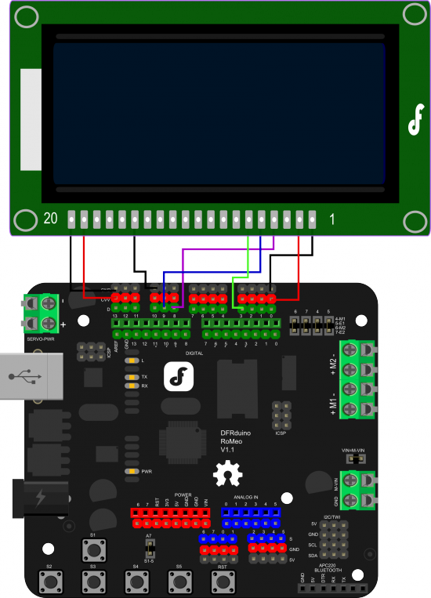](http://wiki.dfrobot.com.cn/index.php?title=%E6%96%87%E4%BB%B6:112.png)

**2.LCD12864RSPI显示字符**

**（1）接线**

与上面12864SPI接线方式相同

**（2）演示显示字符代码**

#include "LCD12864RSPI.h"

#define AR_SIZE( a ) sizeof( a ) / sizeof( a[0] )

unsigned char show[]="dfrobot.com";

void setup()

{

LCDA.Initialise(); // 屏幕初始化

delay(100);

}

void loop()

{

LCDA.CLEAR();//清屏

delay(100);

LCDA.DisplayString(2,1,show,AR_SIZE(show));;//第三行第二格开始，显示网址dfrobot.com/

delay(5000);

}

**3.LCD12864RSPI显示汉字**

**（1）汉字解码方法**

打开汉字解码软件，在待处理=字符串中输入要解码的汉字，点击转换即可，例如：

[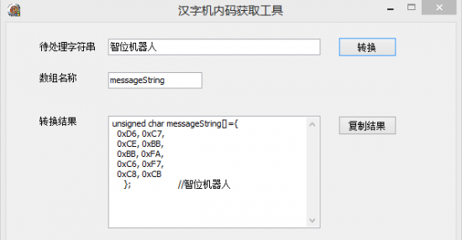](http://wiki.dfrobot.com.cn/index.php?title=%E6%96%87%E4%BB%B6:6091.png)

**（2）连线图**

参考上面12864SPI的连线图

**（3）LCD12864RSPI 文字演示代码**

#include "LCD12864RSPI.h"

#define AR_SIZE( a ) sizeof( a ) / sizeof( a[0] )

unsigned char show[]= { 0xD6, 0xC7, 0xCE, 0xBB, 0xBB, 0xFA, 0xC6, 0xF7, 0xC8, 0xCB }; //智位机器人

void setup()

{

LCDA.Initialise(); // 屏幕初始化

delay(100);

}

void loop()

{

LCDA.CLEAR();//清屏

delay(100);

LCDA.DisplayString(0,2,show,AR_SIZE(show));//第一行第三格开始，显示文智位机器人

delay(5000);

}

**4.LCD12864RSPI 显示图片**

**（1）图片转换**

第一：先打开photoshop，新建文档，大小为128*64，图片做好之后，保存格式为位图。

[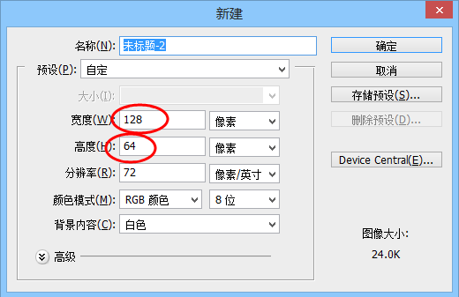](http://wiki.dfrobot.com.cn/index.php?title=%E6%96%87%E4%BB%B6:3344.png)

第二：打开图片取模软件，先设置参数，选择c语言，输出大小X为128，Y为64。

[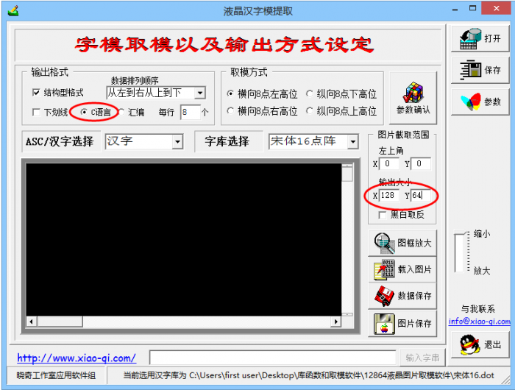](http://wiki.dfrobot.com.cn/index.php?title=%E6%96%87%E4%BB%B6:3366.png)

第三：载入制作好或者已有的位图图片。

[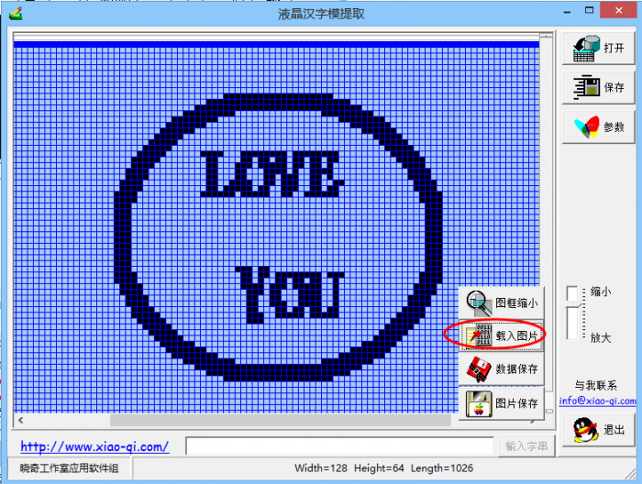](http://wiki.dfrobot.com.cn/index.php?title=%E6%96%87%E4%BB%B6:3377.png)

第四：保存数据，选择适当的位置，并给生成数据的文档命名。

[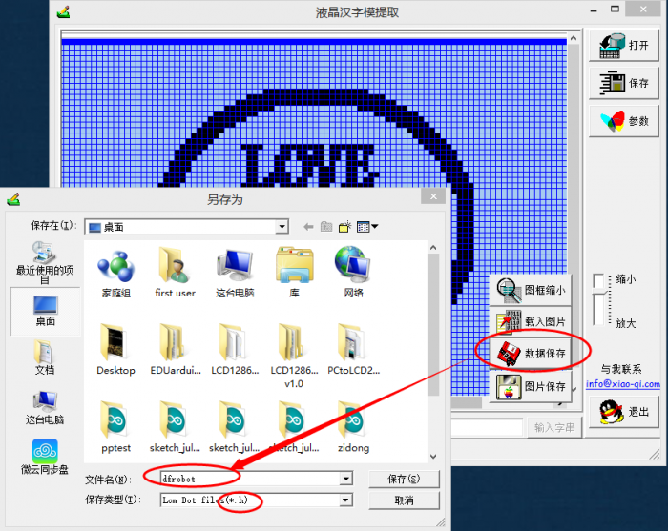](http://wiki.dfrobot.com.cn/index.php?title=%E6%96%87%E4%BB%B6:3312.png)

第五：打开保存生成数据的文档，并将其生成的字符数组复制到代码里面。

[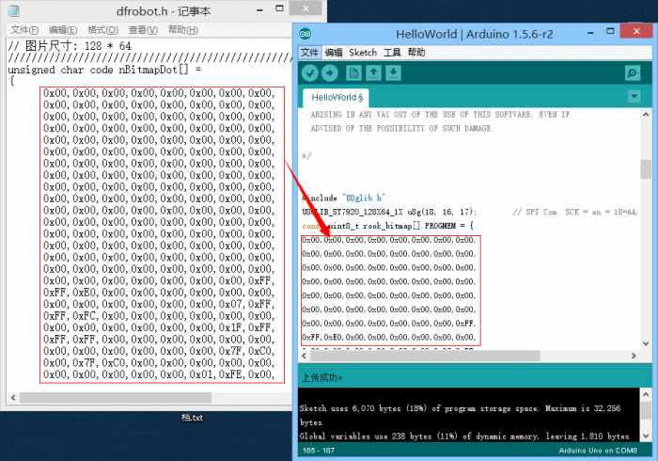](http://wiki.dfrobot.com.cn/index.php?title=%E6%96%87%E4%BB%B6:3314.png)

**（2）连线图**

与上面12864SPI的连线图相同

**（3）LCD12864RSPI的图片显示代码**

#include "LCD12864RSPI.h"

#define AR_SIZE( a ) sizeof( a ) / sizeof( a[0] )

unsigned char logo0[]={ //笑脸

0x00,0x00,0x00,0x00,0x00,0x00,0x00,0x00,

0x00,0x00,0x00,0x00,0x00,0x00,0x00,0x00,

0x00,0x00,0x00,0x00,0x00,0x00,0x00,0x00,

0x00,0x00,0x00,0x00,0x00,0x00,0x00,0x00,

0x00,0x00,0x00,0x00,0x00,0x00,0x00,0x00,

0x00,0x00,0x00,0x00,0x00,0x00,0x00,0x00,

0x00,0x00,0x00,0x00,0x00,0x00,0x00,0x00,

0x00,0x00,0x00,0x00,0x00,0x00,0x00,0x00,

0x00,0x00,0x00,0x00,0x00,0x00,0x00,0x00,

0x00,0x00,0x00,0x00,0x00,0x00,0x00,0x00,

0x00,0x00,0x00,0x00,0x00,0x00,0x00,0x00,

0x00,0x00,0x00,0x00,0x00,0x00,0x00,0x00,

0x00,0x00,0x00,0x00,0x00,0x00,0x00,0x00,

0x00,0x00,0x00,0x00,0x00,0x00,0x00,0x00,

0x00,0x00,0x00,0x00,0x00,0x00,0x00,0x00,

0x00,0x00,0x00,0x00,0x00,0x00,0x00,0x00,

0x00,0x00,0x00,0x00,0x00,0x00,0x00,0xFF,

0xFF,0xE0,0x00,0x00,0x00,0x00,0x00,0x00,

0x00,0x00,0x00,0x00,0x00,0x00,0x07,0xFF,

0xFF,0xFC,0x00,0x00,0x00,0x00,0x00,0x00,

0x00,0x00,0x00,0x00,0x00,0x00,0x1F,0xFF,

0xFF,0xFF,0x00,0x00,0x00,0x00,0x00,0x00,

0x00,0x00,0x00,0x00,0x00,0x00,0x7F,0xC0,

0x00,0x7F,0xC0,0x00,0x00,0x00,0x00,0x00,

0x00,0x00,0x00,0x00,0x00,0x01,0xFE,0x00,

0x00,0x0F,0xF0,0x00,0x00,0x00,0x00,0x00,

0x00,0x00,0x00,0x00,0x00,0x03,0xF8,0x00,

0x00,0x03,0xF8,0x00,0x00,0x00,0x00,0x00,

0x00,0x00,0x00,0x00,0x00,0x07,0xE0,0x00,

0x00,0x00,0xFC,0x00,0x00,0x00,0x00,0x00,

0x00,0x00,0x00,0x00,0x00,0x0F,0x80,0x00,

0x00,0x00,0x3E,0x00,0x00,0x00,0x00,0x00,

0x00,0x00,0x00,0x00,0x00,0x1F,0x00,0x00,

0x00,0x00,0x1F,0x00,0x00,0x00,0x00,0x00,

0x00,0x00,0x00,0x00,0x00,0x3E,0x00,0x00,

0x00,0x00,0x0F,0x80,0x00,0x00,0x00,0x00,

0x00,0x00,0x00,0x00,0x00,0x7C,0x0F,0x1F,

0xEF,0xF0,0x07,0xC0,0x00,0x00,0x00,0x00,

0x00,0x00,0x00,0x00,0x00,0xF8,0x06,0x1B,

0x6D,0xB0,0x03,0xE0,0x00,0x00,0x00,0x00,

0x00,0x00,0x00,0x00,0x00,0xF0,0x06,0x3B,

0xED,0xA0,0x01,0xE0,0x00,0x00,0x00,0x00,

0x00,0x00,0x00,0x00,0x01,0xE0,0x06,0x31,

0xE9,0xE0,0x00,0xF0,0x00,0x00,0x00,0x00,

0x00,0x00,0x00,0x00,0x01,0xE0,0x06,0x31,

0xB9,0xA0,0x00,0xF0,0x00,0x00,0x00,0x00,

0x00,0x00,0x00,0x00,0x03,0xC0,0x06,0x79,

0xB9,0x98,0x00,0x78,0x00,0x00,0x00,0x00,

0x00,0x00,0x00,0x00,0x03,0xC0,0x06,0xFB,

0x39,0xB0,0x00,0x78,0x00,0x00,0x00,0x00,

0x00,0x00,0x00,0x00,0x07,0x80,0x0F,0xDF,

0x33,0xF0,0x00,0x3C,0x00,0x00,0x00,0x00,

0x00,0x00,0x00,0x00,0x07,0x80,0x00,0x00,

0x00,0x00,0x00,0x3C,0x00,0x00,0x00,0x00,

0x00,0x00,0x00,0x00,0x07,0x00,0x00,0x00,

0x00,0x00,0x00,0x1C,0x00,0x00,0x00,0x00,

0x00,0x00,0x00,0x00,0x07,0x00,0x00,0x00,

0x00,0x00,0x00,0x1C,0x00,0x00,0x00,0x00,

0x00,0x00,0x00,0x00,0x07,0x00,0x00,0x00,

0x00,0x00,0x00,0x1C,0x00,0x00,0x00,0x00,

0x00,0x00,0x00,0x00,0x07,0x00,0x00,0x00,

0x00,0x00,0x00,0x1C,0x00,0x00,0x00,0x00,

0x00,0x00,0x00,0x00,0x07,0x00,0x00,0x00,

0x00,0x00,0x00,0x1C,0x00,0x00,0x00,0x00,

0x00,0x00,0x00,0x00,0x07,0x00,0x00,0x00,

0x00,0x00,0x00,0x1C,0x00,0x00,0x00,0x00,

0x00,0x00,0x00,0x00,0x07,0x00,0x00,0x00,

0x00,0x00,0x00,0x1C,0x00,0x00,0x00,0x00,

0x00,0x00,0x00,0x00,0x07,0x00,0x00,0x00,

0x00,0x00,0x00,0x1C,0x00,0x00,0x00,0x00,

0x00,0x00,0x00,0x00,0x07,0x00,0x00,0x00,

0x00,0x00,0x00,0x1C,0x00,0x00,0x00,0x00,

0x00,0x00,0x00,0x00,0x07,0x00,0x00,0x00,

0x00,0x00,0x00,0x1C,0x00,0x00,0x00,0x00,

0x00,0x00,0x00,0x00,0x07,0x00,0x00,0x00,

0x00,0x00,0x00,0x1C,0x00,0x00,0x00,0x00,

0x00,0x00,0x00,0x00,0x07,0x00,0x00,0x3B,

0x00,0x00,0x00,0x1C,0x00,0x00,0x00,0x00,

0x00,0x00,0x00,0x00,0x07,0x80,0x00,0x1B,

0x7F,0xB8,0x00,0x3C,0x00,0x00,0x00,0x00,

0x00,0x00,0x00,0x00,0x07,0x80,0x00,0x1A,

0x6D,0x90,0x00,0x3C,0x00,0x00,0x00,0x00,

0x00,0x00,0x00,0x00,0x03,0xC0,0x00,0x1E,

0xEF,0x90,0x00,0x78,0x00,0x00,0x00,0x00,

0x00,0x00,0x00,0x00,0x03,0xC0,0x00,0x0E,

0xC7,0x90,0x00,0x78,0x00,0x00,0x00,0x00,

0x00,0x00,0x00,0x00,0x01,0xE0,0x00,0x0C,

0xC7,0x90,0x00,0xF0,0x00,0x00,0x00,0x00,

0x00,0x00,0x00,0x00,0x01,0xE0,0x00,0x0C,

0xE7,0x90,0x00,0xF0,0x00,0x00,0x00,0x00,

0x00,0x00,0x00,0x00,0x00,0xF0,0x00,0x0C,

0x6D,0xB0,0x01,0xE0,0x00,0x00,0x00,0x00,

0x00,0x00,0x00,0x00,0x00,0xF8,0x00,0x0E,

0x7D,0xF0,0x03,0xE0,0x00,0x00,0x00,0x00,

0x00,0x00,0x00,0x00,0x00,0x7C,0x00,0x0E,

0x00,0x00,0x07,0xC0,0x00,0x00,0x00,0x00,

0x00,0x00,0x00,0x00,0x00,0x3E,0x00,0x00,

0x00,0x00,0x0F,0x80,0x00,0x00,0x00,0x00,

0x00,0x00,0x00,0x00,0x00,0x1F,0x00,0x00,

0x00,0x00,0x1F,0x00,0x00,0x00,0x00,0x00,

0x00,0x00,0x00,0x00,0x00,0x0F,0x80,0x00,

0x00,0x00,0x3E,0x00,0x00,0x00,0x00,0x00,

0x00,0x00,0x00,0x00,0x00,0x07,0xE0,0x00,

0x00,0x00,0xFC,0x00,0x00,0x00,0x00,0x00,

0x00,0x00,0x00,0x00,0x00,0x03,0xF8,0x00,

0x00,0x03,0xF8,0x00,0x00,0x00,0x00,0x00,

0x00,0x00,0x00,0x00,0x00,0x01,0xFE,0x00,

0x00,0x0F,0xF0,0x00,0x00,0x00,0x00,0x00,

0x00,0x00,0x00,0x00,0x00,0x00,0x7F,0xC0,

0x00,0x7F,0xC0,0x00,0x00,0x00,0x00,0x00,

0x00,0x00,0x00,0x00,0x00,0x00,0x1F,0xFF,

0xFF,0xFF,0x00,0x00,0x00,0x00,0x00,0x00,

0x00,0x00,0x00,0x00,0x00,0x00,0x07,0xFF,

0xFF,0xFC,0x00,0x00,0x00,0x00,0x00,0x00,

0x00,0x00,0x00,0x00,0x00,0x00,0x00,0xFF,

0xFF,0xE0,0x00,0x00,0x00,0x00,0x00,0x00,

0x00,0x00,0x00,0x00,0x00,0x00,0x00,0x00,

0x00,0x00,0x00,0x00,0x00,0x00,0x00,0x00,

0x00,0x00,0x00,0x00,0x00,0x00,0x00,0x00,

0x00,0x00,0x00,0x00,0x00,0x00,0x00,0x00,

0x00,0x00,0x00,0x00,0x00,0x00,0x00,0x00,

0x00,0x00,0x00,0x00,0x00,0x00,0x00,0x00,

0x00,0x00,0x00,0x00,0x00,0x00,0x00,0x00,

0x00,0x00,0x00,0x00,0x00,0x00,0x00,0x00,

0x00,0x00,0x00,0x00,0x00,0x00,0x00,0x00,

0x00,0x00,0x00,0x00,0x00,0x00,0x00,0x00,

0x00,0x00,0x00,0x00,0x00,0x00,0x00,0x00,

0x00,0x00,0x00,0x00,0x00,0x00,0x00,0x00

};

void setup()

{

LCDA.Initialise(); // 屏幕初始化

delay(100);

}

void loop()

{

LCDA.DrawFullScreen(logo0);

delay(5000);

}

**4.部分代码解释**

LCDA.Initialise(); // 屏幕初始化  
LCDA.CLEAR();//清屏  
LCDA.DisplayString(m,n,str,length));//m代表的是行，n代表的是列，str代表的是要显示内容的名字，length是字符串的长度  
LCDA.DrawFullScreen(logo0)//满屏显示内容