Xinhui Zhao (001560851)

**Program Structures & Algorithms**

**Fall 2021**

**Assignment No. 1**

* **Task (List down the tasks performed in the Assignment)**

Imagine a drunken man starting out leaning against a lamp post in the middle of an open space, takes a series of steps of the same length: 1 meter. The direction of these steps is randomly chosen from N, S, E or W. After n steps, how far (d) is the man from the lamp post? Note that d is the Euclidean distance of the man from the lamp-post. It turns out that there is a relationship between d and n which is typically applicable to many different types of stochastic experiments. Your task is to implement the code for the experiment and to deduce the relationship.

* **Relationship Conclusion: (For ex : z = a * b)**

**d=5/4ln(n+1)**

* **Evidence to support the conclusion:**

1. **Output (Snapshot of Code output in the terminal)**

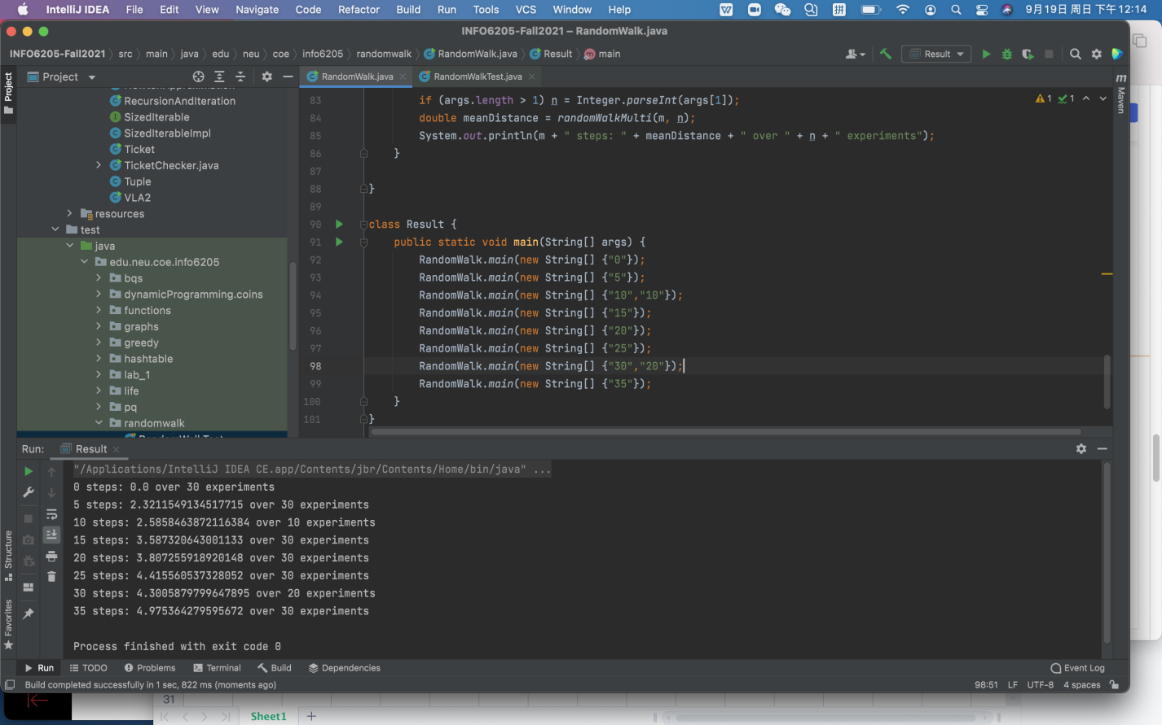

1. **Graphical Representation(Observations from experiments should be tabulated and analyzed by plotting graphs(usually in excel) to arrive on the relationship conclusion)**

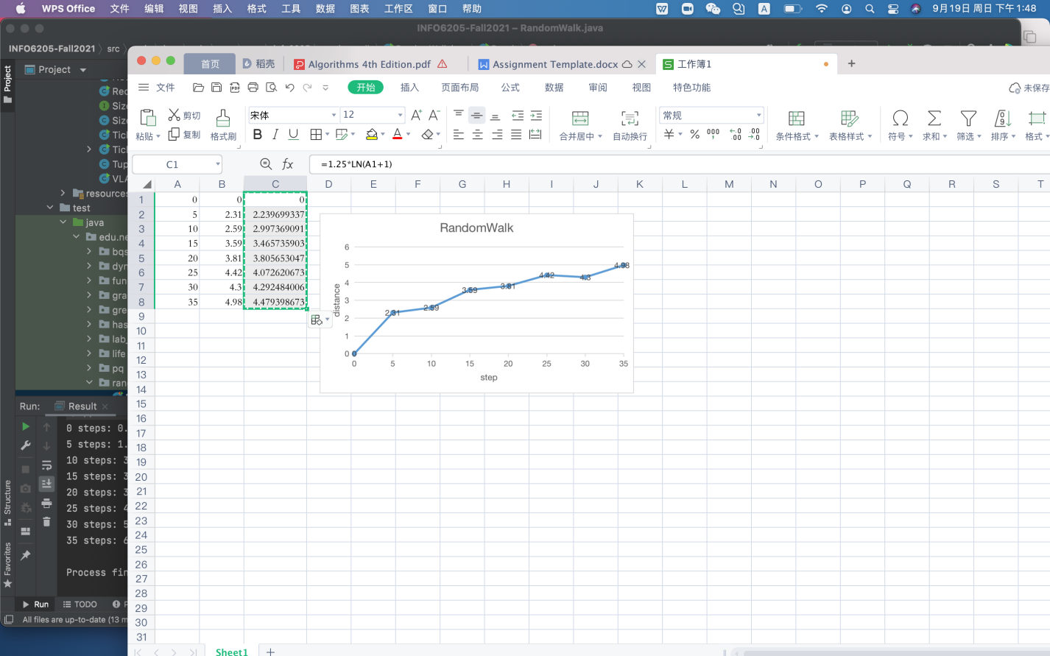

* **Unit tests result:(Snapshot of successful unit test run)**

