Note of MPC

The MPC will try to find the best control sequence over the prediction horizon 𝑁𝑝.

## 3 Rules:

RULE 1 : PREDICTION IN THE CONTROLLER;

RULE 2 : OPTIMIZATION IN THE LOOP;

RULE 3 : RECEDING HORIZON PRINCIPLE.

## Matrix calculus:

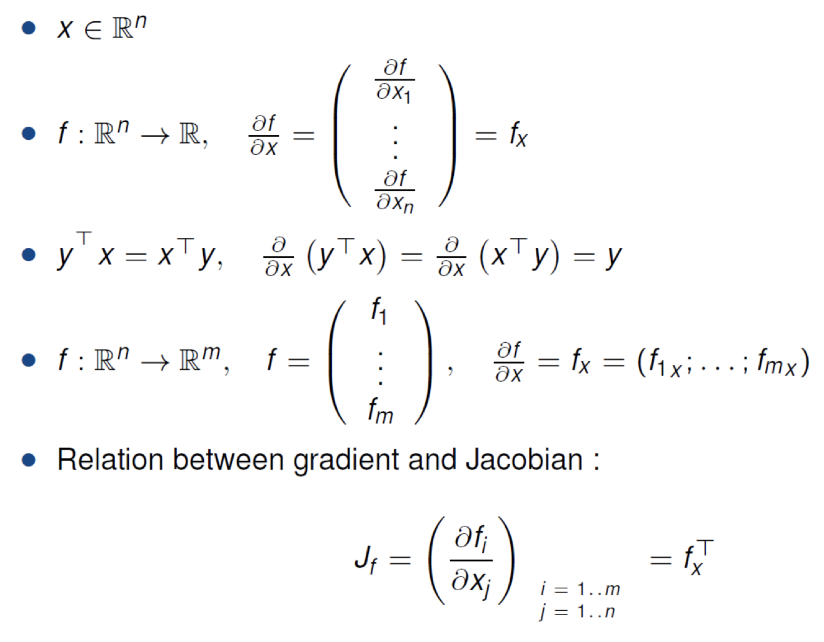

## OPTIMIZATION UNDER CONSTRAINTS: LAGRANGE RELAXATION

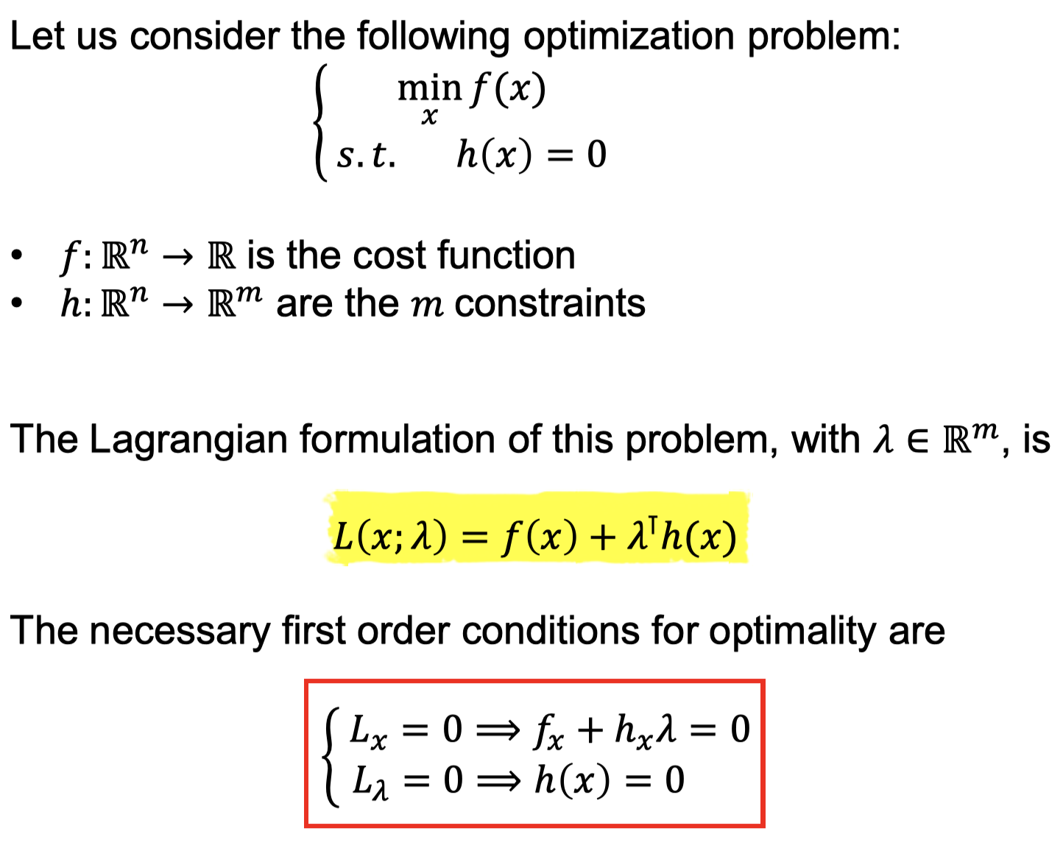

## Convexity

The optimization problem is convex, with respect to the optimization variables.

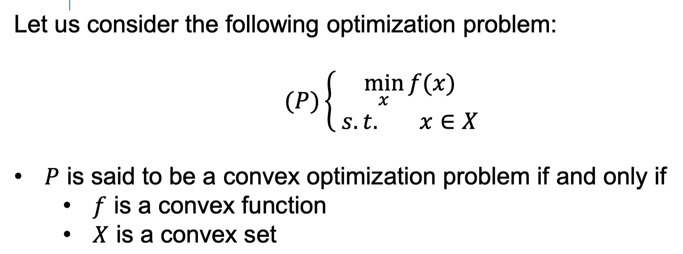

## Convexity: 1st and 2nd order conditions

For quadratic function, the Hessian **is Symmetric Positive Definite.**

## D-LQR:

最优控制理論主要探討的是讓动力系统以在最小成本來運作，若系統動態可以用一組线性微分方程表示，而其成本為二次泛函，這類的問題稱為線性二次（LQ）問題。此類問題的解即為線性二次調節器（英語：linear–quadratic regulator），簡稱LQR。

LQR是回授控制器，方程式在後面會提到。LQR是LQG（線性二次高斯）問題解當中重要的一部份。而LQG問題和LQR問題都是控制理论中最基礎的問題之一。

**Assumptions**:

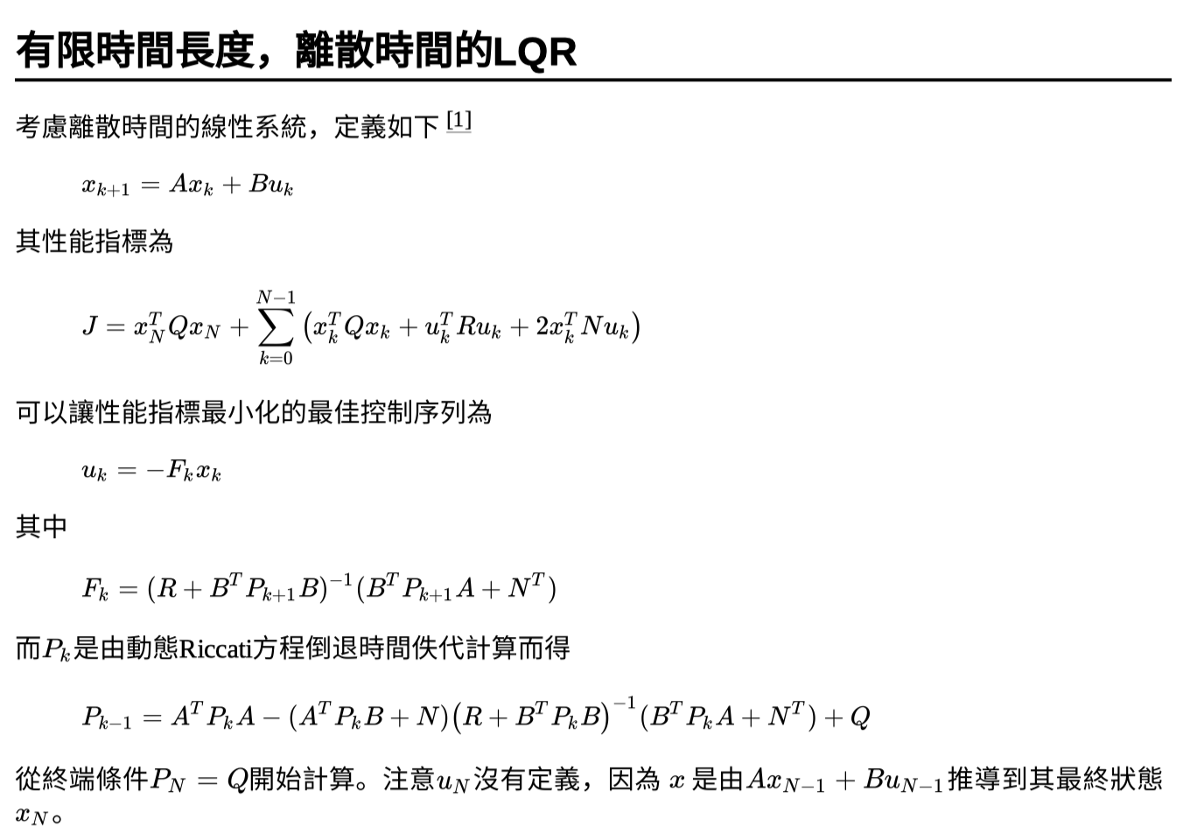

## 3 ways to stabilize a system, using a state feedback

