There are several models proposes in this project:

1. Baseline Model
2. Three Transfer Learning Model:

ResNet50

SeNet50

VGG16

[keras-vggface/models.py at master · rcmalli/keras-vggface (github.com)](https://github.com/rcmalli/keras-vggface/blob/master/keras_vggface/models.py): the three models’ structure

1. Ensemble Learning Model

Transfer learning:

Transfer learning is a machine learning technique where a model trained on one task is re-purposed on a second related task.

This form of transfer learning used in deep learning is called inductive transfer. This is where the scope of possible models (model bias) is narrowed in a beneficial way by using a model fit on a different but related task.

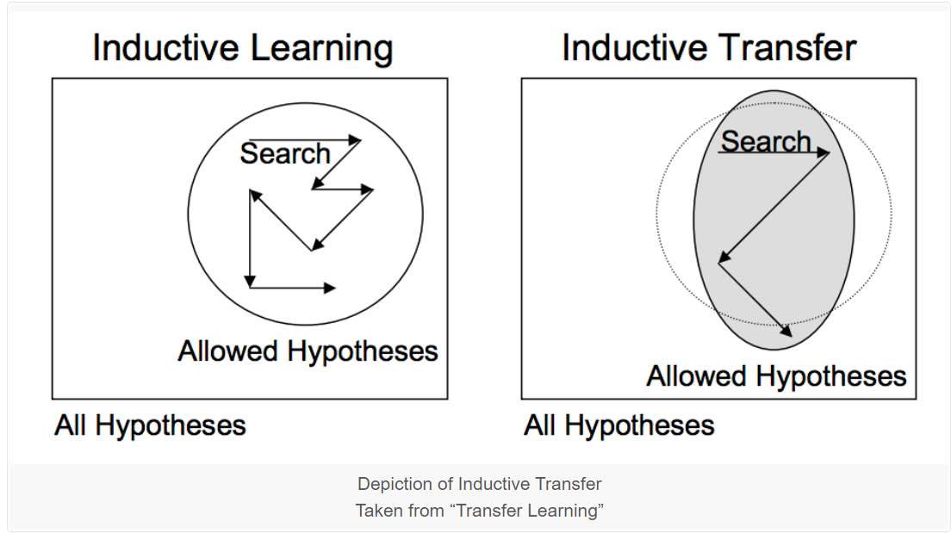

### **Pre-trained Model Approach**

* **Select Source Model**. A pre-trained source model is chosen from available models. Many research institutions release models on large and challenging datasets that may be included in the pool of candidate models from which to choose from.
* **Reuse Model**. The model pre-trained model can then be used as the starting point for a model on the second task of interest. This may involve using all or parts of the model, depending on the modeling technique used.
* **Tune Model**. Optionally, the model may need to be adapted or refined on the input-output pair data available for the task of interest.
* Baseline Model
* ResNet50
* SeNet50
* VGG16