for data with selected 7 features:

Best score: 0.24802993935920192

Best solver: newton-cg

Best C: 1000.0

balanced accuracy score is: 0.269025641025641

f1 score is: 0.526137643934663

for data with selected 8 features:

Best score: 0.2525854816511399

Best solver: newton-cg

Best C: 1000.0

balanced accuracy score is: 0.27697402812241523

f1 score is: 0.5476966959350278

for data with selected 9 features:

Best score: 0.25767279034930324

Best solver: newton-cg

Best C: 1000.0

balanced accuracy score is: 0.2835652605459057

f1 score is: 0.5561215408180461

for data with all 10 features:

Best score: 0.2599796414019337

Best solver: newton-cg

Best C: 1000.0

balanced accuracy score is: 0.2932684863523573

f1 score is: 0.5719384892511221

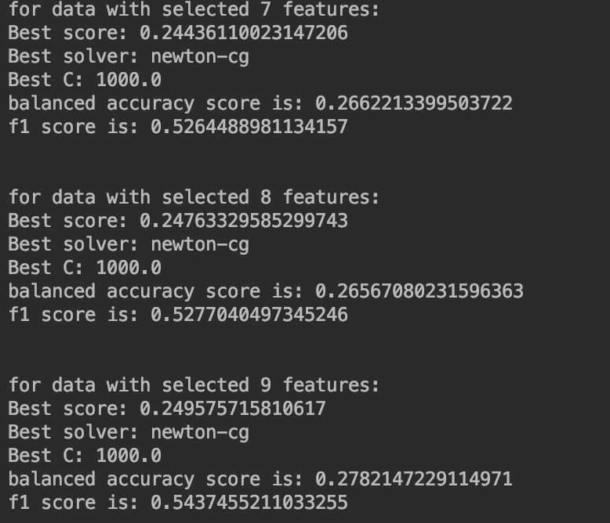

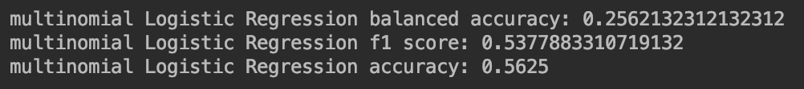

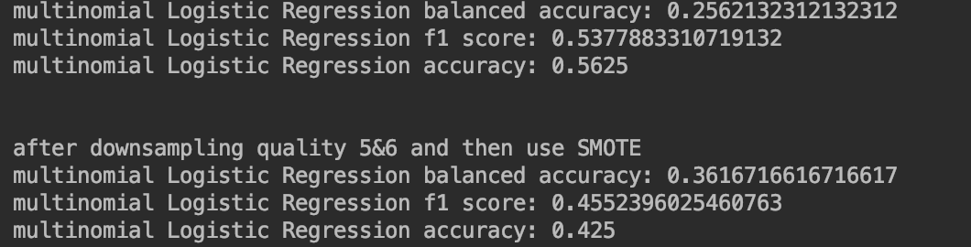

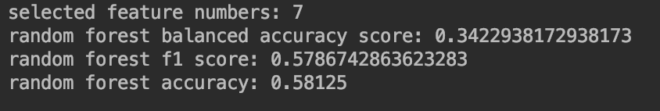

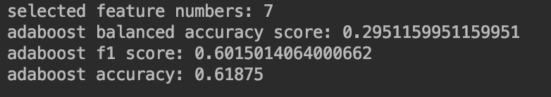

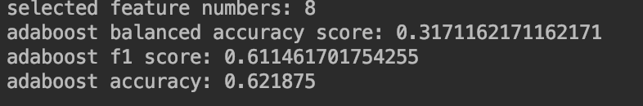

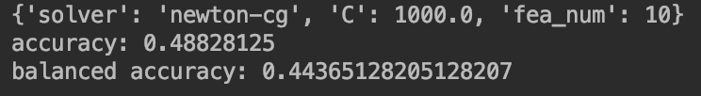

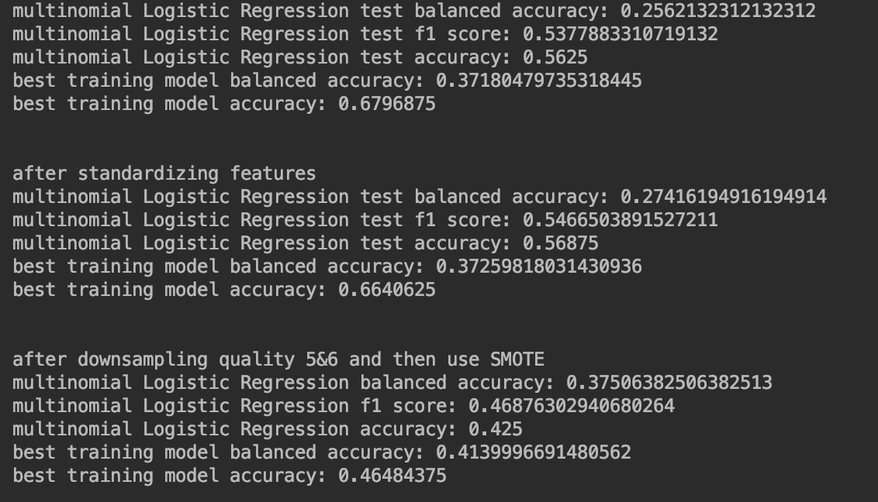

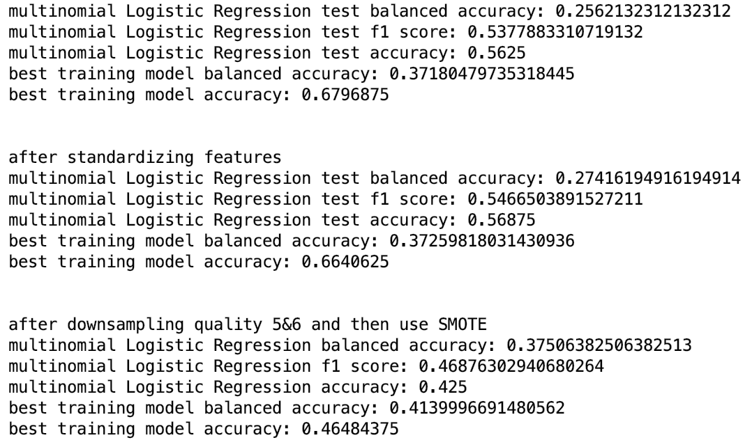

After deleting data of class 3 and 8

