Web application name: Simple Algorithm Calculator

# Introduction

## Implementation

Firstly, I designed the front end of this application using the Bootstrap framework. The table design is taken from the bootstrap documentation. The text input will accept only numbers and commas. The way I make it possible is through the Javascript code shown below.

So I bound this function to the onkeypress of the text input, so the input will be filtered while the user inserts the inputs.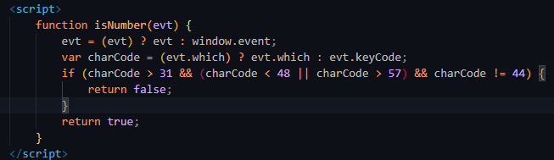

After the user has finished inserting the data, the user can submit the inputs by clicking the submit button below the input field. The button is a type of submit which will trigger the form action once it is clicked. The form action is set to "/result", so it will redirect the page to that route.

After that, the PagesController will be invoked by the route and call the function result() from the PagesController.



The result function is the function that holds all the logic behind the program. Firstly, I created an array called $countObject. After that, I took the input from the request and imploded it into a string and placed it into a variable called "numberString." After that, I explode the string that is separated by “,” into an array. Once that is done, I assign each of the numbers from the myArray into the countObject array as their key and the value as count, which will be initialised as 0. The following for loop will iterate through the myArray and compare which of its keys is equal to that key in the countObject. If the number is the same, the number will be assigned to “T” to be flagged as counted, and its value “$count” will be incremented by 1. In this for loop, it will also ignore any value that is “T” and also blank to reduce the time complexity of this algorithm. Lastly, once it is done, the countObject will be passed to the result view.

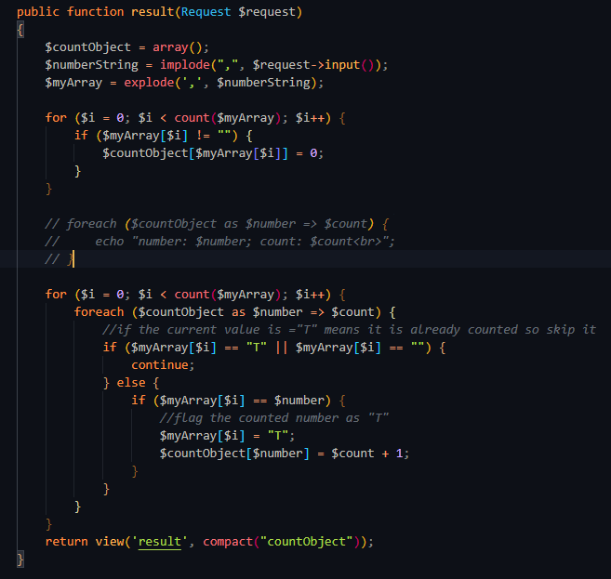

# Result

## Example interface:

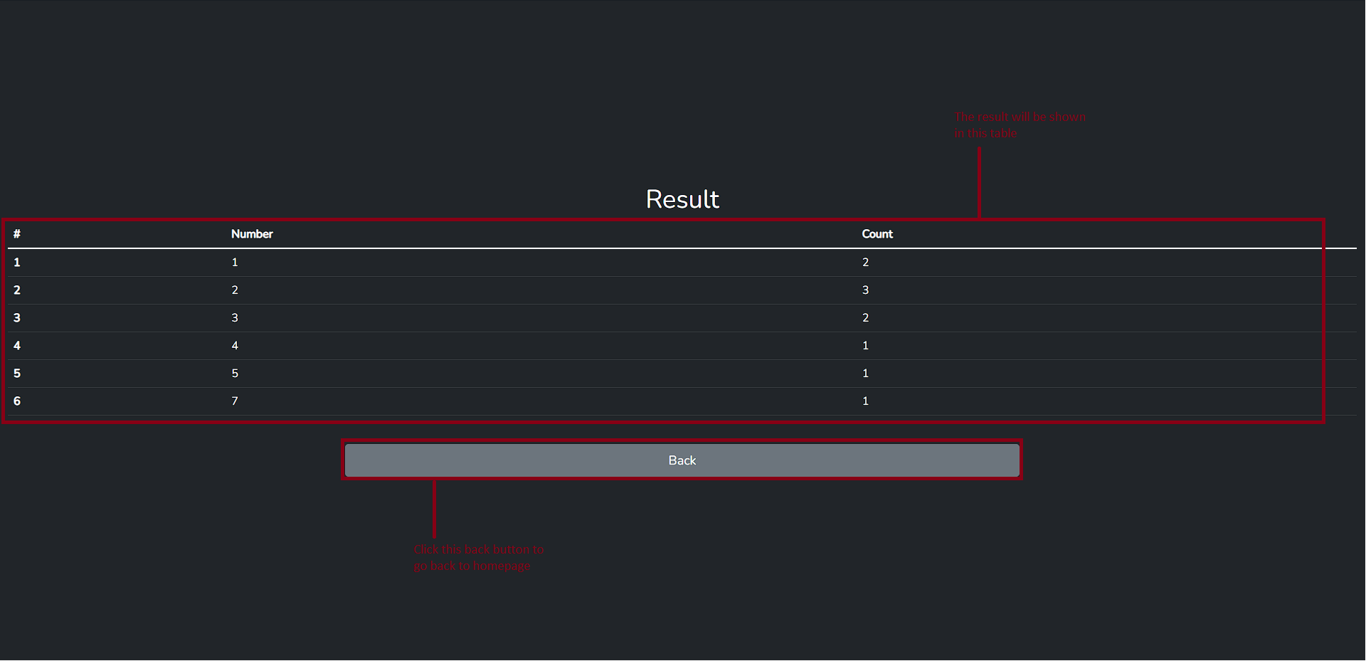

## Example output 1: normal input

Input: 1,2,2,3,4,5,7,1,3,2

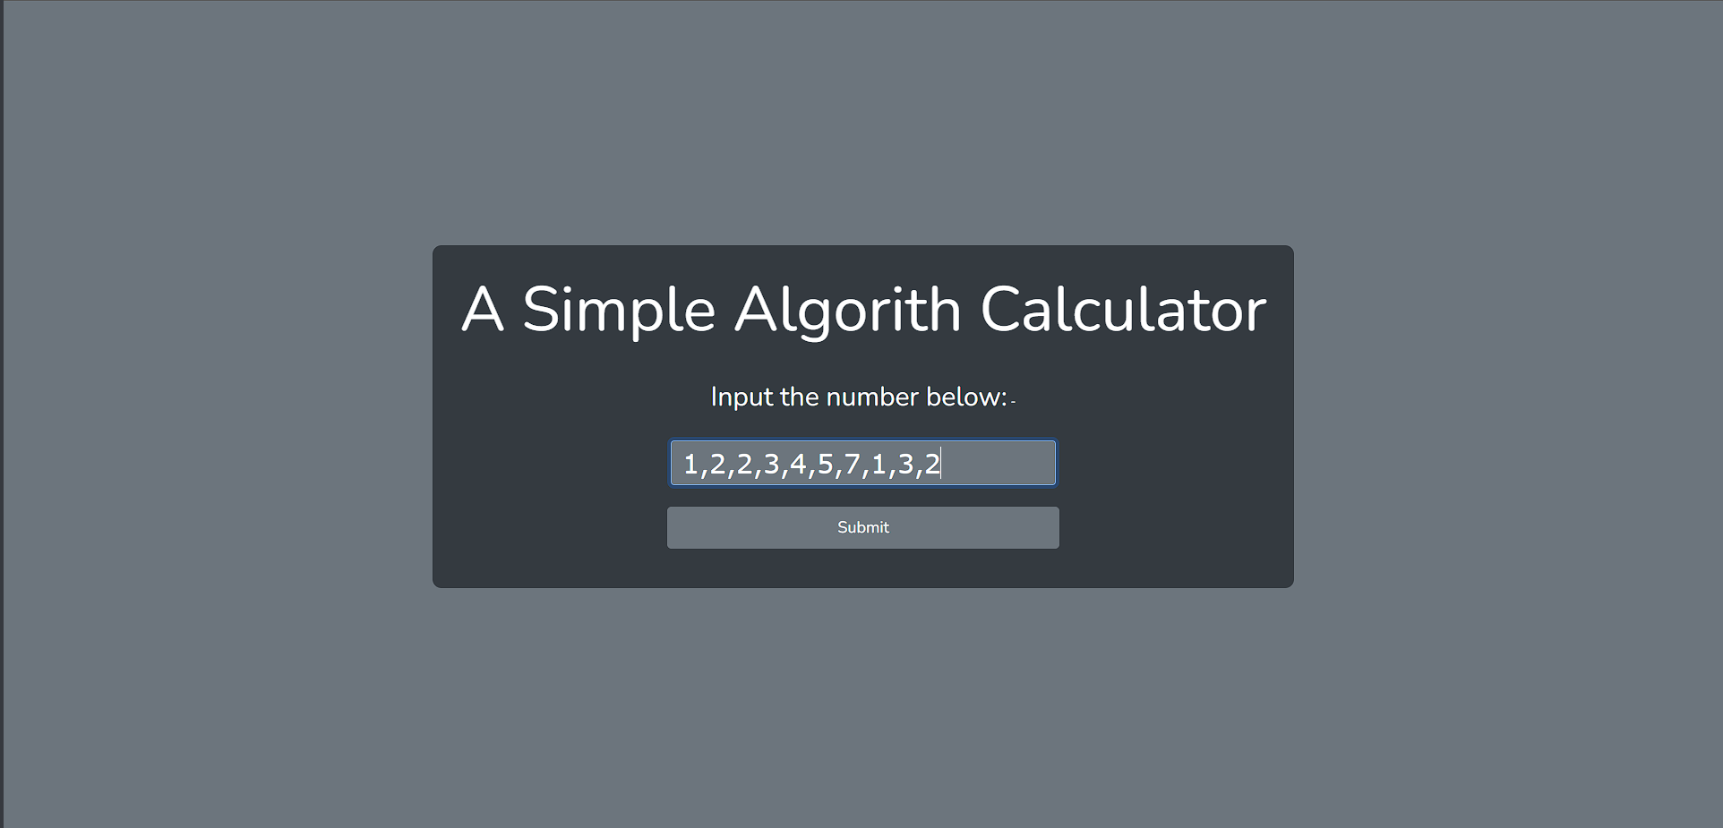

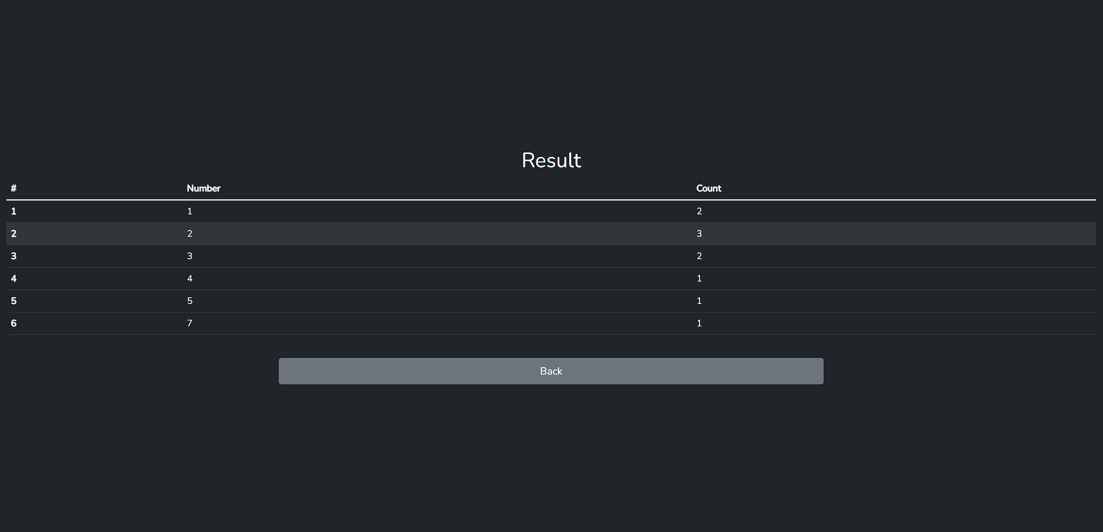

## Example output 2: input with blank

Input: 1,2,,,,5,7,1,3,2

