Design and Implementation of Iris

Date | Update | Author
10/31/2012 | Creation. | Zhenjiang Dong, Jun Wang

Purpose

This document describes the design and implementation of Iris.

Introduction

Iris is simulation model for interconnection networks. Currently it supports two different topologies: ring and torus. Iris operates at flit level and performs cycle-by-cycle simulation. This document describes the design details of Iris' two major components: network interface and router.

Overview

Iris is composed of 2 components: network interface and router. The routers connect to each other to form a network. Each router is connected to one and only one interface and vice versa. A network interface can be connected to at most one terminal. The terminals, through the network, can send packets to each other. The network interface connected to the sending terminal converts a packet into flits, which are then delivered by the routers to the receiving interface, where the flits are assembled back into a packet. The following diagram shows a ring network connection.
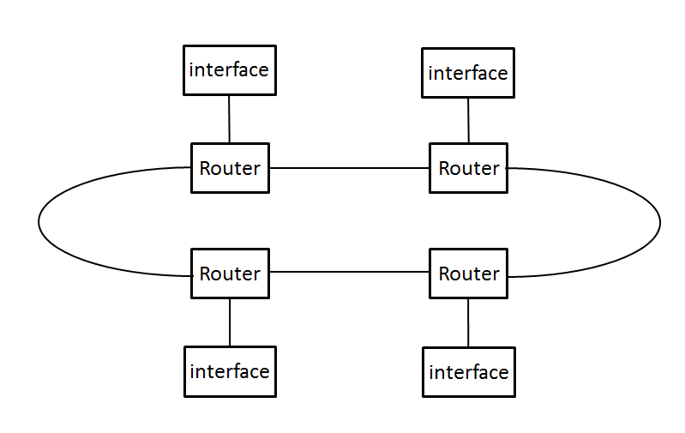

Network Interface (NI)

On the sending end NI accepts packets from terminal, converts packet into flits and pass the flits to the router. On the receiving end, NI is responsible for storing incoming flits and assembling the flits into packet.

In Iris, NI is implemented with the GenericNetworkInterface class, which is a templated class. The rest of the section describes this class in detail.

GenericNetworkInterface<T> class

The GenericNetworkInterface<T> class is a templated class, where the template parameter T is the type of the network packet that terminals can send and receive. The purpose of using a template class is to remove any dependence that terminals have have on Iris. For example, if Iris defines a network packet type, then all the terminals will have to use the definition of the packet type, thus forcing a dependence on Iris. Using a template solves this problem. However, it does have its own restrictions.

First of all, when creating a network, the template parameter must be assigned a real type. This type is the only data type the network interfaces can send/receive. Accordingly, all the terminals can only send/receive this one type.

One way to mitigate the problem is to use the generic NetworkPacket class defined in the uarch layer of Manifold.

In addition, there are restrictions on the template parameter. Specifically, the template parameter must support the following operations:

- get_type(): returns the integer type of the packet.
- set_type(): set the packet's type.
- get_src_port(): get the integer source port number.
- get_dst(): get the integer destination ID.
- set_dst_port(): set the destination port number.

Class diagram for GenNetworkInterface<T> is shown below.

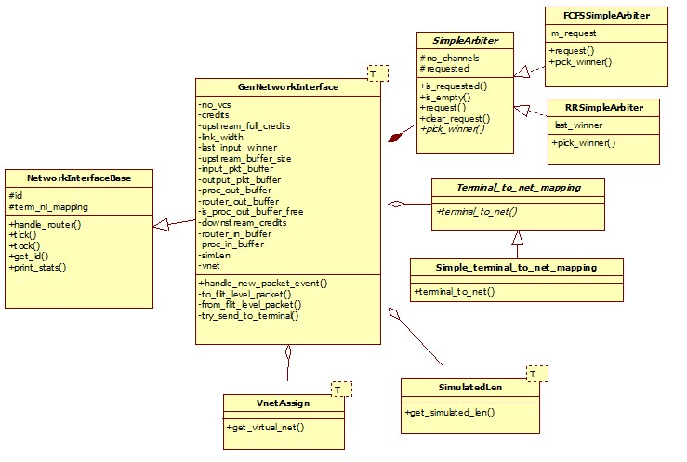

Initialization parameters

The constructor of GenNetworkInterface takes 3 parameters:

- int ifid
- NIInit<T>
- inf_init_params

The 1st is the integer ID assigned to the network interface.

The second is a structure NIInit, as follows.

template<typename T>
class NIInit {
public:
const Terminal_to_net_mapping* mapping;
SimulatedLen<T>* slen;
VnetAssign<T>* vnet;
};

It consists of 3 member. The first is a pointer to an object that performs terminal ID to network interface ID mapping. This object allows the terminal address to be decoupled from the network address. The parameter slen is an object that maps a packet to its simulated length in bytes, and vnet maps a packet to its virtual network ID. Details of these two parameters are given later in this document.

The 3rd parameter of the constructor is a structure inf_init_params, defined as follows:

struct inf_init_params{
unsigned num_vc;
unsigned linkWidth;
unsigned num_credits;
unsigned upstream_credits; //credits for the output link to terminal
int up_credit_msg_type; //message type for credits to terminal
unsigned upstream_buffer_size; //size of output buffer to terminal
};

- num_vc: the number of virtual channels the interface has on its link with the router.
- linkWidth: number of bits that can be sent over the link with the router.
- num_credits: the number of credits for sending flits to the router.
- upstream_credits: the number of credits for sending to the terminal
- up_credit_msg_type: the message type for credit messages to the terminal
- upstream_buffer_size: the size of the output buffer to the terminal.

Important data structures

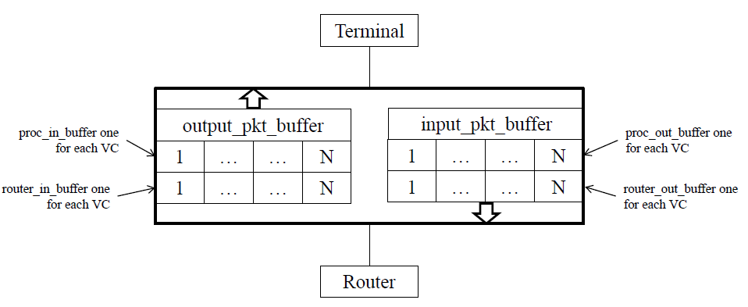
The GenNetworkInterface class has 6 different buffers, 3 input buffers and 3 output buffers.
These buffers are used to convert a packet into flits and vice versa.

input_pkt_buffer: this buffer hold packets from the terminal. Currently it has no size limit. So, it can hold up to N packets, where N is the terminal's sending credits.

proc_out_buffer: this buffer has one element for each virtual channel. Each element holds a “flit-level packet”. Packet from the terminal is converted to flits before the flits can be sent to the router. A “flit-level packet” is a data structure that holds all of the flits of a single packet.

router_out_buffer: from proc_out_buffer the flits are moved to router_out_buffer before they enter into the router. Each router_out_buffer element holds one or more flit for the given virtual channel.

router_in_buffer: this buffer is very similar to router_out_buffer. When flits come in from the router, they are first stored in this buffer until all of the flits for a packet have arrived.

proc_in_buffer: this buffer is similar to proc_out_buffer. Each element of the buffer holds a “flit-level packet”. When all of the flits for a packet have arrived in the router_in_buffer, the flits are put in a “flit-level packet” and stored in proc_in_buffer before delivering to the terminal.

output_pkt_buffer: this buffer holds packet to the terminal before they are delivered. This buffer has a size limit, which is given by upstream_buffer_size of the structure inf_init_params, as described above.

Major operations
The main operations of the GenIrisInterface class are the following:
- tick()
- tock()
- handle_new_packet_event()
- handle_router()

Of the above functions, tick() and tock() are registered with a clock and respectively called at every rising and falling edge of the clock. The other two functions are asynchronous event handlers.

tick()

The tick() function is registered with a clock and is called at every rising edge of the clock. It does the following:
- For each VC, move one flit from proc_out_buffer to router_out_buffer, if available.
- Make arbitration request for each VC with a flit to send, based on sending credit and the flit's type. The winner leaves the interface and enter the router.
- If output_pkt_buffer has packets and the interface has sending credits, then send a packet to ther terminal. Check proc_in_buffer to see if entire packets have been received; if so and if output_pkt_buffer has space, then assemble the flits into packet and put the packet into output_pkt_buffer.
- For each VC, move one flit from router_in_buffer to proc_in_buffer, if possible.

The pseudo-code is given below:

tick()
{
FOR EACH VC
IF the proc_out_buffer is not empty
move one flit to router_out_buffer;

FOR EACH VC
IF VC has pending flit in router_out_buffer AND (credit is not zero and flit type is not HEAD OR credit is full and type is HEAD)
Send a request to arbiter;

arbiter picks a winner;
winner sends one flit;
decrease down-stream credit by one;

CALL try_send_to_terminal();

Search proc_in_buffeMajor operationsr in round-robin manner for VC that has all of theMajor operations flits belonging to a packet
IF one is found AND output_pkt_buffer has space THEN
move packet to output_pkt_buffer;
send a credit to the router.
END IF

FOR EACH VC
IF the router_in_buffer is not empty
move one flit to proc_in_buffer;
}

tock()

The tock function is called at every falling edge and does the following:
- transfer the packets in input_pkt_buffer to proc_out_buffer and decide which vc it should use

The pseudo-code is given below:

tock()
{
FOR EACH VC
IF the proc_out_buffer is free AND credits is full AND
input_pkt_buffer is not empty
IF packet belongs to virtual network 0 and VC ID is even OR
packet belongs to virtual network 1 and VC ID is odd
Convert packet into flit-level packet and put into
proc_out_buffer;
Schedule a credit for the terminal.
}

handle_new_packet_event()

The handle_new_pack_event function is called when a packet from the terminal is received and does the follwing:
- putting packets into the input buffer.

The pseudo code is given below

handle_new_packet_event()
{
IF incoming data is credit
increase upstream_credit by one;
ELSE
store the incoming data to input_pkt_buffer;
}

handle_router()

The handle_router function is called when a flit is received from the router does the following:
- putting flits into buffer
- add the downstream credit when received credit

The pseudo code is given below:

handle_router()
{
IF the incoming data is flit
IF the data is not last flit of a packet
send one credit back to sender;

store the data in router_in_buffer;
}

Class SimpleArbiter
Every clock tick, the interface can send at most one flit to the router. However, since the interface has multiple virtual channels, there may be multiple VCs that have flits to send to the router. For this reason the network interface uses a SimpleArbiter to decide which VC can send its flit.

SimpleArbiter keeps a vector of booleans, one for each VC. When a VC requests arbitration, the request() function is called and the corresponding boolean is set to true.

The pick_winner() function is called to determine the winner of the arbitration. Winner is selected using round-robin priority.

pick_winner()
{
//last_winner is the winner of last arbitration
FOR EACH VC ivc starting from the one after last_winner
IF ivc is a requester
Set last_winner to ivc;
Return ivc as winner;
END IF
}

Router

Routers in Iris are implemented with the SimpleRouter class.

SimpleRouter class
The SimpleRouter class implements a router with up to 5 ports, and 4 virtual channels for each port.

SimpleRouter includes 3 major sub-components:
- One GenericRC for each port for route computing
- One GenericVcAllocator for VC allocation
- One GenericSwitchArbiter for switch arbitration

The SimpleRouter class implements a four-stage pipeline: input buffering, route computing, VC allocation, and switch traversal. Its class diagram is shown below.

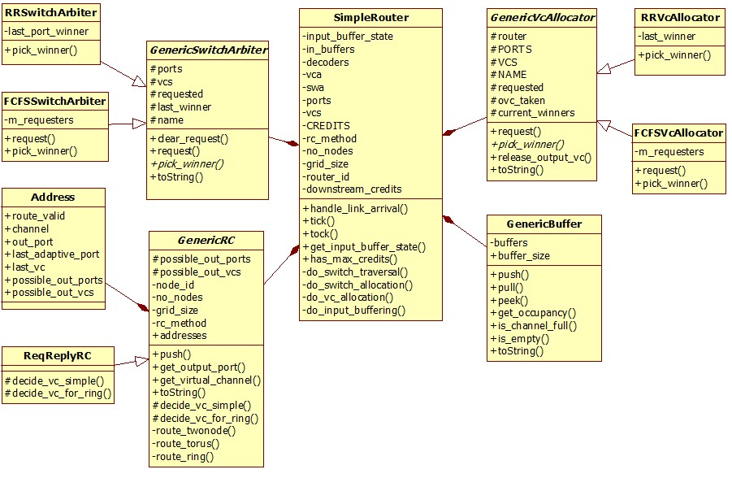

Initialization parameters

The constructor of SimpleRouter takes 2 parameters:

- int id
- router_init_params i_p

The 1st is the integer ID assigned to the router.

The second is a structure router_init_params, as follows.
struct router_init_params {
uint no_nodes;
uint grid_size;
uint no_ports;
uint no_vcs;
uint credits;
ROUTING_SCHEME rc_method;
};

no_nodes: number of routers in the network.
grid_size: In a ring, this is the same as the number of routers. In a torus, this is the x-dimension size of the torus.
no_ports: number of ports. In a ring, it is 3, and in a torus, it is 5.
no_vcs: number of virtual channels; currently this must be 4.
credits: sending credits for each VC.
rc_method: This was intended to define routing methods for the topologies. For example, a ring can be uni-directional or bi-directional. However, currently it has only one value, RING_ROUTING, because uni-directional ring has not been implemented. Torus does not use this parameter.

Major data structures

The following data structures are noteworthy:
- vector<InputBufferState> input_buffer_state
- vector<GenericBuffer*> in_buffers

SimpleRouter uses a vector of InputBufferState to record state of each input virtual channel. The size of the vector is the total number of virtual channels. And each element is the following structure:

class InputBufferState
{
public:
uint input_port;
uint input_channel;
uint output_port;
uint output_channel;
uint64_t pkt_arrival_time;
RouterPipeStage pipe_stage;
bool sa_head_done; //Head flit has gone through Switch Allocation
std::vector<uint> possible_oports;
std::vector<uint> possible_ovcs;
};

It records, among other things, which output port and channel have been selected, what pipeline stage the current flit is in. The data structure is reset once a complete packet has been delivered.

The vector in_buffers is a vector of GenericBuffers. There is one GenericBuffer for each port of the router, and each GenericBuffer internally has one buffer for each virtual channel. Flits are stored in in_buffers before they are moved through the router.

Major operations

Major public functions include:

- tick(): this function does nothing
- tock()
- handle_link_arrival()

The first two are registered with a clock and called respectively at every rising and falling edge of the clock. The function handle_link_arrival() is the event handler for any inputs from the network interface or neighboring routers.

These public functions invoke some private functions to carry out their work.

handle_link_arrival()

This function is the event handler for arriving flits, either from the network interface or from neighboring routers. It's pseudo-code is as follows:

handle_link_arrival(port, data)
{
IF data is a flit
Put the flit in in_buffers;
IF it is a HEAD flit
CALL do_input_buffering();
ELSE
Pass the flit to route computing;
ELSE // it is a credit
Increment the corresponding downstream_credits element.
}

do_input_buffering()

This function is only called for a HEAD flit. It initializes the corresponding input_buffer_state element, then calls route computing to get the possible output ports and VCs.

do_input_buffer()
{
Initialize input_buffer_state to FULL;
CALL GenericRC to compute output ports and VCs
}

Note: the router only calculates route for HEAD flit, the other flits just follow the same path as the HEAD flit.

tock()

At each falling edge of the clock, tock() is called to move the flits through the pipeline.

tock()
{
CALL do_switch_traversal();
CALL do_switch_allocation();
CALL do_vc_allocation();
}

do_switch_traversal()

This is the last stage of the pipeline. This function moves flits out of the router. For each input VC in the SW_TRAVERSAL state, check if a flit can be sent out. If not, move to the VCA_COMPLETE state. If a flit can be sent, send it out and send a credit upstream. If the flit is a tail flit, ask the VC allocator to release the output VC, and the Switch Allocator to clear the request. If not a tail flit, check if more flit can be sent, and if so, move to SWA_REQUESTED, otherwise, move to VCA_COMPLETE and clear the request for SWA. The pseudo code is given below:

do_switch_traversal()
{
FOR EACH VC in SW_TRAVERSAL state
IF there is flit in buffer AND sending credits is not zero
IF it is tail flit OR the only flit in the packet
VC allocator to release the output VC;
Switch arbiter to clear its request for this packet;
ELSE // not a tail flit and not the only flit
//see if more flit can request the switch
IF there is flit in buffer AND sending credits > 1
Make request to switch arbiter;
Change state of input VC to SWA_REQUESTED;
ELSE //no more flits waiting or no sending credits
Change input VC state to VCA_COMPLETE;
Clear switch arbiter's records related to this VC;
END IF
END IF
Send one flit out;
Decrease sending credits by one;
Send one credit back to upstream;
ELSE //VC in SW_TRAVERSAL has no flits in buffer or no credits
Change VC state to VCA_COMPLETE;
Clear request in switch arbiter for this VC;
END IF
}

do_switch_allocation()

Allocate output ports to input VCs. For each output port, ask the SWA to pick a winner. Since for each tick, each output port can send out only 1 flit, only one winner for each port can be picked. The pseudo-code is given below:

do_switch_allocation()
{
FOR EACH port
Ask switch arbiter to pick a winner for this port;

IF no winner
continue;

IF head flit has not gone through switch allocation at winner VC
Set flag to indicate head flit has gone through switch allocation for winner VC;

Set state of winner VC to SW_TRAVERSAL;
}

do_vc_allocation()

This function does three things:
- Allocate output VC for all input VCs in the state VCA_REQUESTED. This arbitration task is designated to the VC allocator. Winners of the arbitration move to the state VCA_COMPLETE.
- Check all input VCs in the state VCA_COMPLETE, if they can use the switch, move them to SWA_REQUESTED.
- Check all input VCs in the state FULL. These are newly arrived packets. Move them to VCA_REQUESTED, and for each one make a request to the VC allocator.

do_vc_allocation()
{
Ask VC allocator to pick winners for each port;

FOR EACH winner VC
Update its output port and output VC;
Set VC state to VCA_COMPLETE;

//check each input VC and update their state if applicable
FOR EACH input VC
IF state of VC is VCA_COMPLETE
//For a VC to go from VCA_COMPLETE to SWA_REQUESTED, there must
//be input flits and credits. If the head flit hasn't passed
//yet, we wait until we have full credits. Otherwise, we
//require credits > 0.
IF there is flit
IF (head flit has been through switch arbitration AND credits> 0) OR (head flit has not been through switch arbitration AND credits are full)
Make request to switch arbiter;
Set VC state to SWA_REQUESTED;
END IF
ELSE IF state of VC is FULL
Set state to VCA_REQUESTED;
Make request to VC allocator;
END IF
}

GenericBuffer class
Each GenericBuffer has a buffer for flits coming from each VC, and it provide the follow functions to ensure some basic function to view and manipulate the buffer:
- push(): push one flit belong to a specific VC back to the end of queue
- pull(): pull one flit belong to a specific VC out from the start of queue
- peek(): have a look one the flit belong to a specific VC at the start of queue
- get_occupancy(): return how many flits is in the queue of a specific VC
- is_channel_full(): see if the buffer of a specific VC is full
- is_empty(): see if the buffer of a specific VC is empty\

GenericRC class
The GenericRC class is responsible for determine the routing for each packet base on the network topology. It can perform route computing for both ring and torus.

There is a subclass ReqReplyRC, which is described below.

Major data structures

GenericRC uses a vector, addresses, to store route computing results. There is one element for each VC. Each element is a structure Address, as follows:

class Address
{
public:
bool route_valid;
unsigned int channel;
unsigned int out_port;
uint last_adaptive_port;
uint last_vc;
std::vector < uint > possible_out_ports;
std::vector < uint > possible_out_vcs;
};

Major operations

The most important public function is push() which computes the route for the packet and stores the results in possible_out_ports and possible_out_vcs.

The pseudo code for push() function is:

push(f) //f is a flit
{
IF it's a head flit
IF the method is torus
CALL route_torus();
ELSE IF the method is ring
CALL route_ring();

Set route valid to true;
ELSE IF it's tail flit
Clear previous results;
Set route valid to false;
ELSE IF it's body flit
Do nothing;
}

route_ring()

route_ring()
{
destx := destination's x dimension
myx := router's x dimension
IF destx == myx
Set output port to NI;
CALL decide_vc_simple() to calculate output VC;
return;

IF destx > myx
IF (destx - myx) > (half of ring size)
Add west port to possible output port; //going west is closer
ELSE
Add east port to possible output port;
ELSE
IF (myx – destx) > (half of ring size)
Add east port to possible output port;
ELSE
Add west port to possible output port;
END IF

//There are a few lines here that don't seem correct.

CALL decide_vc_for_ring() to calculate the VC;
}

route_torus()

route_torus()
{
myx := x dimension of the router;
myy := y dimension of the router;
destx := x dimension of the destination;
desty := y dimension of the destination;

IF myx == destx AND myy == desty THEN
set output port to NI;
CALL decide_vc_simple() to calculate output VC;
return;
END IF

IF myx == destx THEN
IF desty > myy THEN
IF (desty – myy) > (half of y dimension)
Add north port to possible out port;
ELSE
Add south port to possible out port;
ELSE //desty < myy
IF (myy - desty) > (half of y dimension)
Add south port to possible out port;
ELSE
Add north port to possible out port;
END IF
// a few lines here that may not be correct
CALL decide_vc_for_ring() to calculate the VC;
ELSE
IF destx > myx
IF (destx – myx) > (half of x dimension)
Add west port to possible out port;
ELSE
Add east port to possible out port;
ELSE //destx < myx
IF (myx - destx) > (half of x dimension)
Add east port to possible out port;
ELSE
Add west port to possible out port;
END IF
// a few lines here that may not be correct
CALL decide_vc_for_ring() to calculate the VC;
END IF
}

The decide_vc_simple() function is called to select a VC. It simply selects VC 0.

decide_vc_simple()
{
set the possible out put VC to 0;
}

The decide_vc_for_ring() function selects VC for ring routing. It selects VC 1 if the destination's ID is greater than the router's ID, and selects VC 0 otherwise.

decide_vc_for_ring()
{
IF destination has x dimension larger than my x
add 1 to possible out VC;
ELSE
add 0 to possible out VC;
}

Subclass ReqReplyRC

The class GenericRC has a subclass ReqReplyRC, which is designed to support request-reply network. In a request-reply network, the network is divided into two virtual networks: a request network and a reply network.

Since each virtual network must have at least 2 virtual channels to avoid deadlock in a ring, a request-reply network requires at least 4 virtual channels.

The ReqReplyRC class overrides two functions in GenericRC to support request-reply network: decide_vc_simple() and decide_vc_for_ring().

Class GenericVCAllocator

SimpleRouter uses a GenericVcAllocator object to allocate output virtual channel for an input HEAD flit whose route has already been calculated. First, a VC allocation request is made. As multiple flits can compete for output VCs, the VC allocator must perform an arbitration and assign a output VC to at most one flit.
GenericVcAllocator is an abstract class. It has two concrete subclasses: RRVcAllocator and FCFSVcAllocator.

Major data structures
Major data structures include the following:
- vector<vector<VCA_unit> > requested;
- vector<vector<bool> > ovc_taken;
- vector<VCA_unit> current_winners;

The vector requested is used to record which input VCs have made a request for output VC. There is one element for each VC.
The vector ovc_taken indicates whether or not an output VC has been allocated. There is one element for each VC.
The vector current_winners stores the winners of the current VC allocation operation.

Major operations

Major operations include:

- request()
- pick_winner()
- release_output_vc()

pick_winner() is a pure virtual function and must be implemented by subclasses.

Request()

This function is called when an input flit needs to be allocated an output VC. It simply initializes the corresponding element in the requested vector.

release_output_vc()

This function is called when the entire packet has left the router and the output VC can be reused.

Subclass RRVcAllocator
The subclass RRVcAllocator picks winner for VC allocation in a round-robin manner. To do that, it
- uses a 2-D vector, last_winner, to record the last winner for each output VC.
- implements pick_winner() to select winner in a round-robin manner.

pick_winner()

pick_winner()
{
FOR EACH output port OPT
FOR EACH VC OVC of OPT
IF OVC not taken and OVC has full credits
FOR EACH VC IVC starting from one after the last winner for OVC
IF IVC is requesting and OVC is one possible output VC for IVC
Allocate OVC for IVC;
Add IVC to current winners;
Update last winner for OVC;
END IF
END IF
RETURN current winners;
}

Subclass FCFSVcAllocator
The subclass FCFSVcAllocator picks winner for VC allocation in a first-come-first-serve manner. To do that, it
- uses a list for each output port to track the VC allocation requests.
- implements pick_winner() to select winner in a first-come-first-serve manner.

It also overwrites the request() function of the base class.

request()

request()
{
CALL GenericVcAllocator :: request();
put input VC ID at the end of the list for the output port;
}

pick_winner()

pick_winner()
{
FOR EACH output port OPT
IF there are requests for OPT THEN
FOR EACH VC OVC of OPT
IF OVC not taken AND OVC has full credits AND OVC matches the 1st request for OPT THEN
Allocate OVC;
Add 1st request to current winners;
Remove 1st request from list;
END IF
END IF
}

Class GenericSwitchArbiter

Multiple flits can go to the same output port. The job of the switch arbiter is to decide which input VC can actually use the switch to move a flit to the output port. In Iris, this is implemented with the class GenericSwitchArbiter and its subclasses.

Major data structures

- vector<vector<bool> > requested;

The 2-D vector requested is used to record which input VC has requested which output port.

Major operations

- request(): called to make a request;
- clear_requestor(): called to clear the request;
- pick_winner(): this is a pure virtual function and must be implemented by subclasses;

request()

request()
{
Set the corresponding flag in the vector requested;
}

Subclass RRSwitchArbiter
This subclass implements the round-robin priority for switch arbitration. To do that, it

- uses a data structure, last_port_winner, to keep track of the last winner, and
- implements pick_winner() so winners are picked in a round-robin manner.

pick_winner()

pick_winner(port)
{
ivc0 := last winner for the given port;
ivc0 := (ivc0 + 1) % total_vcs;

FOR EACH VC ivc starting from ivc0
IF ivc made a switch request
Set last winner to ivc;
Return ivc as the winner;
END IF
}

Subclass FCFSSwithArbiter

FCFSSwitchArbiter implements the first-come-first-serve priority for swtich arbitration. It does that by

- using a linked list for each port, to order the switch requests, and
- implementing pick_winner() to ensure requests are granted first-come-first-serve.

pick_winner()

pick_winner(port)
{
IF there are requests for the given port
Set last winner to the first request;
Return first requester as winner;
}

Topology Creator

The class topoCreator is the interface to the user of Iris. It defines two static functions for user to create a ring or torus network: create_ring() function creates and returns ring topology and create_torus() function creates and returns torus topology based on user's parameters.

For create_ring() and create_torus() the parameters user should provide include:
- clk The clock for the interfaces and routers of the network.
- params The configure parameters for ring/torus.
- lp_inf The logic process id for interfaces
- lp_rt The logic process id for routers
- Terminal_to_net_mapping the mapping between terminal address and network address.
- SimulatedLen an object that calculates the simulated length of packet
- VnetAssign an object that assigns packets to virtual networks
- ni_credit_type the type for credit packet

Features

Flow control
The flow control for iris is implemented using credits.

FC between network interface and terminal
The FC between NI and terminal is at packet level. On the terminal side, it should do the following:
- Define the sending credits, and use that to limit outstanding packets it can send to the NI.
- When a packet form NI is consumed, it should send a credit back to the NI.

The NI, as mentioned above, has a variable upstream_credits, which it uses to limit the number of outstanding packets it can send to the terminal. Whenever it sends a packet to the terminal, it can only do so if the value of upstream_credits is positive. The variable is decremented by 1 every time a packet is sent, and incremented by 1 when a credit packet is received.

The message type for the credit type is also passed in the initialization parameters. This value obviously should be defined at the system level. That's why it is passed to Iris.

FC between NI and router and between routers
Flow control between routers, and NI and router is at flit level.

The links between NI and router and between routers each have virtual channels. Credits are assigned to each virtual channel for sending flits. Obviously, flits can only be sent where there are credits available.

In addition, there are a few situations where an action can be taken only if the sending credits are full.

- In the NI, before sending a HEAD flit (that is, the first flit of a new packet) to the router, we must ensure the VC has full sending credits. This is to ensure that the previous packet that use the same VC has been consumed by the router.
- In the NI, before a packet can be taken from the input_pkt_buffer and convert into a flit-level packet, we ensure the sending credits are full. (Is this necessary?)
- In RRVcAllocator, an output VC can only be allocated if it has full sending credits. Otherwise, the flit cannot make progress after the VC is allocated.
- In FCFSVcAllocator, an output VC can only be allocated if it has full sending credits. Otherwise, after the allocation, the flit have to wait for credits for previous packets before it can request switch allocation. While it's stuck, it may be overtaken by a later packet.
- In SimpleRouter::do_vc_allocation(), for a head flit, we ensure output VC has full credits before making a switch arbitration request.

Simulated length

The network interface, when receiving a packet from its terminal, would convert the packet into flits before passing the flits to the router. One question is how many flits should there be for a given packet. Generally speaking, the packet that Iris receives contains data that are used by the simulator, in addition to the data being sent between terminals. Therefore, when converting packets to flits, we should not use the size of the actual packet to determine the number of flits. Instead, we need to know the size of the packets we are simulating.

For example, when a cache sends packets to another, the actual packets it uses may have a size of P, while what we want to simulate is a cache model whose messages have 2 sizes: those without data have 10 bytes, and those with data have 42 bytes. These two sizes may well be different from P. It is the simulated length we should use when converting packets to flits. At the same time, the number of flits, based on the simulated length of the packet, must be large enough to carry the data in the actual packet.

The next question is how to determine the simulated length. It should not be determined by Iris, because Iris cannot foresee all the possible terminals and their packets. It also should not be part of the packets, because that way, the terminal would have to decide what the simulated length the packets should have.

The approach we adopt is to leave this to the system modeler. When the network model is created, an object, either belonging to the class SimulatedLen<T> or its subclass, is passed to Iris. The template parameter T is the type of the network packet. This object has one operation, get_simulated_len() that takes as input a packet pointer and returns its simulated length. The function has a default implementation that returns simply the actual size of the packet. The system modeler should overwrite this behavior in a subclass.

The class SimulatedLen<T> is shown below:

template<typename T>
class SimulatedLen {
public:
virtual int get_simulated_len(T*) { return sizeof(T);}
};

Virtual networks

Iris supports two virtual networks: request and reply. But determining whether a packet is a request or a reply should not be the responsibility of Iris. For this reason, an object is injected into Iris when the network is created. This object is responsible for determining the virtual network ID for a given packet. The object belongs to the class VnetAssign<T> or its subclass.

The class VnetAssign<T> is given below:

template<typename T>
class VnetAssign {
public:
virtual int get_virtual_net(T*) { return 0; }
};

