Messaging System in Manifold Kernel

Date | Update | Author
04/28/12 | Creation. | Jun Wang

Purpose

This document describes the design of the messaging system in the Manifold kernel.

Introduction

As a parallel simulation framework, Manifold uses message passing for parallel processing. In Manifold, messages can be divided into two classes:
- messages used by the synchronization algorithms, such as LBTS.
- messages representing simulation events.

This document describes the second type of messages only. It covers important aspects of the messaging system, including:
- component links
- data serialization and deserialization
- event scheduling
- messenger

It also describes requirements imposed by the messaging system that computer architecture models must meet in order to successfully integrate with Manifold.

Manifold Messaging System

A Manifold simulation system comprises of a set of components connected by links. A Manifold link connect an output of a component to one or more other components.

At simulation time, as events are processed, components change their internal state and produce output events. If component A's output is connected to component B's input, the output event of A will cause an input event to be scheduled for B. In a parallel simulation system such as Manifold, if A and B are assigned to different simulation processes (called logical process, or LP), then a message must be sent from A's process to B's so that the later can schedule an event for B.

In the following, we describe the following aspects of Manifold's messaging system.

- Component interconnection. We describe Manifold's data structures that are used to represent a link between two components.
- Data serialization and deserialization. We describe how an object is serialized so that it can be sent from one process to another and how the receiving process re-construct the object from the serialized data.
- Event scheduling.
- Messenger. Details of the messenger object that performs all the message sending and receiving.

Component Interconnections

Before a simulation can start, the interconnection of the system's components must be established. In Manifold, an output port of a component can be connected to multiple input ports of other components, but an input port can only be connected to one output port of another component.

Component interconnection is set up with the Manifold::Connect() function. It has several overloaded versions. The signature of one version is given below:

template <typename T, typename T2>
LinkId_t
Connect(CompId_t sourceComponent, int sourceIndex,
CompId_t dstComponent, int dstIndex,
void (T::*handler)(int, T2), Ticks_t tickLatency)
throw (LinkTypeMismatchException)

where the parameters are:
- sourceComponent: the component ID of the source component.
- sourceIndex: the 0-based output port index.
- dstComponent: the component ID of the destination component.
- dstIndex: the 0-based input port index.
- handler: a member function of the destination component's class. It has two parameters: the first is the integer index of the input port, and the second, of type T2, is the input data sent over the link. Note that, after the link is set up, the source component can only send data of type T2 over the output port sourceIndex. Otherwise, a runtime error would occur. In the current implementation, T2 can be an object or a pointer, but it cannot be a referece.

The exception LinkTypeMismatchException is described below.

The function specifies that the source component's output with index sourceIndex is connected to the input dstIndex of the destination component. The interconnection set up by the Connect() function is depicted in the following figure.

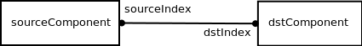

Internally, the Connect() function creates a Link<T2> object for the source component. if one has not been created for the given output port. The Link<T2> object in turn creates a LinkOutput or LinkOutputRemote object. If both components are in the same logical process, then a LinkOutput object is created, otherwise, a LinkOuputRemote is created.

In addition, if source and destination components are in different LPs, the destination component's LP also create a LinkInput<T2, T> object for the input port, where T2 is the data type that is sent over the link, and T is the destination component's type.

Pseudo code for the Connect() function is given below.

FUNCTION Connect
IF source component belongs to this LP THEN
Create a Link object for the output port, if one has not been
created.
IF dest component belongs to this LP THEN
Create a LinkOutput object for the Link.
ELSE
Create a LinkOutputRemote object for the Link.
ELSE
IF dest component belongs to this LP THEN
Create a LinkInput object for the dest component.

The relationship between the objects is shown in the following class diagram.

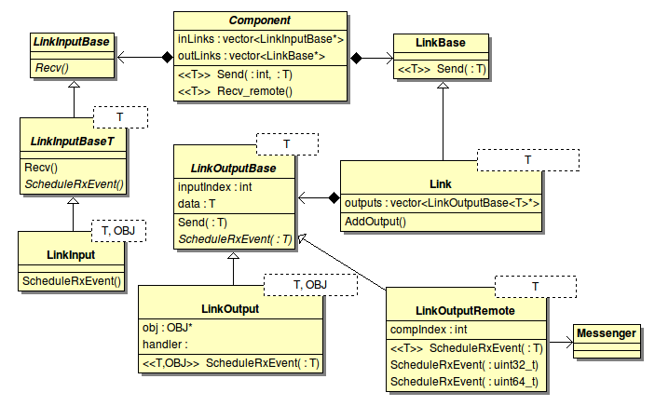

The Component class has a vector of output links (outLinks) and a vector of input links(inLinks).
The index of the two vectors is the output port number and input port number, respectively. Since an output port can be connected to multiple input ports (of other components), there is only one Link object for each output port, but a Link object can have multiple LinkOutput or LinkOutputRemote objects, one for each input port.

LinkTypeMismatchException

An output port can be connected to multiple input ports. As shown above, when the Connect() function is called, the user must specify what data type is expected from the output port. If in a Connect() function call, the output data type for the output port A is given as T1, and in a subsequent call of Connect() it is given as T2, then a LinkTypeMismatchException is thrown. The purpose of this exception is to prevent the user from making such mistakes.

Output changes

When the internal state of a component changes, it may produce output changes. In Manifold, a component produces an output change by sending out data with the Send() function. This output change will result in an input event for its fanout components (those components whose inputs are connected to this output port).

Data types that can be sent out of an output port include:

- User-defined type.
- Built-in types uint32_t and uint64_t.

This section describes how the Send() function eventually causes an input event to be scheduled. And in the process we will also cover data serialization and deserialization. We will refer to the component where the output change take place as the source component, and its fanout components the destination components.

Source Component and Destination Component in Same LP

The following sequence diagram shows how the output change of a component causes an event to be scheduled for its fanout component that is in the same LP.

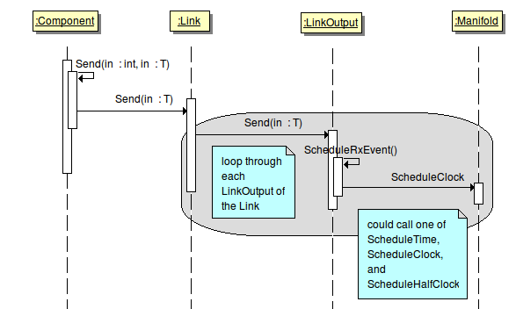
- When a change occurs on a component's output, the Send() function is called with the index of the output and the new data specified.
- Based on the output port number, the Link object for the output port is selected. The Send() function of the Link object is called.
- For each element of the Link object's outputs vector, the Send() function is called, which in turn calls the ScheduleRxEvent() function. An element is either a LinkOutput object or a LinkOutputRemote object. If it is a LinkOutput object, the ScheduleRxEvent() calls Manifold class' ScheduleClock() (or ScheduleTime, ScheduleHalf) function to schedule an event for the local LP.

The signature of ScheduleClock() is given below.

template <typename T, typename OBJ>
TickEventId
ScheduleClock(Ticks_t t, Clock& c, void(T::*handler)(U1), OBJ* obj, T1 t1);

The parameter obj is the dstComponent for which an event is being scheduled. The parameter handler is a pointer to a member function of obj, which will handle the event. And the parameter t1 is the data being passed to the component.

Source Component and Destination Component in Different LPs

When the source and destination components are in different LPs, a message carrying the output data must be sent to the destination LP so it can schedule an event for the destination component.

Sending Message

The following sequence diagram shows the chain of actions from the source component's Send() function to the eventual message sending.

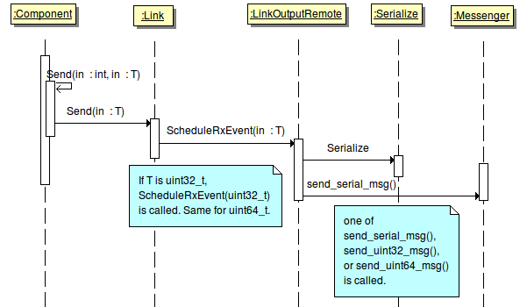

The LinkOutputRemote object's ScheduleRxEvent() function behaves differently from LinkOutput's. It uses the messenger to send a message to the destination component's LP. However, before calling the messenger's send_serial_msg(), it must convert the data into an array of bytes. This is called data serialization. The pseudo-code of ScheduleRxEvent() is given below.

FUNCTION ScheduleRxEvent
CALL Get_serialize_size
CALL Ensure_send_buf_size
CALL Serialize
CALL send_serial_msg

- The function Get_serialize_size() is defined in serialize.h. It returns the data type's size in bytes.
- The function Ensure_send_buf_size() ensures the messenger's send buffer is big enough for the data.
- The function Serialize() is defined in serialize.h. It converts the data into bytes and put them in the messenger's send buffer.
- Finally send_serial_msg() is defined in the Messenger class. It creates an MPI message and send it to the destination LP.

When a component sends out a uint32_t or uint64_t, a different ScheduleRxEvent() function from the LinkOutputRemote class is called which calls either send_uint32_msg or send_uint64_msg from the Messenger class, and no serialization is required.

Also not Serialize is not a class name. The Serialize() function and the Deserialize() function below are global templated functions.

Receiving Message

As shown above, if the source and destination components are in different LPs, a LinkInput object is created for the destination component's input port in its LP. When a message is received, the destination component passes the received data to the LinkInput object, which eventually causes an event to be scheduled for the component. The following sequence diagram shows this process.

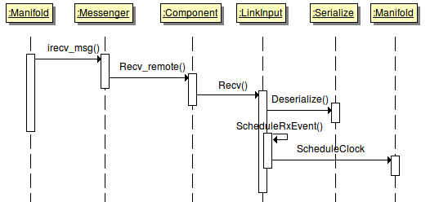

Note that the LinkInput object is templated. When it is created, it knows the data type it is supposed to receive. Therefore, it can call Deserialize() to reconstruct the data from the byte array.

If the data sent over the link is uint32_t or uint64_t, a different version of Recv() of the LinkInput class is called, and no deserialization is required.

Serialization and Deserialization

As we have seen, when a user-defined data type is sent over a Manifold link from one LP to another, serialization and deserialization are required. For the component creators' convenience, Manifold provides a set of templated serialization/deserialization functions in the serialize.h file. The functions are listed below.

template<typename T>
size_t Get_serialize_size(const T& data) ;

template<typename T>
size_t Get_serialize_size(const T* data) ;

template<typename T>
size_t Serialize(const T& data, unsigned char* buf) ;

template<typename T>
size_t Serialize(T* data, unsigned char* buf) ;

template<typename T>
size_t Serialize(const T* data, unsigned char* buf) ;

template<typename T>
T Deserialize(unsigned char* buf, int) ;

template<typename T>
T* Deserialize(unsigned char* buf) ;

If the user-defined type meets the following requirements, then nothing else needs to be done and the above templated functions will be used.

- The data type has no pointer or reference member.
- The data type has no virtual function.

However, if the above requirements are not met, then user must provided specializations of the above templated functions.

The Messenger Class

The Messenger class implements message passing for Manifold. This class is rather straightforward. Here we only describe one feature that has to do with the message size.

By default, the maximum size for data sent over a Manifold link is 1024. If this is not big enough, or the maximum size is not known in advance, the user can turn on the KERNEL_ANY_DATA_SIZE flag during configuration. When this flag is turned on, every time when a message is being received, its size is checked first, and the receiving buffer would be enlarged if necessary, ensuring that the buffer would be large enough.

