Manifold Software Architecture

Jun Wang

History
2011-09-06 | Jun Wang | Initial version.

Purpose

This document describes the software architecture of the Manifold project.

Introduction

The Manifold software system was envisioned as a highly extensible parallel simulation framework for computer architecture research. It provides a parallel discrete event simulation kernel and a set of computer architecture models that allow users to easily build parallel simulations. In addition, the framework allows users to easily plug in their own computer architecture models and then build simulations with these models.

Based on these design goals, we adopted a layered architecture for the software system, which allows the user to focus on developing their own models and running simulations without concerning themselves with the details of parallel discrete event simulation.

Software Architecture

System Use Cases and Primary Quality Attribute

There are two main usages of the Manifold system:

- The user builds simulations using models provided by Manifold and the simulation kernel.
- The user develops their own architecture models for Manifold and then builds simulations with these models.

These two usages are captured in the following use case diagram.
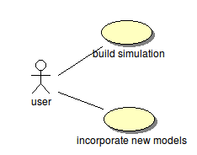

Although Manifold provides a set a architecture models, it is rather limited. Therefore, of the two usages above, the more important one is for users to be able to easily incorporate their own models and build simulations with their models, while Manifold serves primarily as a parallel discrete event simulation framework for architecture simulations.

Based on this, the primary quality attribute of the system should be extensibility. Specifically, the system should make it relatively easy for users to write and incorporate their own models. Also, changes made to the system by incorporating new models should be localized and ripple effects should be prevented.

Software Architecture

To achieve the primary quality attribute, we adopt a layered software architecture which consists of three layers: the simulation kernel, the micro-architecture (uarch), and the model layer, as shown in the following figure.

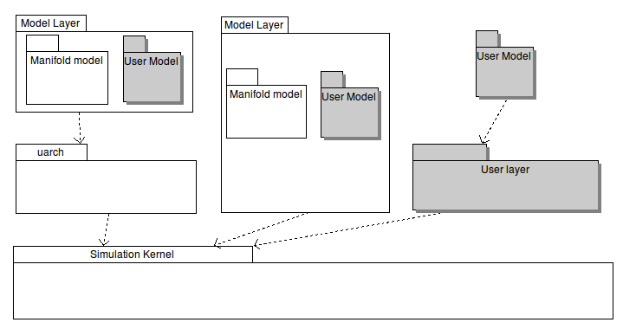
With this architecture, the user can either use the Manifold models to build their simulations, or develop their own models and build simulations with the models. Specifically, the system can be extended in three ways:

- Writing models on top of the uarch layer, which in turn depends on the simulation kernel layer.
- Writing models that directly sits on top of the simulation kernel.
- Developing customized layer(s) on top of the simulation kernel and then developing models on top of the customized layer(s).

The simulation kernel

The simulation kernel implements a parallel discrete event simulation kernel. For a user-developed model to work with the kernel, the components of the model must implement the following:

- A component must be a subclass of the kernel's Component class.
- A component must implement event handlers in a particular form.

In addition, the simulation main program must do the following:

Creating components using the Component::Create() method from the kernel.
Connecting the components using the Manifold::Connect() methods.

The uarch layer

This is a thin layer that contains two types of entities to facilitate building computer architecture simulations:

- Classes that may be useful in building computer architecture simulations.
- Header files used by multiple models. These files are put in this layer to minimize inter-dependence among the models. For example, a cache model and a processor model both use a data structure D for sending messages to each other. Putting D in either model would make the other dependent on it. By putting D in uarch, both models would be dependent on uarch, but they don't depend on each other any more.

Some of the possible classes in this layer are depicted in the following class diagram.

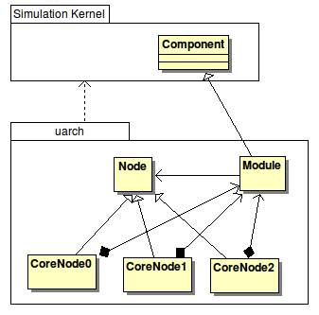

Details of the classes are shown below:

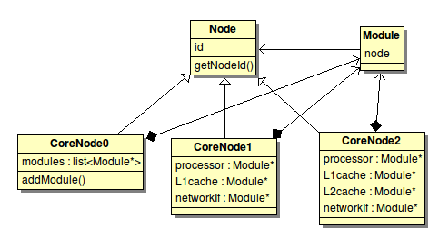

Node

This class represents a node in a multi-core CPU. It contains a member id which is used to identify the node.

CoreNode0

This class represents a generic node in a multi-core CPU. It can contain a list of modules. An operation addModule() is used to add modules to the node.

CoreNode1

This class represents a node with a processor, an L1 cache, and a network interface.

CoreNode2

This class represents a node with a processor, an L1 cache, an L2 cache, and a network interface.

Module

A module represents a component of a node, such as a process core, an L1 cache, etc.. It contains a reference to its containing node.

The model layer

The model layer is where the architecture models reside. There are three places to put a model.

- On top of the uarch layer. Most of the Manifold models are located on top of the uarch layer. Users can create their own models on top of the uarch layer by making the model component a subclass of uarch's Module class.
- Directly on top of the kernel.
- On top of a user created layer or layers. Users can create their own layer(s) on top of the kernel and then create models above the user-created layers.

The layered architecture gives the user great flexibility.

Model Interfaces

Monifold kernel puts the following requirements on any model that is created for the Manifold framework:

- The model must be a subclass of Component.
- The model must have event handles in the form of handler(int, T), where T is the data type the model expects to receive at a certain input port.
- If the model needs to perform actions on every clock tick, it needs to register one or two member functions with a clock.
- The model sends output using Send(int, S), where S is the data type it sends through a certain output port.
- Models are connected using Connect(), which connect an output port of a model to an input port of another model.

Based on the above, we can see the interface of a model is basically defined by the data types that it sends and receives. Manifold doesn't require a model to implement any particular operations (except, of course, it must provide event handlers.).

What should the model interfaces (i.e., data types) be? There are 3 choices:

- Manifold completely defines the data types.
- Manifold partially defines the data types.
- Modelers completely define their own data types.

Options

Option 1

Manifold should define a data structure S that satisfies all communication needs between any 2 models.

Comments: Standardized interface (in the form of S) allows a model to be easily replaced with another. However, standardized interface could also be restrictive for modelers.

Pros: (1) Models are completely decoupled. A model needs only the kernel and possibly uarch to compile. (2) Since a compliant model talks only in S, connecting models to build simulations is easy.

Cons: (1) Is S feasible? This is equivalent to standardizing communications between any two types of models. Could S satisfy all foreseeable needs? Or are we going to be forced to change the definition of S constantly?

The data structure probably looks like the following:

struct S {
int type; //Could we have a reasonably complete list of types?
union {
struct procssor_to_cache {
...
};
struct cache_to_processor {
...
};
struct cache_to_MC {
...
};
struct MC_to_cache {
...
};
// etc., etc.
};
};

Option 2

Similar to Option 1, except S is divided into individual data structures.

Comments: Again, the standardized interfaces allow a model to be easily replaced with another model of the same type, but at the same time, it could be restrictive to modelers.

The standardized interfaces would consist of the following data structures:

struct procssor_to_cache {
...
};

struct cache_to_processor {
...
};

struct cache_to_MC {
...
};

struct MC_to_cache {
...
};

// etc., etc.

Option 3

Manifold should create a base class C, and data passed between models are subclasses of C.

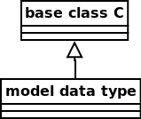

Data passed between any two models would be C*.

A
B
C*
C*

Comments: Since the actual data D being passed is a subclass of C, the sending component must have the definition of D in order to send D. The receiving component must downcast C to D to process it. So what does C provide that D cannot? Or what should be included in the base class C? Time-stamp, source/destination component id? Are there any use cases for this information?

Option 4

Manifold should define a data-type, say, E, and data passed between models are member of E.



Data passed between any two models would be E*.

A
B
E*
E*

Comments: This is similar to Option 3, except that in Option 3, model data D is a subclass of the Manifold-provided base class C, and here composition is used. The question again is, what information should be included in the class E, and are there any use cases for the information?

Option 5

Let the model creators define their own interface data types.

Comments: When writing a model to interact with an existing one, the new model should take care of interfacing with the existing model. If, say, a new processor model is to interact with a number of cache models C1, C2, …, Cn, multiple subclasses of the processor model may have to be created.

Pros: Maximum flexibility. Model creators are not restricted by the Manifold framework.

Cons: (1) Development effort on the part of model creator when writing new models to work with existing ones. (2) The model instantiation and connection process could be complex. When connecting two components, users need to make sure they are compatible. (3) Another difficulty is to integrate 2 models that don't have matching interfaces.

Summary

Option 1 | Manifold provides a single standard data structure.
Option 2 | Manifold provides a set of standard data structures.
Option 3 | Manifold provides a base class; model data types are subclasses.
Option 4 | Manifold provides a containing class; model data types are members.
Option 5 | Manifold does not provide any interface data type.

Context Diagram

The following context diagram shows how Manifold relates to its environment. Manifold is distributed as a collection of libraries. To use it, a user must create a main program that mainly performs the following two tasks:

- Instantiating and connecting components.
- Starting the simulation.

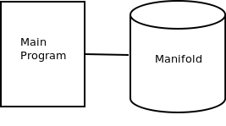

Deployment View

Here we describe two possible deployment scenarios.

Deployment scenario 1

In this scenario, each node and its corresponding network router are assigned to the same host, as shown below:

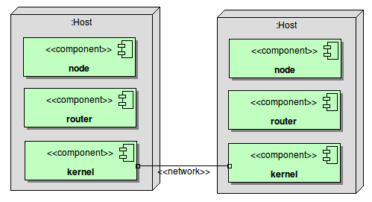

Deployment scenario 2

In this scenario, all the network routers are assigned to a single host, while each node is assigned to a node different from the router node, as shown below.

