Design and Implementation of MCP-Cache

Date | Update | Author
05/15/12 | Creation. | Jun Wang

Purpose

This document describes the design and implementation of the MCP-cache.

Introduction

Manager-Client Paring (MCP) is a methodology for creating hierarchical cache coherence in shared-memory multicore architectures. By defining two generic interfaces for cache coherence operations,
M CP enables cache coherence hierarchy to be easily created while allowing different coherence realms that make up the hierarchy to use different coherence protocols.

Mcp-cache is an implementation of MCP within the Manifold simulation framework. For flexibility and code reuse, it is designed as a layered system with the following two layers:

- Protocol layer: This layer consists of implementation of specific coherence protocols such as MESI in the form of state machines which also implement the generic client/manager interfaces. Currently only the MESI protocol is implemented.
- Protocol-independent layer: This layer implements the basic cache functions that are independent of the coherence protocols.

In the rest of the document, we first describe the protocol layer, then the protocol-independent layer.

Protocol Layer

The protocol layer implements coherence protocols. In general, each protocol is implemented with two state machines, one for the manager and one for the client. The manager and client state machines implement the generic manager interface and generic client interface, respectively. The following class diagram shows the major classes in the protocol layer.

Note that the class diagram does not show all the members of the classes. And only the MESI protocol has been implemented.

One important design decision is the decoupling of message sending and the state machines. Note, for example, the sendmsg() functions in MESI_client and MESI_manager are abstract and should be implemented in subclasses. The intent is to make it easier for the protocol layer to be reused.

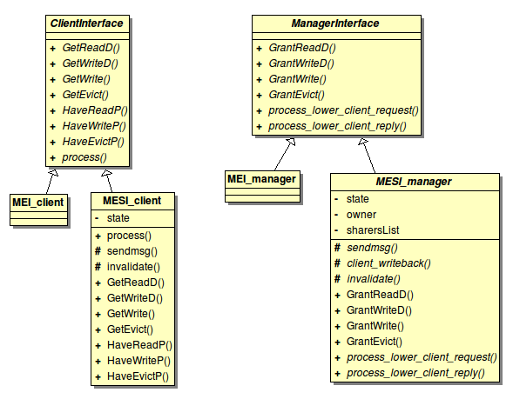

MESI

For the most part, the MESI protocol is implemented in the classes MESI_client and MESI_manager. These two classes implement the MESI state machines. The only functionality not included in these two classes is the actual sending/receiving of messages, which, as mentioned above, is purposefully left to subclasses.

It should be pointed out that these two classes only implement part of the client and manager interfaces as specified in the classes ClientInterface and ManagerInterface. Specifically, the following functions are not implemented.

ClientInterface functions not implemented in MESI_client

- SupplyAck()
- InvalidateAck()
- SupplyDowngradeAck()
- SupplyInvalidateAck()

ManagerInterface functions not implemented in MESI_manager

- Supply()
- Invalidate()
- SupplyDowngrade()
- SupplyInvalidate()
- GrantReadD()
- GrantWriteD()
- GrantWrite()
- GrantEvict()

The reason for this is these functions are only used in a mid-tier MCP node where a client and a manager co-exist. The client functions are called by the manager, and the manager functions are called by the client. We have only implemented top-tier nodes which only have managers and bottom-tier nodes which only have clients.

Class MESI_client

In this section we describe the public interface of the class MESI_client. The state machine is private and described in a later section.

The public interface consists of the following functions:

- process()
- req_pending()
- GetReadD()
- GetWriteD()
- GetWrite()
- GetEvict()
- HaveReadP()
- HaveWriteP()
- HaveEvictP()

process()

This function is the entry point to the state machine. It calls the state machine function for the current state to process input to the state machine.

req_pending()

This function tests whether the client is in a stable state, i.e., I, S, E, M state.

GetReadD()

This function is inherited from ClientInterface and is called for the client to get data and read permission. The implementation simply calls process() with GET_S as the message type.

GetWriteD()

This function is inherited from ClientInterface and is called for the client to get data and write permission. The implementation simply calls process() with GET_E as the message type.

GetWrite()

This function is inherited from ClientInterface and is called for the client to get write permission. The implementation simply calls process() with GET_E as the message type.

GetEvict()

This function is inherited from ClientInterface and is called for the client to start eviction. The implementation simply calls process() with GET_EVICT as the message type.

HaveReadP()

This function tests whether or not the client has read permission. It returns true only if the state is E, S, or M.

HaveWriteP()

This function tests whether or not the client has write permission. It returns true only if the state is M.

HaveEvictP()

This function tests whether or not the client has eviction permission. It returns true only if the state is I.

Class MESI_manager

This class does not have many public functions. The entry to the state machine is a function called process(), as with MESI_client. However, it is a protected function and may be called by the subclasses' implementation of the two public functions: process_lower_client_request(), and process_lower_client_reply(). These two functions are declared pure virtual in ManagerInterface, and are not implemented in MESI_manager, so they must be implemented in the subclasses.

MESI Client State Machine

The client state machine consists of a number of stable states and transitional states.

- Stable states: I, S, E, M
- Transitional states: IE, SE, EI, MI

We next describe each state in detail.

State I

The I (invalid) state indicates the memory line is not cached. The state transitions are shown in the following table.

Input Message | Explanation | Output Message | New State
GET_E | A write request. | CM_I_to_E | IE
GET_S | A read request. | CM_I_to_S | IE

State S

The S (shared) state indicates multiple caches holding the line.

Input Message | Explanation | Output Message | New State
GET_E | A write request. | CM_I_to_E | SE
GET_S | A read request. | None | S
GET_EVICT | The line is being evicted. | None | I
MC_DEMAND_I | Manager invalidates the line. | CM_UNBLOCK_I | I

State E

The E (exclusive) state indicates the cache is the only one holding the line.

Input Message | Explanation | Output Message | New State
GET_E | A write request. | None | M
GET_S | A read request. | None | E
GET_EVICT | The line is being evicted. | CM_E_to_I | EI
MC_FWD_E | Another cache writes the line. | CC_E_DATA | I
MC_FWD_S | Another cache reads the line. | CC_S_DATA, CM_CLEAN | S
MC_DEMAND_I | Manager invalidates the line. | CM_UNBLOCK_I | I

State M

The M (modified) state indicates the cache is the only one holding the line, and the line has been modified.

Input Message | Explanation | Output Message | New State
GET_E | A write request. | None | M
GET_S | A read request. | None | M
GET_EVICT | The line is being evicted. | CM_M_to_I | MI
MC_FWD_E | Another cache writes the line. | CC_M_DATA | I
MC_FWD_S | Another cache reads the line. | CC_S_DATA, CM_WRITEBACK | S
MC_DEMAND_I | Manager invalidates the line. | CM_UNBLOCK_I_DIRTY | I

State IE

This is a transitional state out of state I, and the state may end up to be E, S, or M.

Input Message | Explanation | Output Message | New State
CC_E_DATA | Data forwarded by current owner for a write. | CM_UNBLOCK_E | E
CC_S_DATA | Data forwarded by current owner for a read. | CM_UNBLOCK_S | S
MC_GRANT_E_DATA | Manager gives data for a read or write. | CM_UNBLOCK_E | E
MC_GRANT_S_DATA | Manager gives data for a read. | CM_UNBLOCK_S | S
CC_M_DATA | Data forwarded by owner in M state. | CM_UNBLOCK_E | M
MC_DEMAND_I | Manager invalidates the line. Request conflict. See below. | CM_UNBLOCK_I | I

State SE

This is a transitional state out of state S, and the state may end up to be E, M, or I.

Input Message | Explanation | Output Message | New State
MC_GRANT_E_DATA | Manager gives data for a write. | CM_UNBLOCK_E | E
MC_DEMAND_I | Manager invalidates the line. Request conflict. See below. | CM_UNBLOCK_I | SE
CC_M_DATA | Data forwarded by owner in M state. | CM_UNBLOCK_E | M

State EI

This is a transitional state out of state E, and the state ends up to be I.

Input Message | Explanation | Output Message | New State
MC_GRANT_I | Manager allows transition to I. | CM_UNBLOCK_I | I
MC_FWD_S | Manager demands forward to another client. Request conflict. See below. | CC_E_DATA | I
MC_FWD_E | Manager demands forward to another client. Request conflict.  See below. | CC_E_DATA | I
MC_DEMAND_I | Manager invalidates the line. Request conflict. See below. | CM_UNBLOCK_I | I

State MI

This is a transitional state out of state M, and the state ends up to be I.

Input Message | Explanation | Output Message | New State
MC_GRANT_I | Manager allows transition to I. | CM_UNBLOCK_I | I
MC_FWD_S | Manager demands forward to another client. Request conflict. See below. | CC_M_DATA | I
MC_FWD_E | Manager demands forward to another client.  Request conflict. See below. | CC_M_DATA | I
MC_DEMAND_I | Manager invalidates the line. See below. | CM_UNBLOCK_I_DIRTY | I

A state diagram for the MESI client is shown below. Transitions in red are request conflicts.

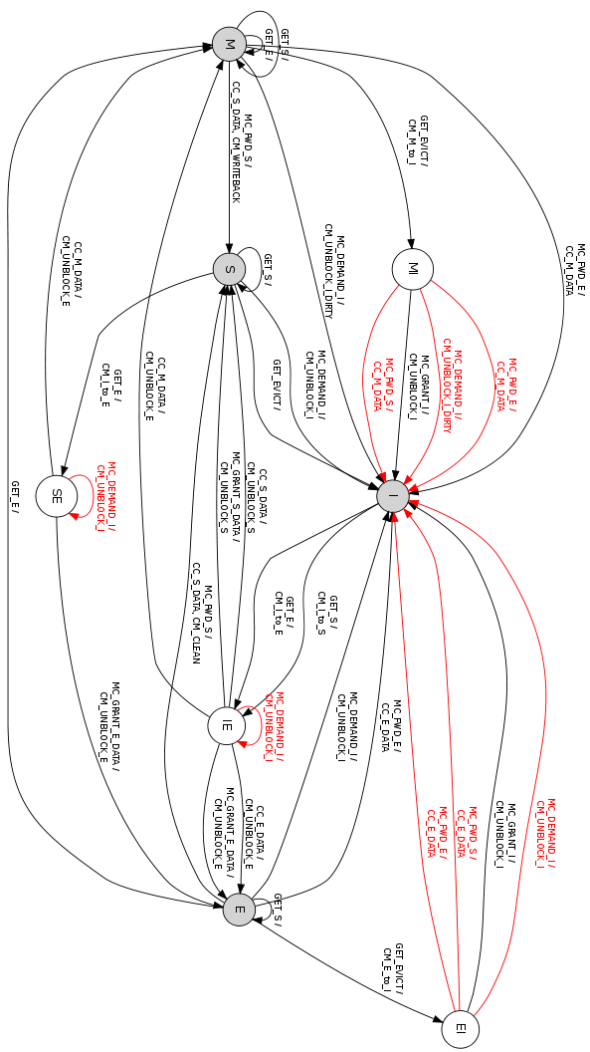

MESI Manager State Machine

The manager state machine consists of a number of stable states and transitional states.

- Stable states: I, S, E
- Transitional states: IE, EE, ES, SS, SIE, EI_PUT, EI_EVICT, SI_EVICT

We next describe each state in detail.

State I

The I (invalid) state indicates the memory line is not cached. The state transitions are shown in the following table.

Input Message | Explanation | Output Message | New State
CM_I_to_E | A write request. | MC_GRANT_E_DATA | IE
CM_I_to_S | A read request. | MC_GRANT_E_DATA | IE
CM_E_to_I | Invalidation request. See below. | None. | I
CM_M_to_I | Invalidation request. See below. | None. | I

State E

The E (exclusive) state indicates there is one and only one cache holding the line.

Input Message | Explanation | Output Message | New State
CM_I_to_E | A write request. | MC_FWD_E | EE
CM_I_to_S | A read request. | MC_FWD_S | ES
GET_EVICT | The line is being evicted. | MC_DEMAND_I | EI_EVICT
CM_E_to_I | Client requests invalidation. | MC_GRANT_I | EI_PUT
CM_E_to_I | Client requests invalidation. Request conflict. See below. | None, if sender is not owner. | E
CM_M_to_I | Client requests invalidation. | MC_GRNAT_I, if sender is owner. | EI_PUT
CM_M_to_I | Client requests invalidation. Requeest conflict. See below. | None, if sender is not owner. | E

State S

The S (shared) state indicates multiple caches holding the line.

Input Message | Explanation | Output Message | New State
CM_I_to_S | A read request. | MC_GRANT_S_DATA | SS
CM_I_to_E | A write request. | MC_DEMAND_I to all sharers | SIE
GET_EVICT | The line is being evicted. | MC_DEMAND_I to all sharers. | SI_EVICT

State IE

The IE state is a transitional state out of state I.

Input Message | Explanation | Output Message | New State
CM_UNBLOCK_E | Client indicates it has changed to E state. | None | E

State EE

The EE state is a transitional state out of state E.

Input Message | Explanation | Output Message | New State
CM_UNBLOCK_E | Client indicates it has changed to E state. | None | E

State EI_PUT

The EI_PUT is entered when the manager is in the E state and the client requests invalidation of the line.

Input Message | Explanation | Output Message | New State
CM_UNBLOCK_I | Client indicates it has changed to I state. | None | I

State EI_EVICT

The EI_EVICT is entered when the manager is in the E state and starts evicting the line.

Input Message | Explanation | Output Message | New State
CM_UNBLOCK_I | Client indicates it has changed to I state. | None | I
CM_UNBLOCK_I_DIRTY | Client indicates it has changed to I state. | None. | I

State ES

The ES is a transitional state out of the state E.

Input Message | Explanation | Output Message | New State
CM_UNBLOCK_S | Client indicates it has changed to S state. | None. | S, if CM_CLEAN or CM_WRITEBACK has been received.
CM_CLEAN | Client indicates it has forwarded data to another client. | None. | S, if CM_UNBLOCK_S has been received.
CM_WRITEBACK | Client indicates it has forwarded data to another client. | None. | S, if CM_UNBLOCK_S has been received.
CM_UNBLOCK_E | Client enters E state. Request conflict; see below. | None. | E

State SS

The SS state is a transitional state out of state S.

Input Message | Explanation | Output Message | New State
CM_UNBLOCK_S | Client indicates it has changed to S state. | None | S

State SI_EVICT

The SI_EVICT state is entered when manager is in S state and starts evicting the line.

Input Message | Explanation | Output Message | New State
CM_UNBLOCK_I | Client indicates it has changed to I state. | None | I, when all sharers have responded.

State SIE

The SIE state is entered when manager is in S state and receives a write request. It must invalidate all sharers.

Input Message | Explanation | Output Message | New State
CM_UNBLOCK_I | Client indicates it has changed to I state. | MC_GRANT_E_DATA, when all sharers have responded. | IE, when all sharers have responded.

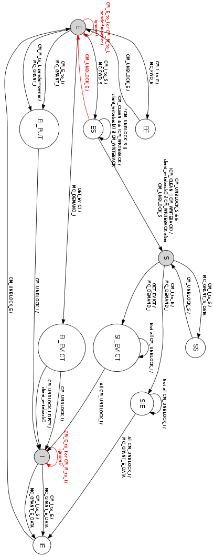

Client-Manager Interactions

This section describes the dynamics of client-manager interactions. We divide the scenarios into the following categories, based on what starts the interaction.

- Client read.
- Client write.
- Client eviction.
- Manager eviction.

The interactions are presented in tables. The first column of each table is the client's states.

Client Read

 | Manager in I state
I | 1. Client → Manager, CM_I_to_S; client enters IE.  2. Manager → Client, MC_GRANT_E_DATA; manager enters IE.  3. Client → Manager, CM_UNBLOCK_E; client enters E.  4. Manager enters E.
S | Not possible.
E | Not possible.
M | Not possible.

 | Manager in S state
I | 1. Client → Manager, CM_I_to_S; client enters IE.  2. Manager → Client, MC_GRANT_S_DATA; manager enters SS.  3. Client → Manager, CM_UNBLOCK_S; client enters S.  4. Manager enters S.
S | No messages sent.
E | Not possible.
M | Not possible.

 | Manager in E state
I | 1. Client → Manager, CM_I_to_S; client enters IE.  2. Manager → Owner, MC_FWD_S; manager enters ES.  3. Owner → Client, CC_S_DATA; owner → manager, CM_CLEAN (if owner in E) or CM_WRITEBACK (if owner in M); owner enters S.  4. Client → Manager, CM_UNBLOCK_S; client enters S.  5. Manager enters S after receiving both CM_UNBLOCK_S and CM_CLEAN (or CM_WRITEBACK).
S | Not possible.
E | No messages sent.
M | No messages sent.

Client Write

 | Manager in I state
I | 1. Client → Manager, CM_I_to_E; client enters IE.  2. Manager → Client, MC_GRANT_E_DATA; manager enters IE.  3. Client → Manager, CM_UNBLOCK_E; client enters E.  4. Manager enters E.  5. Client in E is called with GET_E again; client enters M.  Possible improvement: It may be better for the client to enter M directly, instead of being called again.
S | Not possible.
E | Not possible.
M | Not possible.

 | Manager in S state
I | 1. Client → Manager, CM_I_to_E; client enters IE.  2. Manager → Sharers, MC_DEMAND_I; manager enters SIE.  3. Sharers → Manager, CM_UNBLOCK_I.  4. Manager → Client, MC_GRANT_E_DATA; manager enters IE.  5. Client → Manager, CM_UNBLOCK_E; client enters E.  6. Manager enters E.  7. Client in E is called with GET_E again; client enters M.  Possible improvement: It may be better for the client to enter M directly, instead of being called again.
S | 1. Client → Manager, CM_I_to_E; client enters SE.  2. Manager → Sharers, MC_DEMAND_I; manager enters SIE.  3. Sharers → Manager, CM_UNBLOCK_I.  4. Manager → Client, MC_GRANT_E_DATA; manager enters IE.  5. Client → Manager, CM_UNBLOCK_E; client enters E.  6. Manager enters E.  7. Client in E is called with GET_E again; client enters M.  Possible improvement: It may be better for the client to enter M directly, instead of being called again.
E | Not possible.
M | Not possible.

 | Manager in E state
I | 1. Client → Manager, CM_I_to_E; client enters IE.  2. Manager → Owner, MC_FWD_E; manager enters EE.  3. Owner → Client, CC_E_DATA or CC_M_DATA; owner enters I.  4. Client → Manager, CM_UNBLOCK_E; client enters E.  5. Manager enters E.  6. Client in E is called with GET_E again; client enters M.  Possible improvement: It may be better for the client to enter M directly, instead of being called again.
S | No possible.
E | No messages sent. Client enters M.
M | No messages sent.

Client Eviction

 | Manager in I state
I | Not possible.
S | Not possible.
E | Not possible.
M | Not possible.

 | Manager in S state
I | Not possible.
S | No messages sent. Client enters I.
E | Not possible.
M | Not possible.

 | Manager in E state
I | Not possible.
S | Not possible.
E | 1. Client → Manager, CM_E_to_I; client enters EI.  2. Manager → Client, MC_GRANT_I; manager enters EI_PUT.  3. Client → Manager, CM_UNBLOCK_I; client enters I.  4. Manager enters I.
M | 1. Client → Manager, CM_M_to_I; client enters MI.  2. Manager → Client, MC_GRANT_I; manager calls client_writeback() and enters EI_PUT.  3. Client → Manager, CM_UNBLOCK_I; client enters I.  4. Manager enters I.

Manager Eviction

 | Manager in I state
I | Not possible.
S | Not possible.
E | Not possible.
M | Not possible.

 | Manager in S state
I | Not possible.
S | 1. Manager → Sharers, MC_DEMAND_I; manager enters SI_EVICT.  2. Sharers → Manager, CM_UNBLOCK_I; sharers enter I.  3. Manager enters I after receiving from all sharers.
E | Not possible.
M | Not possible.

 | Manager in E state
I | Not possible.
S | Not possible.
E | 1. Manager → Client, MC_DEMAND_I; manager enters EI_EVICT.  2. Client → Manager, CM_UNBLOCK_I; client enters I.  3. Manager enters I.
M | 1. Manager → Client, MC_DEMAND_I; manager enters EI_EVICT.  2. Client → Manager, CM_UNBLOCK_I_DIRTY; client enters I.  3. Manager calls client_writeback() and enters I.

Request Conflicts

The various message types that are sent between client and manager are given below.

// Client to Manager messages
MESI_CM_I_to_E,
MESI_CM_I_to_S,
MESI_CM_E_to_I,
MESI_CM_M_to_I,
MESI_CM_UNBLOCK_I,
MESI_CM_UNBLOCK_I_DIRTY,
MESI_CM_UNBLOCK_E,
MESI_CM_UNBLOCK_S,
MESI_CM_CLEAN,
MESI_CM_WRITEBACK,

// Manager to Client messages
MESI_MC_GRANT_E_DATA,
MESI_MC_GRANT_S_DATA,
MESI_MC_GRANT_I,
MESI_MC_FWD_E,
MESI_MC_FWD_S,
MESI_MC_DEMAND_I,

// Client to Client messages
MESI_CC_E_DATA,
MESI_CC_M_DATA,
MESI_CC_S_DATA,

Of all these message types, 7 are requests initiated by either the client or the manager, and the rest are responses to a request. Of the 7 types, 4 are requests sent from client to manager, and 3 are from manager to client. The question is, what happens when a client/manager, right after sending a request, receives a manager/client request for the same line? In this document, we refer to these situations as request conflicts.

The following table summarizes the request conflicts. The first row shows the manager requests with the manager's state in parentheses, and the first column shows the client requests with the client's state in parentheses. There are 8 cases, indicated by the number in parentheses.

 | MC_FWD_E (EE) | MC_FWD_S (ES) | MC_DEMAND_I (EI_EVICT)
CM_I_to_E (IE, SE) | NA | NA | Conflict (7, 8)
CM_I_to_S (IE) | NA | NA | NA
CM_E_to_I (EI) | Conflict (1) | Conflict (3) | Conflict (5)
CM_M_to_I (MI) | Conflict (2) | Conflict(4) | Conflict (6)

Case 1: CM_E_to_I and MC_FWD_E

This occurs when the client starts to evict a line, which is is E state, and it receives a MC_FWD_E because it is the owner of the line. The client is in the EI state.

- Client in EI state receives MC_FWD_E. It forwards the data to the other client with CC_E_DATA, and enters I state.
- The requesting client receives CC_E_DATA, enters E (eventually M) state, and sends CM_UNBLOCK_E to manager.
- Manager receives CM_UNBLOCK_E and enters E state.
- Now manager processes the CM_E_to_I. Since the sender is different from the current owner, it knows a request conflict has occurred and the sender has already entered I state. So it ignores the message by calling ignore().

Case 2: CM_M_to_I and MC_FWD_E

This occurs when the client starts to evict a line, which is is M state, and it receives a MC_FWD_E because it is the owner of the line. The client is in the MI state.

- Client in MI state receives MC_FWD_E. It forwards the data to the other client with CC_M_DATA, and enters I state.
- The requesting client receives CC_M_DATA, enters E (eventually M) state, and sends CM_UNBLOCK_E to manager.
- Manager receives CM_UNBLOCK_E and enters E state.
- Now manager processes the CM_M_to_I. Since the sender is different from the current owner, it knows a request conflict has occurred and the sender has already entered I state. So it ignores the message by calling ignore().

Case 3: CM_E_to_I and MC_FWD_S

This occurs when the client starts to evict a line, which is is E state, and it receives a MC_FWD_S because it is the owner of the line. The client is in the EI state.

- Client in EI state receives MC_FWD_S. It forwards the data to the other client with CC_E_DATA (Not CC_S_DATA), and enters I state.
- The requesting client receives CC_E_DATA, enters E state, and sends CM_UNBLOCK_E to manager.
- Manager in ES receives CM_UNBLOCK_E and enters E state.
- Now manager processes the CM_E_to_I. Since the sender is different from the current owner, it knows a request conflict has occurred and the sender has already entered I state. So it ignores the message by calling ignore().

Case 4: CM_M_to_I and MC_FWD_S

This occurs when the client starts to evict a line, which is is M state, and it receives a MC_FWD_S because it is the owner of the line. The client is in the MI state.

- Client in MI state receives MC_FWD_S. It forwards the data to the other client with CC_M_DATA, and enters I state.
- The requesting client receives CC_M_DATA, enters E state, and sends CM_UNBLOCK_E to manager.
- Manager in ES receives CM_UNBLOCK_E and enters E state.
- Now manager processes the CM_M_to_I. Since the sender is different from the current owner, it knows a request conflict has occurred and the sender has already entered I state. So it ignores the message by calling ignore().

Case 5: CM_E_to_I and MC_DEMAND_I

This occurs when the client starts to evict a line, which is is E state, and it receives a MC_DEMAND_I. The client is in the EI state.

- Client in EI state receives MC_DEMAND_I. It replies to the manager with CM_UNBLOCK_I, and enters I state.
- Manager receives CM_UNBLOCK_I and enters I state.
- Now manager in I state processes the CM_E_to_I. It ignores the message by calling ignore().

Case 6: CM_M_to_I and MC_DEMAND_I

This occurs when the client starts to evict a line, which is is M state, and it receives a MC_DEMAND_I. The client is in the MI state.

- Client in MI state receives MC_DEMAND_I. It replies to the manager with CM_UNBLOCK_I_DIRTY, and enters I state.
- Manager receives CM_UNBLOCK_I_DIRTY and enters I state.
- Now manager in I state processes the CM_M_to_I. It ignores the message by calling ignore().

Case 7: CM_I_to_E and MC_DEMAND_I

This occurs when the client in I state writes to the line a line. It sends a CM_I_to_E and receives a MC_DEMAND_I because the manager is evicting the line, and it thinks the client is still a sharer. This could happen because in this implementation when a client in S state is evicted, it does not notify the manager.

The client is in the IE state. In this case, the manager is not aware of the conflict.

- Client in IE state receives MC_DEMAND_I. It replies to the manager with CM_UNBLOCK_I, and stays in IE state.
- Manager receives all CM_UNBLOCK_I and enters I state.
- Now manager processes the CM_I_to_E, and sends MC_GRANT_E_DATA to client. Manger enters IE state.
- Client enters E (eventually M) state, and sends CM_UNBLOCK_E to manager.
- Manager enters E state.

Case 8: CM_I_to_E and MC_DEMAND_I

This occurs when the client in S state writes to the line a line. It sends a CM_I_to_E and receives a MC_DEMAND_I because the manager is evicting the line. The client is in the SE state. In this case, the manager is not aware of the conflict.

- Client in SE state receives MC_DEMAND_I. It replies to the manager with CM_UNBLOCK_I, and stays in SE state.
- Manager receives all CM_UNBLOCK_I and enters I state.
- Now manager processes the CM_I_to_E, and sends MC_GRANT_E_DATA to client. Manger enters IE state.
- Client enters E (eventually M) state, and sends CM_UNBLOCK_E to manager.
- Manager enters E state.

Protocol-Independent Layer: Class L1_cache

Two most important classes in the protocol-independent layer are L1_cache and L2_cache. This section describes in detail L1_cache and its related classes. The next section focuses on L2_cache.

The class hierarchy of L1_cache is shown in the class diagram below.

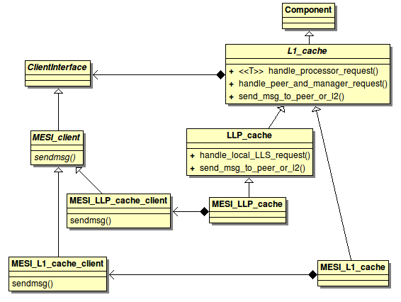

As stated above, L1 cache has one client for each cache line but no managers.

For the L1_cache class, we first describe its data structures, then its dynamics, including:

- Event handlers for request from processor and peer/manager.
- MSHR management.
- Stall buffer management.

Details of L1_cache are shown in the following class diagram.

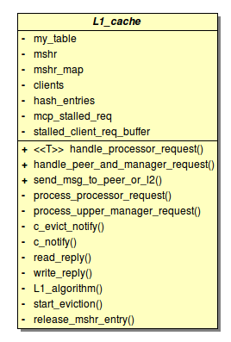

Data Structures for L1_cache

The L1_cache class has the following internal data structures.

MemoryControllerMap* l2_map
This is an object that maps a memory address to the L2 cache's node ID. This is used when the L1 cache needs to send a message to L2.

hash_table* my_table
This is the hash table that holds the memory address tags. Each hash entry represents a cache line, and for each entry there is a client.

hash_table* mshr
This is the MSHR, implemented as a fully associative hash table.

std::map<int, hash_entry*> mshr_map
This map maps an MSHR entry ID to an entry in the hash table. This is used when we need to find the client for an MSHR entry. From the MSHR entry, using this map, we can find the hash table entry, and then the client associated with the entry.

std::vector<ClientInterface*> clients
This vector contains all the clients, one for each hash table entry (or cache line).

std::vector<hash_entry*> hash_entries
This vector allows mapping from client to hash table entry.

std::vector<cache_req*> mcp_stalled_req
This vector holds currently stalled request for each client. This makes it easy to identify the stalled request in the stall buffer once the client has finished processing.

std::list<Stall_buffer_entry> stalled_client_req_buffer
This is the stall buffer. It holds request that are being processed or waiting to be processed.

Hash entry-client association

Conceptually there is a one-to-one association between a hash entry and a client. In L1_cache, each hash entry (cache line) and client is given an integer ID between 0 and N-1, where N is the number of cache lines. The mapping between hash entry and client is implemented with the following two vectors:

- vector<ClientInterface*> clients, indexed by hash entry's ID.
- vector<hash_entry*> hash_entries, indexed by client's ID.

The advantages of this approach include:

- The hash entry class and client class are completely decoupled.
- The hash entry, through its ID, can be mapped not only to a client, but any arbitrary data structure. In other words, the hash entry class can be extended in any arbitrary way.

The disadvantage is there is one more indirection in accessing the client from the hash entry and vice versa.

An alternative approach is to make client a member of hash entry. But then we need at least two sets of hash_table, hash_set, and hash_entry classes: one for client and one for manager.

Dynamics of L1_cache

Handling Processor Requests

The member function handle_processor_request() is the event handler for requests from processor. This function is the event handler that is specified when the user sets up the connection between the L1 cache and the processor with the Manifold::Connect() function. The function is templated so it can be used with different processors as long as the request data type implements the following two functions:

- get_addr(): This function returns the memory address for which the request is created.
- is_read(): This function returns true if the request is a load.

Since the processor's request may contain more data than the address and read-write flag, the handle_processor_request() function creates a cache_req which is a wrapper for the processor's original request. It then calls process_processor_request(). The pseudo-code is given below.

FUNCTION handle_processor_request
Create cache_req from processor request.
CALL process_processor_request.

The following explains process_processor_request() in detail. A high-level view is given first, followed by a detailed view.

High-level view of process_processor_request()

Allocate MSHR entry

IF miss THEN
miss logic
ELSE
hit logic
ENDIF

Allocating MSHR entry
For a new processor request, the function first attempts to allocate an MSHR entry. However, if there is already a request for the same line or there is no MSHR entry available, the request is put in the stall buffer. In addition, we need to check if the stall buffer already has a request for the same line. If so, the new request also must stall. Since requests in the stall buffer don't have MSHR entries, this check is to ensure requests for the same line are processed in the correct order.

IF MSHR entry for same line exists THEN # must be new request
PREV_PEND_STALL; RETURN

IF request is new and stall buffer has request for same line THEN
PREV_PEND_STALL; RETURN

Allocate an MSHR entry

IF failure THEN
MSHR_STALL; RETURN

Miss logic

After an MSHR is allocated for the request, we check whether the request is a miss or hit. For a miss, we try to allocate a hash entry. If successful, the processing continues with a call of L1_algorithm. Otherwise, we need to start the eviction process. If the victim is busy, then the request is put in the stall buffer.

IF miss in hash table THEN
Allocate a hash entry
IF success THEN
Map MSHR entry to hash entry
CALL L1_algorithm
RETURN
ELSE #did not get hash entry; needs eviction
IF LRU entry not busy THEN
CALL start_eviction
RETURN
ELSE #LRU is busy
Invalidate MSHR entry
LRU_BUSY_STALL
RETURN
ENDIF
ENDIF
ELSE
#hit logic
ENDIF

Hit logic

If the request hits in the cache, we need to check if the client for the line is busy, and if it is, the request is put in the stall buffer. Otherwise, the processing continues.

IF miss THEN
miss logic
ELSE
IF client is busy THEN
Invalidate MSHR entry
TRANS_STALL
RETURN

Map MSHR entry to hash entry
CALL L1_algorithm
ENDIF

From the above, we can see there are three types of exit from process_processor_request():

- Calling L1_algorithm() for further processing.
- Calling start_eviction() to start evicting the victim.
- Calling stall() to put the request in the stall buffer.

The function stall() if very simple. It simply puts the request at the end of the stall buffer stalled_client_req_buffer. We next take a look at L1_algorithm() and start_eviction().

L1_algorithm()

This function is where the client may communicate with its manager.

If the request is load, we check if the client has read permission, and if it does, then the request is finished. We send a reply to processor, call release_mshr_entry() to release the MSHR entry and wake up a stalled request, if any.

On the other hand, if the client does not have read permission (for example, if it is in the I state in MESI), it needs to communicate with its manager to get the data. The request is put in mcp_stalled_req for the transaction with the manager to finish.

Store requests are slightly more complex. First we check if the client has write permission. If it does, the request is finished. A reply is sent to processor and release_mshr_entry() is called. If the client does not have write permission, we attempt an upgrade. Therefore, depending on the client's state it may or may not need to communicate with its manager. For example, with MESI, the client can transit from E state to M state without communicating with the manager. We then check again and see if the client has write permission. If yes, the request is finished. Otherwise, it is put in mcp_stalled_req for the transaction with the manager to complete.

In the following we present the pseudo-code for L1_algorithm() in two parts: first for the load request and then for the store request.

Get client from MSHR entry

IF request is load THEN
IF client->HaveReadP() THEN #if client has read permission
Reply to processor
CALL release_mshr_entry
RETURN #at this point the request is finished
ELSE
CALL client->GetReadD()
Put request in mcp_stalled_req for the client
ENDIF
ELSE
# store request
ENDIF

IF request is load THEN
# load request
ELSE
IF client->HaveWriteP() THEN
Reply to processor
CALL release_mshr_entry
RETURN # request is finished
ELSE
IF client->HaveReadP() THEN
CALL client->GetWrite()
ELSE
CALL client->GetWriteD()

IF client->HaveWriteP() THEN
Reply to processor
CALL release_mshr_entry
RETURN # request is finished
ELSE
Put request in mcp_stalled_req for the client
ENDIF
ENDIF

start_eviction()

In a cache miss, if the cache set is full, eviction is required. We first call GetEvict() for the victim's client, and then check if we have eviction permission right away. This could happen, for example, with MESI when the client is in the S state, in which case the line is silently evicted without notifying the manager. If we have eviction permission, then the request that caused the eviction can be processed by calling L1_algorithm(). Otherwise, the request is put in mcp_stalled_req for the client, waiting for the eviction to complete. The state for the client is set to EVICTING. The pseudo-code is given below.

CALL victim_client->GetEvict

IF vectim_client->HaveEvictP THEN #if client has eviction permission
Allocate hash entry for request
Map MSHR entry to hash entry
CALL L1_algorithm
RETURN
ELSE
Put request in mcp_stalled_req for its client
Set client state to EVICTING
ENDIF

Handling Manager or Peer Request/Reply

In addition to requests from processor, the L1 cache can also receive requests or replies from its peers or manager. Handling of manager/peer request/reply is implemented with the following functions.

- handle_peer_and_manager_request()
- process_upper_manager_request()
- c_notify()
- c_evict_notify()
- respond_with_default()

The function respond_with_default() is pure virtual, and must be implemented by subclasses.

Handle_peer_and_manager_request()

The top level function handle_peer_and_manager request() is the event handler specified in the call of the Manifold::Connect() function when the connections of L1_cache is set up. Therefore, when a request/reply is received from the manager or peer, this functions is first called. The pseudo-code is given below.

IF received request THEN # request can only come from manager: downgrade
# or invalidation
IF there is no hash entry for the address THEN
CALL respond_with_default
RETURN
ELSE
CALL process_upper_manager_request
ELSE # must be reply
IF there is an MSHR entry for the address THEN
# this is a reply to a request being processed
CALL client->process()
IF request is complete THEN
CALL c_noify
ELSE
# must be a reply for an eviction
CALL client->process()
IF request is complete THEN
CALL c_evict_notify
ENDIF

How can L1_cache receive a request from its manager (which is either a downgrade or invalidation request) but there is no hash entry for the address? This could happen in MESI. When a client is S is evicted, the manager is not notified. Therefore, later on, when the line is evicted in the manager, it thinks the client is still a sharer, so it sends an invalidation message. At this moment, the line may not be in the L1 cache.

process_upper_manager_request()

This is only called by handle_peer_and_manager request() to process a manager request.

CALL client->process()
IF client in stable state THEN
IF there is pending request for the client in mcp_stalled_req THEN
# the request must be waiting for an eviction
CALL c_evict_notify
ENDIF
ENDIF

c_notify()

This function is called when a reply from the manager or peer is processed and as a result the request is complete. The request is re-processed by passing it to L1_algorithm().

Get the request from mcp_stalled_req
CALL L1_algorithm

c_evict_notify()

This is called when a client completes eviction of the line. We need to reprocess the request that is waiting for the eviction.

Remove request from mcp_stalled_req
Get hash entry
Map MSHR entry to hash entry
CALL L1_algorithm

MSHR Management

Allocation

An MSHR entry is allocated in the following situations:

- When a new processor request is first processed in handle_processor_request().
- When a request is removed from the stall buffer in release_mshr_entry() and reprocessed in handle_processor_request().

Release

An MSHR entry is released in the following situations:

- In release_mshr_entry() when a request is complete.
- When LRU_BUSY_STALL or TRANS_STALL occurs, the already allocated MSHR entry is released by invalidating it.

release_mshr_entry()

The function release_mshr_entry() is called when a processor request is complete. Since an MSHR entry is released, we need to check the stall buffer and see if any request waiting to allocate MSHR entry can be removed from the stall buffer and start allocating MSHR entry. To ensure requests are processed in their correct order, a request is woken up only if it won't stall right away with a stall type PREV_PEND_STALL, LRU_BUSY_STALL, or TRANS_STALL. It cannot have a MSHR_STALL because an MSHR entry has just been released.

Clear the mshr_map
Invalidate the MSHR entry

found := false
FOREACH request in stall buffer DO
IF request won't get PREV_PEND_STALL THEN
IF request will miss THEN
IF request won't get LRU_BUSY_STALL THEN
found := true
ELSE # request will hit
IF request won't get TRANS_STALL THEN
found := true
ENDIF
ENDIF

IF found THEN
Remove request from stall buffer
GOTO Loopend
ENDIF
ENDDO

Loopend:

IF found THEN
CALL process_processor_request

Classes LLP_cache and MESI_LLP_cache

LLP_cache

Classes LLP_cache and LLS_cache are created for a system configuration where each processor has a local private cache (last-level private, or LLP) connected to a shared higher-level cache slice (last-level shared, or LLS), as shown in the following figure.
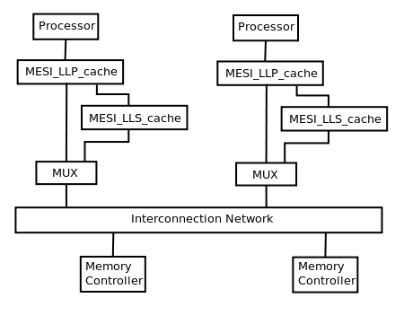

We make LLP_cache a subclass of L1_cache for code reuse. Its additional functionality is implemented in the following member functions:

- handle_local_LLS_request()
- send_msg_to_peer_or_l2()

The function handle_local_LLS_request() is the event handler for events from local LLS cache. It simply calls handle_peer_and_manager_request() that is inherited from L1_cache.

The function send_msg_to_peer_or_L2() overwrites the same function from L1_cache. It checks the address and find out whether the message should be sent to the local LLS or a remote node.

MESI_LLP_cache

Both L1_cache and its subclass LLP_cache are protocol independent. Class MESI_LLP_cache is a subclass of LLP_cache and part of the implementation of the MESI protocol.

The majority of the MESI protocol is implemented in the protocol layer in the classes MESI_client and MESI_manager. The only missing part is the message sending functionality, which, as noted above, is intentionally separated from the protocol state machines. This functionality must be implemented somewhere for the protocol layer to be complete.

On the other hand, the protocol independent class L1_cache and its subclass LLP_cache, s subclasses of the Manifold :: Component class, have the ability of sending messages, but they cannot put protocol-specific information in the messages.

The class MESI_LLP_cache is designed to bridge this gap. It is charged with the responsibility of sending protocol specific messages. As a subclass of LLP_cache, it can send messages, and as part of the protocol layer, it has knowledge of the particular protocol.

Class MESI_L1_cache

Class MESI_L1_cache and MESI_L2_cache implement the MESI protocol for a system configuration where the processor has a private cache and the L2 caches are in separate nodes, as shown below.

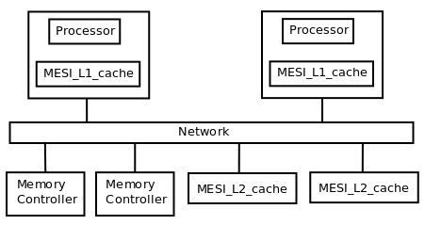

Similar to MESI_LLP_cache, MESI_L1_cache mainly implements sending MESI-specific protocol messages for the state machines.

Protocol-Independent Layer: Class L2_cache

The L2_cache class implements a top-tier node in the MCP protocol. For each cache line there is an associated manager, but no client. Class L2_cache and its related classes are shown in the following class diagram.

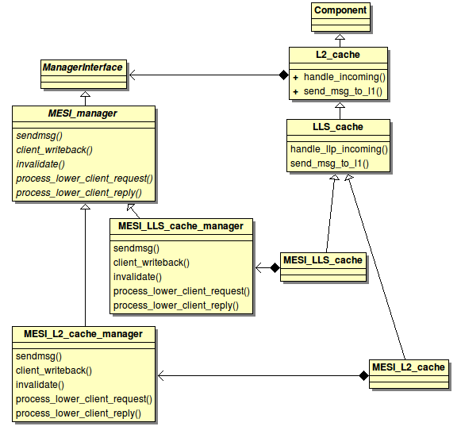

For the L2_cache class, we first describe its data structures, then its dynamics, including:

- Event handlers for requests from clients.
- MSHR management.
- Stall buffer management.

Details of L2_cache are shown in the following class diagram.

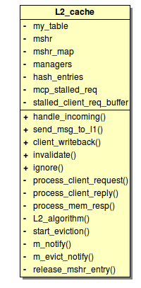

Data Structures for L2_cache

The L2_cache class has the following internal data structures.

MemoryControllerMap* mc_map
This is an object that maps a memory address to the memory controller's node ID. This is used when the L2 cache needs to send a message to a memory controller. A system can have more than one memory controller.

hash_table* my_table
This is the hash table that holds the memory address tags. Each hash entry represents a cache line, and for each entry there is a manager.

hash_table* mshr
This is the MSHR, implemented as a fully associative hash table.

std::map<int, hash_entry*> mshr_map
This map maps an MSHR entry ID to an entry in the hash table. This is used when we need to find the manager for an MSHR entry. From the MSHR entry, using this map, we can find the hash table entry, and then the manager associated with the entry.

std::vector<ManagerInterface*> managers
This vector contains all the managers, one for each hash table entry (or cache line).

std::vector<hash_entry*> hash_entries
This vector allows mapping from manager to hash table entry.

std::vector<cache_req*> mcp_stalled_req
This vector holds currently stalled request for each manager. This makes it easy to identify the stalled request in the stall buffer once the manager has finished processing.

std::list<Stall_buffer_entry> stalled_client_req_buffer
This is the stall buffer. It holds request that are being processed or waiting to be processed.

Hash entry-manager association

Conceptually there is a one-to-one association between a hash entry and a manager. In L2_cache, each hash entry (cache line) and manager is given an integer ID between 0 and N-1, where N is the number of cache lines. The mapping between hash entry and manager is implemented with the following two vectors:

- vector<ManagerInterface*> managers, indexed by hash entry's ID.
- vector<hash_entry*> hash_entries, indexed by client's ID.

The advantages of this approach include:

- The hash entry class and manager class are completely decoupled.
- The hash entry, through its ID, can be mapped not only to a manager, but any arbitrary data structure. In other words, the hash entry class can be extended in any arbitrary way.

The disadvantage is there is one more indirection in accessing the manager from the hash entry and vice versa.

An alternative approach is to make manager a member of hash entry. But then we need at least two sets of hash_table, hash_set, and hash_entry classes: one for client and one for manager.

Dynamics of L2_cache

Requests from client to manager can be a request originated from the client, or a response to a requested initiated by the manager. These two types of messages are handled differently.

Handling Client Requests

The member function handle_incoming() is the event handler for requests from clients (L1 cache). This function is the event handler that is specified when the user sets up the connection between the L2 cache and the network with the Manifold::Connect() function. The pseudo-code is given below.

IF request is from memory controller THEN
CALL process_mem_resp
ELSE IF request is coherence request THEN
CALL process_client_request
ELSE
CALL process_client_reply
ENDIF

process_mem_resp()

When the L2 cache receives either a read or a write request, if the requested cache line is not in the cache, the line is first read from the memory controller. This function is called when the L2 cache receives a response from the memory controller. It removes the stalled request from mcp_stalled_req, set a flag for the hash entry to true that indicates whether the entry has data, and then calls L2_algorithm to process the request.

Remove request from mcp_stalled_req
Set flag for hash entry to true
CALL L2_algorithm

High-level view of process_client_request()

This is a key function of L2_cache. We first give a high-level view of it, and then go into details.

Allocate MSHR entry

IF miss THEN
miss logic
ELSE
hit logic
ENDIF

Allocating MSHR entry

This part is almost identical to L1_cache. For a new client request, the function first attempts to allocate an MSHR entry. However, if there is already a request for the same line or there is no MSHR entry available, the request is put in the stall buffer. In addition, we need to check if the stall buffer already has a request for the same line. If so, the new request also must stall. Since requests in the stall buffer don't have MSHR entries, this check is to ensure requests for the same line are processed in the correct order.

IF MSHR entry for same line exists THEN # must be new request
PREV_PEND_STALL; RETURN

IF request is new and stall buffer has request for same line THEN
PREV_PEND_STALL; RETURN

Allocate an MSHR entry

IF failure THEN
MSHR_STALL; RETURN

Miss logic

After an MSHR is allocated for the request, we check whether the request is a miss or hit. For a miss, we first check if the request is an invalidation request. If so, it is ignored and the MSHR entry is released by invalidating it. Otherwise, we try to allocate a hash entry. If successful, the processing continues with a call of L2_algorithm. Otherwise, we need to start the eviction process. If the victim is busy, then the request is put in the stall buffer.

IF miss in hash table THEN
IF request is invalidation THEN
Invalidate MSHR entry
RETURN

Allocate a hash entry
IF success THEN
Map MSHR entry to hash entry
CALL L2_algorithm
RETURN
ELSE #did not get hash entry; needs eviction
IF LRU entry not busy and no request pending THEN
CALL start_eviction
RETURN
ELSE #LRU is busy
Invalidate MSHR entry
LRU_BUSY_STALL
RETURN
ENDIF
ENDIF
ELSE
#hit logic
ENDIF

Note that the condition for the LRU entry not being busy is that the manager is not busy and there is no pending request for the manager in mcp_stalled_req. The 2nd part of the condition is necessary because the manager could be in the I state (in MESI) and waiting for reply from memory.

Hit logic

If the request hits in the cache, we need to check if the client for the line is busy, and if it is, the request is put in the stall buffer. Otherwise, the processing continues.

IF miss THEN
miss logic
ELSE
IF client is busy THEN
Invalidate MSHR entry
TRANS_STALL
RETURN

Map MSHR entry to hash entry
CALL L2_algorithm
ENDIF

From the above, we can see there are three types of exit from process_client_request():

- Calling L2_algorithm() for further processing.
- Calling start_eviction() to start evicting the victim.
- Calling stall() to put the request in the stall buffer.

We next look at L2_algorithm() and start_eviction().

L2_algorithm()

This function is where the protocol layer is involved and where the manager may communicate with its clients.

Regardless of whether the request is load or store, we first check if the cache entry has data. If not, a message is sent to the memory controller to read the data, and the cache request is put in mcp_stalled_req to wait for response from the memory controller. The response is eventually processed by process_mem_resp(), as described above.

If the cache entry already has data, we call the manager's process_lower_client_request() function. It this function returns true, it means the processing of the request is complete, and we then call release_mshr_entry() to release the MSHR entry and find a request that can be processed from the stall buffer. However, if process_lower_client_request() returns false, it means the processing is not complete. The request is put in mcp_stalled_req.

Get manager from MSHR entry

IF MSHR entry has data THEN
IF manager->process_lower_client_request() = true THEN
CALL release_mshr_entry
RETURN
ELSE
Put request in mcp_stalled_req
ELSE
Send message to memory controller to read the line
Put request in mcp_stalled_req
ENDIF

start_eviction()

In a cache miss, if the cache set is full, eviction is required. We simply call the Evict() function for the manager, and then put the request in mcp_stalled_req for the manager. The underlying assumption after return from Evict(), the eviction is not yet complete.

CALL victim_manager->Evict
Put request in mcp_stalled_req for its client

Handling Client Reply

Replies to coherence requests that are received by the manager is handled in process_client_reply(). This function basically just pass the reply to the protocol layer.

IF there is an MSHR entry for the address THEN
Get the manager from the MSHR entry
CALL manager->process_lower_client_reply()
IF the request is finished THEN
CALL m_notify
ELSE #must be eviction reply
Get the manager from the hash entry
CALL manager->process_lower_client_reply
IF the request is finished THEN
CALL m_evict_notify
ENDIF

m_notify()

This function is called when the manager, after processing a client reply, enters a stable state. The original request is processed again by the manager. And if the request is finished, we release the MSHR entry and wakes up a stalled request.

IF manager->process_lower_client_request() = true THEN #request finishes
CLEAR mcp_stalled_req for the manager
CALL release_mshr_entry
ELSE
#do nothing since request is already in mcp_stalled_req
ENDIF

m_evict_notify()

This function is called when the manager, after processing a client reply for an eviction, enters a stable state. We consider the eviction complete and start processing the request waiting for the eviction.

Get the request in mcp_stalled_req
CLEAR mcp_stalled_req for the manager
Allocate hash entry
Map MSHR entry to hash entry
CALL L2_algorithm

MSHR Managerment

MSHR management for L2_cache is very similar to that for L1_cache.

Allocation

An MSHR entry is allocated in the following situations:

- When a new processor request is first processed in process_client_request().
- When a request is removed from the stall buffer in release_mshr_entry() and reprocessed in process_client_request().

Release

An MSHR entry is released in the following situations:

- In release_mshr_entry() when a request is complete.
- When LRU_BUSY_STALL or TRANS_STALL occurs, the already allocated MSHR entry is released by invalidating it.

release_mshr_entry()

The function release_mshr_entry() is called by L2_algorithm() and m_notify() when a request from client is complete. Since an MSHR entry is released, we need to check the stall buffer and see if any request waiting to allocate MSHR entry can be removed from the stall buffer and start allocating MSHR entry. To ensure requests are processed in their correct order, a request is woken up only if it won't stall right away with a stall type PREV_PEND_STALL, LRU_BUSY_STALL, or TRANS_STALL. It cannot have a MSHR_STALL because an MSHR entry has just been released.

Clear the mshr_map
Invalidate the MSHR entry

found := false
FOREACH request in stall buffer DO
IF request won't get PREV_PEND_STALL THEN
IF request will miss THEN
IF request won't get LRU_BUSY_STALL THEN
found := true
ELSE # request will hit
IF request won't get TRANS_STALL THEN
found := true
ENDIF
ENDIF

IF found THEN
Remove request from stall buffer
GOTO Loopend
ENDIF
ENDDO

Loopend:

IF found THEN
CALL process_client_request

Miscellaneous Functions

This section a few member functions of L2_cache that are part of the implementation, including:

- client_writeback()
- invalidate()
- dirty_to_meory()
- ignore()
- update_hash_entry()

client_writeback()

In our implementation of MESI, there are three cases where client needs to write back dirty cache line to its manager. The manager, in turn, calls client_writeback() of L2_cache, which simply marks the cache line dirty.

The three cases are as follows:

- When a dirty line (client in M state) is being evicted, a CM_M_to_I messages is sent to the manager.
- When the manager, while evicting the cache line, sends MC_DEMAND_I to client and gets UNBLOCK_I_DIRTY, and
- When the manager, after receiving a CM_I_to_S and sending a MC_FWD_S to the owner, receives a CM_WRITEBACK from the owner.

invalidate()

When a line is being invalidated (in MESI, this happens when the line transitions to the I state), the L2_cache's invalidate() function is called. This function first checks if the line is dirty, and, if so, calls dirty_to_memory() to write the line back to the memory controller. Then the hash entry is invalidated.

dirty_to_memory()

As mentioned above, this function is called by invalidate() to write a dirty line back to the memory controller when the cache line is being invalidated.

ignore()

In some race conditions, manager would detect the race condition and decide to ignore a message. It calls the ignore() function in case L2_cache has some cleanup to perform.

update_hash_entry()

This is called to update the hash entry's flag that indicates whether the cache line has data.

Classes LLS_cache and MESI_LLS_cache

LLS_cache

As explained in the last section, classes LLP_cache and LLS_cache are created for a system configuration where each processor has a local private cache (last-level private, or LLP) connected to a shared higher-level cache slice (last-level shared, or LLS).

We make LLS_cache a subclass of L2_cache for code reuse. Its additional functionality is implemented in the following member functions:

- handle_llp_incoming()
- send_msg_to_l1()

The function handle_llp_incoming() is the event handler for events from local LLP cache. It simply calls handle_incoming() that is inherited from L2_cache.

The function send_msg_to_l1() overwrites the same function from L2_cache. It checks the address and find out whether the message should be sent to the local LLP or a remote node.

MESI_LLS_cache

Both L2_cache and its subclass LLS_cache are protocol independent. Class MESI_LLS_cache is a subclass of LLS_cache and part of the implementation of the MESI protocol.

The majority of the MESI protocol is implemented in the protocol layer in the classes MESI_client and MESI_manager. The only missing part is the message sending functionality, which, as noted above, is intentionally separated from the protocol state machines. This functionality must be implemented somewhere for the protocol layer to be complete.

On the other hand, the protocol independent class L2_cache and its subclass LLS_cache, as s subclasses of the Manifold :: Component class, have the ability of sending messages, but they cannot put protocol-specific information in the messages.

The class MESI_LLS_cache is designed to bridge this gap. It is charged with the responsibility of sending protocol specific messages. As a subclass of LLS_cache, it can send messages, and as part of the protocol layer, it has knowledge of the particular protocol.

Class MESI_L2_cache

Class MESI_L1_cache and MESI_L2_cache implement the MESI protocol for a system configuration where the processor has a private cache and the L2 caches are in separate nodes.

Similar to MESI_LLS_cache, MESI_L2_cache mainly implements sending MESI-specific protocol messages for the state machines.

Appendix: dot file for MESI_client and MESI_manager.

digraph MESI_client {
rankdir=LR; //left-right; could be TD for top-down.
size="11, 8"

node [shape = circle];
edge [fontsize=10];

M [style = filled];
E [style = filled];
S [style = filled];
I [style = filled];

I -> IE [ label = "GET_E /\n CM_I_to_E" ];
I -> IE [ label = "GET_S /\n CM_I_to_S" ];

S -> SE [ label = "GET_E /\nCM_I_to_E" ];
S -> S [ label = "GET_S /" ];
S -> I [ label = "GET_EVICT /" ];
S -> I [ label = "MC_DEMAND_I /\n CM_UNBLOCK_I " ];

E -> M [ label = "GET_E /" ];
E -> E [ label = "GET_S /" ];
E -> I [ label = "MC_FWD_E /\n CC_E_DATA" ];
E -> S [ label = "MC_FWD_S /\n CC_S_DATA, CM_CLEAN" ];
E -> EI [ label = "GET_EVICT /\n CM_E_to_I" ];
E -> I [ label = "MC_DEMAND_I /\n CM_UNBLOCK_I" ];

M -> M [ label = "GET_E /" ];
M -> M [ label = "GET_S /" ];
M -> I [ label = "MC_DEMAND_I /\n CM_UNBLOCK_I_DIRTY" ];
M -> MI [ label = "GET_EVICT /\n CM_M_to_I" ];
M -> I [ label = "MC_FWD_E /\n CC_M_DATA" ];
M -> S [ label = "MC_FWD_S /\n CC_S_DATA, CM_WRITEBACK" ];

IE -> E [label = "CC_E_DATA /\n CM_UNBLOCK_E" ];
IE -> S [label = "CC_S_DATA /\n CM_UNBLOCK_S" ];
IE -> E [label = "MC_GRANT_E_DATA /\n CM_UNBLOCK_E" ];
IE -> S [label = "MC_GRANT_S_DATA /\n CM_UNBLOCK_S" ];
IE -> M [label = "CC_M_DATA /\n CM_UNBLOCK_E" ];
IE -> IE [label = "MC_DEMAND_I /\n CM_UNBLOCK_I", fontcolor=red, color=red ];

SE -> E [label = "MC_GRANT_E_DATA /\n CM_UNBLOCK_E" ];
SE -> SE [label = "MC_DEMAND_I /\n CM_UNBLOCK_I", fontcolor=red, color=red ];
SE -> M [label = "CC_M_DATA /\n CM_UNBLOCK_E" ];

EI -> I [label = "MC_GRANT_I /\n CM_UNBLOCK_I" ];
EI -> I [label = "MC_FWD_S /\n CC_E_DATA", fontcolor=red, color=red ];
EI -> I [label = "MC_FWD_E /\n CC_E_DATA", fontcolor=red, color=red ];
EI -> I [ label = "MC_DEMAND_I /\n CM_UNBLOCK_I", fontcolor=red, color=red];

MI -> I [label = "MC_GRANT_I /\n CM_UNBLOCK_I" ];
MI -> I [label = "MC_FWD_S /\n CC_M_DATA", fontcolor=red, color=red ];
MI -> I [label = "MC_FWD_E /\n CC_M_DATA", fontcolor=red, color=red ];
MI -> I [ label = "MC_DEMAND_I /\n CM_UNBLOCK_I_DIRTY", fontcolor=red, color=red ];

}

digraph MESI_manager {
rankdir=LR; //left-right; could be TD for top-down.
size="11, 8"

node [shape = circle];
edge [fontsize=10];

E [style = filled];
S [style = filled];
I [style = filled];

I -> IE [ label = "CM_I_to_E /\n MC_GRANT_E_DATA" ];
I -> IE [ label = "CM_I_to_S /\n MC_GRANT_E_DATA" ];
I -> I [ label = "CM_E_to_I or CM_M_to_I /\n ignore()", fontcolor=red, color=red ];
//I -> I [ label = "CM_M_to_I /\n ignore()", fontcolor=red, color=red ];

E -> EE [ label = "CM_I_to_E /\n MC_FWD_E" ];
E -> ES [ label = "CM_I_to_S /\n MC_FWD_S" ];
E -> EI_EVICT [ label = "GET_EVICT /\n MC_DEMAND_I" ];
E -> EI_PUT [ label = "CM_E_to_I /\n MC_GRANT_I" ];
E -> EI_PUT [ label = "CM_M_to_I, sender=owner /\n MC_GRANT_I" ];
E -> E [ label = "CM_E_to_I or CM_M_to_I,\n sender!=owner /\n ignore()", fontcolor=red, color = red ];

S -> SS [ label = "CM_I_to_S /\n MC_GRANT_S_DATA" ];
S -> SIE [ label = "CM_I_to_E /\n MC_DEMAND_I" ];
S -> SI_EVICT [ label = "GET_EVICT /\n MC_DEMAND_I" ];

IE -> E [label = "CM_UNBLOCK_E /" ];

EE -> E [label = "CM_UNBLOCK_E /" ];

EI_PUT -> I [label = "CM_UNBLOCK_I /" ];

EI_EVICT -> I [label = "CM_UNBLOCK_I /" ];
EI_EVICT -> I [label = "CM_UNBLOCK_I_DIRTY /\n client_writeback()" ];

ES -> S [label = "CM_UNBLOCK_S &&\n (CM_CLEAN || CM_WRITEBACK) /\n client_writeback() if CM_WRITEBACK after\n CM_UNBLOCK_S" ];
ES -> ES [label = "!CM_UNBLOCK_S ||\n !CM_CLEAN && !CM_WRITEBACK /\n client_writeback() if CM_WRITEBACK" ];
ES -> E [label = "CM_UNBLOCK_E /", fontcolor=red, color=red ];

SS -> S [label = "CM_UNBLOCK_S /" ];

SI_EVICT -> I [label = "All CM_UNBLOCK_I /" ];
SI_EVICT -> SI_EVICT [label = "Not all CM_UNBLOCK_I /" ];

SIE -> IE [label = "All CM_UNBLOCK_I /\n MC_GRANT_E_DATA" ];
SIE -> SIE [label = "Not all CM_UNBLOCK_I /" ];

}

