GD2 – Fa ‘21

3D Survival Part 3: Smarter AI and Useable Items

# Project Administration (10):

* Add annotations to this rubric: fill in the blanks, answer relevant questions, etc. Make sure your annotated rubric accurately and thoroughly describes what you’ve built.
* Put a copy of your annotated rubric into the root folder of your project.
* The entire first project is due in-class on Wednesday 10/13

# Base Requirements (75):

Animal-like AI:

* Build a script that does animal-like AI.
* Script should have 7+ states
* Must include “DecidingWhatToDo” state, with thoughtful and logical decision code
* Must include “Cloning” state, where animal reproduces
* Must make effective use of “FindingClosestItemWithTag”
* *Explain: Using a state diagram (like the one I sketched in class) show how your animal’s AI works. Draw a box for each state. Label each box with a state name. Draw a line for each transition. Next to each transition line, use words to explain what causes the transition. Paste the state diagram below:* 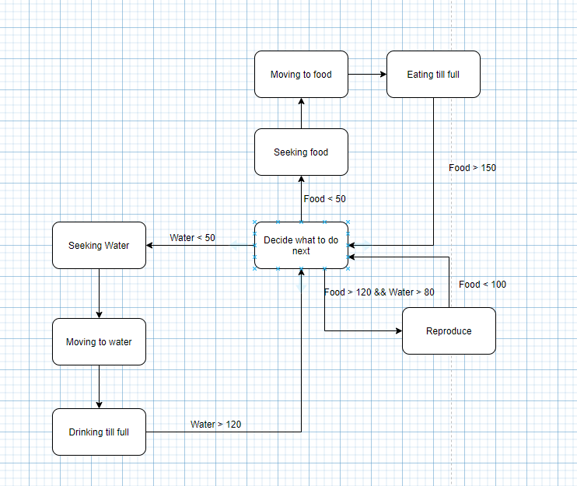

Items through Inheritance:

* Build a working Item script.
* Update your AvatarController script so that players can get (G), drop (D), use (space), eat (E), and wear (W) items. Use the same control scheme that I did: GDspaceEW.
* Build TWO items that the player can Use.
* Build TWO items that the player can Eat.
* Build TWO items that the player can Wear.
* Each item should have a *different* effect.
* *Explain: What are the TWO Useable items? What happens when you use them?*
* *Magic Hammer: When the hammer touches a rabbit, it can create a new rabbit. Each hammer could create 3 new rabbits*
* *Spike: The avatar can hold a spike and pokes the suns to destroy them.*
* *Explain: What are the TWO edible items? What happens when you eat them?*
* *Carrot: The avatar will grow bigger when it eats the carrot.*
* *Apple: The avatar will grow smaller when it eats the carrot.*
* *Explain: What are the TWO wearable items? What happens when you wear them?*
* *SunClothe: the avatar will become shiny when it wears the SunClothe.*
* *Rabbit’s hat: the avatar will have a pair of rabbit’s ear.*
* *Explain: Think about inheritance in computer science. What does the virtual keyword do?*
* *It is used to tell the compiler to perform dynamic linkage or late binding on the function.*
* *Explain: Think about inheritance in computer science. What does the override keyword do?*
* *It shows the reader of the code that "this is a virtual method, that is overriding a virtual method of the base class."*
* *The compiler also knows that it's an override, so it can "check" that you are not altering/adding new methods that you think are overrides.*

# Stretch Goals:

* **Animal animations** (+5 to +10): Create a set of animations for your animal-thing. Upgrade your code so that animations change with the animal’s state. You need not have a different animation for every state. However, each animation should be clearly different.

*Explain: What animations did you create for your animal?*

* **Predator animal species** (+2 to +20): Create a second animal species. Make this one a predator. The predator should chase the other animal. Extra respect if the prey animals react to nearby predators (e.g. run, hide, etc.).

*Explain: Using a state diagram (like the one I sketched in class) show how your predator’s AI works. Draw a box for each state. Label each box with a state name. Draw a line for each transition. Next to each transition line, use words to explain what causes the transition. Paste the state diagram below:*

* **Additional item types** (+1 to +20): Create additional types of items. Be creative, and stretch your abilities. Try to make each item do something very different from the other items. If possible, create items that interact with the environment and each other. Ex: Use a lighter on a tree to create a bonfire. Ex: Use scythe on corn plant to create corn. Ex: Use scythe on sheep to get sheep meat. Ex: Drop corn on campfire to create popcorn. Something else? Your choice. Create some sort of interaction.

*Explain: For each item you create, give a detailed explanation of how it works:*

* **Other** (+1 to +20): Something nifty and interesting on the theme of AI, Inheritance, and useable items. Your choice.

*Explain: What nifty thing did you build?*

*AND What does the player need to do to enjoy your nifty thing?*