Task1 Result:

In this task, I implemented the SLIC based on the algorithm from the paper SLIC Superpixels. Then, I compared my result with the SLIC from the scikit-image.

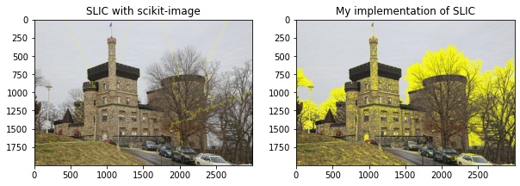

Figure 1: Brandeis Castle (k = 15, m = 10)

Figure 2: Brandeis Shapiro Science Center (k = 20, m = 10)

With the same k and m, my implementation is performing worse when the colors are alike. It fails to recognize the wall of the castle in figure 1 and the grass in figure 2. It did okay on recognizing the shape of the building, sky, and the clouds. Additionally, my implementation takes way longer to do this task, compared to the SLIC form the scikit-image library.

I checked the scikit package. The initialization of the scikit-image is also more complex while I’m simply using the random initialization. Also, the scikit-image uses more advanced packages. Additionally, the package has post-processing which enforces connectivity.

References:

[1] R. Achanta, A. Shaji, K. Smith, A. Lucchi, P. Fua, and S. Süsstrunk, “SLIC Superpixels.” Available: https://www.iro.umontreal.ca/~mignotte/IFT6150/Articles/SLIC_Superpixels.pdf

‌