Image-Derived Three-Dimensional Reconstruction of Cardiac Electrophysiological Mapping Data and Co-Registration to Patient Anatomy for Radiotherapy Treatment Planning
Patent Application (China / CNIPA) — English working version for review
Inventor(s): Xinyu Lu (confirm co-inventors) · Applicant: [to be confirmed]

TECHNICAL FIELD
[0001] The present disclosure relates to medical image and signal processing for radiotherapy treatment planning, and more particularly to reconstructing three-dimensional cardiac electrophysiological mapping information from two-dimensional, view-based images of a mapping-system display and co-registering the reconstructed information to a patient-specific anatomical model derived from medical imaging, for use in radiotherapy treatment planning of a cardiac arrhythmia. The cardiac electrophysiological mapping information may be produced by an invasive electroanatomic mapping (EAM) system or by a non-invasive mapping system such as an electrocardiographic imaging (ECGi) or body-surface potential mapping system. The radiotherapy treatment planning includes, without limitation, planning for external-beam radiosurgery such as stereotactic arrhythmia radiotherapy (STAR), particle or proton radiotherapy, and brachytherapy, and the cardiac arrhythmia includes, without limitation, ventricular tachycardia and atrial fibrillation.

BACKGROUND
[0002] Ventricular tachycardia and atrial fibrillation are both arrhythmias of the heart. To treat such conditions with conventional methods, measurements are taken from the heart's electrophysiology. For example, a catheter records voltage data from a large set of points on the inner surface of the heart. After this recording step, the physician analyzes a map of voltages and defines a target region for an ablation. The ablation step removes (ablates) tissue in appropriate regions of the heart. A catheter can not only record voltages but can also create lesions directly, by delivering thermal energy to a specific target location, whereby arrhythmic activation cycles of the heart can be blocked. This treatment of arrhythmia is often effective, but it has limitations. In particular, appropriate areas for treating arrhythmias may lie on the outer (epicardial) surface of the heart rather than on the inner surface, so that larger lesions than would otherwise be needed must be created, which may cause further damage to a heart that is often already in critical condition.
[0003] Radiosurgical ablation of target points, based on standard radiosurgery equipment, has therefore been proposed to treat ventricular tachycardia and other arrhythmias. In this way, a point anywhere in the body can be targeted non-invasively, and treatment can potentially be shortened and simplified. As part of the process, electroanatomic maps (EAM maps) of the heart or of parts of the heart are generated.
[0004] One type of hardware system for acquiring an EAM map is a catheter system, in which a catheter is introduced into the heart via the blood vessels and used to measure electroanatomical properties at individual points inside the heart; the catheter tip is moved to a series of locations inside the heart to generate a full map of the electroanatomical properties of the patient's heart. Data generated by such an EAM system typically include the three-dimensional location of each measured point, together with a variety of voltage information and other electroanatomical data. Hardware methods that produce EAM mapping data can also acquire the data without placing a catheter into the heart. Such non-invasive methods — for example electrocardiographic imaging (ECGi) and body-surface potential mapping — can produce maps more frequently and at lower cost.
[0005] Both invasive catheter EAM systems and non-invasive mapping systems can produce full or partial temporal maps of the electrophysiological properties of the patient's heart. A temporal map comprises a series of one or more locations together with temporal activation data associated with one or more such locations, where the time steps may be points in a clock system or points referenced to the heart's cycle. The heart cycle can thereby be visualized by the system as a movie, with colors used to represent data values at each location, so that wavefront movies show the flow of activation over the heart and, in some cases, cardiac arrhythmias can be visualized in this way.
[0006] For radiotherapy treatment planning, the electrophysiological mapping information described above must be brought into spatial correspondence with a planning imaging dataset, for example a CT or MRI dataset. Existing approaches to this correspondence problem have significant limitations. A coarse segment decomposition (for example a 17-segment model), applied independently to the mapping data and to the imaging data, yields poor spatial correspondence because the segments are fixed and rectangular while real substrate regions are irregular and curved. Exporting a native three-dimensional geometry dataset from the mapping system for three-dimensional-to-three-dimensional registration depends on export formats that are frequently proprietary, undocumented, vendor-specific, incomplete, or unavailable, and that may change without notice. Manually overlaying a single two-dimensional screenshot of the mapping display onto a single projection of the imaging data cannot recover out-of-plane geometry and is operator-dependent. There is accordingly a need for a method and system that recover usable three-dimensional electrophysiological spatial information directly from the displayed output of a cardiac electrophysiological mapping system — whether invasive or non-invasive — without depending on proprietary native three-dimensional geometry export, and that bring this information into reliable spatial correspondence with patient anatomy for subsequent radiotherapy treatment planning.

References
[R1] Cuculich, P.S. et al., "Noninvasive Cardiac Radiation for Ablation of Ventricular Tachycardia," New England Journal of Medicine, 377, 2325-2336 (2017).
[R2] Robinson, C.G. et al., "Phase I/II Trial of Electrophysiology-Guided Noninvasive Cardiac Radioablation for Ventricular Tachycardia," Circulation, 139, 313-321 (2019).
[R3] Mayinger, M. et al., "Quality assurance process within the RAdiosurgery for VENtricular TAchycardia (RAVENTA) trial for the fusion of electroanatomical mapping and radiotherapy planning imaging data in cardiac radioablation," Physics and Imaging in Radiation Oncology, 25, 52-58 (2023).
[R4] Grehn, M. et al., "STereotactic Arrhythmia Radioablation (STAR): the standardized treatment and outcome platform for stereotactic therapy of re-entrant tachycardia by a multidisciplinary consortium," Europace, 25(4), 1284-1295 (2023).
[R5] Lee, S.L. et al., "The integration of electroanatomic maps into cardiac radioablation target volume definition," Medical Physics (2025).
[R6] US Patent No. US 12,293,820 B2, "Methods and apparatus for determining radioablation treatment," relating to cardiac radioablation treatment planning systems and display of organ substructures and dose information.
[R7] CN Patent No. CN102481457A, ”基于心脏组织表面轮廓的放射外科手术治疗方案设计“

SUMMARY
[0007] Disclosed are a method, a system, and a non-transitory computer-readable medium that reconstruct a three-dimensional cardiac electrophysiological surface model from a plurality of two-dimensional, view-based images of a mapping-system display and co-register the reconstructed model to a patient-specific anatomical model derived from a medical-imaging dataset, so that the reconstructed model and its electrophysiological information are expressed in the coordinate system of the medical-imaging dataset for use in radiotherapy treatment planning.
[0008] In a representative implementation, a plurality of two-dimensional mapping-display images depicting a cardiac chamber surface and its color-coded electrophysiological information from different viewing directions are obtained. From each image, chamber-surface image features and the color-coded electrophysiological information are extracted. For each image, a view-specific spatial representation of the chamber surface is generated; in a lead embodiment a trained neural network produces a per-view depth map, the depth along the viewing axis of the representation being relative or defined only up to an unknown scale and offset. Through a user interface, the view-specific spatial representations are presented together with the obtained images, and operator input is received that (i) sets an absolute axial extent — the total height of the surface along the viewing axis — of each view-specific spatial representation with reference to a further image whose viewing direction is substantially orthogonal to that viewing axis and in which the corresponding extent of the chamber appears as an in-plane dimension, the set axial extent being applied to scale the representation along the viewing axis, and (ii) positions and assembles the axially-scaled view-specific spatial representations into a common coordinate system. A three-dimensional reconstructed surface model is formed from the assembled representations, and the color-coded electrophysiological information is mapped onto the model. The three-dimensional reconstructed surface model is then co-registered, by a rigid transformation, with the patient-specific anatomical model, bringing the reconstructed model and the mapped electrophysiological information into the coordinate system of the medical-imaging dataset.
[0009] The disclosed subject matter solves a technical problem by technical means and achieves a technical effect: it reconstructs a three-dimensional electrophysiological surface model from display images, thereby (i) eliminating dependence on proprietary, undocumented, or unavailable native three-dimensional geometry export; (ii) recovering out-of-plane geometry that single-view overlay cannot; and (iii) enabling three-dimensional-to-three-dimensional co-registration of the electrophysiological information to patient anatomy. These are improvements to a technical process of data and image processing. The absolute scale that monocular per-view estimation leaves undetermined is established by technical means — a user interface that displays a substantially orthogonal view and applies an operator-supplied axial extent to scale and to assemble the representations — so that the operator interaction is received as a parameter and acted upon computationally, rather than constituting a mental act. The method is computer-implemented and is carried out on previously acquired image data; it includes no step performed on a living human or animal body, and it produces a spatial registration result rather than a diagnostic conclusion of disease. Any subsequent target definition and treatment are performed separately, outside the claimed method.
[0010] Numerous embodiments are described. In various embodiments the cardiac electrophysiological mapping system is an invasive electroanatomic mapping (EAM) system or a non-invasive mapping system such as an electrocardiographic imaging (ECGi) or body-surface potential mapping system; the cardiac arrhythmia is ventricular tachycardia or atrial fibrillation; and the cardiac chamber is a ventricle or an atrium. Further embodiments include the standard viewing directions used for acquisition, operator-driven setting and verification of absolute axial extent using orthogonal views, operator-driven assembly of the views, alternative automatic calibration and assembly strategies, alternative view-specific spatial representations, color-to-value decoding, alternative anatomical references, manual rigid co-registration via a user interface, uncertainty quantification, and export of the co-registered model or of the rigid transformation.

BRIEF DESCRIPTION OF THE DRAWINGS
[0011] FIG. 1 is a schematic block diagram of a plurality of modules with which embodiments of the invention may be implemented;
[0012] FIG. 2 is a flowchart illustrating a method of registering cardiac electrophysiological mapping information to a patient anatomical model according to an embodiment;
[0013] FIG. 3 is a diagram of a plurality of mapping-system display images (screenshots) of a cardiac chamber acquired from different viewing directions according to an embodiment;
[0014] FIG. 4 is a diagram of a reconstruction pipeline in which a screenshot is processed into a depth map and thence into a per-view surface representation, and the representations are assembled into a three-dimensional reconstructed surface model, according to an embodiment;
[0015] FIG. 5 is a diagram illustrating the constraining and adjustment of surfaces generated from opposite-view depth maps in accordance with a two-dimensional contour of a substantially orthogonal viewing direction, according to an embodiment; and
[0016] FIG. 6 is a diagram illustrating manual rigid co-registration of the reconstructed surface model with a patient-specific anatomical model according to an embodiment.

DETAILED DESCRIPTION
[0017] In the following description, various embodiments of the invention are described. For purposes of explanation, specific configurations and details are set forth in order to provide a thorough understanding of the embodiments. However, it will also be apparent to one skilled in the art that the invention may be practised without the specific details. Furthermore, well-known features may be omitted or simplified in order not to obscure the embodiment being described. Where a feature is introduced as “in one embodiment,” “optionally,” “preferably,” or “for example,” it is non-essential unless recited in a claim.
[0018] Embodiments herein relate to registering cardiac electrophysiological mapping information to a patient-specific anatomical model for radiotherapy treatment planning; some described embodiments relate to treatment planning for ventricular tachycardia and atrial fibrillation, but the features described herein are not limited to that content. The method ends at the co-registration, its output being a three-dimensional model bearing electrophysiological information and expressed in the coordinate system of the medical-imaging dataset; any subsequent target delineation and treatment planning may be performed by a clinician or by a conventional radiotherapy treatment-planning tool, and does not form part of the method.
[0019] As used herein, a “cardiac electrophysiological mapping system” (also “mapping system”) encompasses both an invasive electroanatomic mapping (EAM) system that acquires data using an intracardiac catheter and a non-invasive mapping system, such as an electrocardiographic imaging (ECGi) system or a body-surface potential mapping system, that reconstructs cardiac electrophysiological information without an intracardiac catheter. References herein to “EAM” are used as a non-limiting example of such a mapping system. “Electrophysiological mapping information” refers to any electrophysiological scalar, categorical, or visual information associated with a cardiac chamber surface, including without limitation bipolar or unipolar voltage, local activation time, scar, border zone, late potentials or LAVA, pace-map similarity, conduction velocity, ablation-lesion sites, and clinician annotations; such information may be displayed statically or as a time-resolved wavefront movie, and is typically presented on the display of the mapping system as colour-coded information on a three-dimensional rendering of the chamber surface.
[0020] The treatment planning described herein may utilise many of the components included in, or derived from, known radiotherapy systems. The radiosurgical system used to deliver treatment may be conventional or modified, and may for example comprise a lightweight linear accelerator mounted to a robotic manipulator, an image-guidance system, and a patient support; the invention is not limited to particular delivery hardware. The imaging system used to acquire the patient anatomy may be a computed-tomography (CT), magnetic-resonance-imaging (MRI), positron-emission-tomography/computed-tomography (PET/CT), four-dimensional computed-tomography, or cone-beam computed-tomography system. In the various examples described herein, the patient-specific anatomical model is segmented from three-dimensional image data acquired by such an imaging system.
[0021] In one embodiment the cardiac arrhythmia is ventricular tachycardia and the cardiac chamber is a ventricle, such as a left ventricle. In another embodiment the cardiac arrhythmia is atrial fibrillation and the cardiac chamber is an atrium, such as a left atrium. A left ventricle is used as an example below and is not limiting; the methods described herein apply to any cardiac chamber or substructure thereof.
[0022] FIG. 1 schematically illustrates a plurality of modules with which embodiments of the invention may be implemented, together constituting a system 100. The modules may be software modules, hardware modules, or a combination thereof. If the modules are software modules, they will be embodied on a computer-readable medium and processed by one or more processors. The system 100 further comprises memory storing instructions and a user interface, the user interface comprising user-interface input devices (such as a keyboard, a mouse or other pointing device, a touch screen, and the like) and user-interface output devices (such as a display subsystem).
[0023] An input module 110 receives the input data used by the system 100. In one embodiment the input module 110 receives: a medical-imaging dataset of the patient, such as a computed-tomography (CT) dataset; a segmentation of the cardiac chamber derived from that dataset, from which the patient-specific anatomical model is obtained; and a plurality of two-dimensional images of a display of a cardiac electrophysiological mapping system, such as screenshots of an invasive electroanatomic mapping (EAM) system or of a non-invasive electrocardiographic imaging (ECGi) system, each depicting the chamber surface and its colour-coded electrophysiological information from a viewing direction. The segmentation may be received as a pre-existing structure set (for example in DICOM format), or may be generated by the input module 110 from the medical-imaging dataset, whether automatically, semi-automatically, or manually. The images may be received as screenshots, exported rendered views, or video frames, and the system 100 need not include the mapping system itself. A depth-map module 120 generates, for each received image, a view-specific spatial representation. In an exemplary implementation, the depth-map module 120 comprises a trained neural network that produces a depth map from the image; such depth-estimation modules are known, and example implementation details are provided below together with the description of FIG. 4.
[0024] A reconstruction module 130 provides a user interface that presents the view-specific spatial representations generated by the depth-map module 120 together with the obtained images; the reconstruction module 130 receives operator input that sets an absolute axial extent of each representation with reference to a substantially orthogonal view, and positions and assembles the axially-scaled representations so as to form a three-dimensional reconstructed surface model. Example implementations of the reconstruction module 130 are set forth below together with the descriptions of FIG. 4 and FIG. 5. A registration module 140 co-registers the three-dimensional reconstructed surface model with a patient-specific anatomical model by a rigid transformation, thereby bringing the model and the electrophysiological information it bears into the coordinate system of the medical-imaging dataset; example implementations are set forth below together with the description of FIG. 6.
[0025] The system 100 may further comprise a feature-extraction module, a value-mapping module, and a review/export interface. The modules need not be at the same physical location, but may be distributed at various locations within a distributed network. The co-registered model and/or the rigid transformation may be output to a conventional radiotherapy treatment-planning tool for subsequent target delineation and planning.
[0026] Referring now to FIG. 2, a flowchart illustrates a method according to an embodiment. The method is computer-implemented and is carried out on previously acquired image data; it includes no step practised on a living human or animal body and produces no diagnostic conclusion of disease. At 201, a plurality of two-dimensional images of a display of a cardiac electrophysiological mapping system are obtained. At 202, chamber-surface features and the colour-coded electrophysiological information are extracted from each image. At 203, a view-specific spatial representation is generated for each image, the depth of which along the viewing axis is relative. At 204, an absolute axial extent along the viewing axis is set with reference to a two-dimensional contour of a substantially orthogonal view, and the representation is scaled accordingly. At 205, the scaled representations are assembled into a common coordinate system. At 206, a three-dimensional reconstructed surface model is formed from the assembled representations. At 207, the colour-coded electrophysiological information is mapped onto the three-dimensional reconstructed surface model. At 208, the three-dimensional reconstructed surface model is co-registered with the patient-specific anatomical model by a rigid transformation. At 209, the co-registered model is output.
[0027] It should be understood that the acts set forth in the flowcharts of the present disclosure are not limited to the order in which they are presented, unless otherwise stated herein. For example, the value mapping of 207 may be performed after 206, or may be performed per view before the representations are assembled. Each of these operations is described in greater detail below.
[0028] FIG. 3 shows a plurality of mapping-system display images of a cardiac chamber. The images may be screenshots, exported rendered views, or video frames, each depicting, from one viewing direction, a chamber surface 301 and its colour-coded electrophysiological information, in which a scar or low-voltage region 302 and other surface features 303 may be visible. The viewing directions may include standard anatomical or radiographic directions such as anterior-posterior (AP) 300, posterior-anterior (PA), right lateral (RL) 340, left lateral (LL) 330, right anterior oblique (RAO), left anterior oblique (LAO), cranial/superior (SUP) 210, and caudal/inferior (INF) 320.
[0029] By radiological convention, the viewing axes of the AP and PA views lie along the anterior-posterior axis, those of the RL and LL views along the left-right axis, and those of the SUP and INF views along the superior-inferior axis; these three axes are substantially mutually orthogonal. Accordingly, the viewing axis of an AP or PA view is substantially orthogonal to that of an RL, LL, SUP, or INF view, and so forth. A set of substantially mutually orthogonal viewing directions (for example AP or PA, RL or LL, and SUP or INF) is generally sufficient to reconstruct a complete surface of the cardiac chamber, whereas a smaller number of viewing directions generally yields an incomplete or partial surface, which may be completed by interpolation, an anatomical prior, or template fitting as described below.
[0030] Optional view metadata (such as orientation, zoom, projection mode, or field of view) may be received where available; where unavailable, the view geometry may be estimated from image content or supplied by the operator via the user interface. Furthermore, each image may be cropped or segmented so as to isolate the chamber surface from background, software-interface elements, menus, text labels, catheter renderings, and lesion tags, so that subsequent feature extraction operates on true chamber-surface pixels rather than overlay artefacts. Where a colour scale, value range, and map type are displayed, these may be detected and stored for later value decoding.
[0031] FIG. 4 shows a reconstruction pipeline according to an embodiment. For each image (screenshot 402), the depth-map module 120 generates a depth map 404 that assigns an estimated depth to visible surface pixels. In an exemplary implementation, the depth map 404 is produced by a trained neural network, which may be trained on synthetic mapping renderings, exported mapping geometries having known surface geometry, simulated chamber surfaces, manually annotated screenshots, or paired image-and-geometry datasets. Alternatively, the view-specific spatial representation may be a partial surface patch, a silhouette-constrained surface, a point cloud, a neural implicit surface representation, a camera-pose-dependent projection, or a deformation of a generic or patient-specific chamber template; the invention is not limited to a particular algorithm for producing the representation.
[0032] Importantly, the depth estimated from a single view is, along the viewing axis of that view, relative or defined only up to an unknown scale and/or offset, rather than true metric depth. This is because monocular depth estimation does not by itself fix the absolute scale along the viewing axis. Accordingly, as described below together with FIG. 5, the extent of the representation along its viewing axis is determined with reference to a substantially orthogonal view.
[0033] Once the representations have been given an absolute axial extent, a reconstruction module 406 (corresponding to the reconstruction module 130 of FIG. 1) positions and assembles the representations into a common coordinate system, thereby forming a three-dimensional reconstructed surface model 408. In overlapping regions, contributions may be averaged or selected by the operator; inconsistent contributions may be removed; and sparsely covered or missing regions may be completed by interpolation, anatomical priors, template fitting, or learned shape completion. The model may be represented as a point cloud, a triangular mesh, an implicit surface, or other three-dimensional geometry.
[0034] In one embodiment the positioning and assembly of the views is performed by the operator via the user interface, optionally assisted by displayed anatomical landmarks, contour overlap, or colour and scar patterns shared between the views. Alternatively, the registration and assembly of the views may be performed automatically using one or more of camera-pose estimation, anatomical-landmark correspondence, contour overlap, surface matching, colour-pattern matching, scar-pattern matching, selected fiducials, or a global multi-view optimisation.
[0035] The colour-coded electrophysiological information is then mapped onto the reconstructed surface model 408. Where a colour scale is available, RGB values may be converted into numerical or categorical electrophysiological values. Where multiple views contribute to the same surface region, the contributing values may be selected or fused based on viewing angle, surface normal, image quality, registration confidence, or physiological consistency; conflicts may be resolved by a defined rule and may be flagged.
[0036] FIG. 5 shows an example of constraining the extent along the viewing axis according to an embodiment. As described above, the scale of a representation generated from a single view is unknown along its viewing axis. To determine that scale, one of the plurality of images is selected whose viewing direction is substantially orthogonal to that viewing axis, that image directly displaying the corresponding extent of the cardiac chamber along the viewing axis as an in-plane dimension.
[0037] In the example shown in FIG. 5, a surface 501 generated from the depth map of a posterior-anterior (PA) view and a surface 502 generated from the depth map of an anterior-posterior (AP) view are projected along a viewing direction substantially orthogonal to their viewing axis (in the present example, a right-lateral (RL) direction), yielding projections 511 and 512 respectively. The image of that substantially orthogonal viewing direction is taken from the plurality of images (namely an RL view screenshot 503, being one of the plurality of two-dimensional images shown in FIG. 3), and a two-dimensional contour 513 is extracted therefrom. The surfaces 501 and 502 are then adjusted in accordance with the two-dimensional contour 513——for example by scaling and/or translating them along the viewing axis until their projections 511 and 512 conform to the two-dimensional contour 513——thereby yielding a reconstruction result 520.
[0038] The contour of the orthogonal view thereby provides a constraint on the extent along the viewing axis, including the total height of the surface along that axis. It should be noted that, in the projections 511 and 512, the horizontal direction corresponds to the depth axis of the AP/PA views, that is, the direction whose scale is unknown and which is to be adjusted, whereas the vertical direction is an in-plane dimension of that orthogonal view and is known.
[0039] Likewise, surfaces generated from right-lateral (RL) and left-lateral (LL) views may be constrained using a caudal/inferior (INF) or cranial/superior (SUP) view, and surfaces generated from caudal/inferior (INF) and cranial/superior (SUP) views may be constrained using an anterior-posterior (AP) or posterior-anterior (PA) view. Multiple reconstruction results obtained from multiple viewing directions may be combined, for example by weighted averaging, to form a final three-dimensional reconstruction result.
[0040] In one embodiment the adjustment is performed by the operator via the user interface, which presents, alongside the representation being adjusted, the substantially orthogonal view and its two-dimensional contour, together with a control (such as a slider or a numerical input) by which the operator adjusts the extent or scale of the representation along its viewing axis until its projection conforms to the two-dimensional contour; the received value is then applied by the system to scale the representation along the viewing axis. In this manner the operator input is received as a parameter and acted upon computationally. Alternatively, the adjustment may be performed automatically, for example by minimising a deviation between the projection and the two-dimensional contour. The per-view representations are thereby brought into mutual metric consistency, reducing scale and offset errors in the reconstructed three-dimensional model.
[0041] FIG. 6 shows a co-registration according to an embodiment. A segmented anatomical model 602 of the cardiac chamber is obtained from a medical-imaging dataset. For a ventricle the model may include the endocardium, epicardium, myocardial wall, cavity, valves, and papillary muscles; for an atrium it may include the atrial wall, pulmonary-vein ostia, and appendage. Adding a contrast agent while acquiring the CT or MRI image can enhance the demarcation between tissue and blood, thereby allowing the surface to be defined more precisely.
[0042] The three-dimensional reconstructed surface model 500 is co-registered with the segmented anatomical model 502 by a rigid transformation, thereby bringing the reconstructed model and the electrophysiological information mapped thereon into the coordinate system of the medical-imaging dataset, yielding a co-registered model 506. In one embodiment the rigid co-registration is performed manually by a user via a user interface that allows the reconstructed surface model to be translated along, and rotated about, three mutually orthogonal axes, that is, through six degrees of freedom 504, until it is aligned with the anatomical model; the manual alignment may be initialised or assisted by corresponding anatomical landmarks or by surface matching. Alternatively, the rigid transformation may be determined automatically from corresponding anatomical landmarks identified on the two models, or by surface matching.
[0043] It should be noted that this co-registration is a distinct operation from the axial-extent setting and view assembly described in connection with FIG. 5, which act upon the individual view-specific representations, whereas the present co-registration acts upon the already-reconstructed surface model. The rigid transformation preserves the shape and scale of the reconstructed model.
[0044] Because the three-dimensional information is reconstructed from view-based images, a confidence or uncertainty score may be computed for one or more reconstructed surface elements, including one or more of: image-segmentation confidence, per-view depth-estimation uncertainty, axial-extent-setting uncertainty, view-assembly uncertainty, colour-decoding uncertainty, and co-registration uncertainty. The uncertainty information may be displayed, used to mark low-confidence regions, or used to prioritise manual review.
[0045] The co-registered reconstructed model and/or the rigid transformation may be exported to a radiotherapy planning or research environment in a format such as DICOM, STL, OBJ, VTK, PLY, or NIfTI. Once the model has been output, a clinician or a conventional radiotherapy treatment-planning tool may delineate a radiotherapy target and generate a treatment plan with reference to the electrophysiological information borne thereon (such as scar, border zone, or late-potential regions); that subsequent operation does not form part of the method described herein.
[0046] Other variations are within the spirit of the present invention. In a depth-map embodiment, each screenshot is processed by a trained model to estimate a depth map; the depth maps are lifted into per-view representations whose axial extents are set by the operator against orthogonal views, and the operator assembles the calibrated representations into a reconstructed model which is then rigidly co-registered with the anatomical model. In a template-deformation embodiment, a generic or patient-specific chamber template is instead deformed so that its projections match the views, and the electrophysiological colours are projected onto it. In a non-invasive embodiment, the display images are produced by a non-invasive mapping system such as an ECGi or body-surface potential mapping system. In a further embodiment, the operator-driven axial-extent setting and/or the view assembly is replaced by an automatic counterpart. Features of the embodiments may be combined in any combination.
[0047] The use of the terms “a,” “an,” and “the” and similar referents in the context of describing the invention (especially in the context of the following claims) is to be construed to cover both the singular and the plural, unless otherwise indicated herein or clearly contradicted by context. The terms “comprising,” “having,” and “including” are to be construed as open-ended terms (i.e., meaning “including, but not limited to”) unless otherwise noted. All methods described herein can be performed in any suitable order unless otherwise indicated herein or otherwise clearly contradicted by context. The use of any and all examples, or exemplary language (e.g., “such as”) provided herein, is intended merely to better illuminate embodiments of the invention and does not pose a limitation on the scope of the invention unless otherwise claimed. No language in the specification should be construed as indicating any non-claimed element as essential to the practice of the invention.
[0048] Preferred embodiments of this invention are described herein, including the best mode known to the inventors for carrying out the invention. Variations of those preferred embodiments may become apparent to those of ordinary skill in the art upon reading the foregoing description. Accordingly, this invention includes all modifications and equivalents of the subject matter recited in the claims appended hereto as permitted by applicable law. Moreover, any combination of the above-described elements in all possible variations thereof is encompassed by the invention unless otherwise indicated herein or otherwise clearly contradicted by context. The description supports each term recited in the claims below.

CLAIMS
What is claimed is:
1. A computer-implemented method for preparing cardiac electrophysiological information for radiotherapy planning of a cardiac arrhythmia, the method comprising:
obtaining electrophysiological mapping information of a heart or a cardiac chamber;
obtaining a patient-specific anatomical model from at least one medical imaging data set;
establishing a spatial correspondence between the electrophysiological mapping information and the patient-specific anatomical model;
generating location information representing at least one electrophysiologically relevant cardiac region in a coordinate system associated with the medical imaging data set; and
exporting or storing the location information in a format readable by a radiotherapy or radiosurgery planning system.
2. The method of claim 1, wherein establishing the spatial correspondence comprises:
obtaining a plurality of two-dimensional view-based images displayed by a cardiac electrophysiological mapping system, the images depicting a cardiac chamber surface from different viewing directions and carrying color-coded electrophysiological information;
extracting cardiac chamber surface image features and the color-coded electrophysiological information from the images;
generating, for each image, a view-specific spatial representation of the cardiac chamber surface; assembling the view-specific spatial representations into a three-dimensional reconstructed surface model;
mapping the electrophysiological information onto the three-dimensional reconstructed surface model;
and registering the three-dimensional reconstructed surface model to the patient-specific anatomical model.
3. The method of claim 2, wherein each view-specific spatial representation comprises at least one of: a depth map, a partial surface patch, a contour-constrained surface, a point cloud, a neural implicit surface representation, or a deformed cardiac chamber surface template.
4. The method of claim 2 or 3, wherein generating the view-specific spatial representation comprises applying a trained machine-learning model to at least one of the two-dimensional view-based images to estimate depth or surface geometry of the visible cardiac chamber surface.
5. The method of any one of claims 2 to 4, wherein an absolute axial extent of at least one view-specific spatial representation is determined by reference to another image whose viewing direction is substantially orthogonal to the viewing direction of said view-specific spatial representation.
6. The method of claim 5, wherein the absolute axial extent is determined by operator input through a user interface, and wherein the determined axial extent is applied to scale the corresponding view-specific spatial representation along its viewing axis.
7. The method of any one of claims 1 to 6, wherein establishing the spatial correspondence comprises registering electrophysiological mapping information to morphologic image information using one or more contours, cross-sections, landmarks, chamber boundaries, surface features, or user-defined reference points visualized on a computer display.
8. The method of any one of claims 1 to 7, wherein the medical imaging data set comprises at least one of:
a planning computed tomography data set, a contrast-enhanced computed tomography data set, a magnetic resonance imaging data set, a positron emission tomography data set, a single-photon emission computed tomography data set, a four-dimensional computed tomography data set, or a cone-beam computed tomography data set.
9. The method of any one of claims 1 to 8, wherein resolution information, position information, contour information, or reference-marker information from a plurality of medical or electrophysiological data sets is combined to infer a position of a cardiac structure or electrophysiologically relevant region that is not clearly visible in at least one of the data sets.
10. The method of any one of claims 1 to 9, wherein the exported or stored location information is provided in a DICOM-compatible format, a DICOM RT format, or a format convertible into a radiotherapy structure set, dose-planning object, contour object, point set, surface mesh, or treatment-planning reference object.

ABSTRACT
A method, system, and computer-readable medium reconstruct three-dimensional cardiac electrophysiological mapping information from a plurality of two-dimensional, view-based images of a mapping-system display and co-register the reconstruction to patient anatomy for radiotherapy treatment planning. The mapping system may be an invasive electroanatomic mapping (EAM) system or a non-invasive mapping system such as an electrocardiographic imaging (ECGi) or body-surface potential mapping system. Chamber-surface and color-coded electrophysiological features are extracted from each view; a view-specific spatial representation, in a lead embodiment a neural-network-generated depth map, is produced per view, the axial depth being relative. Through a user interface, an operator sets the absolute axial extent (height) of each representation with reference to a substantially orthogonal view in which that extent appears as an in-plane dimension, and assembles the calibrated representations into a three-dimensional reconstructed surface model onto which the electrophysiological information is mapped; the reconstructed model is co-registered to a patient-specific anatomical model by a rigid transformation. The approach recovers usable three-dimensional electrophysiological geometry from display images without relying on proprietary native geometry export.

DRAWINGS

Schematic block diagram of a system according to an embodiment.
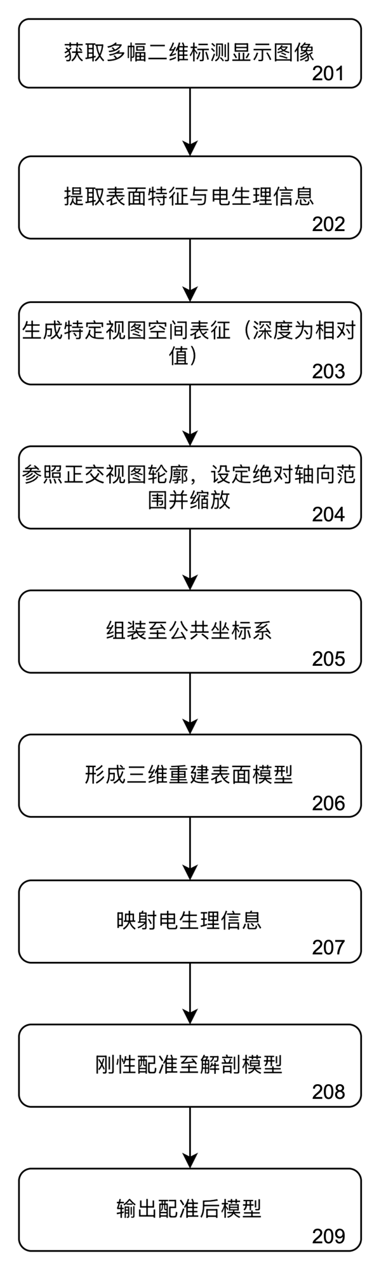
Flowchart of a method according to an embodiment.

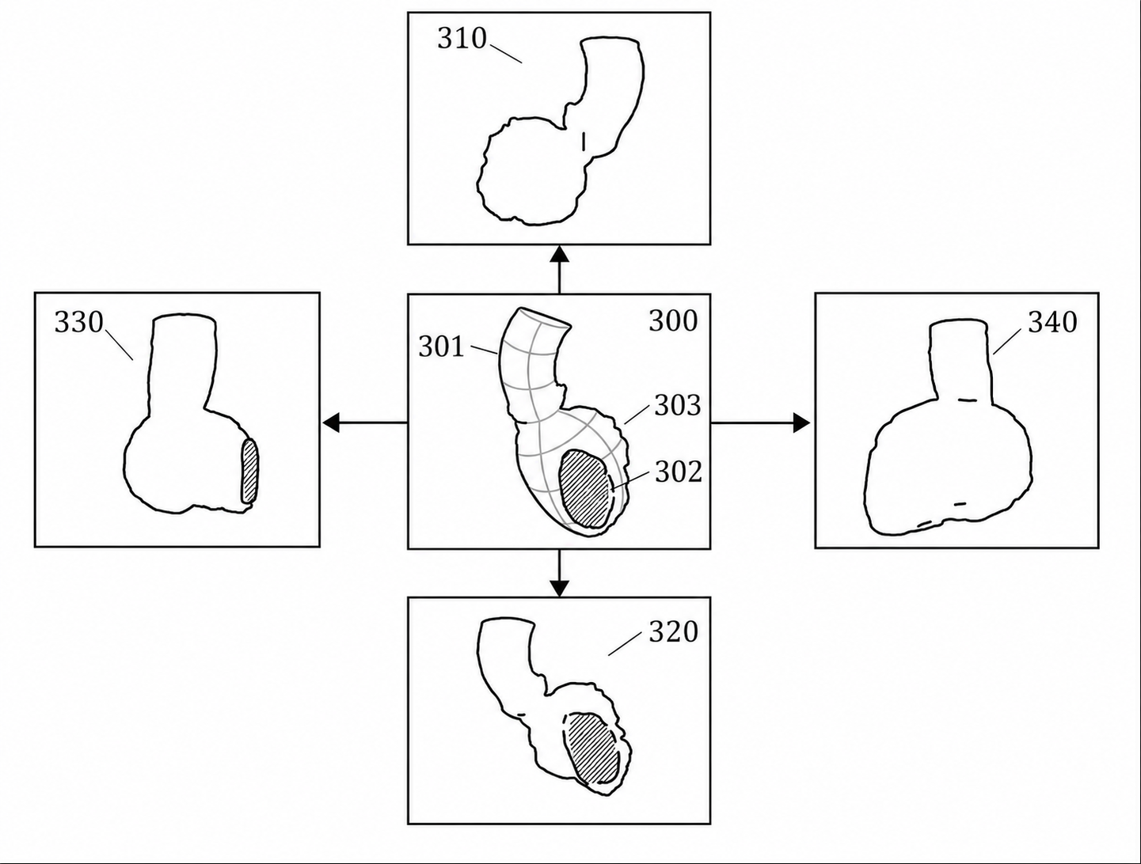
Mapping-system display images (screenshots) of a cardiac chamber from different viewing directions.
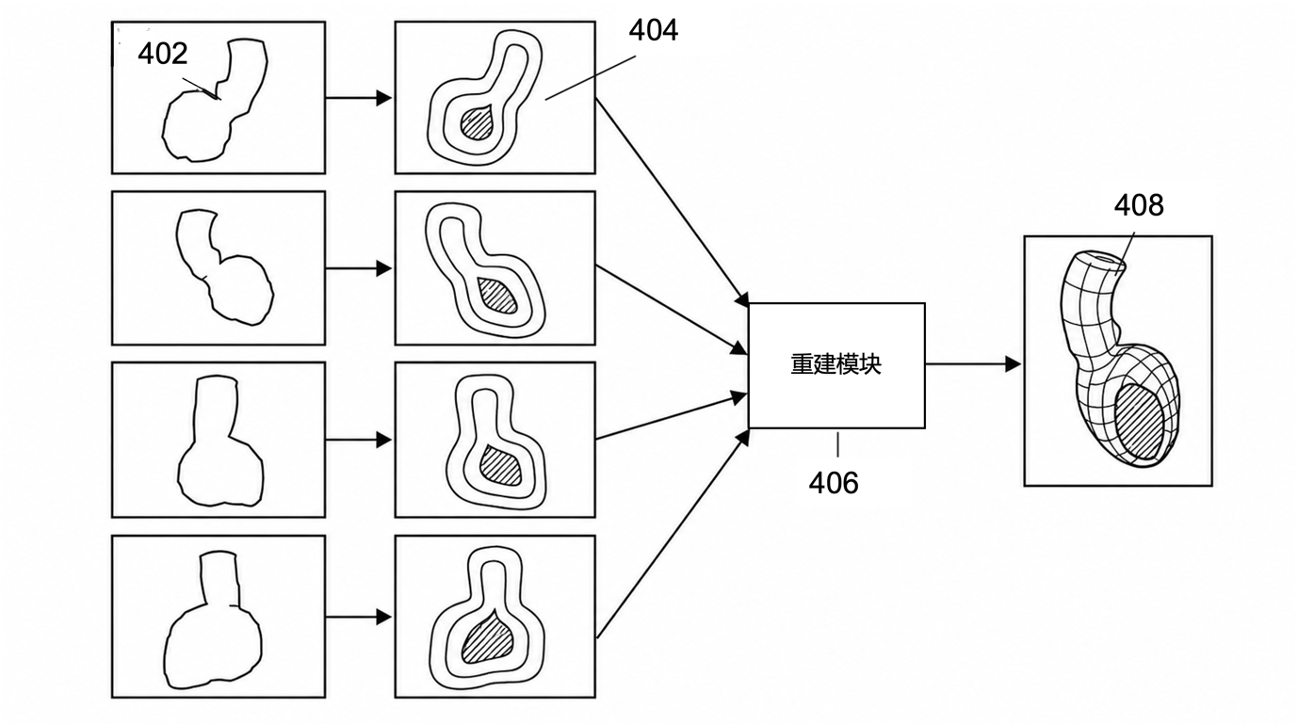
Reconstruction pipeline: screenshot to depth map to per-view surface representation to assembled three-dimensional reconstructed surface model.
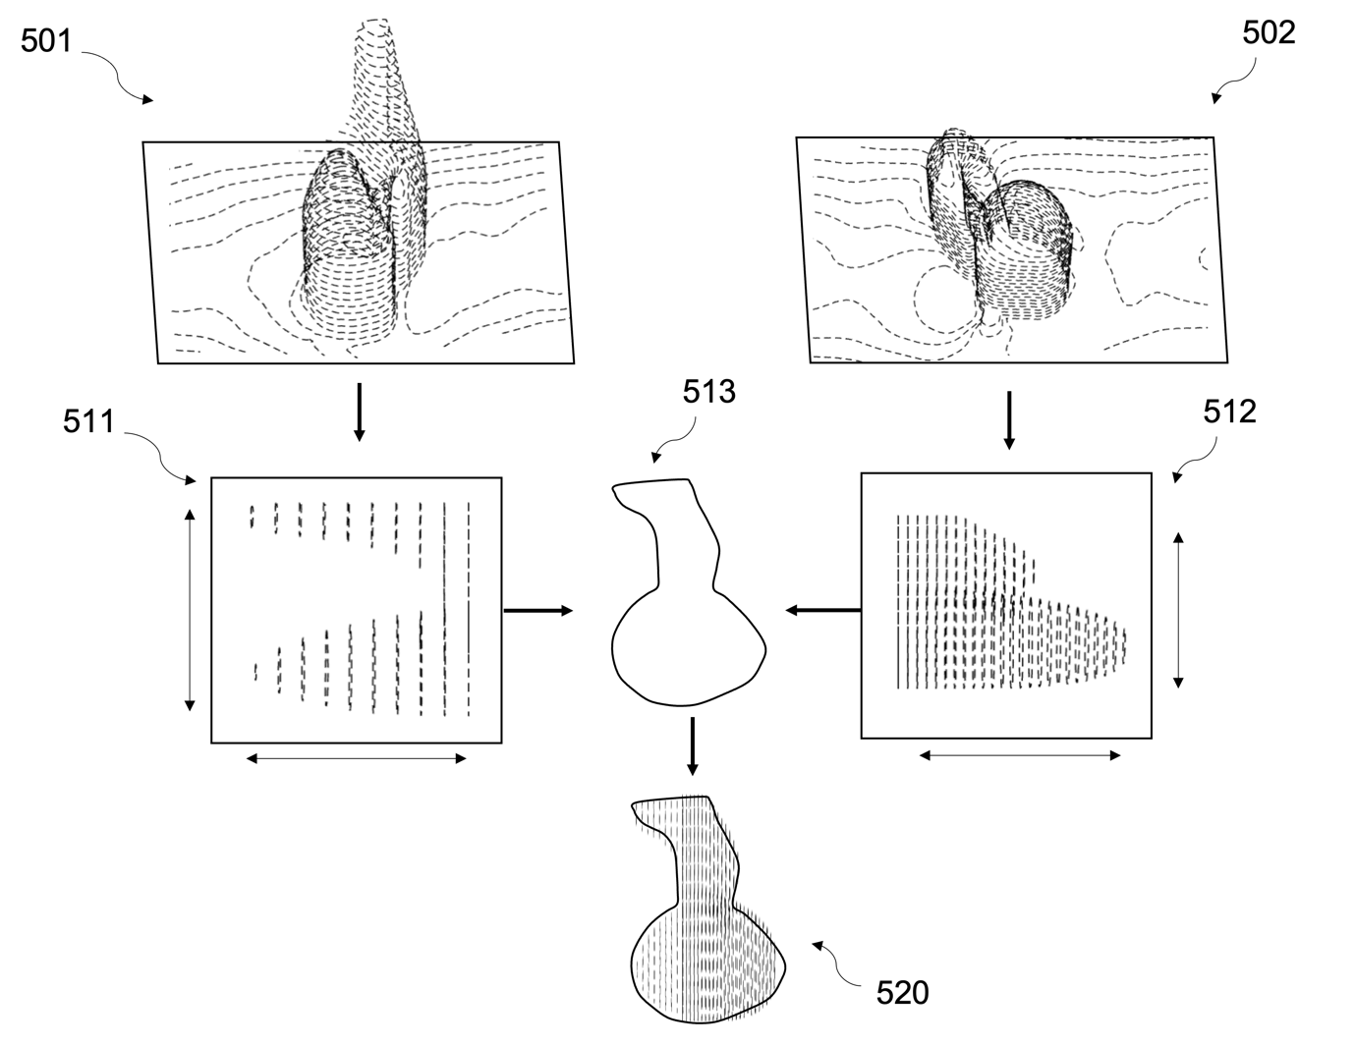
Reconstruction module: surfaces from opposite-view depth maps constrained and adjusted by the two-dimensional contour of a substantially orthogonal viewing direction.
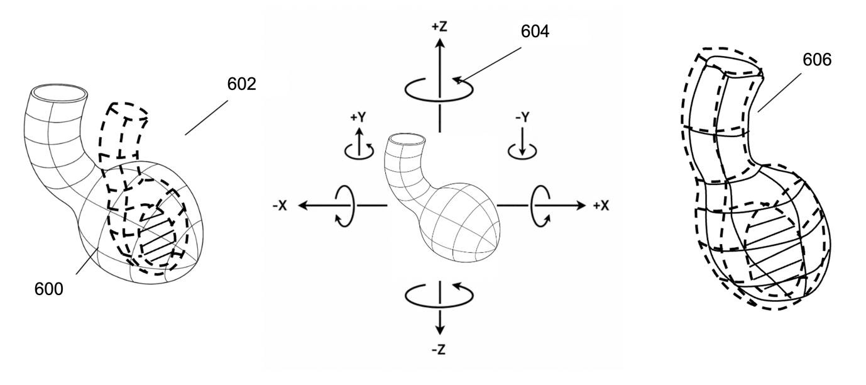
Manual rigid co-registration of the reconstructed model to the patient anatomical model.

