Candidate Conductivity Model Selection for Ablation Target Determination
Inventor: Xinyu Lu
FIELD OF INVENTION
[1] The present invention relates to systems and methods for computer-assisted planning of cardiac catheter ablation. More particularly, the invention relates to the generation, from three-dimensional medical image data, of a plurality of candidate patient-specific cardiac electrophysiology models which differ in the relationship assigning electrical conductivity to an image-derived tissue characteristic, to the computation of simulated baseline activation and simulated stimulation responses for those candidate models, to the selection of a candidate model using activation data acquired from the subject during a cardiac rhythm other than the tachycardia, and to the derivation of ablation target data from the isthmus of one or more reentrant activations determined within the selected model. The description refers to ventricular tachycardia by way of principal example; the invention is not limited to that arrhythmia.
BACKGROUND OF THE DISCLOSURE
[2] Ventricular tachycardia (VT) is a cardiac arrhythmia that can be sustained by reentrant propagation through surviving myocardial pathways within or adjacent to diseased myocardium. Catheter ablation is used to interrupt such pathways by creating lesions at selected cardiac locations. In clinical electrophysiology procedures, electro-anatomical mapping (EAM) systems acquire spatially localized electrical information from the endocardial or epicardial surface of the heart, including bipolar voltage, unipolar voltage, local activation time, conduction velocity, electrogram morphology, late potentials, fractionated potentials and decrement-evoked potentials.
[3] The reference technique for localizing the critical isthmus of a reentrant circuit is activation mapping and entrainment mapping performed while the tachycardia is running. This requires that the tachycardia be inducible and that it be haemodynamically tolerated for long enough to complete the map. In a substantial proportion of patients neither condition is satisfied: the clinical tachycardia is not reproducibly inducible, is polymorphic, or degenerates or causes haemodynamic collapse within seconds, so that it must be terminated before the circuit has been characterized.
[4] For such patients, substrate-based strategies are used instead. These strategies target abnormal electrograms recorded during sinus or paced rhythm, such as late potentials, local abnormal ventricular activity, fractionated potentials, decrement-evoked potentials, isochronal crowding and deceleration zones. Substrate criteria identify tissue that is abnormal, but they are not specific to the isthmus of the clinical circuit: abnormal electrograms are typically distributed over an area much larger than the isthmus, and only a small fraction of the annotated sites is critical to the reentry. The practical consequence is extensive substrate homogenization, with correspondingly large lesion volumes, long procedure times and residual recurrence.
[5] Separately, computed tomography and magnetic resonance imaging provide three-dimensional anatomical and tissue information. Contrast-enhanced CT (CTA), delayed-enhancement or late-enhancement CT, magnetic resonance imaging and late-gadolinium-enhancement MRI can be processed to identify ventricular anatomy, myocardial wall thickness and wall thinning, dense scar, border-zone tissue, fibrosis, intramyocardial fat infiltration, calcification, motion and strain. In ischaemic cardiomyopathy in particular, regional wall thinning is a robust and directly measurable marker of the infarcted region, and the residual thickness of the surviving wall within the thinned region is related to the presence of a surviving conducting corridor. Image information of this kind covers the full myocardial wall, including intramural and epicardial tissue that contact mapping does not sample.
[6] Computational electrophysiology models can assign electrical properties to image-derived myocardial tissue and simulate propagation for one or more pacing sites and stimulation protocols. A limitation of purely pre-procedural simulation is that the relationship between an image-derived tissue characteristic and the corresponding electrophysiological model parameter is not known for the individual patient. Where literature values are used, the resulting model is anatomically patient-specific while remaining only generically patient-specific with respect to electrical function. A first patient and a second patient can exhibit closely similar scar morphology in CT or MRI while exhibiting substantially different activation delay, functional block and circuit location.
[7] It has been proposed to reduce this uncertainty by calibrating a computational model against electrophysiological data acquired during the procedure. In known approaches of this kind the substrate description is derived from the endocardial bipolar voltage map itself, the effect of the substrate is expressed through a single scalar impairment field, the conductivity is modulated by a single free scalar parameter which is adjusted until simulated electrograms or simulated activation times approximate the measured ones, and the myocardial wall thickness is extrapolated from the same voltage field by a rule rather than measured.
[8] Such approaches remain limited in several respects. Because the substrate description is derived from contact voltage recordings, it is confined to the sampled surface and cannot represent intramural or epicardial substrate, and it cannot distinguish tissue classes which are electrically distinct but which produce similar low bipolar voltage, in particular intramyocardial fat infiltration as opposed to dense fibrous scar. Reducing the tissue-to-conductivity relationship to a single scalar degree of freedom does not permit the several tissue classes to be assigned mutually independent conductivity relationships, which is precisely what determines whether a slow-conducting corridor exists within the diseased region. And because each candidate value requires a complete propagation simulation, the calibration is performed after the procedure, so that its result is not available while the catheter is in the patient.
[9] A further deficiency concerns the multiplicity of circuits. One and the same substrate commonly supports more than one reentrant circuit, and which circuit is elicited depends on the site and on the timing of the stimulation applied. In the clinical procedure this is the reason for programmed stimulation from several sites with several protocols, which is precisely what cannot be carried out where the tachycardia is not tolerated. A planning method that evaluates only a single stimulation condition per model therefore reports at best one of the circuits that the substrate is capable of sustaining, and gives the operator no indication of the others.
[10] Accordingly, there is a need for a system which derives several mutually independent candidate relationships between an image-derived tissue characteristic and electrical conductivity, which evaluates those candidate relationships by simulation so that the evaluation is available intra-procedurally, which selects among them using activation data of a type that can be acquired without inducing the tachycardia, and which then reports as an ablation target the isthmus of one or more reentrant activations obtained by simulated stimulation from a plurality of stimulation configurations within the selected candidate, rather than an undifferentiated region of abnormal substrate.
[11] There is a further need for a system which does not presuppose that the selection is unique, but which quantifies the residual ambiguity and expresses it in the reported target region, and for a system which allows the resulting target regions to be annotated as ablation points and transferred into the mapping system that the operator is already using.
References cited: patent documents and other publications to be completed by patent counsel. The characterization of the closest known art in paragraphs [7] to [9] is to be reconciled with the final citation list before filing.
SUMMARY OF THE DISCLOSURE
[12] In accordance with the present invention, a computer-implemented method is provided for generating cardiac ablation target data. Three-dimensional medical image data of a heart of a subject are processed to determine a myocardial volume and at least one spatially resolved image-derived tissue characteristic of that volume.
[13] A plurality of candidate parameter sets is generated. Each candidate parameter set comprises at least one conductivity assignment function which maps the image-derived tissue characteristic to a local electrical conductivity, and the candidate parameter sets differ from one another in at least one parameter of that function, for example in a threshold or in a transition slope. The plurality of candidate parameter sets thus represents, in an explicit and enumerable form, the uncertainty in the relationship between what is visible in the image and how the tissue conducts.
[14] For each candidate parameter set, a simulated baseline activation sequence of the myocardial volume is computed, together with a plurality of simulated stimulation responses obtained for a plurality of virtual stimulation configurations. The plurality of virtual stimulation configurations is defined in advance of the computation and comprises different virtual pacing locations and different virtual stimulation protocols, the purpose of that plurality being to elicit, within one and the same candidate parameter set, the several distinct reentrant circuits that the substrate is capable of sustaining. For each simulated stimulation response in which a self-sustaining reentrant activation is established, the location of the isthmus region of that reentrant activation is determined. In a preferred embodiment these computations are performed before the procedure and stored as a simulation library, so that the intra-procedural operations reduce to a comparison against stored results.
[15] Measured activation data of the subject are received, acquired during a cardiac rhythm other than the reentrant tachycardia, and are brought into spatial correspondence with the myocardial volume. At least one candidate parameter set is selected on the basis of a comparison between the measured activation data and the simulated baseline activation sequence of each candidate parameter set.
[16] Ablation target data are then generated which identify at least one target region determined from the isthmus region of the selected candidate parameter set. Where the selected candidate parameter set has produced several distinct reentrant activations from different virtual stimulation configurations, the ablation target data can identify a corresponding plurality of target regions. The reported target is therefore the isthmus of a reentrant activation, and not merely a region of abnormal substrate, although the tachycardia has not been induced in the subject.
[17] In a preferred embodiment, at least three tissue classes are segmented from the image data, comprising scar tissue, intramyocardial fat tissue and a region of reduced myocardial wall thickness, and each tissue class is assigned its own conductivity assignment function. The inclusion of a class defined by reduced wall thickness is of particular relevance in ischaemic cardiomyopathy, in which regional thinning is the most directly measurable image correlate of the infarct and in which the residual thickness within the thinned region governs whether a surviving corridor is present.
[18] In a further embodiment, a plurality of candidate parameter sets is retained and weighted according to the comparison, and a spatially resolved isthmus probability map is generated from their respective isthmus regions, so that the residual ambiguity of the selection is made explicit to the operator.
[19] In a further embodiment, the target regions are annotated as ablation points in an operator interface and the annotated points are converted into a format accepted by an electro-anatomical mapping system or a catheter navigation system and transferred to that system, so that the operator sees the planned points in the same display in which the catheter is being navigated. The method does not comprise any repeated intra-procedural simulation.
[20] The invention further provides a corresponding system and a corresponding non-transitory computer-readable medium. The method operates on image data and on previously acquired measurement data and outputs planning data; it does not comprise the delivery of ablation energy to the subject, which is performed separately by the clinician.
DETAILED DESCRIPTION OF THE DISCLOSURE
[21] Referring to Figure 1, an overview of one embodiment is shown. In a pre-procedural phase, three-dimensional image data are segmented, a plurality of candidate parameter sets is generated, and for each candidate parameter set a simulated baseline activation sequence and a set of simulated stimulation responses are computed and stored in a simulation library. In an intra-procedural phase, measured activation data acquired in the absence of the tachycardia are registered to the myocardial volume and compared with the stored simulated baseline activation sequences; one or more candidate parameter sets are selected; and the isthmus regions stored for the selected candidate or candidates are converted into ablation target data, annotated as ablation points and transferred to the mapping system. No simulation is performed during the procedure.
Image data and tissue segmentation
[22] The medical image data can comprise CT, contrast-enhanced CT (CTA), delayed-enhancement or late-enhancement CT, MRI, late-gadolinium-enhancement MRI, T1 mapping, PET, SPECT, or combinations thereof. Image registration can be used to combine anatomical and tissue information from several data sets, for example a CTA data set providing wall geometry and fat, and a late-enhancement data set providing scar and border zone. The image data can be acquired before the catheter procedure or during a prior intervention.
[23] The myocardial volume is delimited by segmented endocardial and epicardial surfaces and can be represented as a tetrahedral or hexahedral finite-element mesh, a voxel grid, a surface mesh carrying thickness information, or another computational representation suitable for electrophysiological simulation. The anatomical model can further include the ventricular chambers, valve planes, papillary muscles, coronary arteries and cardiac veins.
[24] For the myocardial volume, a spatially resolved value of at least one continuous image-derived tissue characteristic is determined. This characteristic can be a normalized image signal intensity, a signal-intensity z-score relative to remote myocardium, a scar probability, a border-zone probability, a local tissue density, a fat fraction, a local wall thickness, a strain value, or a combination thereof. The characteristic is preferably retained as a continuous field rather than being reduced to a binary label, so that the conductivity assignment functions described below can act on a graded quantity.
[25] Referring to Figure 2, in a preferred embodiment at least three tissue classes are segmented within the myocardial volume. A first class is scar tissue. A second class is intramyocardial fat tissue. A third class is a region of reduced myocardial wall thickness. A class of viable myocardium and a class of border-zone tissue lying between viable myocardium and dense scar can additionally be segmented. Segmentation can be performed by thresholding of normalized image intensity, by reference to remote normal myocardium, by clustering, by atlas-based methods, by trained segmentation networks, or by combinations thereof.
[26] A local myocardial wall thickness is determined from the image data, for example as the distance between the segmented endocardial and epicardial surfaces along a transmural direction obtained from a Laplace field, and the region of reduced myocardial wall thickness is defined as the set of locations at which the local wall thickness falls below a predetermined value, below a predetermined fraction of the thickness of remote myocardium, or below a value derived from the distribution of thickness over the ventricle. The wall thickness used in the model is therefore measured from the image and is not extrapolated from an electrical measurement.
[27] The inclusion of the reduced-wall-thickness class addresses the ischaemic case specifically. After myocardial infarction the affected wall thins, and this thinning is directly and reliably measurable on CT even where the delayed-enhancement contrast between scar and viable tissue is weak. Furthermore, the residual thickness within the thinned region carries information that the intensity-based classes do not: a residual thickness of the order of one to a few millimetres is compatible with a surviving conducting corridor, whereas a thickness approaching zero is not. The candidate parameter sets can accordingly assign to the reduced-wall-thickness class a conductivity assignment function which is a function of the residual thickness itself.
[28] Intramyocardial fat is distinguished from dense fibrous scar on the basis of its image characteristics, for example negative Hounsfield values on CT or a fat-selective magnetic resonance contrast. This distinction is of consequence because dense fibrous scar and fat infiltration can both present as low bipolar voltage on a contact map while differing in their effect on propagation, so that a substrate description derived from voltage alone cannot separate them, whereas a description derived from the image can.
[29] A local fiber orientation can be assigned by a rule-based method in which the helix angle varies transmurally between predetermined endocardial and epicardial values, or can be taken from diffusion-tensor data where available, and is used to render the conductivity anisotropic.
Candidate parameter sets and conductivity assignment functions
[30] A plurality of candidate parameter sets is generated. Each candidate parameter set comprises at least one conductivity assignment function which maps the value of the image-derived tissue characteristic to a local electrical conductivity. Where several tissue classes have been segmented, each candidate parameter set preferably comprises a separate conductivity assignment function for each class.
[31] Referring to Figure 3, in one embodiment each conductivity assignment function is a monotonically decreasing function of the normalized image signal intensity, defined by a lower intensity threshold T1 below which the conductivity takes a first, viable-myocardium value, an upper intensity threshold T2 above which the conductivity takes a second, dense-scar value, and a transition slope describing the behaviour of the function between the two thresholds. The transition segment corresponds to the border zone. The functions may equivalently be expressed in piecewise-linear, sigmoidal or exponential form; the invention is not limited to a particular functional form, and a function of the residual wall thickness or of a fat fraction can be used for the corresponding class.
[32] The candidate parameter sets differ from one another in at least one parameter of at least one of the conductivity assignment functions. For example, a first candidate parameter set can specify a steep transition slope, so that the border zone forms a narrow rim of intermediate conductivity, while a second candidate parameter set specifies a shallow transition slope, so that a broad corridor of slowly conducting tissue extends into the diseased region. A third candidate parameter set can retain the transition slope of the first but shift the upper intensity threshold, thereby changing the extent of tissue treated as electrically inexcitable. Candidate parameter sets can additionally differ in the anisotropy ratio, in the excitability, in the refractory period, in the action-potential duration, or in restitution parameters assigned to a tissue class.
[33] The conductivity assignment function of the intramyocardial fat class and that of the reduced-wall-thickness class are independent of the function of the scar class. In one embodiment the fat class is assigned a substantially non-conductive value or a propagation boundary while the dense scar class retains a small residual conductivity permitting slow propagation, or the converse; the candidate parameter sets can differ in which of these assignments is made. Because the classes are parameterized independently, the plurality of candidate parameter sets spans qualitatively different substrate topologies rather than a single family scaled by one factor.
[34] The candidate parameter sets can be generated by enumerating predetermined combinations of function parameters, by sampling the parameters from predetermined ranges, by Latin-hypercube or quasi-random sampling, by sampling weighted according to an image-derived confidence, or by a trained generative model. The number of candidate parameter sets is chosen with regard to the computation available; values in the range of tens to hundreds are suitable.
[35] For each candidate parameter set, a conductivity tensor is assembled from the local fiber orientation and from the conductivity values returned by the conductivity assignment functions, and is applied within the myocardial volume delimited by the measured local wall thickness. Propagation can be simulated by a monodomain or bidomain formulation coupled to a cell model, by an eikonal formulation, by a reaction-diffusion formulation with a phenomenological cell model, or by a trained surrogate of any of these. The invention is not limited to a particular solver or cell model.
Simulated baseline activation, simulated stimulation and the simulation library
[36] For each candidate parameter set, a simulated baseline activation sequence of the myocardial volume is computed. The baseline activation corresponds to a cardiac rhythm other than the reentrant tachycardia, typically sinus rhythm. Physiological activation can be reproduced by stimulating at a plurality of endocardial sites representing the terminations of the conduction system, by coupling an explicit or rule-based Purkinje network, or by prescribing an endocardial activation profile. Where the measured data are to be acquired under pacing, the corresponding pacing site is used as the baseline stimulus. The same stimulation description is used for every candidate parameter set, so that differences between the resulting simulated baseline activation sequences are attributable to the candidate parameter sets alone.
[37] For each candidate parameter set, a plurality of simulated stimulation responses is further computed for a plurality of virtual stimulation configurations, each configuration being defined by a virtual pacing location and a virtual stimulation protocol. The plurality of virtual stimulation configurations is fixed in advance of the computation, and is chosen so as to span the stimulation conditions under which distinct reentrant circuits are expected to arise, in the same way that programmed stimulation from several sites and with several protocols is used clinically for that purpose. Virtual pacing locations can include the right ventricular apex, the right ventricular outflow tract, one or more left ventricular endocardial sites, one or more epicardial sites, and sites selected automatically at the border of the segmented diseased region. Virtual stimulation protocols can include drive trains with one, two or three extrastimuli, S1-S2 and S1-S2-S3 protocols with decrementing coupling intervals, and burst protocols. All such stimulation is applied to the computational model and not to the subject.
[38] For each simulated stimulation response it is determined whether a self-sustaining reentrant activation is established, for example by detecting that activation persists for longer than a predetermined number of cycles after the last applied stimulus, or by detecting and tracking a phase singularity or a filament. Where a self-sustaining reentrant activation is established, its cycle length is recorded and the location of the isthmus region is determined.
[39] The isthmus region can be determined as a corridor of tissue that is traversed by the reentrant wavefront in each cycle, that is bounded on both sides by tissue which is inexcitable or which remains refractory during the passage of the wavefront, and whose cross-section is smaller than a predetermined value. The entrance and the exit of the corridor can be determined from the activation sequence, and the corridor can be extracted as the connected path of tissue joining them along which the activation time increases monotonically within a single cycle. Where several reentrant activations are obtained for one candidate parameter set from different virtual stimulation configurations, each is stored with its isthmus region. This is the intended outcome rather than an incidental one: a given substrate commonly supports several circuits, and it is the plurality of virtual stimulation configurations that brings them out. Two reentrant activations are treated as distinct where their isthmus regions do not substantially overlap, where their exit sites differ, or where their cycle lengths differ by more than a predetermined amount; reentrant activations that are not distinct in this sense can be merged so that the same circuit found from several stimulation configurations is reported once.
[40] Referring to Figure 4, the simulated baseline activation sequences, the determination of whether a reentrant activation was established, the cycle lengths and the isthmus regions are stored as a simulation library indexed by candidate parameter set and by virtual stimulation configuration. In the preferred embodiment the simulation library is computed before the measured activation data are received, in the interval between the pre-procedural imaging and the procedure, using parallel computation on graphics-processing hardware, so that the intra-procedural operations reduce to registration and comparison. In an alternative embodiment reduced-order or surrogate models are used to compute part of the library on demand during the procedure.
Measured activation data, registration and candidate selection
[41] Referring to Figure 5, measured activation data comprising local activation times of the subject are received from an electro-anatomical mapping system or another cardiac mapping system. The measured activation data are acquired during a cardiac rhythm other than the reentrant tachycardia, that is, during sinus rhythm, during ventricular or atrial pacing, or during both. They may further comprise bipolar and unipolar voltage, electrogram morphology, conduction velocity, wavefront direction, isochronal crowding, late potentials, decrement-evoked potential information and functional conduction block. In the preferred embodiment no data acquired during the tachycardia are used, and the tachycardia is not induced for the purposes of the method.
[42] The measured activation data and the myocardial volume are brought into spatial correspondence. Registration can use anatomical landmarks, chamber and surface geometry, valve and vessel locations, catheter-defined landmarks, fluoroscopic information, prior registration information, or combinations thereof, and can be rigid, affine, deformable or mesh-based. Each measured point is thereby associated with a location in the myocardial volume and with the corresponding simulated activation time of each candidate parameter set.
[43] For each candidate parameter set, an error measure is computed between the simulated baseline activation sequence and the measured activation data. The error measure can comprise a root-mean-square difference of local activation time after alignment of a common reference, a difference in activation order expressed as a rank correlation, a difference in wavefront direction, a difference in local conduction velocity, and a spatial overlap of regions of slow conduction, of functional block or of late activation. The individual terms can be combined with predetermined weights.
[44] In a preferred embodiment the error measure is spatially weighted. Locations lying within a predetermined distance of a boundary of the segmented scar tissue class are given a greater weight than remaining locations, because it is in that region that the candidate parameter sets differ most and that the isthmus is expected. Locations at which the measurement carries a low confidence, for example because of poor catheter contact or a large distance to the nearest measured point, can be down-weighted or excluded.
[45] At least one candidate parameter set is selected on the basis of the error measure. In one embodiment the candidate having the smallest error measure is selected. In another embodiment the selected candidate parameter set provides initial values and a subsequent optimization adjusts one or more function parameters so as to reduce the error measure further, in which case the selection and the optimization can be applied globally, per anatomical segment, or per diseased region.
Identifiability and residual ambiguity
[46] Activation data acquired during a baseline rhythm do not necessarily constrain every model parameter equally. A wavefront that propagates through the conduction system and over healthy myocardium may enter a deep slow-conducting corridor only marginally, so that two candidate parameter sets differing substantially in the conductivity assigned within the diseased region may yield closely similar simulated baseline activation sequences at the sampled locations. The method therefore does not presuppose that the selection is unique, and provides several measures which address this directly.
[47] First, the measured activation data preferably comprise activation sequences obtained under a plurality of different activation wavefronts, for example under sinus rhythm and additionally under pacing from the right ventricular apex, from the right ventricular outflow tract and from one or more left ventricular sites. This set of baseline acquisitions is likewise fixed in advance, together with the virtual stimulation configurations, and the corresponding simulated baseline activation sequence is stored in the simulation library for each of them. Each additional wavefront enters the substrate from a different direction and imposes an additional constraint on the selection, and none of them requires the tachycardia. The error measure is then computed over the whole set of wavefronts.
[48] Second, the spatial weighting described above concentrates the error measure on the peri-scar region, in which the candidate parameter sets are separable, rather than on healthy myocardium, in which they are not.
[49] Third, quantities that are sensitive to conduction within the substrate are included in the error measure. Late potentials, decrement-evoked potentials, the degree of electrogram fractionation and isochronal crowding depend on propagation within the slow-conducting corridors and can be computed from the simulation as well as being measured, so that including them constrains parameters to which the surface activation time alone is comparatively insensitive.
[50] Fourth, and referring again to Figure 5, the residual ambiguity is quantified rather than concealed. In one embodiment a plurality of candidate parameter sets whose error measure satisfies a predetermined criterion is retained, each retained candidate is assigned a weight derived from its error measure, and a spatially resolved isthmus probability map is generated by accumulating the weights of the retained candidates over their respective isthmus regions. Ablation target data can then identify the regions of that map exceeding a predetermined probability threshold, or can identify only those isthmus regions which occur in at least a predetermined number of the retained candidates. A target region obtained in this way is robust with respect to the non-uniqueness of the selection, whereas a target obtained from a single best-fitting candidate is not.
[51] The iteration continues until a termination criterion is satisfied, for example until no self-sustaining reentrant activation is established for any of the tested stimulation configurations, until a lesion-volume constraint is reached, until no further candidate target is identified, or until a predetermined number of iterations has been performed. The iteration can be constrained so as to minimize the total volume of the modified region, its transmural extent, the number of separate regions, or the proximity to a structure to be spared, subject to the suppression of the reentrant activation. Where a plurality of candidate parameter sets has been retained, the iteration can require the suppression to hold for each retained candidate.
Output, annotation, export and system architecture
[52] The ablation target data can comprise points, lines, surface patches, volumetric regions, an isthmus probability map, predicted entrance and exit locations, a predicted cycle length, confidence values, safety margins and ranked alternatives. They can be displayed on the image-derived three-dimensional model, on a representation of the electro-anatomical map, or on both, and can be displayed together with the underlying image-derived tissue classes so that the operator can judge the anatomical plausibility of the target. Where several distinct reentrant activations have been obtained, the corresponding target regions can be listed and displayed separately, each with the virtual stimulation configuration that elicited it and with the cycle length of the associated reentrant activation, so that the operator can decide which of them to address.
[53] An operator interface allows the target regions to be annotated as ablation points. An ablation point can be placed automatically at a representative location of a target region, for example at the centre of the isthmus region or at its entrance and its exit, or can be placed, displaced, added or deleted manually by the operator on the displayed model. Each annotated ablation point can carry a label, an intended sequence index, a required lesion depth, and the identifier of the reentrant activation to which it relates. The annotated ablation points are converted into a format accepted by the electro-anatomical mapping system or the catheter navigation system, for example a set of labelled coordinates, a lesion or tag object, a mesh label set, a VTK data set or a DICOM structure set, and are transferred to that system, so that the planned points appear in the display in which the catheter is navigated and can be compared there with the lesions actually delivered.
[54] Referring to Figure 6, the system comprises an imaging workstation 10 and an electro-anatomical mapping system 20, from which a first interface 30 receives the image data and a second interface 40 receives the measured activation data. One or more processors 50 perform the segmentation, the generation of the candidate parameter sets, the registration, the computation of the error measure and the selection. A simulation engine 60 computes the simulated baseline activation sequences and the simulated stimulation responses, on parallel or graphics-processing hardware. A memory 70 holds the simulation library. A visualization component 80 displays the target data on the anatomical model and provides the operator interface for annotating the ablation points, and an export interface 90 outputs the annotated ablation points to a catheter navigation system 100 or to the electro-anatomical mapping system 20. The components 30 to 90 can be embodied in a single processing computer 110 or distributed over several computers, and data exchange can occur through local storage, hospital networks, secure interfaces or direct integration with a mapping platform.
[55] The transformation relating image space and mapping space is preserved on export, so that the annotated ablation points and any subsequently acquired mapping data remain in correspondence.
[56] During the procedure the operator uses the target data together with conventional mapping measurements and clinical judgement. The invention does not require that any reported target region be ablated, and does not itself comprise the delivery of ablation energy. No simulation is performed during the procedure: the simulation library is fixed once it has been computed, and the intra-procedural operations are limited to registration, comparison against the library, retrieval of the stored isthmus regions, annotation and export.
[57] The embodiments are described with reference to ventricular tachycardia, which is the principal clinical application, but the method is not limited to that arrhythmia and can be applied wherever image-derived tissue information and activation data acquired outside the arrhythmia are available.
[58] The foregoing embodiments are illustrative and are not intended to limit the scope of the invention. Individual processing steps can be omitted, combined or performed in a different order where the result permits. Segmentation, candidate generation, simulation and selection can be performed by deterministic numerical methods, probabilistic methods, machine-learning models or combinations thereof.
BRIEF DESCRIPTION OF THE DRAWINGS
Figure 1 shows an overview of the workflow, divided into a pre-procedural phase and an intra-procedural phase.
Figure 2 shows, in a short-axis section of the left ventricle, the tissue classes segmented from the image data, including scar, intramyocardial fat and a region of reduced wall thickness.
Figure 3 shows conductivity assignment functions of three candidate parameter sets, differing in their thresholds and in their transition slope.
Figure 4 shows the structure of the simulation library, indexed by candidate parameter set and by virtual stimulation configuration, the several stimulation configurations eliciting several distinct reentrant circuits within one candidate parameter set.
Figure 5 shows the comparison of the measured activation data with the stored simulated baseline activation sequences, the retention and weighting of candidate parameter sets, the resulting isthmus probability map, and the annotated ablation points transferred to the mapping system.
Figure 6 shows an example system architecture.

DRAWINGS
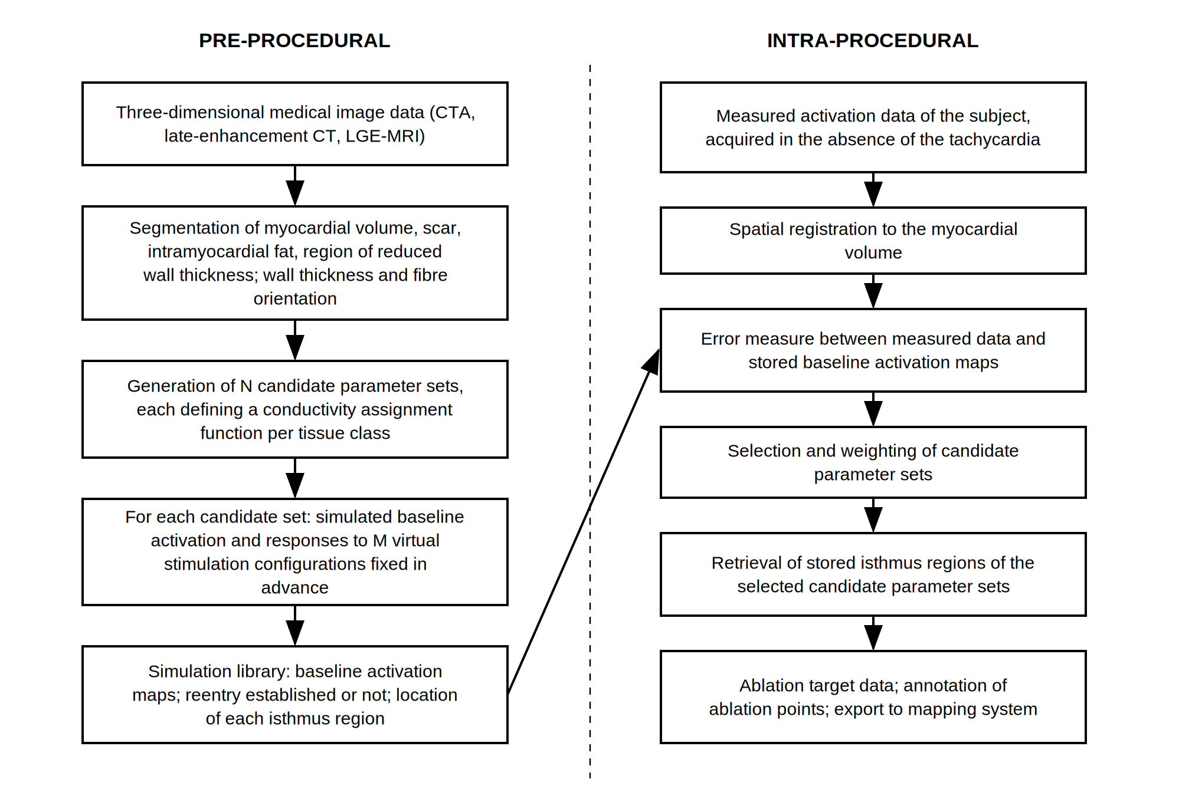
Figure 1 Overview of the workflow: pre-procedural candidate model generation and simulation, intra-procedural selection, annotation and export.
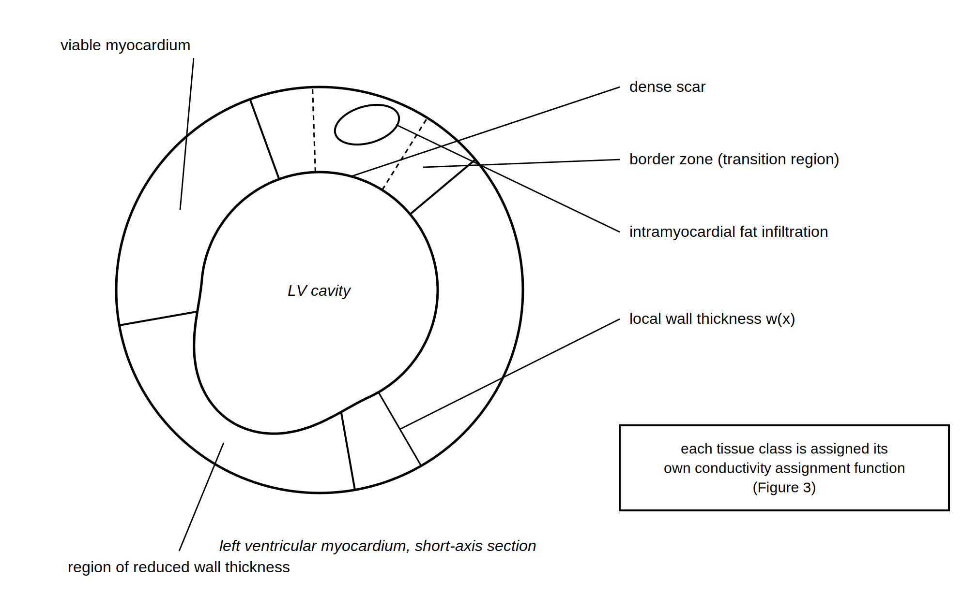
Figure 2 Tissue classes segmented from the image data, shown in a short-axis section of the left ventricle.

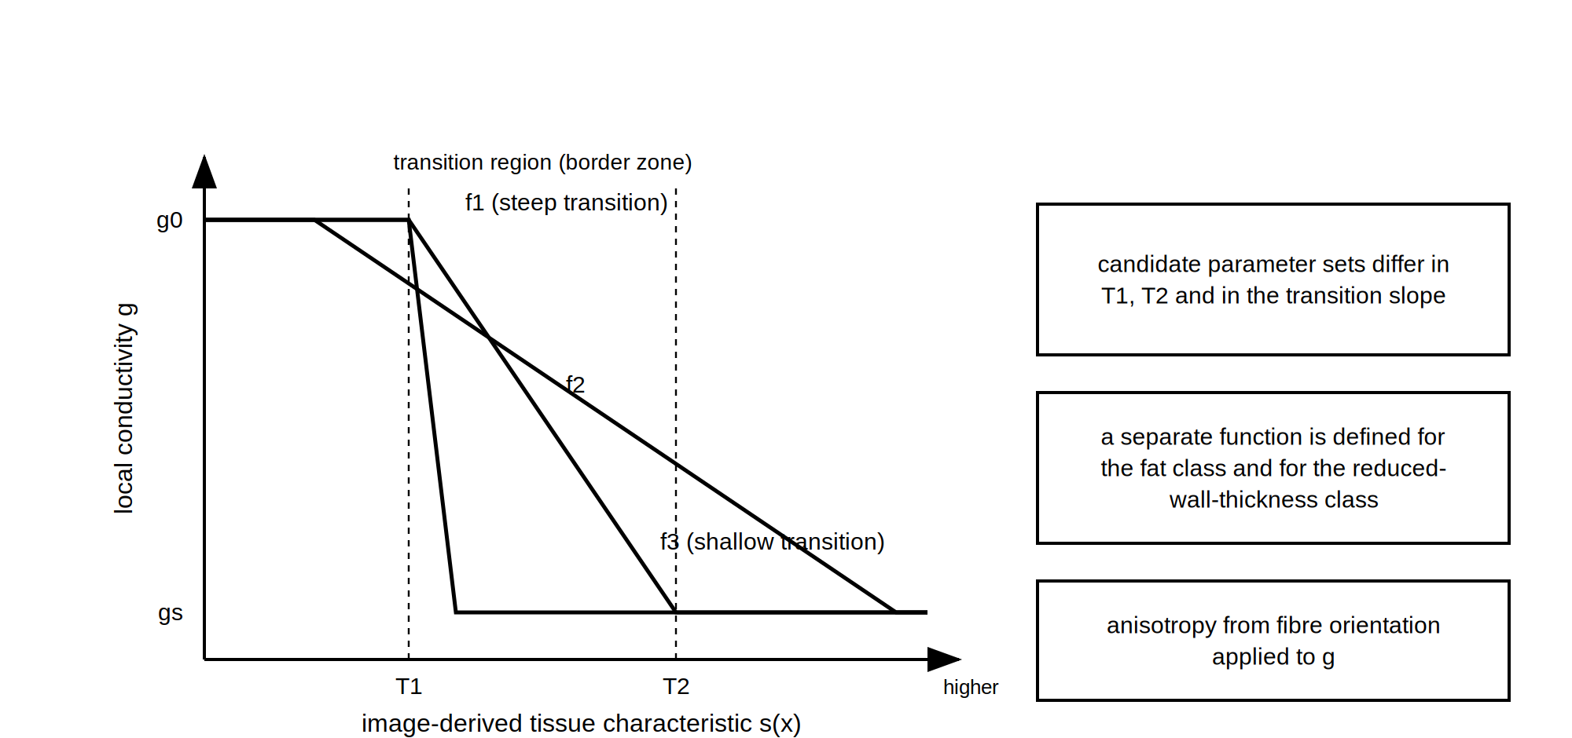
Figure 3 Conductivity assignment functions of three candidate parameter sets.
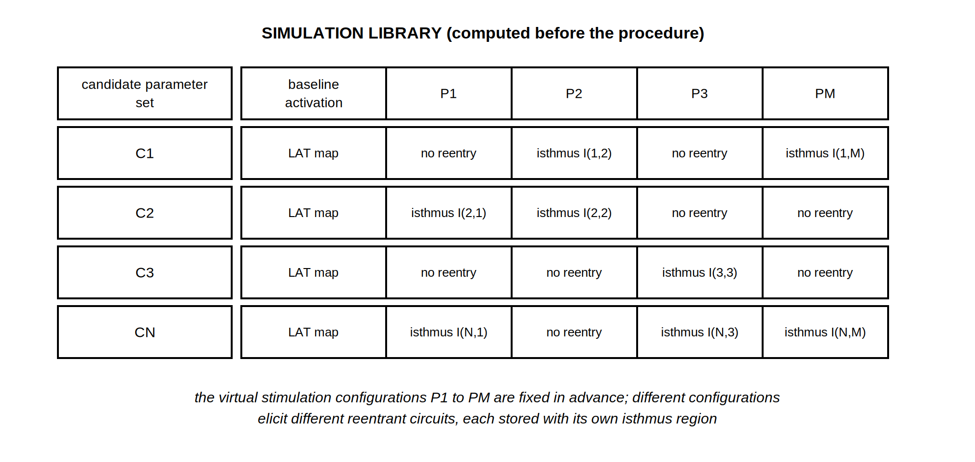
Figure 4 Structure of the simulation library.

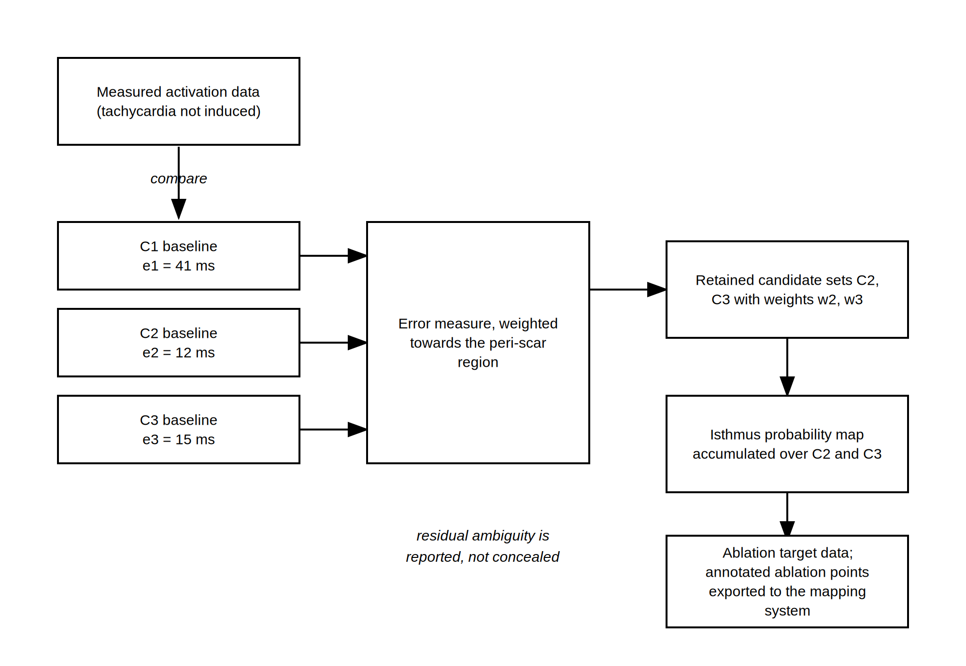
Figure 5 Candidate selection, isthmus probability map and export of the annotated ablation points.
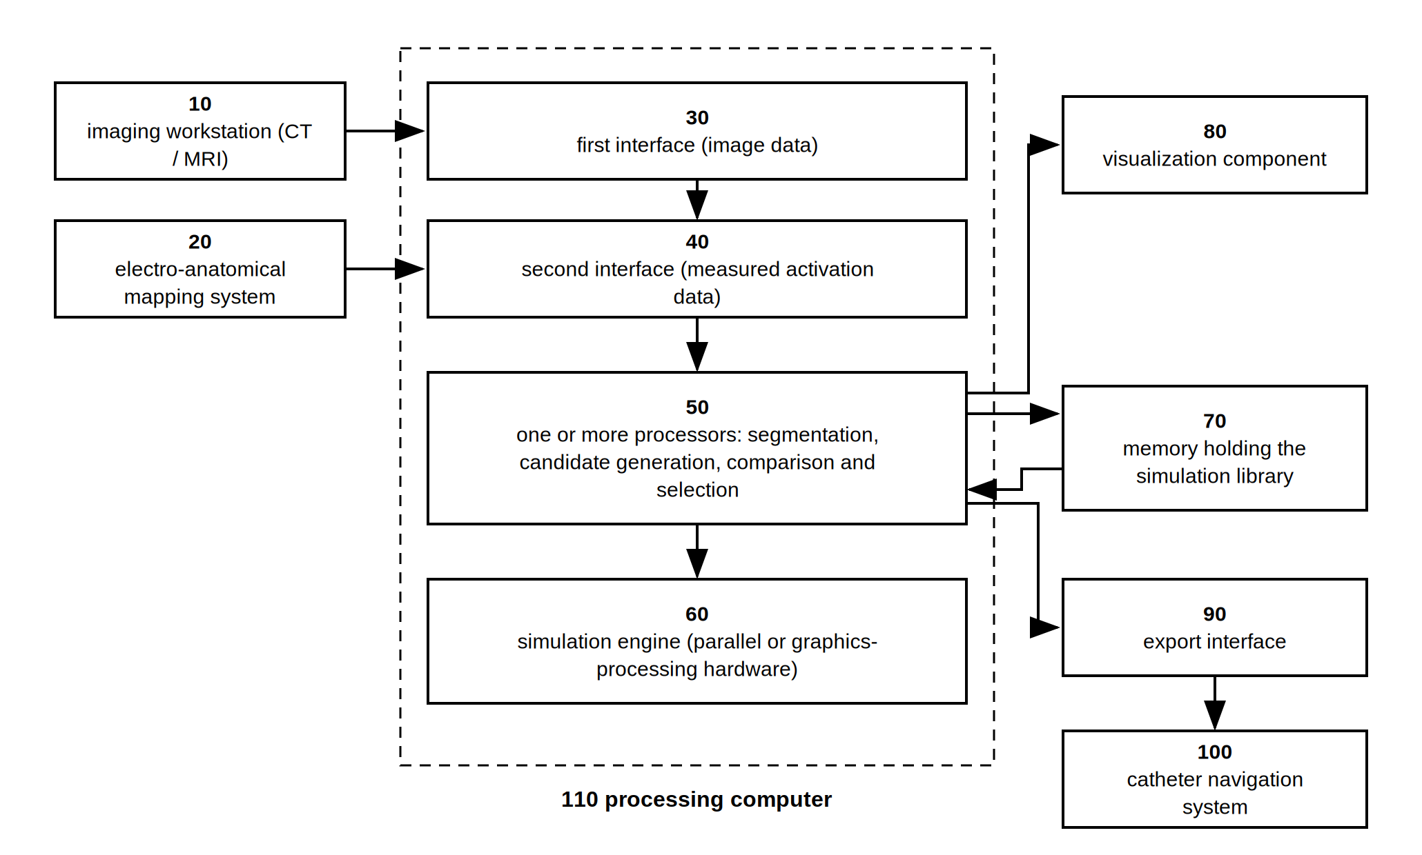
Figure 6 Example system architecture.

WHAT IS CLAIMED IS:
1. A computer-implemented method for generating cardiac ablation target data, comprising: receiving three-dimensional medical image data of a heart of a subject; determining, from the medical image data, a myocardial volume and at least one spatially resolved image-derived tissue characteristic of the myocardial volume; generating a plurality of candidate parameter sets, each candidate parameter set comprising at least one conductivity assignment function mapping the image-derived tissue characteristic to a local electrical conductivity, the candidate parameter sets differing from one another in at least one parameter of the at least one conductivity assignment function; computing, for each candidate parameter set, a simulated baseline activation sequence of the myocardial volume and a plurality of simulated stimulation responses for a plurality of virtual stimulation configurations defined in advance of said computing, each virtual stimulation configuration being defined by a virtual pacing location and a virtual stimulation protocol, and determining, for each simulated stimulation response in which a self-sustaining reentrant activation is established, a location of an isthmus region of said self-sustaining reentrant activation; receiving measured activation data of the subject acquired during a cardiac rhythm other than a reentrant tachycardia, and establishing a spatial correspondence between the measured activation data and the myocardial volume; selecting at least one candidate parameter set on the basis of a comparison between the measured activation data and the simulated baseline activation sequence of each candidate parameter set; and generating ablation target data identifying at least one target region, the target region being determined from the location of the isthmus region determined for the selected at least one candidate parameter set.
2. The method of claim 1, wherein determining the myocardial volume comprises segmenting from the medical image data at least three tissue classes comprising scar tissue, intramyocardial fat tissue and a region of reduced myocardial wall thickness, the region of reduced myocardial wall thickness being determined from a local myocardial wall thickness measured from the medical image data, and wherein each candidate parameter set comprises a separate conductivity assignment function for each of the segmented tissue classes.
3. The method of claim 1, wherein the simulated baseline activation sequences, the simulated stimulation responses and the locations of the isthmus regions are computed and stored in a simulation library before the measured activation data are received, and wherein the measured activation data consist of data acquired from the subject during sinus rhythm, during paced rhythm, or during both, the ablation target data being generated without use of any data acquired from the subject during the reentrant tachycardia, and no simulation being performed after the measured activation data are received.
4. The method of claim 1, wherein the conductivity assignment function is a monotonic function of a normalized image signal intensity and is defined by a lower intensity threshold, an upper intensity threshold and a transition slope between the lower intensity threshold and the upper intensity threshold, and wherein the candidate parameter sets differ from one another in at least one of the lower intensity threshold, the upper intensity threshold and the transition slope.
5. The method of claim 1, wherein the comparison comprises an error measure comprising a weighted combination of a local activation time difference, an activation order difference and a wavefront direction difference, and wherein locations lying within a predetermined distance of a boundary of a segmented scar tissue class are given a greater weight in the error measure than remaining locations.
6. The method of claim 1, wherein the plurality of virtual stimulation configurations comprises at least two different virtual pacing locations and at least two different virtual stimulation protocols, wherein for the selected at least one candidate parameter set a plurality of mutually distinct self-sustaining reentrant activations is established from different ones of the virtual stimulation configurations, two self-sustaining reentrant activations being treated as mutually distinct where their isthmus regions do not substantially overlap, where their exit sites differ, or where their cycle lengths differ by more than a predetermined amount, and wherein the ablation target data identify a plurality of target regions determined from the locations of the isthmus regions of said mutually distinct self-sustaining reentrant activations.
7. The method of claim 1, wherein selecting comprises retaining a plurality of candidate parameter sets satisfying a predetermined criterion and assigning to each retained candidate parameter set a weight derived from the comparison, and wherein generating the ablation target data comprises generating a spatially resolved isthmus probability map by accumulating the weights of the retained candidate parameter sets over the locations of their respective isthmus regions, and identifying as the target region a region of the isthmus probability map exceeding a predetermined probability threshold.
8. The method of claim 1, further comprising displaying the at least one target region on a representation of the myocardial volume, annotating at least one ablation point within the displayed target region in response to an operator input or by automatic placement at a representative location of the target region, converting the at least one annotated ablation point into a data format accepted by an electro-anatomical mapping system or a catheter navigation system, and transferring the converted at least one annotated ablation point to that system in a spatial correspondence with the measured activation data.
9. A system for generating cardiac ablation target data, comprising: a first interface configured to receive three-dimensional medical image data of a heart of a subject; a second interface configured to receive measured activation data of the subject acquired during a cardiac rhythm other than a reentrant tachycardia; a memory configured to store a simulation library; a simulation engine; and one or more processors configured to: determine, from the medical image data, a myocardial volume and at least one spatially resolved image-derived tissue characteristic of the myocardial volume; generate a plurality of candidate parameter sets, each candidate parameter set comprising at least one conductivity assignment function mapping the image-derived tissue characteristic to a local electrical conductivity, the candidate parameter sets differing from one another in at least one parameter of the at least one conductivity assignment function; cause the simulation engine to compute, for each candidate parameter set, a simulated baseline activation sequence of the myocardial volume and a plurality of simulated stimulation responses for a plurality of virtual stimulation configurations, determine, for each simulated stimulation response in which a self-sustaining reentrant activation is established, a location of an isthmus region of said self-sustaining reentrant activation, and store the simulated baseline activation sequences and the locations of the isthmus regions in the memory as the simulation library; establish a spatial correspondence between the received measured activation data and the myocardial volume and select at least one candidate parameter set on the basis of a comparison between the measured activation data and the simulated baseline activation sequence of each candidate parameter set; and generate ablation target data identifying at least one target region determined from the location of the isthmus region stored in the simulation library for the selected at least one candidate parameter set; an operator interface configured to display the at least one target region and to annotate at least one ablation point therein; and a third interface configured to output the at least one annotated ablation point to an electro-anatomical mapping system or a catheter navigation system.
10. A non-transitory computer-readable medium storing instructions which, when executed by one or more processors, cause the one or more processors to carry out the method of claim 1.
ABSTRACT
A computer-implemented method and system for generating cardiac ablation target data. Three-dimensional medical image data are processed to determine a myocardial volume and an image-derived tissue characteristic, and a plurality of candidate parameter sets is generated, each comprising a conductivity assignment function mapping that characteristic to a local electrical conductivity and differing from the others in at least one function parameter. For each candidate parameter set a simulated baseline activation sequence and simulated stimulation responses for a plurality of virtual stimulation configurations fixed in advance are computed, and the isthmus region of each self-sustaining reentrant activation so established is determined, the several stimulation configurations serving to elicit the several distinct reentrant circuits that the substrate can sustain. Measured activation data acquired from the subject during a rhythm other than the tachycardia are registered to the myocardial volume and compared with the simulated baseline activation sequences, and a candidate parameter set is selected from the comparison. Ablation target data are generated from the isthmus regions determined for the selected candidate parameter set, so that a reentry isthmus is localized without the tachycardia having been induced and without any simulation being performed during the procedure. Retained candidate parameter sets may be weighted to yield an isthmus probability map, and the target regions may be annotated as ablation points and transferred to an electro-anatomical mapping system.

