**Part1**

**Part2**

1. Accuracy of my data

By run 5 times the accuracy is:

|  |  |  |  |  |  |
| --- | --- | --- | --- | --- | --- |
| Number of Run | 1 | 2 | 34 | 4 | 5 |
| Accuracy | 1.0 | 1.0 | 1.0 | 1.0 | 1.0 |

1. Since the accuracy is 1.0, it means the list I draw doesn’t make any error. One reason is the graph I draw has similar identity, which means in the process of retrieve function, it always yields the stored pattern (right local minimum). In addition, since it has similar identity, it reduces the probability that the pattern converges to a false local minimum (false local minimum). Also, because Hopfield is using fragment to determine the result, after updating the Vin value. It eventually computed to the same with ‘two’ and ‘five’ list provided.

**Part3**

1. Accuracy of MLP

By run 5 times the accuracy is:

|  |  |  |  |  |  |
| --- | --- | --- | --- | --- | --- |
| Number of Run | 1 | 2 | 3 | 4 | 5 |
| Accuracy | 1.0 | 1.0 | 1.0 | 1.0 | 1.0 |

1. Since the accuracy is 1.0 which means there is no error for MLP. Because for MLP algorithm, it uses backpropagation to train the data, also it uses multiple layers and non-linear function to generate the output value. For my data, because for all “two” and “five” groups have similar identity, therefore, it reduces the probability that exists more than one local minimum (because it could have multiple local minimum for MLP), so that the result is accurate.

**Part4**

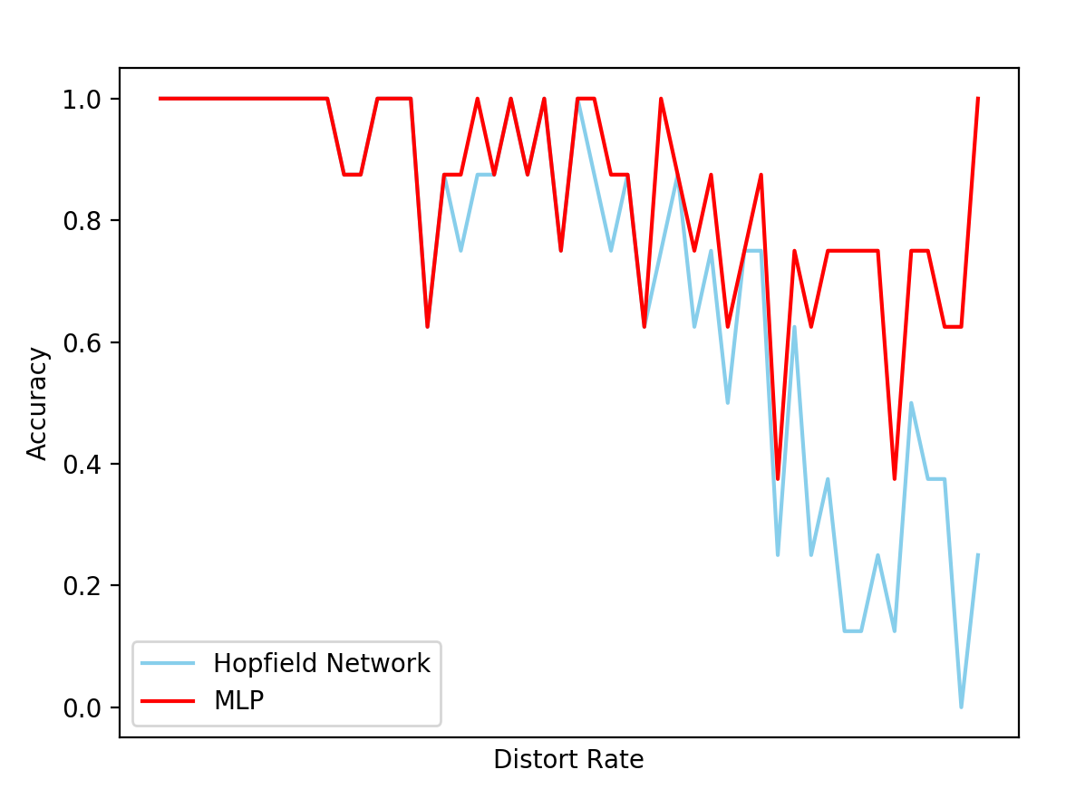

Base on the graph, overall, MLP algorithm yields higher accuracy compare to Hopfield Network in different distort rate.

**Part5**

Hyperparameter:

First MLP: (10, 5, 1)

Second MLP: (100, 50, 10)

Third MLP: (1000, 500, 100)

Base on the output graph, by increase the number of layers, the accuracy of the 50-output is also increasing. For example, first MLP has 10, 5, 1 layer, second MLP has 100, 50, 10 layers, third MLP has 1000, 500, 100 layers. First MLP has the worst overall accuracy, second MLP accuracy is better than first MLP, and third MLP has best overall accuracy.