1. Base on the 50 runs
   1. The average generation is: 25.77
   2. The min generation is: 11
   3. The max generation is: 47
2. Base on the graph, as the generation value goes up, for all five runs, the average fitness value also goes up which means it is getting closer to get the optimal string (string has all 1).

1. If change the crossover rate to 0, then for all 50 runs, we cannot find the genome string which contain all 1. This is because when crossover rate is 0. The program will never crossover two genome. Therefore, it kills the probability that genome get mutate, so it cannot find the genome string contain all 1.
2. Base: best_i.append(runGA(100, 0.7, 0.001, "run1.txt")) (Graph shows above)
3. Population

Population size=50, crossover rate=0.7, mutate rate=0.001

For population, if decreasing the population size. The function will less likely to find the genome string contain all 1. Because by decreasing the population and keep all the other parameter the same. The runGA function will have less sample to run, so it will less likely to find the optimal string.



Note:

-1 means it cannot find genome contain all 1.

Other positive number means how many generations need to find the genome contain all 1. For example, 33 means it need 33 generations to find the optimal string

Population size=100, crossover rate=0.7, mutate rate=0.001

For population, if increase the size of population. The function will more likely to find the optimal string.

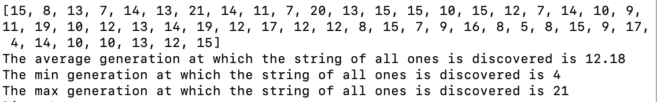

1. Population size=100, crossover rate=0.1, mutate rate=0.001

For crossover, if decrease the crossover rate. The function will less likely to find the optimal string.

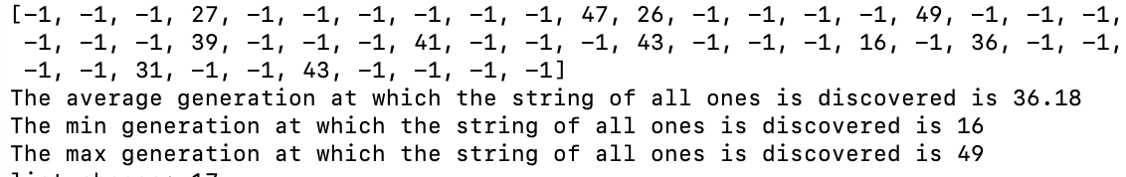

Population size=100, crossover rate=0.9, mutate rate=0.001

For crossover, if increase the crossover rate. The function will more likely to find the optimal string. This is because for cross over in runGA function, we randomly generate a random number and compare with the cross over rate pass in. If the random number is greater than the cross over rate, we do cross over. Since the cross over rate is very high, it is less likely the two genomes will do cross over, so it is less likely to find the optimal string.

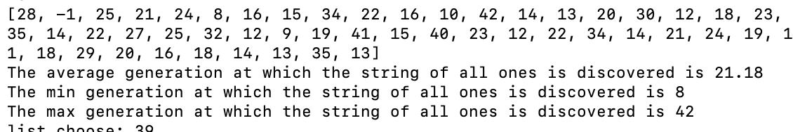

1. Population size=100, crossover rate=0.7, mutate rate=0.9

For mutate, if increase the mutate rate. The function will less likely to find the optimal string.

Population size=100, crossover rate=0.7, mutate rate=0

If decrease the mutate rate. The function will more likely to find the optimal string.

This is because if mutate rate is very high, the mutate function will mutate the string very often. Therefore, even though the function “finds” the optimal string, the mutate function will mutate the string so that string is not longer optimal. Thus, it is good to set the mutate rate to a certain range that won’t mutate the optimal string and only mutate the un-optimal string.

