1. select * from hwCategories;

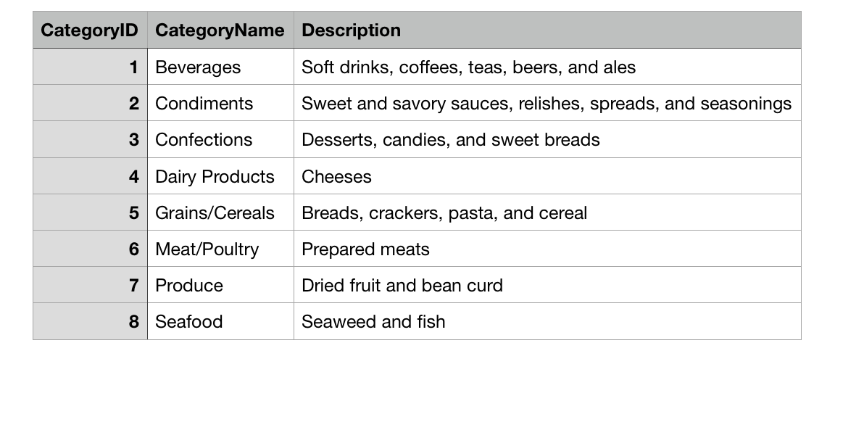2. select CompanyName, Address, City,Region,PostalCode,Phone

from hwSuppliers

where Country="France" or Country="Germany";

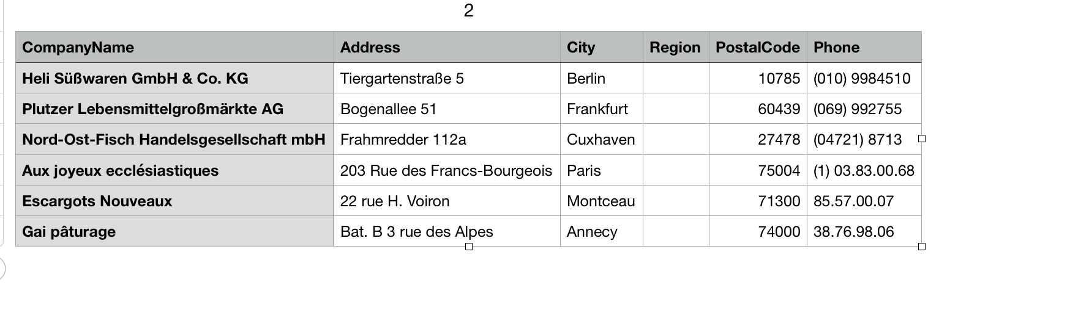3. select ContactName,ContactTitle

from hwSuppliers

where SupplierID>=5 and SupplierID<=20

order by ContactName;

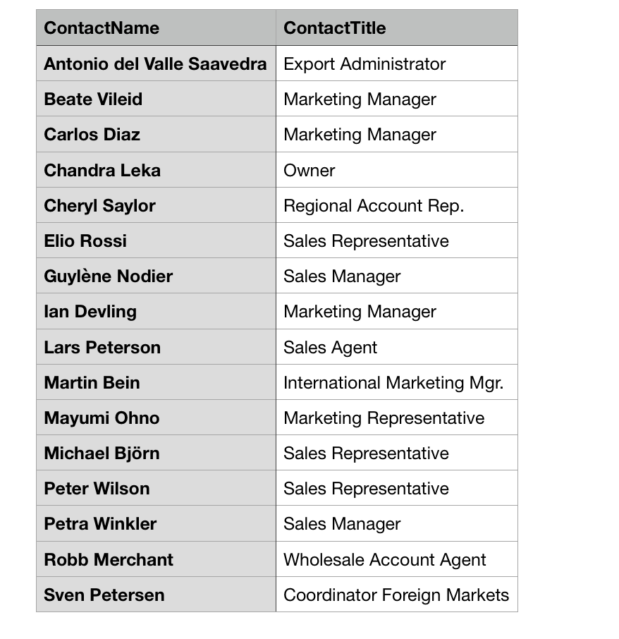4. select ProductName, QuantityPerUnit, UnitPrice, UnitsInStock

from hwProducts

where UnitPrice<10;

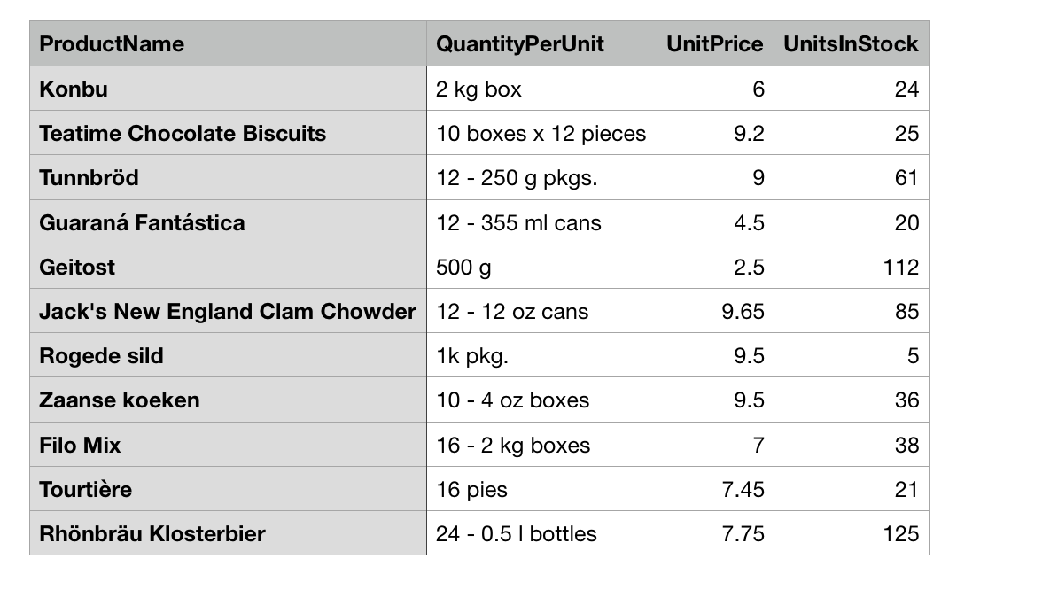5. select ProductID, ProductName, UnitsInStock, UnitPrice, ReorderLevel

from hwProducts

where UnitsInStock>0 and UnitsInStock<=ReorderLevel;

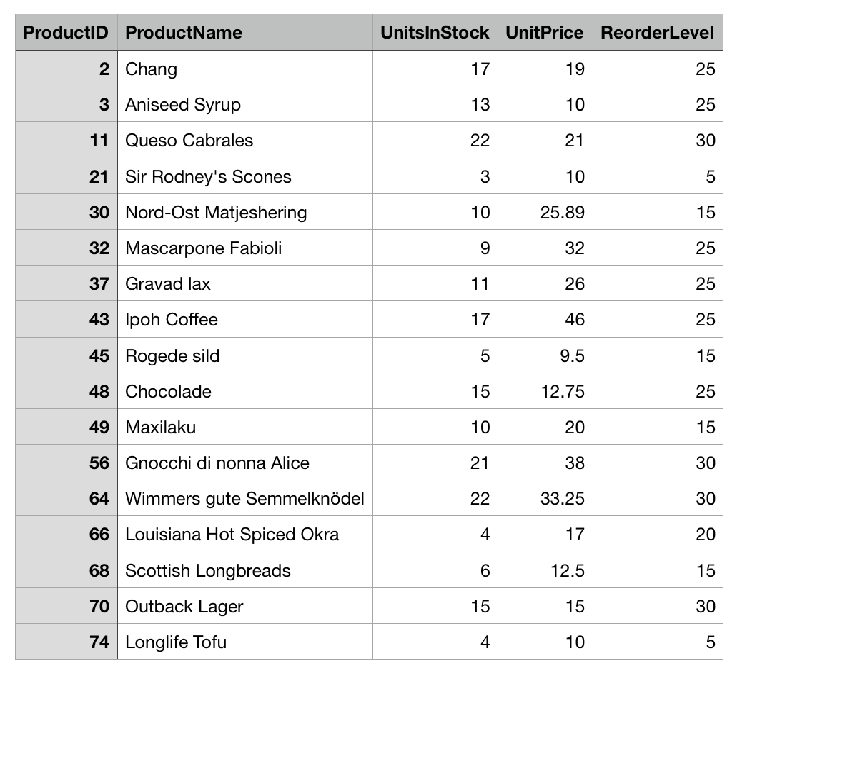6. SELECT LastName,FirstName, Date_Format(HireDate, '%m/%d/%Y')

FROM hwEmployees

WHERE Country!="USA" and HireDate<='2014-06-28'

order by LastName;

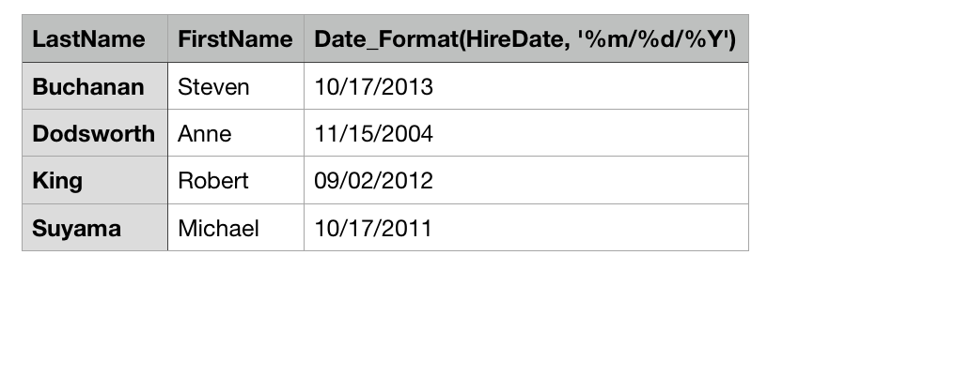7. SELECT ProductName, UnitPrice

FROM hwProducts

WHERE ProductID

IN(SELECT ProductID

FROM hwProducts

WHERE UnitPrice =(SELECT MAX(UnitPrice)

FROM hwProducts));

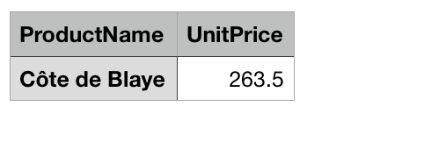

8. SELECT ProductID, ProductName,(UnitsInStock*UnitPrice) as "Total Inventory Value"

from hwProducts

WHERE UnitsInStock*UnitPrice>2000;

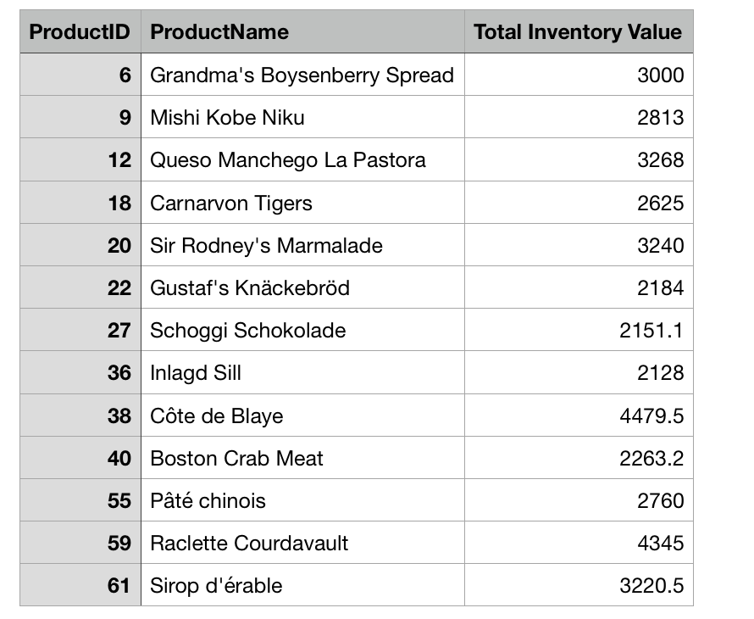9. Select ProductID,ProductName,UnitPrice

from hwProducts

where QuantityPerUnit

like '%cans%' and Discontinued=1;

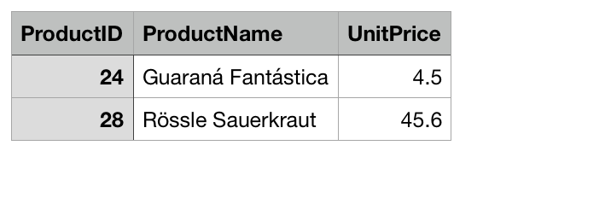

10. SELECT ShipCountry,COUNT(OrderID) as Orders

FROM hwOrders

WHERE ShipCountry != "USA"

and MONTH(ShippedDate)='9'

and YEAR(ShippedDate)='2013'

Group BY ShipCountry;

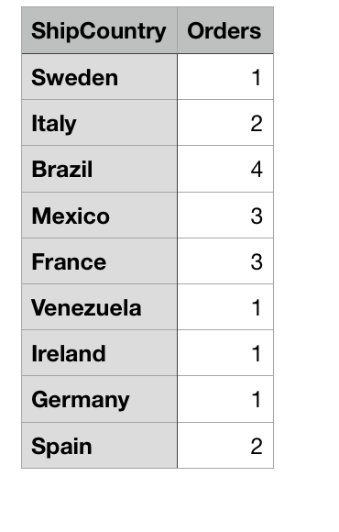

11. SELECT Round(sum(UnitPrice)/COUNT(ProductID),2) as 'Average Unit Price'

From hwProducts;

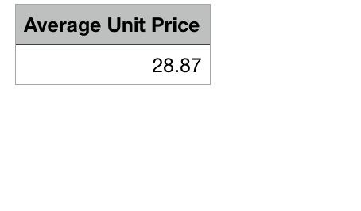

12. Select Count(CustomerID) as "Customer from France"

From hwCustomers

Where Country="France";

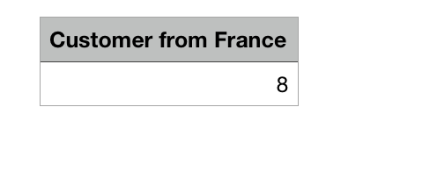

13. select CustomerID, ShipCountry

from hwOrders

group by CustomerID,ShipCountry

having COUNT(CustomerID)>20;

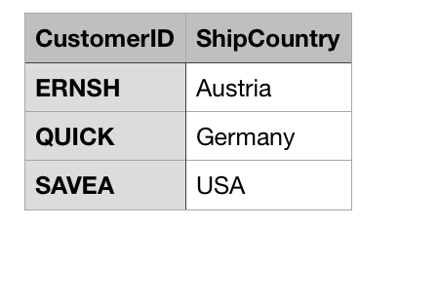

14. select SupplierID, SUM(UnitPrice*UnitsInStock)

as "total value of inventory"

from hwProducts

where SupplierID BETWEEN 1 and 5

group by SupplierID;

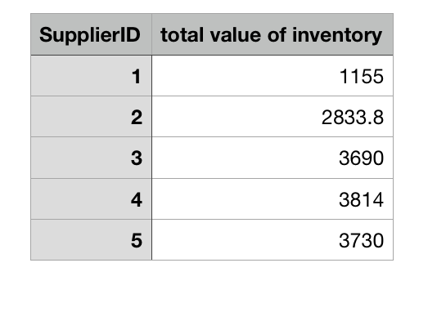

15. SELECT CompanyName, hwProducts.ProductName,hwProducts.UnitPrice

from hwSuppliers

Join hwProducts

on hwProducts.SupplierID=hwSuppliers.SupplierID

WHERE Country='USA'

GROUP BY CompanyName, hwProducts.ProductName,hwProducts.UnitPrice;

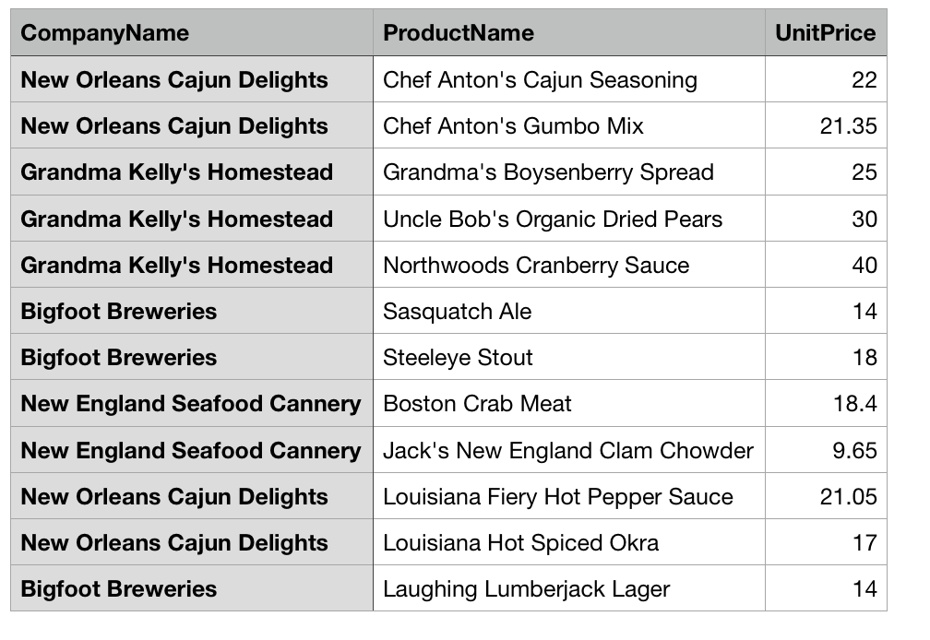

16. select FirstName, LastName,Title, count(hwOrders.OrderID)

from hwOrders

join hwEmployees

on hwEmployees.employeeId=hwOrders.EmployeeID

group by FirstName, LastName,Title

having count(hwOrders.OrderID)>100

order by Concat(FirstName,' ',LastName);

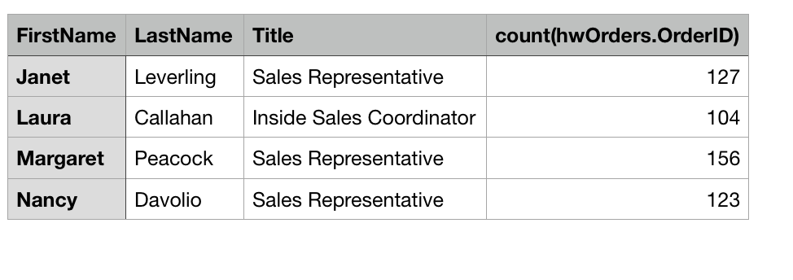

17. Select hwCustomers.CustomerID, hwCustomers.CompanyName

from hwCustomers

Left join hwOrders

on hwCustomers.CustomerID=hwOrders.CustomerID

where hwOrders.OrderID is NULL;

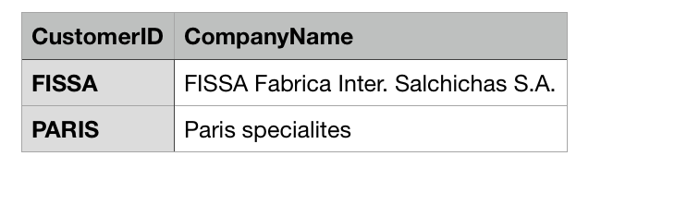

18. Select CompanyName, ContactName,

hwCategories.CategoryName,hwCategories.Description,

hwProducts.ProductName,hwProducts.UnitsInStock

from hwSuppliers

Join hwCategories,hwProducts

where hwProducts.UnitsInStock=0

and hwProducts.SupplierID=hwSuppliers.SupplierID

and hwProducts.CategoryID=hwCategories.CategoryID;

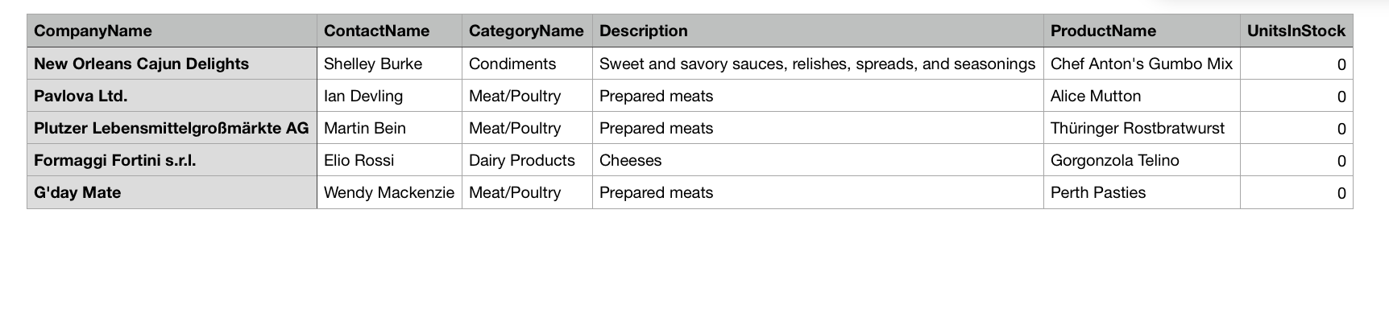

19. Select ProductName,UnitsInStock,

hwSuppliers.CompanyName,hwSuppliers.Country

from hwProducts

Join hwSuppliers

where hwProducts.SupplierID=hwSuppliers.SupplierID

and QuantityPerUnit Like '%bottle%' or '%bottles%';

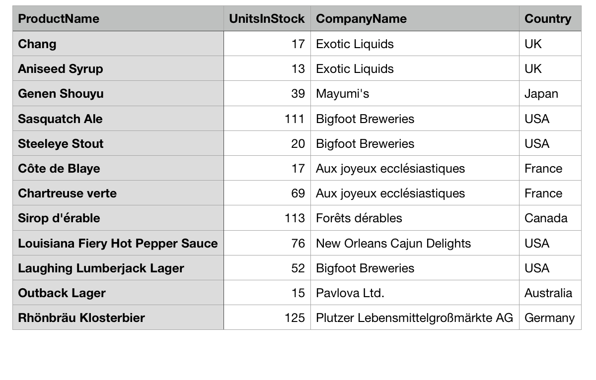

20. SELECT CompanyName,hwOrders.ShipName,

Round((hwOrderDetails.UnitPrice*hwOrderDetails.Quantity)*(1-hwOrderDetails.Discount),2)

as 'Value of all orders'

from hwCustomers

Inner JOIN hwOrders,hwOrderDetails

where hwCustomers.Country='Mexico'

and hwCustomers.CustomerID=hwOrders.CustomerID

and hwOrders.OrderID=hwOrderDetails.OrderID;

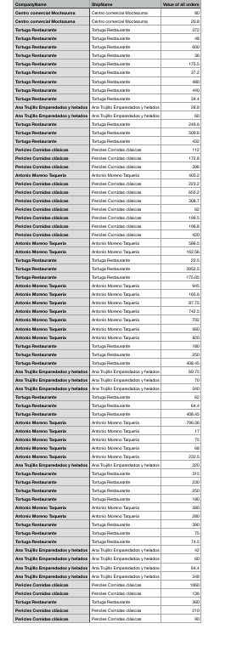

21. Create VIEW EmployeesOrders As

SELECT FirstName,LastName,COUNT(hwOrders.OrderID)

as 'OrderCount'

from hwEmployees

Inner Join hwOrders

where hwEmployees.EmployeeID=hwOrders.EmployeeID

GROUP BY FirstName,LastName;

22. Select * from EmployeesOrders;

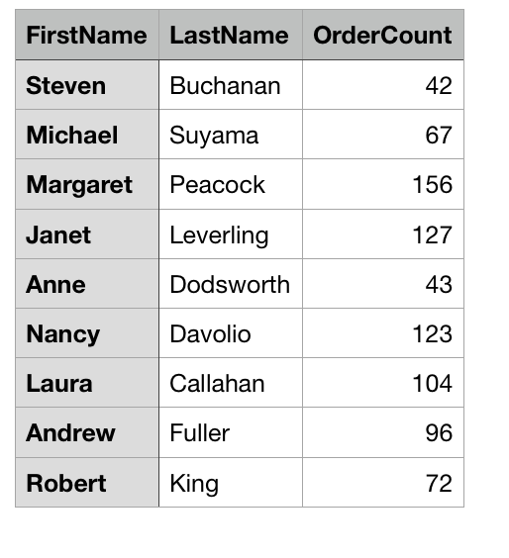

23. CREATE TABLE IF NOT EXISTS TopItems (

ItemID INT NOT NULL,

ItemCode INT,

ItemName VARCHAR(40) NOT NULL,

ItemDate DATE NOT NULL,

ItemQuantity INT NOT NULL,

ItemPrice DECIMAL(9, 2) NOT NULL,

SupplierID INT NOT NULL,

PRIMARY KEY (ItemID)

);

24. insert into

TopItems (ItemID, ItemName,ItemDate,ItemQuantity,ItemPrice,SupplierID)

select ProductID,ProductName,curdate(),UnitsInStock,UnitPrice,SupplierID

from hwProducts

where UnitPrice<8;

select * from TopItems;

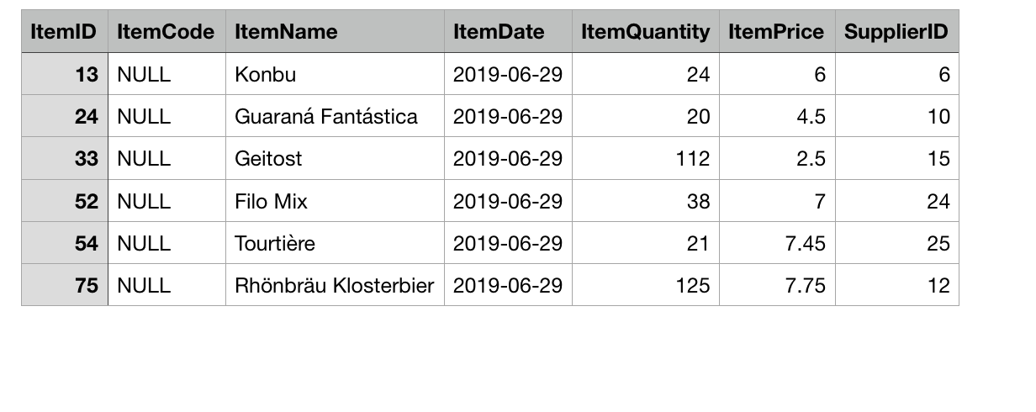

25. delete from TopItems where itemID=54 or itemID=75;

select * from TopItems;

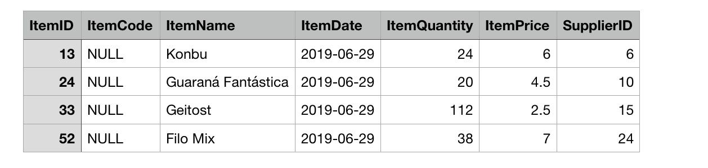

26. alter table TopItems add InventoryValue decimal(9,2) After ItemPrice;

select * from TopItems;

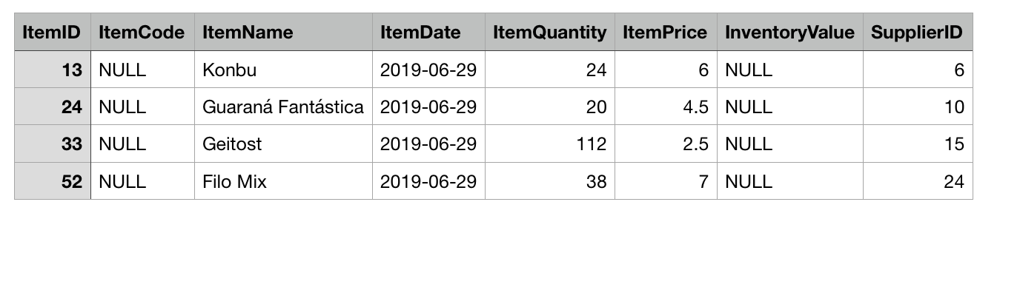

27. update TopItems set InventoryValue=ItemPrice*ItemQuantity;

Select * from TopItems;

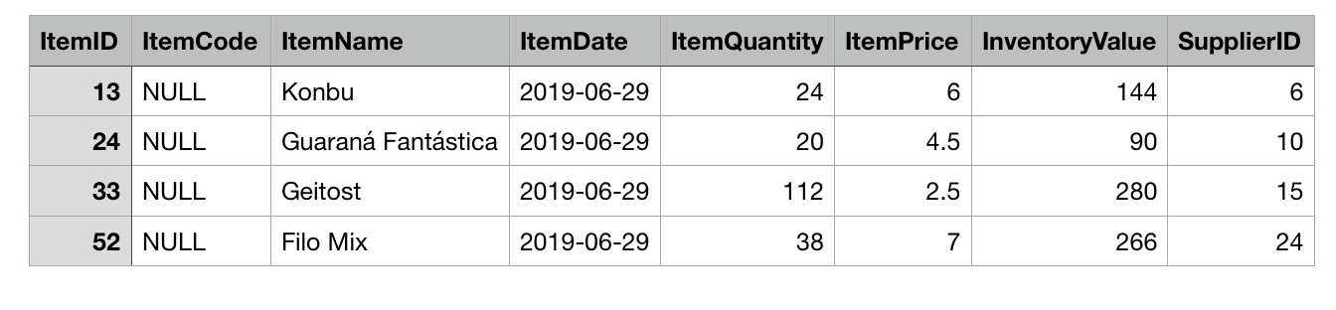

28. SHOW COLUMNS FROM TopItems;

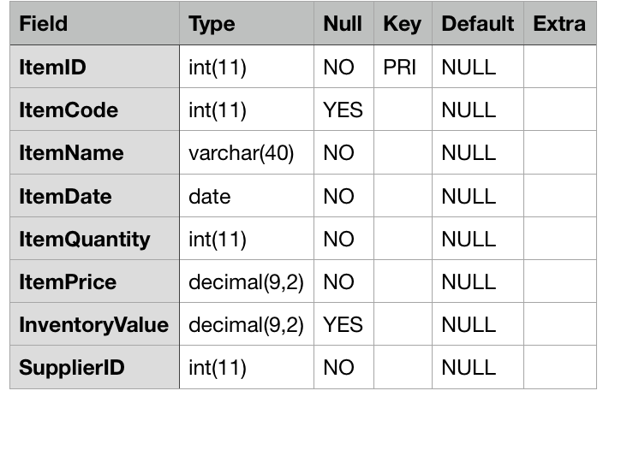

29. drop table TopItems;

30. drop view EmployeesOrders;