HW_4_DataWarehouse

1. SELECT SalesPersonName,

SUM(fact_productsales.SalesPrice*fact_productsales.Quantity)

as 'Total Revenue'

from dim_salesperson

JOIN fact_productsales

on dim_salesperson.SalesPersonID=fact_productsales.SalesPersonID

Join dim_date

on fact_productsales.SalesDateKey=dim_date.DateKey

WHERE dim_date.Year=2012

GROUP BY SalesPersonName

ORDER BY SUM(fact_productsales.SalesPrice*fact_productsales.Quantity) DESC

LIMIT 1;

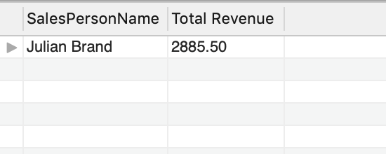

1. SELECT CustomerName,

SUM(fact_productsales.SalesPrice*fact_productsales.Quantity)

as 'Total Revenue'

from dim_customer

Join fact_productsales

on fact_productsales.CustomerID=dim_customer.CustomerID

Join dim_date

on fact_productsales.SalesDateKey=dim_date.DateKey

WHERE dim_date.Year=2013

GROUP BY CustomerName

ORDER BY SUM(fact_productsales.SalesPrice*fact_productsales.Quantity) DESC

LIMIT 3;

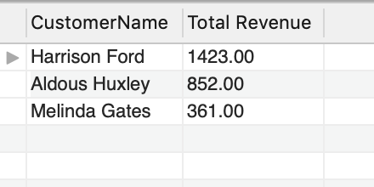

1. SELECT YEAR,

fact_productsales.StoreID,SUM(SalesPrice)

as 'Total Sales Price'

from Dim_Date

JOIN fact_productsales

on fact_productsales.SalesDateKey=dim_date.DateKey

where Dim_Date.YEAR BETWEEN 2016 and 2017

GROUP BY Dim_Date.YEAR,fact_productsales.StoreID;

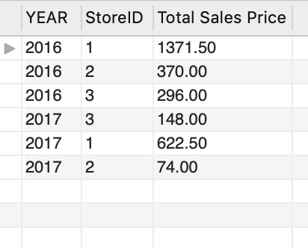

1. SELECT ProductName,

SUM((ProductSalesPrice-ProductActualCost)*fact_productsales.Quantity)

as 'Profit'

from dim_product

JOIN fact_productsales

on dim_product.ProductKey=fact_productsales.ProductID

JOIN dim_date

on fact_productsales.SalesDateKey=dim_date.DateKey

where dim_date.Year=2015

GROUP BY dim_product.ProductName

ORDER BY SUM((ProductSalesPrice-ProductActualCost)*fact_productsales.Quantity) DESC

LIMIT 3;

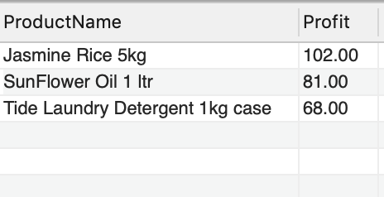

1. SELECT QUARTER,

SUM(fact_productsales.SalesPrice*fact_productsales.Quantity)

as 'revenue'

from dim_date

JOIN fact_productsales

on fact_productsales.SalesDateKey=dim_date.DateKey

Join dim_store

on dim_store.StoreID=fact_productsales.StoreID

WHERE dim_store.StoreName='ValueMart Boulder' and dim_date.Year=2016

GROUP BY dim_date.QUARTER

Order BY SUM(fact_productsales.SalesPrice*fact_productsales.Quantity) DESC

LIMIT 1;

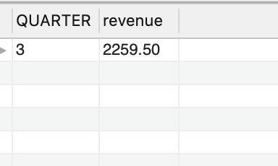

1. SELECT CustomerName, SUM(SalesPrice) as 'Total Sales Price'

FROM Fact_ProductSales

JOIN Dim_Customer

ON Fact_ProductSales.CustomerID = Dim_Customer.CustomerID

WHERE Dim_Customer.CustomerName = "Melinda Gates";

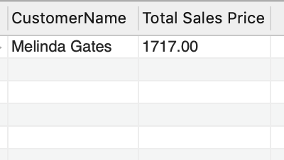

1. SELECT StoreName,

SUM(fact_productsales.SalesPrice*fact_productsales.Quantity)

as 'Total Revenue'

FROM dim_store

JOIN fact_productsales

on dim_store.StoreID=fact_productsales.StoreID

JOIN dim_date

on fact_productsales.SalesDateKey=dim_date.DateKey

where dim_date.YEAR=2013 and dim_date.MONTH ='3'

GROUP BY StoreName;

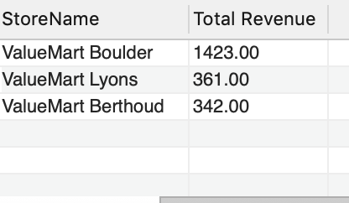

1. SELECT SalesPersonName,

SUM(fact_productsales.SalesPrice*fact_productsales.Quantity)

as 'Total Revenue'

FROM dim_salesperson

JOIN fact_productsales

ON dim_salesperson.SalesPersonID=fact_productsales.SalesPersonID

GROUP BY dim_salesperson.SalesPersonName

ORDER BY SUM(fact_productsales.SalesPrice*fact_productsales.Quantity) DESC

LIMIT 1;

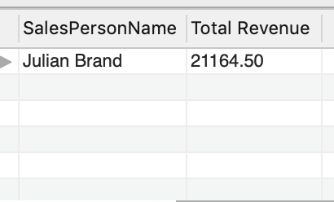

1. SELECT ProductName,

SUM((Fact_ProductSales.salesprice*Fact_ProductSales.quantity)-(Fact_ProductSales.productcost*Fact_ProductSales.quantity))

as 'Profit'

FROM dim_product

Join Fact_ProductSales

on dim_product.ProductKey=fact_productsales.ProductID

GROUP BY ProductName

ORDER BY SUM((Fact_ProductSales.salesprice*Fact_ProductSales.quantity)-(Fact_ProductSales.productcost*Fact_ProductSales.quantity)) DESC

LIMIT 1;

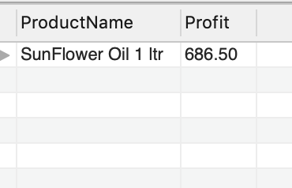

1. SELECT YEAR,MONTHNAME,

SUM(fact_productsales.SalesPrice*fact_productsales.Quantity)

as 'Total Revenue'

FROM dim_date

JOIN fact_productsales

on dim_date.DateKey=fact_productsales.SalesDateKey

WHERE (dim_date.MONTH='1' or dim_date.MONTH='2' or dim_date.MONTH='3')

and dim_date.YEAR=2017

GROUP BY YEAR,MONTHNAME;

