Hash 1

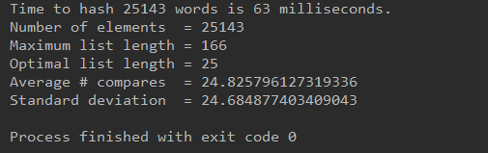

Hash 2

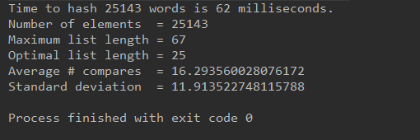

Hash 3

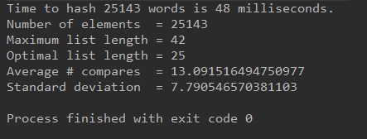

Math abs

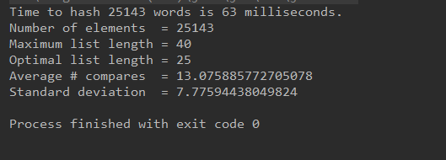

Math abs works the best. Hash 1 works the worst.

1050 is the best.

