Guide of EDGARPulse: SEC Filing Analytics System

1. Project Summary
EDGARPulse is a distributed analytics system that retrieves SEC filing data, computes filing-level risk and disclosure signals, stores request-level logs, and presents operational analytics through a browser-based dashboard. The system integrates an Android client, a Java Servlet backend, the SEC EDGAR API, MongoDB Atlas, and monitoring workflows.

2. Problem
Public SEC filings contain valuable metadata and text disclosures, but they are not immediately usable for lightweight analytics workflows. Raw filing data must be retrieved, normalized, filtered, transformed, and presented in a structured way before it can support downstream interpretation, monitoring, or exploratory analysis.

3. Solution
To address this, I built EDGARPulse, an end-to-end analytics system that accepts a company CIK, retrieves filing metadata and filing text from the SEC EDGAR API, computes interpretable risk tone and disclosure activity signals, stores request-level logs in MongoDB Atlas, and surfaces both results and operational metrics through a browser-based dashboard.
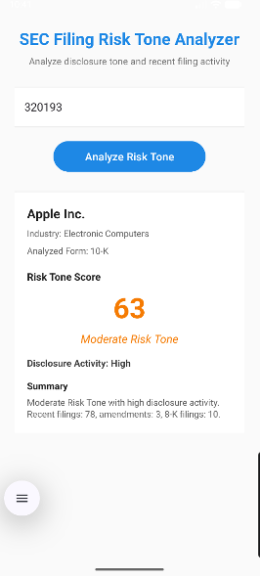
Fig1/2. Android Home and Results
4. System Design
The system is organized as a lightweight analytics workflow with four components:
- Frontend: Android client for CIK-based querying and result display
- Backend: Java/Jakarta Servlet-based analytics services
- Data Source: SEC EDGAR filings and archive documents
- Storage and Monitoring: MongoDB Atlas + browser-based dashboard
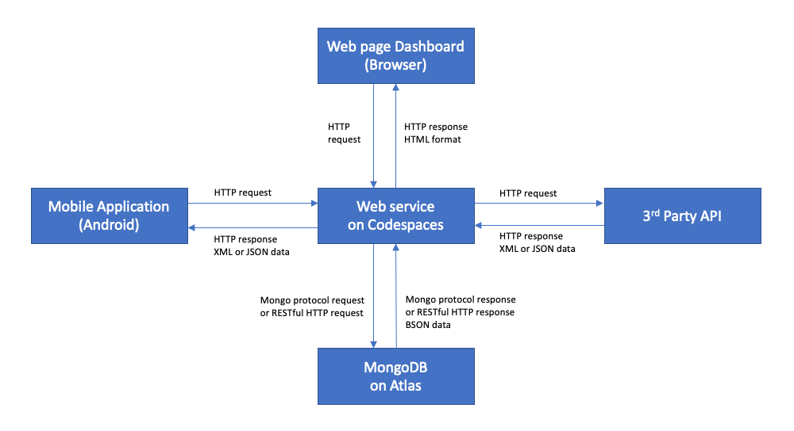
Fig3. System Design

5. My Contributions
- Built REST-style backend services for SEC filing retrieval, identifier normalization, filing prioritization, and JSON response generation.
- Designed a rule-based text analytics pipeline to compute filing-level risk tone scores and disclosure activity indicators.
- Implemented MongoDB-backed request logging for analysis results, API performance, and service telemetry.
- Developed the Android client and dashboard workflows to support querying, result visualization, and operational monitoring.

6. Technical Highlights
- Converted semi-structured filing metadata and unstructured filing text into structured analytical signals.
- Integrated external API retrieval, data validation, text preprocessing, persistent logging, and dashboard analytics into a single workflow.
- Improved observability by tracking request success, latency, queried entities, form types, and aggregate risk metrics.
- Built an interpretable analytics pipeline that combines text-based risk scoring with filing activity indicators for lightweight disclosure monitoring.
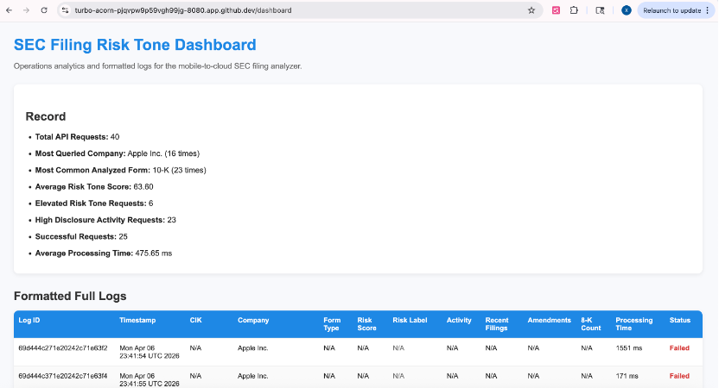
Fig4. Dashboard Analytics Part
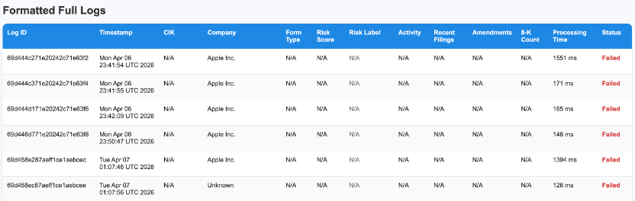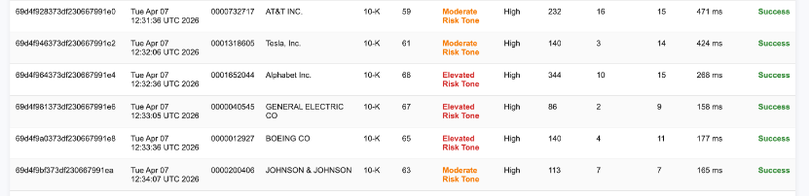
Fig5/6. Dashboard Log Part

7. Why It Matters
EDGARPulse demonstrates how semi-structured public disclosures can be transformed into usable analytical signals through a compact, end-to-end system. The project highlights my ability to combine external API integration, text analytics, persistent logging, and dashboard-based observability in a single analytics workflow.
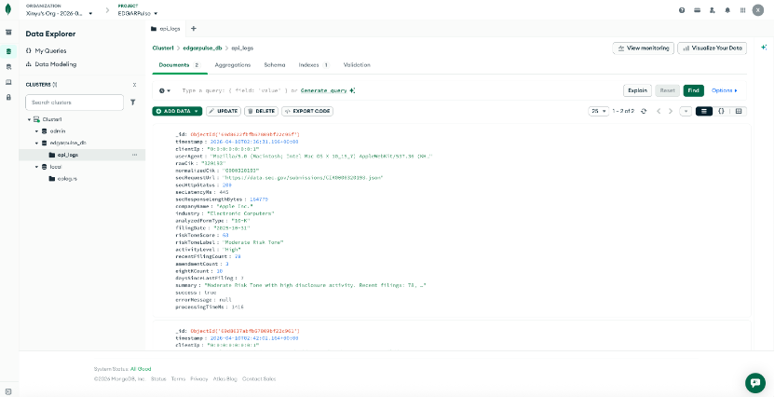
Fig7. MongoDB Logs

