**train_final_5**

text 100， 3 attention (10,20)

audio 25

fusion 100

text acc: 0.5376850605652759 audio acc: 0.38373655913978494 final acc: 0.5639300134589502

0.5338928343558634

0.5231513476775446

**1. attention**

1.1

**test_1**

:text 100, 6 attention (8,64)

audio 0

fusion 0

text acc: 0.5282392026578073

0.5145255005536655

0.4914698162729659

1.2

**test_1**

text 100, 3 attention (8,64)

audio 0

fusion 0

text acc 0.5171319796954315

text acc 0.5284900286598423

text acc 0.5386138613074526

1.3

**test_1**

text 100, 3 attention (20,20)

audio 0

fusion 0

text acc 0.5206942593303319

text acc 0.5202702702702703

**2.audio**

**Test_1**

audio 13, 3 attention (4,16),no dropout, globalmaxpooling, adam

text 0

fusion 0

model

acc_a 0.3554987212276215(模型不在了)

0.37890625

audio 13, 3 attention (4,16),no dropout, globalmaxpooling, sgd

text 0

fusion 0

model_ testaudo

0.45866141732283466

**3. adma + sgd**

**3.1**

**Test_2**

text 100, 3 attention (10,20),no dropout, globalmaxpooling, adam

audio 0

fusion 0

text acc 0.5408031088082902

text acc 0.5202429153015096

model

text 100, 3 attention (10,20),no dropout, globalmaxpooling, sgd

audio 0

fusion 0

text acc 0.7973258275536061

text acc 0.8057455540355677

text acc 0.8021319126939869

model1

3.2

Test_2

text 50, 3 attention (10,20),no dropout, globalmaxpooling, adam

audio 0

fusion 0

text acc 0.47956403302236866

text 50, 3 attention (10,20),no dropout, globalmaxpooling, sgd

text acc 0.7904761908816642

model2

3.3

Test_2

text 100, 3 attention (10,20),no dropout, globalmaxpooling, adam

audio 0

fusion 0

text acc 0.5269102990033223

model3

text 100, 3 attention (10,20),no dropout, globalmaxpooling, sgd, model3

audio 1, ->audio_model2

fusion 100， ->final_model2,

text acc 0.7456197274690476

text acc: 0.768135593220339 audio acc: 0.3353658536585366 final acc: 0.783728813559322

0 {'0': 147, '1': 7, '2': 2, '3': 56, '4': 11}

1 {'0': 3, '1': 283, '2': 2, '3': 6, '4': 28}

2 {'0': 0, '1': 5, '2': 178, '3': 15, '4': 16}

3 {'0': 19, '1': 17, '2': 9, '3': 295, '4': 45}

4 {'0': 4, '1': 26, '2': 18, '3': 30, '4': 253}

text acc: 0.7639257294429708 audio acc: 0.34748010610079577 final acc: 0.7844827586206896

0 {'0': 185, '1': 14, '2': 3, '3': 36, '4': 16}

1 {'0': 1, '1': 274, '2': 4, '3': 6, '4': 30}

2 {'0': 1, '1': 5, '2': 177, '3': 14, '4': 15}

3 {'0': 35, '1': 12, '2': 14, '3': 272, '4': 38}

4 {'0': 6, '1': 26, '2': 20, '3': 29, '4': 275}

**4.fusion without cnn**

**File:Test_2**

T1:

text (100,100) 3 attention (10,20),no dropout, globalmaxpooling, adam,sgd, text_model3

audio 1 , audio_model2,

fusion 100, no cnn ->final_model2

text acc: 0.7768651608691324 audio acc: 0.34084699453551914 final acc: 0.7967145790758401

0 {'0': 161, '1': 3, '2': 2, '3': 29, '4': 20}

1 {'0': 2, '1': 298, '2': 2, '3': 11, '4': 23}

2 {'0': 0, '1': 9, '2': 179, '3': 5, '4': 15}

3 {'0': 31, '1': 8, '2': 18, '3': 260, '4': 37}

4 {'0': 3, '1': 26, '2': 20, '3': 33, '4': 266}

T2:

text (100,100) 3 attention (10,20),no dropout, globalmaxpooling, adam,sgd, text_model3

audio 1 , audio_model2,

fusion 100, no cnn ->final_model2

text acc: 0.7711864411442345 audio acc: 0.3365885416666667 final acc: 0.796610169802371

0 {'0': 164, '1': 7, '2': 1, '3': 39, '4': 12}

1 {'0': 2, '1': 311, '2': 5, '3': 5, '4': 25}

2 {'0': 1, '1': 7, '2': 185, '3': 22, '4': 12}

3 {'0': 18, '1': 7, '2': 13, '3': 303, '4': 28}

4 {'0': 7, '1': 23, '2': 25, '3': 53, '4': 259}

5.position_embedding

Only text branch 50 with adam without pe with Maxpooling

0.5401907358572333

0.5444444444444444

0.5374746794317479

6.max or average

Only text branch 50 with adam with pe

Max: 1. 0.5380039656508938

2. 0.5371269951422624

3. 0.5239030780086504

Average: 1. 0.520958084070278

2. 0.5333773959218786

3. 0.523346303656562

6. 4-class

File: Test_4_class, test_load_4_class

Max adam 0.6409749675331066

Text ,100(adam), 100(sgd), max-> text_model_4_class.h5

1. Adma 0.6398362895476379
2. Sgd

text acc: 0.80234163918374621 audio acc: 0.4728835978835979 final acc: 0.8558201058201058

0 {'0': 192, '1': 2, '2': 2, '3': 37}

1 {'0': 2, '1': 281, '2': 12, '3': 33}

2 {'0': 2, '1': 3, '2': 185, '3': 26}

3 {'0': 31, '1': 32, '2': 36, '3': 636}

Audio ,1,

Fusion ,100, no cnn

**7.fusion without cnn, with sgd**

8. without cnn we can use different att as the output

9.dense self -attention

1/27

1. Plot audio loss curve

Text 50 epoch(adm)

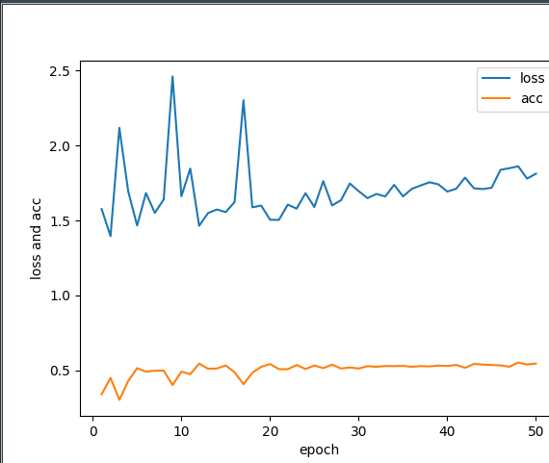

loss: [1.5763737176661536, 1.3955214256232713, 2.118301702540463, 1.693521633443409, 1.4665021963748444, 1.6833600924120937, 1.5511946042806593, 1.640583092158768, 2.461524157312324, 1.6619793155793385, 1.846784676709695, 1.4644518298865328, 1.549314581850496, 1.573477045844734, 1.555990247193769, 1.6228457307430488, 2.303072814825887, 1.588209819986233, 1.5994921576126426, 1.5051681146647375, 1.503670638534936, 1.6059443308078103, 1.5792582485910058, 1.6820010535649625, 1.5901791327413608, 1.762555205164174, 1.6006172568127413, 1.6349813925305414, 1.7468356583994458, 1.6958976627840168, 1.6490668940832927, 1.6771894662890428, 1.6605865318393322, 1.7382027005443341, 1.660755176884329, 1.7114445928930435, 1.7340766669603247, 1.7550948672147009, 1.7412151661406936, 1.693297959112062, 1.711881248979838, 1.786170222075759, 1.7148854506288531, 1.70990935838399, 1.7186814986199421, 1.8379550151837787, 1.8489847639688413, 1.8618124051177485, 1.7794996113347172, 1.81229015891998]

acc [0.340511440127727, 0.44952893682315564, 0.30282637962261727, 0.42934051148021846, 0.5141318979526432, 0.49125168240888606, 0.49730820995962316, 0.4986541052204764, 0.4017496635463004, 0.49125168239885836, 0.47442799461641993, 0.5450874830960907, 0.510767160241729, 0.5121130552619174, 0.532301480725187, 0.48721399754887473, 0.40713324364710946, 0.4838492597978497, 0.5235531628532974, 0.5417227457060628, 0.5080753703617953, 0.5074024224505932, 0.5356662182756581, 0.5087483175510031, 0.5323014804845222, 0.5148048452621835, 0.5376850607257191, 0.5121130552218066, 0.5188425303227487, 0.5121130551014742, 0.5275908481545275, 0.5235531630939623, 0.528936743174716, 0.5282637953437354, 0.5296096903639238, 0.5235531628532974, 0.528263795423957, 0.5262449530541174, 0.5316285330145388, 0.528936743174716, 0.5363391655851982, 0.5168236879930201, 0.5423956932963786, 0.5383580079951485, 0.5356662181152149, 0.5329744282352812, 0.5242261105238348, 0.5518169585179191, 0.5390309558261291, 0.5450874830960907]

predict : (evaluate bias)

loss [0.6155164779729585]

acc [0.8215465962059515]

Text 50 epoch(sgd):

Load_weights evaluate bias:

Text 50 (adam), audio 1 (adam), fusion 10 (adam):

final result:

text acc: 0.5434491978609626 audio acc: 0.32085561497326204 final acc: 0.3409090909090909

0 {'0': 18, '1': 106, '2': 9, '3': 31, '4': 42}

1 {'0': 22, '1': 147, '2': 14, '3': 63, '4': 83}

2 {'0': 0, '1': 6, '2': 106, '3': 16, '4': 88}

3 {'0': 5, '1': 152, '2': 42, '3': 89, '4': 136}

4 {'0': 7, '1': 62, '2': 45, '3': 57, '4': 150}

final result:

text acc: 0.5463087248322148

0 {'0': 34, '1': 55, '2': 26, '3': 38, '4': 59}

1 {'0': 50, '1': 81, '2': 43, '3': 64, '4': 108}

2 {'0': 32, '1': 62, '2': 30, '3': 42, '4': 54}

3 {'0': 65, '1': 101, '2': 58, '3': 59, '4': 89}

4 {'0': 47, '1': 81, '2': 58, '3': 65, '4': 89}

Load Text 50 (adam), audio 1 (adam), fusion 10 (adam):

Test_6:

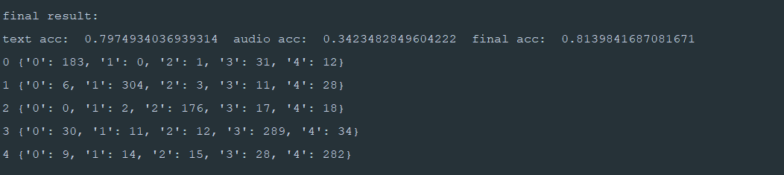

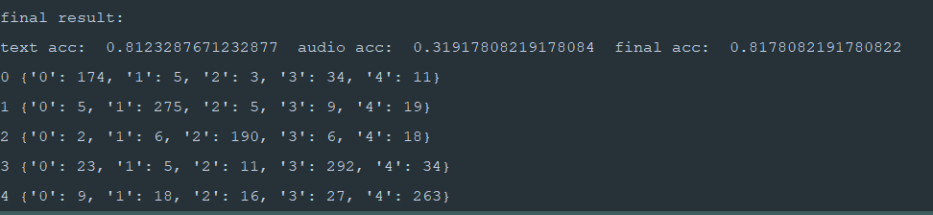

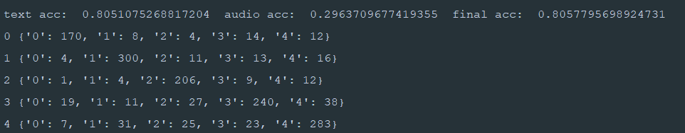

Retrain adam2 to sgd2, fusion at the same time

final result:

text acc: 0.7953333331743876 audio acc: 0.276 final acc: 0.8126666665077209

0 {'0': 181, '1': 7, '2': 3, '3': 29, '4': 2}

1 {'0': 0, '1': 317, '2': 11, '3': 7, '4': 18}

2 {'0': 0, '1': 8, '2': 177, '3': 10, '4': 13}

3 {'0': 21, '1': 12, '2': 16, '3': 282, '4': 37}

4 {'0': 6, '1': 33, '2': 18, '3': 30, '4': 262}

Time: audio train 1 epoch 6min10s

Pre trained(1) VS word2vec(2):

Text 50 epoch adam-> reload adam:

Bert

: 0.557171183084898->0.7563312800268372

final result:

text acc: 0.7675675675675676 audio acc: 0.31756756756756754 final acc: 0.3587837837837838

0 {'0': 64, '1': 42, '2': 14, '3': 69, '4': 29}

1 {'0': 36, '1': 89, '2': 28, '3': 101, '4': 76}

2 {'0': 2, '1': 10, '2': 119, '3': 24, '4': 66}

3 {'0': 40, '1': 61, '2': 53, '3': 114, '4': 101}

4 {'0': 13, '1': 43, '2': 53, '3': 88, '4': 145}

Pre sgd 50 :0.6244131455598942

Pre text adam 50 attention (16,64)0.5159401431359791

Eva test(test_6): 50,1,100

1. Load adam ->train sgd
2. Load adam ->train adam
3. Load adam

final result:

text acc: 0.7815631263321371 audio acc: 0.33 final acc: 0.8122912492446288

0 {'0': 184, '1': 7, '2': 1, '3': 25, '4': 18}

1 {'0': 2, '1': 296, '2': 4, '3': 9, '4': 13}

2 {'0': 2, '1': 5, '2': 178, '3': 14, '4': 18}

3 {'0': 33, '1': 13, '2': 9, '3': 298, '4': 27}

4 {'0': 6, '1': 35, '2': 8, '3': 32, '4': 260}

1. Load sgd
2. Train adam

50 adam 1 audio 100 fusion:

final result:

text acc: 0.5607661823379159 audio acc: 0.3245382585751979 final acc: 0.5898282696422844

0 {'0': 140, '1': 13, '2': 4, '3': 39, '4': 24}

1 {'0': 15, '1': 258, '2': 15, '3': 23, '4': 38}

2 {'0': 7, '1': 19, '2': 124, '3': 15, '4': 33}

3 {'0': 72, '1': 26, '2': 19, '3': 187, '4': 74}

4 {'0': 13, '1': 61, '2': 35, '3': 76, '4': 184}

1. Train sgd

Reload 看矩阵输出:

text_adam_50:

先跑一个adam看loss和矩阵

loss_t 1.8802054045448733 acc_t 0.5361645654011975

final result:

text acc: 0.5361645654011975

0 {'0': 98, '1': 9, '2': 7, '3': 46, '4': 37}

1 {'0': 13, '1': 234, '2': 19, '3': 24, '4': 58}

2 {'0': 15, '1': 23, '2': 110, '3': 42, '4': 45}

3 {'0': 62, '1': 25, '2': 30, '3': 193, '4': 86}

4 {'0': 25, '1': 48, '2': 25, '3': 60, '4': 173}

再reload 看loss 和输出矩阵

Loss：0.6670937940666696

Acc: 0.809713905601603

final result:

text acc: 0.809713905601603

0 {'0': 183, '1': 1, '2': 1, '3': 31, '4': 14}

1 {'0': 5, '1': 292, '2': 5, '3': 6, '4': 22}

2 {'0': 5, '1': 8, '2': 175, '3': 17, '4': 27}

3 {'0': 27, '1': 11, '2': 7, '3': 291, '4': 39}

4 {'0': 8, '1': 19, '2': 9, '3': 24, '4': 276}

text_adam_50_1.h5

先跑一个adam看loss和矩阵

loss_t 1.982715782529351 acc_t 0.5072765073178134

final result:

text acc: 0.5183645184058244

0 {'0': 105, '1': 14, '2': 6, '3': 60, '4': 25}

1 {'0': 14, '1': 196, '2': 24, '3': 30, '4': 74}

2 {'0': 12, '1': 19, '2': 93, '3': 35, '4': 53}

3 {'0': 70, '1': 9, '2': 29, '3': 165, '4': 79}

4 {'0': 38, '1': 37, '2': 26, '3': 57, '4': 173}

再reload 看loss 和输出矩阵

Loss_t 0.6358609387685228

Acc_t 0.803122878479294

final result:

text acc: 0.803122878479294

0 {'0': 161, '1': 5, '2': 0, '3': 39, '4': 13}

1 {'0': 2, '1': 250, '2': 5, '3': 13, '4': 37}

2 {'0': 4, '1': 8, '2': 165, '3': 15, '4': 19}

3 {'0': 21, '1': 8, '2': 7, '3': 330, '4': 34}

4 {'0': 10, '1': 12, '2': 11, '3': 27, '4': 277}

再reload 看loss 和输出矩阵

0.6292961700711139

0.8055555555555556

final result:

text acc: 0.8055555555555556

0 {'0': 200, '1': 4, '2': 0, '3': 34, '4': 15}

1 {'0': 3, '1': 267, '2': 4, '3': 14, '4': 36}

2 {'0': 2, '1': 4, '2': 174, '3': 22, '4': 33}

3 {'0': 15, '1': 2, '2': 10, '3': 298, '4': 36}

4 {'0': 8, '1': 8, '2': 14, '3': 37, '4': 308}

text_adam_50_2.h5

先跑一个adam看loss和矩阵

loss_t 1.8210216841051265 acc_t 0.5260078023407022

0.5396618985695709

final result:

text acc: 0.5396618985695709

0 {'0': 135, '1': 10, '2': 6, '3': 45, '4': 29}

1 {'0': 19, '1': 195, '2': 18, '3': 35, '4': 64}

2 {'0': 15, '1': 23, '2': 121, '3': 41, '4': 35}

3 {'0': 71, '1': 11, '2': 26, '3': 192, '4': 74}

4 {'0': 35, '1': 44, '2': 33, '3': 95, '4': 166}

Reload

0.6699460459052559

0.7729903536977492

final result:

text acc: 0.7729903536977492

0 {'0': 154, '1': 8, '2': 3, '3': 44, '4': 7}

1 {'0': 1, '1': 295, '2': 13, '3': 9, '4': 42}

2 {'0': 3, '1': 8, '2': 181, '3': 14, '4': 17}

3 {'0': 25, '1': 9, '2': 21, '3': 305, '4': 49}

4 {'0': 6, '1': 18, '2': 30, '3': 26, '4': 267}

text_sgd_50.h5

loss_t 2.64010592041882 acc_t 0.3468685480782023

0.47900894703183267

final result:

text acc: 0.47900894703183267

0 {'0': 78, '1': 1, '2': 2, '3': 7, '4': 112}

1 {'0': 6, '1': 51, '2': 11, '3': 2, '4': 272}

2 {'0': 9, '1': 3, '2': 49, '3': 2, '4': 136}

3 {'0': 78, '1': 1, '2': 13, '3': 26, '4': 269}

4 {'0': 9, '1': 4, '2': 5, '3': 7, '4': 300}

1.6664693342912102

0.5404509283819628

final result:

text acc: 0.5404509283819628

0 {'0': 101, '1': 55, '2': 0, '3': 62, '4': 14}

1 {'0': 2, '1': 302, '2': 0, '3': 20, '4': 17}

2 {'0': 5, '1': 116, '2': 2, '3': 81, '4': 27}

3 {'0': 13, '1': 54, '2': 1, '3': 275, '4': 26}

4 {'0': 7, '1': 119, '2': 0, '3': 74, '4': 135}

text_sgd_100.h5

效果很差

**loss_t 1.7532586969178299 acc_t 0.4336870026525199**

text acc: 0.46021220159151194

0 {'0': 33, '1': 1, '2': 175, '3': 9, '4': 7}

1 {'0': 2, '1': 42, '2': 281, '3': 2, '4': 19}

2 {'0': 1, '1': 1, '2': 239, '3': 3, '4': 1}

3 {'0': 17, '1': 0, '2': 321, '3': 35, '4': 18}

4 {'0': 1, '1': 2, '2': 263, '3': 5, '4': 30}

1.1334390280352036

0.5557020437426683

final result:

text acc: 0.5557020437426683

0 {'0': 103, '1': 6, '2': 2, '3': 75, '4': 54}

1 {'0': 3, '1': 199, '2': 0, '3': 19, '4': 121}

2 {'0': 2, '1': 11, '2': 47, '3': 36, '4': 105}

3 {'0': 37, '1': 10, '2': 1, '3': 218, '4': 108}

4 {'0': 5, '1': 23, '2': 2, '3': 54, '4': 276}

text_adam_50_2 ->text_sgd_50_2

reload adam -> train sgd()

loss 0.5591330174827771

text acc: 0.820915926179084

0 {'0': 178, '1': 5, '2': 3, '3': 22, '4': 18}

1 {'0': 1, '1': 275, '2': 14, '3': 7, '4': 33}

2 {'0': 5, '1': 5, '2': 170, '3': 13, '4': 18}

3 {'0': 29, '1': 10, '2': 15, '3': 246, '4': 42}

4 {'0': 8, '1': 14, '2': 21, '3': 24, '4': 287}

only 100 adam

0.548469387755102

final result:

text acc: 0.548469387755102

0 {'0': 122, '1': 12, '2': 12, '3': 52, '4': 29}

1 {'0': 17, '1': 250, '2': 23, '3': 31, '4': 69}

2 {'0': 13, '1': 25, '2': 104, '3': 23, '4': 49}

3 {'0': 62, '1': 18, '2': 47, '3': 182, '4': 79}

4 {'0': 31, '1': 45, '2': 40, '3': 72, '4': 161}

Load text_adam_50-> train 50 adam

0.618221782127802

0.8153638815622767

text acc: 0.8153638815622767

0 {'0': 127, '1': 5, '2': 8, '3': 57, '4': 21}

1 {'0': 6, '1': 239, '2': 13, '3': 16, '4': 54}

2 {'0': 6, '1': 18, '2': 132, '3': 27, '4': 33}

3 {'0': 36, '1': 15, '2': 43, '3': 218, '4': 57}

4 {'0': 10, '1': 44, '2': 31, '3': 49, '4': 219}

看audio最多能跑成多少

70 adam 0.4200268817204301 +10adam 0.432+10adam 0.46059782608695654

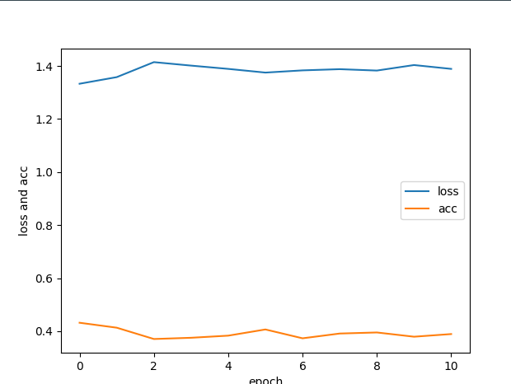

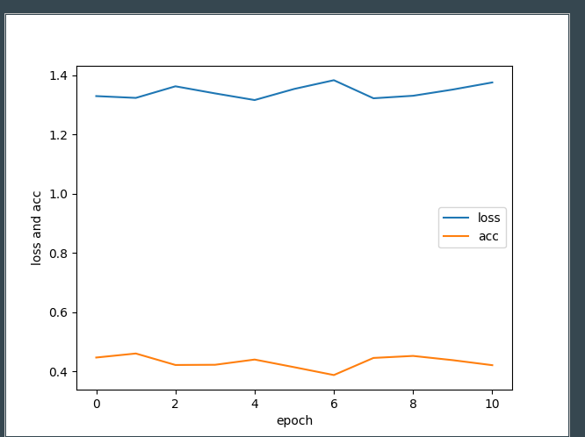

10 sgd 0.43766233766233764

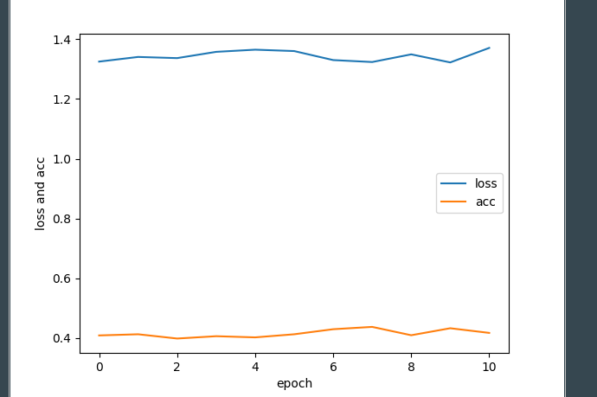

+10 adam 0.4437830687830688

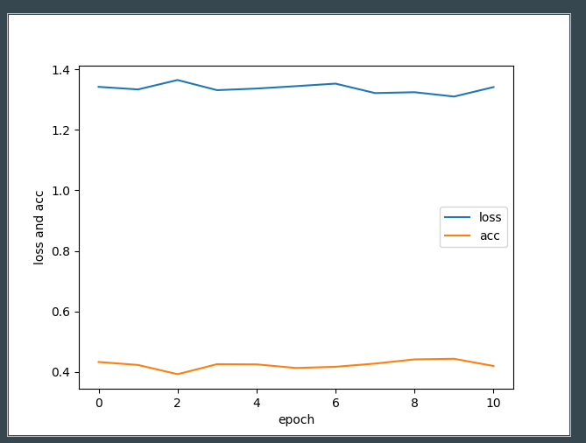

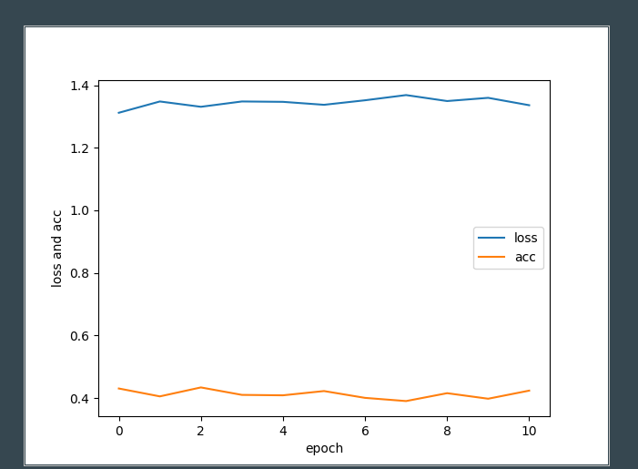

1.31

1. maxlen=98 100 adam

final result:

text acc: 0.5274204468517265

0 {'0': 127, '1': 9, '2': 10, '3': 54, '4': 17}

1 {'0': 19, '1': 209, '2': 23, '3': 33, '4': 50}

2 {'0': 15, '1': 31, '2': 102, '3': 39, '4': 35}

3 {'0': 63, '1': 18, '2': 42, '3': 179, '4': 71}

4 {'0': 27, '1': 56, '2': 38, '3': 76, '4': 134}

2. save test/train dataset as npy on more model

3.

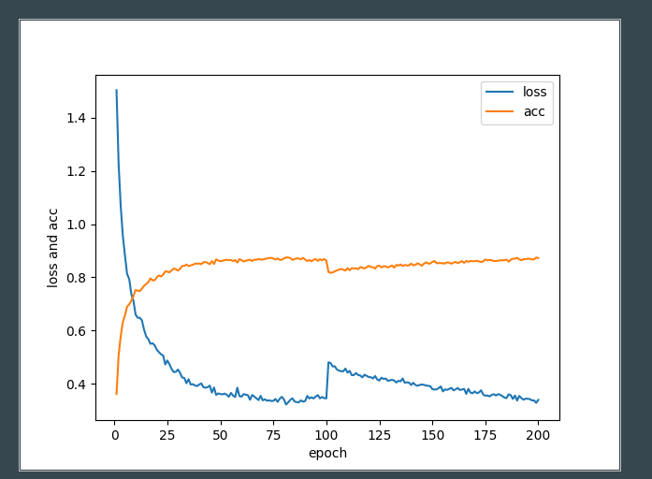

1. 200+200

adam ends: 0.5366178429952156

sgd ends : 0.5399467377227727

**final result:**

**text acc: 0.5399467377227727**

**0 {'0': 118, '1': 7, '2': 9, '3': 75, '4': 24}**

**1 {'0': 18, '1': 205, '2': 14, '3': 23, '4': 43}**

**2 {'0': 11, '1': 23, '2': 100, '3': 42, '4': 34}**

**3 {'0': 71, '1': 19, '2': 31, '3': 195, '4': 73}**

**4 {'0': 34, '1': 50, '2': 30, '3': 91, '4': 162}**

np.save('train_audio_data.npy',train_audio_data)  
np.save('train_text_data.npy',train_text_data)  
np.save('train_label.npy',train_label)  
  
np.save('test_audio_data.npy',test_audio_data)  
np.save('test_text_data.npy',test_text_data)  
np.save('test_label.npy',test_label)  
  
np.save('test_label_o.npy',test_label_o)

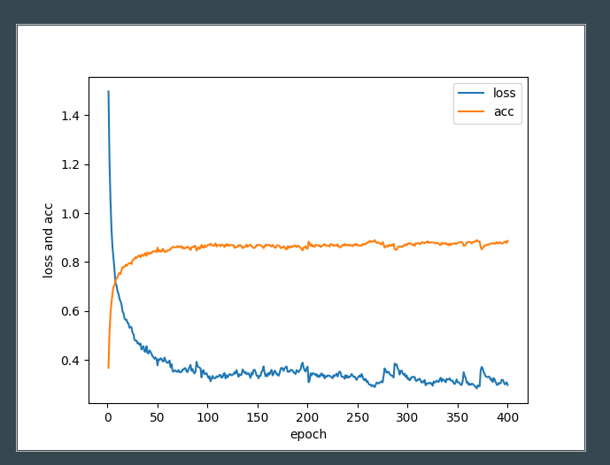

1. 500+500

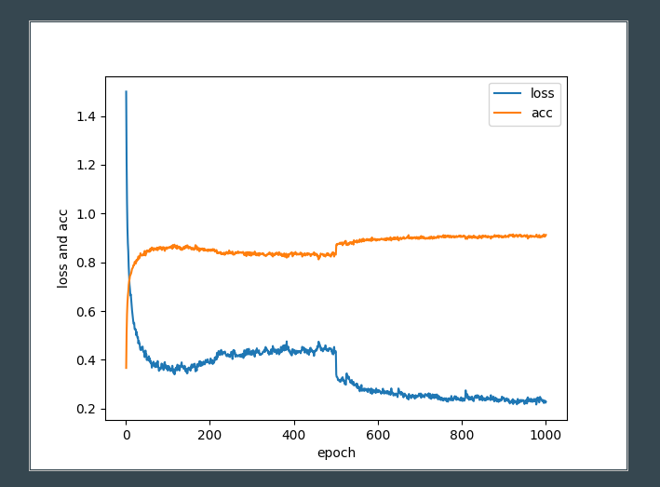

np.save('train_audio_data1.npy',train_audio_data)  
np.save('train_text_data1.npy',train_text_data)  
np.save('train_label1.npy',train_label)  
  
np.save('test_audio_data1.npy',test_audio_data)  
np.save('test_text_data1.npy',test_text_data)  
np.save('test_label1.npy',test_label)  
  
np.save('test_label_o1.npy',test_label_o)

sgd ends : 0.5507246377989552

final result:

text acc: 0.5507246377989552

0 {'0': 119, '1': 13, '2': 11, '3': 75, '4': 26}

1 {'0': 11, '1': 207, '2': 31, '3': 29, '4': 53}

2 {'0': 11, '1': 18, '2': 115, '3': 28, '4': 30}

3 {'0': 65, '1': 24, '2': 37, '3': 189, '4': 63}

4 {'0': 29, '1': 40, '2': 52, '3': 80, '4': 162}

1. 500+500

sgd ends : 0.550501672280672

final result:

text acc: 0.550501672280672

0 {'0': 139, '1': 9, '2': 4, '3': 57, '4': 19}

1 {'0': 15, '1': 202, '2': 31, '3': 30, '4': 70}

2 {'0': 8, '1': 19, '2': 101, '3': 32, '4': 34}

3 {'0': 67, '1': 23, '2': 32, '3': 195, '4': 74}

4 {'0': 29, '1': 47, '2': 34, '3': 71, '4': 153}

np.save('train_audio_data2.npy',train_audio_data)  
np.save('train_text_data2.npy',train_text_data)  
np.save('train_label2.npy',train_label)  
  
np.save('test_audio_data2.npy',test_audio_data)  
np.save('test_text_data2.npy',test_text_data)  
np.save('test_label2.npy',test_label)

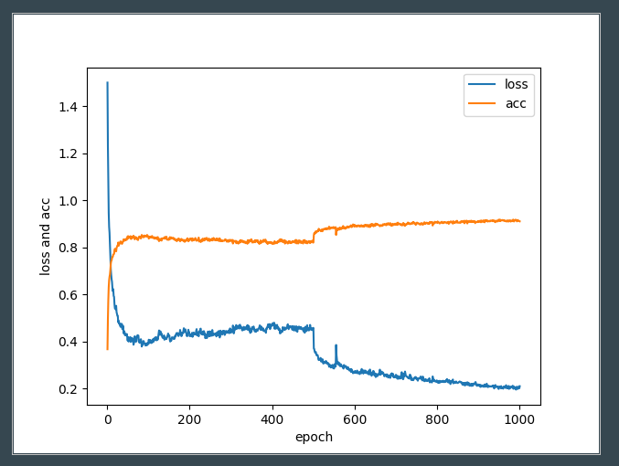

1. sgd ends : 0.5471956223534821
2. final result:
3. text acc: 0.5471956223534821
4. 0 {'0': 115, '1': 9, '2': 9, '3': 61, '4': 30}
5. 1 {'0': 14, '1': 196, '2': 21, '3': 37, '4': 49}
6. 2 {'0': 6, '1': 16, '2': 111, '3': 34, '4': 35}
7. 3 {'0': 49, '1': 28, '2': 41, '3': 195, '4': 69}
8. 4 {'0': 28, '1': 54, '2': 27, '3': 79, '4': 149}

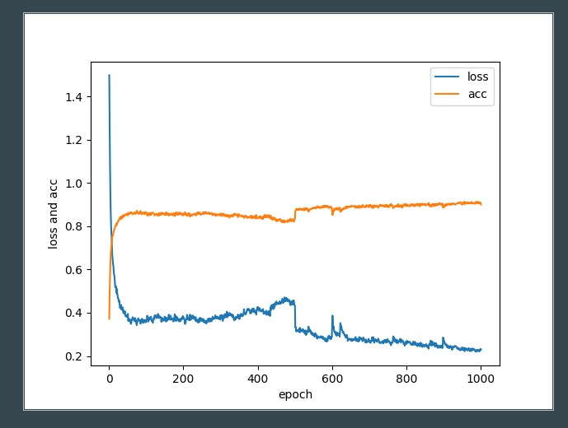

5classFusion 跑一下

4_class text

loss_t 1.8522824481913918 acc_t 0.6282894736842105

sgd ends : 0.6585526315789474

final result:

text acc: 0.6585526315789474

0 {'0': 133, '1': 16, '2': 12, '3': 83}

1 {'0': 10, '1': 197, '2': 23, '3': 79}

2 {'0': 12, '1': 20, '2': 128, '3': 60}

3 {'0': 101, '1': 66, '2': 83, '3': 497}

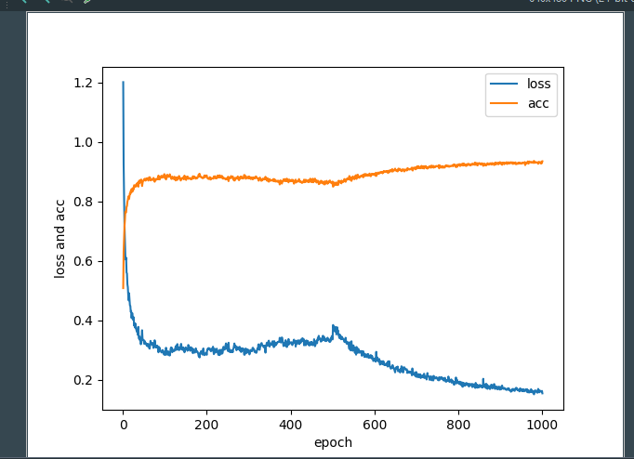

4_clas fusion

Bert 1000

0.5146082337317397

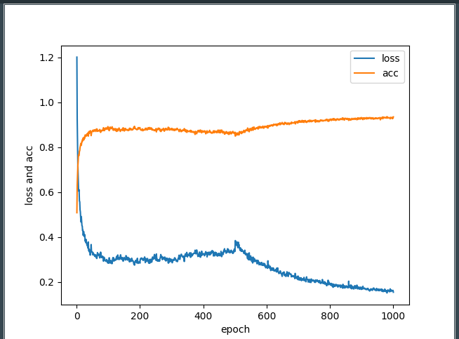

Self-attention1:

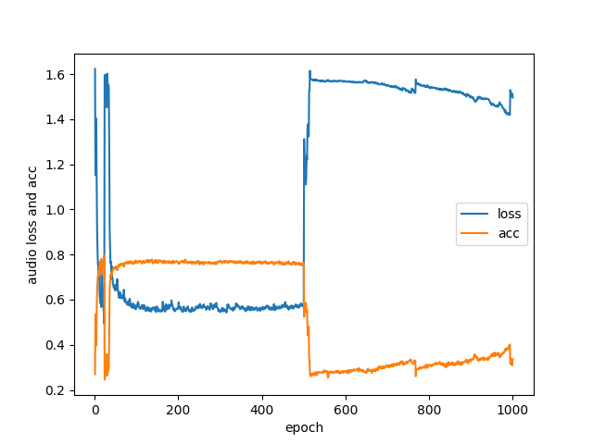

final result: （500+500）

text acc: 0.5105540897883967

0 {'0': 4, '1': 53, '2': 0, '3': 81, '4': 93}

1 {'0': 0, '1': 62, '2': 1, '3': 56, '4': 208}

2 {'0': 1, '1': 48, '2': 2, '3': 58, '4': 134}

3 {'0': 5, '1': 81, '2': 1, '3': 173, '4': 110}

4 {'0': 2, '1': 60, '2': 1, '3': 94, '4': 188}

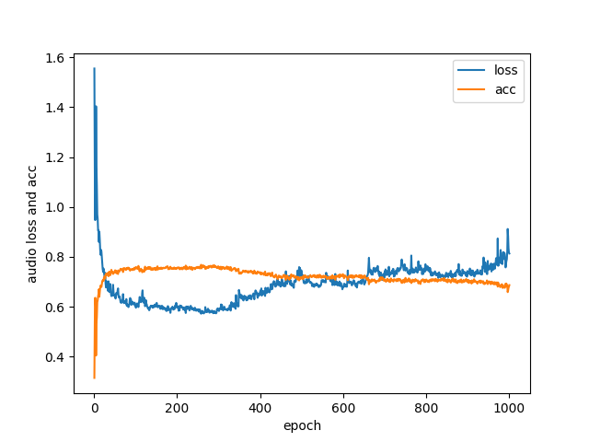

final result: 1000 adam

text acc: 0.5102853351424053

0 {'0': 9, '1': 122, '2': 8, '3': 38, '4': 26}

1 {'0': 0, '1': 316, '2': 8, '3': 6, '4': 23}

2 {'0': 0, '1': 161, '2': 23, '3': 13, '4': 31}

3 {'0': 4, '1': 180, '2': 24, '3': 103, '4': 77}

4 {'0': 0, '1': 197, '2': 26, '3': 40, '4': 72}

text acc: 0.5309734514897335

0 {'0': 119, '1': 4, '2': 7, '3': 83, '4': 19}

1 {'0': 14, '1': 166, '2': 29, '3': 37, '4': 64}

2 {'0': 5, '1': 20, '2': 112, '3': 60, '4': 35}

3 {'0': 44, '1': 19, '2': 23, '3': 222, '4': 49}

4 {'0': 29, '1': 34, '2': 33, '3': 81, '4': 161}

Attention Test：

Multi head attention(self_attention 2 new 0.1):

1000

text acc: 0.5085638996326562

0 {'0': 106, '1': 14, '2': 5, '3': 84, '4': 15}

1 {'0': 14, '1': 213, '2': 22, '3': 31, '4': 47}

2 {'0': 11, '1': 32, '2': 86, '3': 60, '4': 40}

3 {'0': 48, '1': 35, '2': 18, '3': 212, '4': 69}

4 {'0': 25, '1': 56, '2': 26, '3': 94, '4': 155}

Multi head attention(self_attention 2 new 2 layer 0.1):

1000

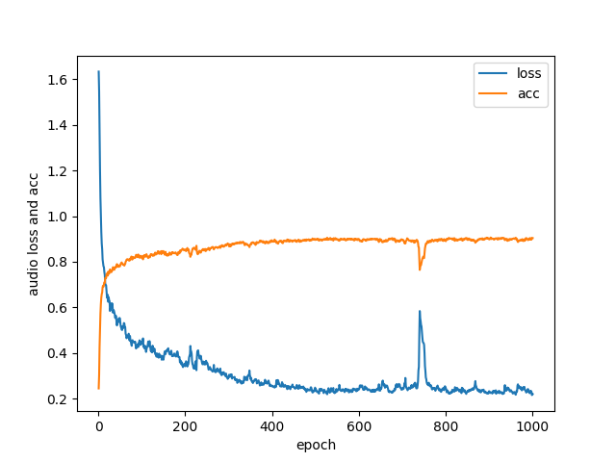

sgd ends : 0.5211360634869282

final result:

text acc: 0.5211360634869282

0 {'0': 76, '1': 10, '2': 9, '3': 70, '4': 42}

1 {'0': 12, '1': 192, '2': 37, '3': 23, '4': 59}

2 {'0': 5, '1': 30, '2': 107, '3': 44, '4': 36}

3 {'0': 49, '1': 26, '2': 38, '3': 231, '4': 80}

4 {'0': 15, '1': 40, '2': 36, '3': 64, '4': 183}

Multi head attention(self_attention 2 new 2 layer 0.00):

1000

final result:

text acc: 0.51657824933687

0 {'0': 112, '1': 2, '2': 9, '3': 66, '4': 32}

1 {'0': 18, '1': 198, '2': 27, '3': 31, '4': 62}

2 {'0': 10, '1': 18, '2': 111, '3': 37, '4': 42}

3 {'0': 58, '1': 30, '2': 37, '3': 201, '4': 67}

4 {'0': 19, '1': 36, '2': 42, '3': 86, '4': 157}

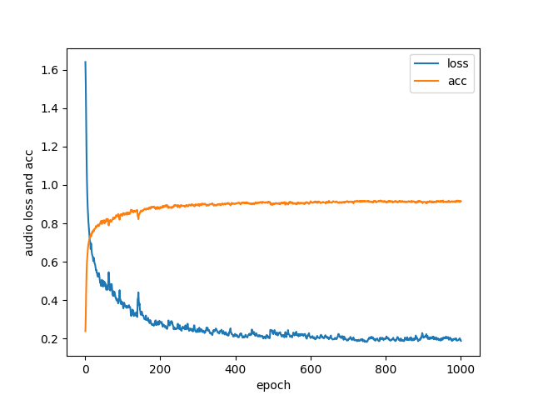

Multi head attention(self_attention 2 layer=2 dp= 0.25):（正常）

1000

final result:

text acc: 0.5447470817120622

0 {'0': 97, '1': 7, '2': 7, '3': 88, '4': 23}

1 {'0': 8, '1': 223, '2': 23, '3': 25, '4': 70}

2 {'0': 5, '1': 24, '2': 134, '3': 30, '4': 38}

3 {'0': 33, '1': 35, '2': 26, '3': 222, '4': 91}

4 {'0': 9, '1': 54, '2': 37, '3': 69, '4': 164}

text acc: 0.5246433204018188

0 {'2': 6, '3': 56, '1': 14, '0': 128, '4': 38}

1 {'2': 17, '3': 13, '1': 245, '0': 17, '4': 68}

2 {'2': 102, '3': 36, '1': 23, '0': 21, '4': 33}

3 {'2': 30, '3': 157, '1': 24, '0': 86, '4': 89}

4 {'2': 24, '3': 67, '1': 41, '0': 30, '4': 177}

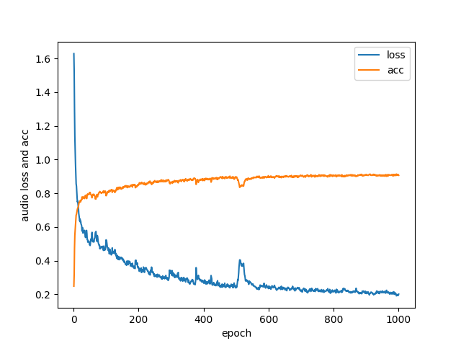

Multi head attention(self_attention 2 new 2 layer 0.35):

final result:

text acc: 0.5122923588039867

0 {'0': 105, '1': 4, '2': 4, '3': 87, '4': 29}

1 {'0': 6, '1': 187, '2': 7, '3': 41, '4': 74}

2 {'0': 9, '1': 20, '2': 67, '3': 66, '4': 48}

3 {'0': 40, '1': 29, '2': 10, '3': 233, '4': 91}

4 {'0': 10, '1': 33, '2': 13, '3': 113, '4': 179}

Multi head attention(self_attention 2 new 2 layer 0.3):

final result:

text acc: 0.5255813953488372

0 {'0': 124, '4': 26, '3': 51, '2': 10, '1': 9}

1 {'0': 9, '4': 66, '3': 31, '2': 27, '1': 189}

2 {'0': 9, '4': 38, '3': 41, '2': 114, '1': 21}

3 {'0': 49, '4': 76, '3': 196, '2': 44, '1': 21}

4 {'0': 19, '4': 168, '3': 76, '2': 38, '1': 53}

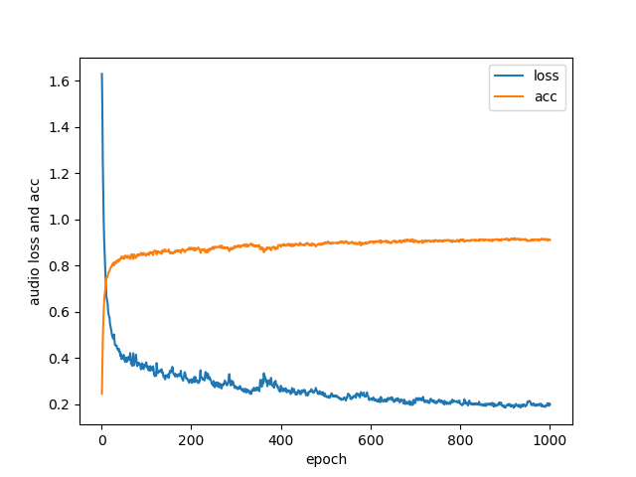

Multi head attention(self_attention 2 layer=2, dp=0.25)(10,20,64)再试一下

final result:

text acc: 0.5429530201342282

0 {'4': 28, '0': 112, '2': 17, '1': 11, '3': 52}

1 {'4': 53, '0': 11, '2': 26, '1': 209, '3': 18}

2 {'4': 38, '0': 10, '2': 115, '1': 26, '3': 33}

3 {'4': 59, '0': 57, '2': 40, '1': 28, '3': 190}

4 {'4 final result:

text acc: 0.54460719049215

0 {'2': 9, '3': 47, '4': 19, '1': 10, '0': 135}

1 {'2': 23, '3': 22, '4': 48, '1': 228, '0': 14}

2 {'2': 105, '3': 37, '4': 37, '1': 26, '0': 16}

3 {'2': 32, '3': 172, '4': 59, '1': 40, '0': 59}

4 {'2': 25, '3': 70, '4': 178, '1': 56, '0': 35}': 180, '0': 18, '2': 33, '1': 52, '3': 74}

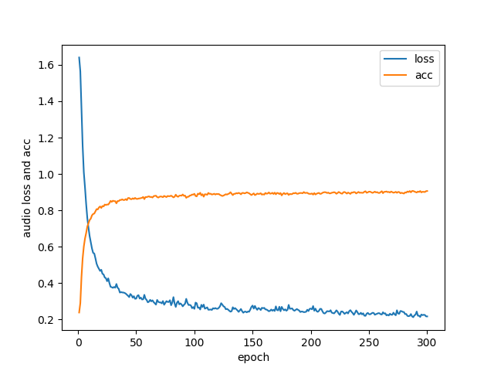

Multi head attention(self_attention 2 layer=2, dp=0.25)(10,20,20)

final result:

text acc: 0.5286219081693319

0 {'2': 12, '0': 127, '3': 55, '4': 13, '1': 4}

1 {'2': 40, '0': 16, '3': 38, '4': 35, '1': 200}

2 {'2': 129, '0': 10, '3': 31, '4': 26, '1': 16}

3 {'2': 34, '0': 56, '3': 160, '4': 65, '1': 25}

4 {'2': 53, '0': 24, '3': 66, '4': 132, '1': 48}

final result:

text acc: 0.5291359678599472

0 {'1': 7, '3': 57, '0': 111, '4': 21, '2': 8}

1 {'1': 206, '3': 22, '0': 17, '4': 66, '2': 28}

2 {'1': 19, '3': 19, '0': 12, '4': 41, '2': 114}

3 {'1': 16, '3': 160, '0': 69, '4': 85, '2': 51}

4 {'1': 44, '3': 61, '0': 21, '4': 199, '2': 39}

text acc: 0.5328418230563002

0 {'1': 10, '2': 5, '0': 102, '3': 68, '4': 30}

1 {'1': 198, '2': 20, '0': 11, '3': 26, '4': 69}

2 {'1': 18, '2': 91, '0': 14, '3': 46, '4': 47}

3 {'1': 22, '2': 22, '0': 45, '3': 210, '4': 93}

4 {'1': 54, '2': 19, '0': 18, '3': 60, '4': 194}

Multi head attention(self_attention 2 layer=3, dp=0.25)(10,20,64)

final result:

text acc: 0.4755197854189166

0 {'3': 89, '2': 11, '4': 29, '1': 7, '0': 104}

1 {'3': 34, '2': 17, '4': 80, '1': 197, '0': 23}

2 {'3': 49, '2': 92, '4': 50, '1': 12, '0': 5}

3 {'3': 162, '2': 49, '4': 71, '1': 17, '0': 53}

4 {'3': 88, '2': 32, '4': 154, '1': 38, '0': 28}

Multi head attention(self_attention 2 layer=3, dp=0.25)(10,20,20)

sgd ends : 0.5331978319783198

final result:

text acc: 0.5331978319783198

0 {'2': 17, '0': 123, '4': 12, '3': 56, '1': 15}

1 {'2': 30, '0': 12, '4': 22, '3': 29, '1': 196}

2 {'2': 127, '0': 9, '4': 10, '3': 41, '1': 22}

3 {'2': 38, '0': 73, '4': 40, '3': 220, '1': 32}

4 {'2': 52, '0': 32, '4': 121, '3': 78, '1': 69}

sgd ends : 0.5522580647468567

final result:

text acc: 0.5522580647468567

0 {'4': 16, '3': 74, '0': 115, '2': 15, '1': 21}

1 {'4': 41, '3': 15, '0': 6, '2': 28, '1': 250}

2 {'4': 15, '3': 19, '0': 6, '2': 151, '1': 36}

3 {'4': 41, '3': 200, '0': 46, '2': 54, '1': 34}

4 {'4': 140, '3': 72, '0': 19, '2': 64, '1': 72}

text acc: 0.53421926910299

0 {'2': 13, '1': 12, '3': 60, '0': 119, '4': 25}

1 {'2': 53, '1': 207, '3': 11, '0': 12, '4': 54}

2 {'2': 146, '1': 16, '3': 24, '0': 9, '4': 24}

3 {'2': 46, '1': 17, '3': 173, '0': 58, '4': 51}

4 {'2': 55, '1': 64, '3': 71, '0': 26, '4': 159}

sgd ends : 0.5177971793149765

final result:

text acc: 0.5177971793149765

0 {'2': 13, '0': 150, '3': 47, '1': 13, '4': 15}

1 {'2': 24, '0': 23, '3': 11, '1': 243, '4': 23}

2 {'2': 117, '0': 16, '3': 39, '1': 33, '4': 13}

3 {'2': 52, '0': 65, '3': 149, '1': 53, '4': 53}

4 {'2': 48, '0': 30, '3': 53, '1': 94, '4': 112}

Head size kqv

两层 10，20/64，64

三层10， 20，20

Self_attention

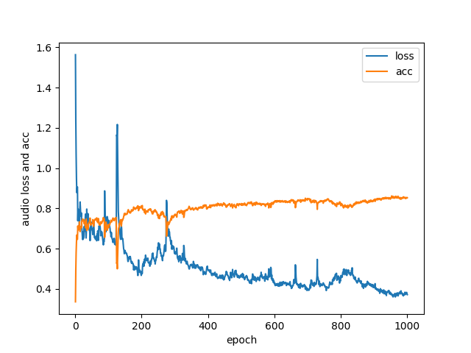

1000

text acc: 0.5195681513079747

0 {'0': 108, '1': 13, '2': 8, '3': 63, '4': 28}

1 {'0': 15, '1': 227, '2': 21, '3': 28, '4': 57}

2 {'0': 15, '1': 37, '2': 102, '3': 39, '4': 33}

3 {'0': 53, '1': 31, '2': 27, '3': 179, '4': 57}

4 {'0': 22, '1': 50, '2': 39, '3': 76, '4': 154}

Self_attention (4,64) 三层

final result:

text acc: 0.5023411372433538

0 {'0': 138, '2': 4, '4': 48, '1': 9, '3': 46}

1 {'0': 14, '2': 2, '4': 81, '1': 207, '3': 9}

2 {'0': 26, '2': 59, '4': 77, '1': 27, '3': 25}

3 {'0': 84, '2': 12, '4': 122, '1': 32, '3': 127}

4 {'0': 31, '2': 6, '4': 220, '1': 40, '3': 49}

Self_attention (10,20) 三层

final result:

text acc: 0.5390359809911744

0 {'1': 14, '3': 54, '0': 131, '2': 12, '4': 21}

1 {'1': 218, '3': 26, '0': 10, '2': 23, '4': 59}

2 {'1': 26, '3': 15, '0': 10, '2': 108, '4': 35}

3 {'1': 31, '3': 174, '0': 58, '2': 43, '4': 61}

4 {'1': 65, '3': 63, '0': 23, '2': 30, '4': 163}

Self_attention (10,20)两层

sgd ends : 0.5505992009858793

final result:

text acc: 0.5505992009858793

0 {'4': 48, '0': 110, '3': 59, '1': 11, '2': 13}

1 {'4': 69, '0': 5, '3': 23, '1': 186, '2': 35}

2 {'4': 46, '0': 7, '3': 28, '1': 21, '2': 139}

3 {'4': 80, '0': 42, '3': 184, '1': 15, '2': 44}

4 {'4': 208, '0': 9, '3': 46, '1': 41, '2': 33}

Self_attention (4,64)两层

这里

Self_attention1

1000

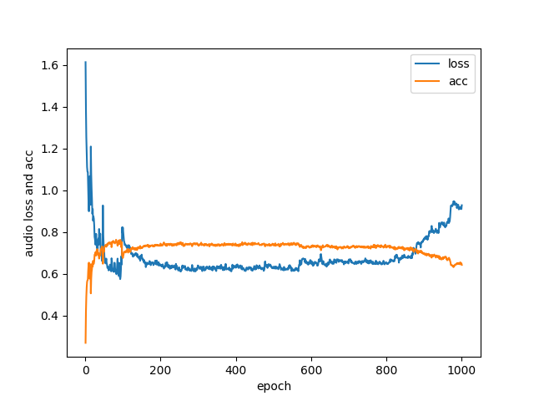

text acc: 0.4957488556170167

0 {'0': 104, '1': 13, '2': 8, '3': 57, '4': 24}

1 {'0': 9, '1': 205, '2': 23, '3': 60, '4': 61}

2 {'0': 16, '1': 30, '2': 71, '3': 66, '4': 41}

3 {'0': 43, '1': 20, '2': 32, '3': 219, '4': 64}

4 {'0': 17, '1': 61, '2': 29, '3': 97, '4': 159}

Bert self_attention （10，20）

text acc: 0.4480651731160896

0 {'1': 25, '2': 5, '3': 111, '4': 27, '0': 25}

1 {'1': 136, '2': 29, '3': 93, '4': 54, '0': 8}

2 {'1': 27, '2': 78, '3': 81, '4': 55, '0': 4}

3 {'1': 33, '2': 25, '3': 218, '4': 72, '0': 24}

4 {'1': 45, '2': 26, '3': 148, '4': 117, '0': 7}

Bert self attention 1 (4,64)

Bert self attention (4,64)

Self_attention(2 layer)

(n_head=10, d_k=100, d_model=200, dropout=0.25, attn_dropout=0.1, ffn_dropout=0.1, use_norm=True, use_ffn=True)

adam ends: 0.4625

final result:

text acc: 0.4625

0 {'3': 32, '4': 0, '2': 22, '0': 139, '1': 24}

1 {'3': 15, '4': 0, '2': 56, '0': 32, '1': 222}

2 {'3': 23, '4': 0, '2': 139, '0': 19, '1': 26}

3 {'3': 119, '4': 0, '2': 93, '0': 83, '1': 58}

4 {'3': 45, '4': 0, '2': 116, '0': 43, '1': 134}

(n_head=10, d_k=100, d_model=200, dropout=0.25, attn_dropout=0.1, ffn_dropout=0.1, use_norm=True, use_ffn=False)

final result:

text acc: 0.5221179624664879

0 {'2': 28, '0': 125, '3': 53, '4': 8, '1': 7}

1 {'2': 61, '0': 28, '3': 21, '4': 17, '1': 157}

2 {'2': 158, '0': 19, '3': 28, '4': 8, '1': 20}

3 {'2': 77, '0': 78, '3': 184, '4': 26, '1': 13}

4 {'2': 110, '0': 55, '3': 90, '4': 70, '1': 51}

(n_head=10, d_k=100, d_model=200, dropout=0.25, attn_dropout=0.25, ffn_dropout=0.1, use_norm=True, use_ffn=False)

final result:

text acc: 0.5086206896551724

0 {'2': 15, '1': 16, '4': 16, '3': 58, '0': 123}

1 {'2': 46, '1': 192, '4': 30, '3': 25, '0': 19}

2 {'2': 125, '1': 12, '4': 16, '3': 51, '0': 13}

3 {'2': 47, '1': 27, '4': 45, '3': 183, '0': 77}

4 {'2': 61, '1': 57, '4': 118, '3': 97, '0': 39}

Head:

(n_head=4, d_k=50, d_model=200, dropout=0.25, attn_dropout=0.1, ffn_dropout=0.1, use_norm=True, use_ffn=False)

text acc: 0.500666666507721

0 {'4': 43, '2': 24, '3': 53, '1': 11, '0': 82}

1 {'4': 70, '2': 53, '3': 28, '1': 180, '0': 7}

2 {'4': 44, '2': 138, '3': 14, '1': 16, '0': 10}

3 {'4': 97, '2': 67, '3': 131, '1': 28, '0': 53}

4 {'4': 183, '2': 62, '3': 54, '1': 41, '0': 11}

(n_head=10, d_k=50, d_model=200, dropout=0.25, attn_dropout=0.1, ffn_dropout=0.1, use_norm=True, use_ffn=False)

final result:

text acc: 0.5296523518398171

0 {'2': 16, '4': 26, '0': 104, '3': 69, '1': 12}

1 {'2': 27, '4': 46, '0': 11, '3': 27, '1': 216}

2 {'2': 103, '4': 28, '0': 11, '3': 36, '1': 32}

3 {'2': 36, '4': 77, '0': 41, '3': 188, '1': 26}

4 {'2': 43, '4': 149, '0': 19, '3': 62, '1': 62}

(n_head=20, d_k=50, d_model=200, dropout=0.25, attn_dropout=0.1, ffn_dropout=0.1, use_norm=True, use_ffn=False)

final result:

text acc: 0.5299600533020005

0 {'2': 22, '4': 30, '0': 101, '1': 17, '3': 60}

1 {'2': 30, '4': 59, '0': 9, '1': 222, '3': 21}

2 {'2': 122, '4': 37, '0': 3, '1': 19, '3': 48}

3 {'2': 39, '4': 93, '0': 36, '1': 24, '3': 172}

4 {'2': 56, '4': 161, '0': 13, '1': 55, '3': 53}

(n_head=50, d_k=50, d_model=200, dropout=0.25, attn_dropout=0.1, ffn_dropout=0.1, use_norm=True, use_ffn=False)

final result:

text acc: 0.5531914893617021

0 {'3': 25, '4': 26, '0': 158, '2': 16, '1': 6}

1 {'3': 12, '4': 76, '0': 19, '2': 43, '1': 191}

2 {'3': 25, '4': 36, '0': 21, '2': 118, '1': 13}

3 {'3': 105, '4': 94, '0': 94, '2': 43, '1': 17}

4 {'3': 58, '4': 150, '0': 36, '2': 39, '1': 36}

final result:

text acc: 0.5259697567389875

0 {'4': 53, '3': 67, '1': 9, '0': 95, '2': 3}

1 {'4': 92, '3': 19, '1': 206, '0': 9, '2': 38}

2 {'4': 35, '3': 36, '1': 18, '0': 4, '2': 112}

3 {'4': 112, '3': 161, '1': 15, '0': 32, '2': 46}

4 {'4': 191, '3': 64, '1': 30, '0': 18, '2': 56}

(n_head=75, d_k=50, d_model=200, dropout=0.25, attn_dropout=0.1, ffn_dropout=0.1, use_norm=True, use_ffn=False)

final result:

text acc: 0.5245683930942895

0 {'3': 32, '0': 138, '1': 8, '2': 25, '4': 28}

1 {'3': 16, '0': 16, '1': 194, '2': 54, '4': 58}

2 {'3': 13, '0': 17, '1': 16, '2': 146, '4': 34}

3 {'3': 113, '0': 72, '1': 19, '2': 89, '4': 70}

4 {'3': 47, '0': 26, '1': 47, '2': 60, '4': 168}

final result:

text acc: 0.5162144276103304

0 {'3': 49, '2': 25, '4': 24, '1': 6, '0': 116}

1 {'3': 11, '2': 55, '4': 68, '1': 183, '0': 10}

2 {'3': 24, '2': 144, '4': 24, '1': 22, '0': 7}

3 {'3': 141, '2': 79, '4': 83, '1': 33, '0': 74}

4 {'3': 52, '2': 73, '4': 148, '1': 44, '0': 16}

(n_head=100, d_k=50, d_model=200, dropout=0.25, attn_dropout=0.1, ffn_dropout=0.1, use_norm=True, use_ffn=False)

final result:

text acc: 0.5399467377227727

0 {'4': 36, '0': 125, '3': 12, '1': 14, '2': 36}

1 {'4': 54, '0': 12, '3': 4, '1': 220, '2': 46}

2 {'4': 31, '0': 17, '3': 2, '1': 20, '2': 143}

3 {'4': 126, '0': 77, '3': 27, '1': 21, '2': 153}

4 {'4': 167, '0': 20, '3': 5, '1': 50, '2': 84}

final result:

text acc: 0.5257870061079768

0 {'3': 58, '1': 9, '0': 85, '4': 14, '2': 24}

1 {'3': 31, '1': 208, '0': 6, '4': 31, '2': 57}

2 {'3': 35, '1': 24, '0': 8, '4': 11, '2': 136}

3 {'3': 174, '1': 20, '0': 59, '4': 34, '2': 84}

4 {'3': 105, '1': 55, '0': 26, '4': 99, '2': 100}

D_k

(n_head=50, d_k=50, d_model=200, dropout=0.25, attn_dropout=0.1, ffn_dropout=0.1, use_norm=True, use_ffn=False)

final result:

text acc: 0.5531914893617021

0 {'3': 25, '4': 26, '0': 158, '2': 16, '1': 6}

1 {'3': 12, '4': 76, '0': 19, '2': 43, '1': 191}

2 {'3': 25, '4': 36, '0': 21, '2': 118, '1': 13}

3 {'3': 105, '4': 94, '0': 94, '2': 43, '1': 17}

4 {'3': 58, '4': 150, '0': 36, '2': 39, '1': 36}

final result:

text acc: 0.5259697567389875

0 {'4': 53, '3': 67, '1': 9, '0': 95, '2': 3}

1 {'4': 92, '3': 19, '1': 206, '0': 9, '2': 38}

2 {'4': 35, '3': 36, '1': 18, '0': 4, '2': 112}

3 {'4': 112, '3': 161, '1': 15, '0': 32, '2': 46}

4 {'4': 191, '3': 64, '1': 30, '0': 18, '2': 56}

(n_head=50, d_k=20, d_model=200, dropout=0.25, attn_dropout=0.1, ffn_dropout=0.1, use_norm=True, use_ffn=False)

text acc: 0.5328368314553856

0 {'4': 29, '1': 10, '3': 54, '0': 134, '2': 13}

1 {'4': 68, '1': 216, '3': 23, '0': 12, '2': 19}

2 {'4': 24, '1': 27, '3': 26, '0': 14, '2': 106}

3 {'4': 89, '1': 22, '3': 148, '0': 75, '2': 44}

4 {'4': 150, '1': 50, '3': 54, '0': 33, '2': 37}

(n_head=50, d_k=200, d_model=200, dropout=0.25, attn_dropout=0.1, ffn_dropout=0.1, use_norm=True, use_ffn=False)

final result:

text acc: 0.5092402464167701

0 {'0': 115, '1': 6, '2': 12, '4': 26, '3': 56}

1 {'0': 6, '1': 192, '2': 34, '4': 62, '3': 27}

2 {'0': 11, '1': 26, '2': 120, '4': 39, '3': 26}

3 {'0': 55, '1': 16, '2': 59, '4': 55, '3': 158}

4 {'0': 27, '1': 61, '2': 44, '4': 138, '3': 90}

(n_head=50, d_k=10, d_model=200, dropout=0.25, attn_dropout=0.1, ffn_dropout=0.1, use_norm=True, use_ffn=False)

final result:

text acc: 0.5241935483870968

0 {'3': 59, '4': 16, '2': 14, '0': 124, '1': 12}

1 {'3': 32, '4': 45, '2': 24, '0': 20, '1': 194}

2 {'3': 46, '4': 27, '2': 120, '0': 15, '1': 19}

3 {'3': 171, '4': 66, '2': 42, '0': 65, '1': 18}

4 {'3': 81, '4': 139, '2': 44, '0': 38, '1': 57}

(n_head=50, d_k=10, d_model=200, dropout=0.25, attn_dropout=0.1, ffn_dropout=0.1, use_norm=True, use_ffn=False)

text acc: 0.546831955758665

0 {'0': 139, '4': 22, '3': 55, '1': 7, '2': 7}

1 {'0': 23, '4': 43, '3': 15, '1': 205, '2': 20}

2 {'0': 12, '4': 21, '3': 32, '1': 28, '2': 111}

3 {'0': 66, '4': 47, '3': 188, '1': 32, '2': 46}

4 {'0': 41, '4': 131, '3': 65, '1': 61, '2': 35}

(n_head=100, d_k=10, d_model=200, dropout=0.25, attn_dropout=0.1, ffn_dropout=0.1, use_norm=True, use_ffn=False)

adam ends: 0.5471947196293192

final result:

text acc: 0.5471947196293192

0 {'3': 40, '2': 9, '1': 6, '4': 32, '0': 144}

1 {'3': 14, '2': 26, '1': 204, '4': 58, '0': 15}

2 {'3': 29, '2': 132, '1': 18, '4': 27, '0': 9}

3 {'3': 135, '2': 39, '1': 23, '4': 93, '0': 92}

4 {'3': 51, '2': 45, '1': 61, '4': 180, '0': 33}

(n_head=200, d_k=10, d_model=200, dropout=0.25, attn_dropout=0.1, ffn_dropout=0.1, use_norm=True, use_ffn=False)

final result:

text acc: 0.5262807719483823

0 {'2': 25, '3': 26, '1': 9, '0': 145, '4': 16}

1 {'2': 56, '3': 14, '1': 214, '0': 23, '4': 46}

2 {'2': 146, '3': 6, '1': 14, '0': 10, '4': 29}

3 {'2': 94, '3': 83, '1': 12, '0': 104, '4': 73}

4 {'2': 81, '3': 41, '1': 51, '0': 35, '4': 150}

(n_head=150, d_k=10, d_model=200, dropout=0.25, attn_dropout=0.1, ffn_dropout=0.1, use_norm=True, use_ffn=False)

adam ends: 0.5372836218772334

final result:

text acc: 0.5372836218772334

0 {'2': 14, '4': 24, '3': 67, '1': 7, '0': 119}

1 {'2': 56, '4': 55, '3': 18, '1': 200, '0': 11}

2 {'2': 115, '4': 25, '3': 37, '1': 17, '0': 6}

3 {'2': 32, '4': 65, '3': 199, '1': 30, '0': 60}

4 {'2': 38, '4': 151, '3': 87, '1': 52, '0': 17}

4class

(n_head=50, d_k=20, d_model=200, dropout=0.25, attn_dropout=0.25, ffn_dropout=0.1, use_norm=True, use_ffn=False)

text acc: 0.6374423203887952

0 {'2': 16, '3': 60, '1': 13, '0': 124}

1 {'2': 46, '3': 44, '1': 204, '0': 21}

2 {'2': 138, '3': 50, '1': 31, '0': 13}

3 {'2': 122, '3': 412, '1': 105, '0': 118}

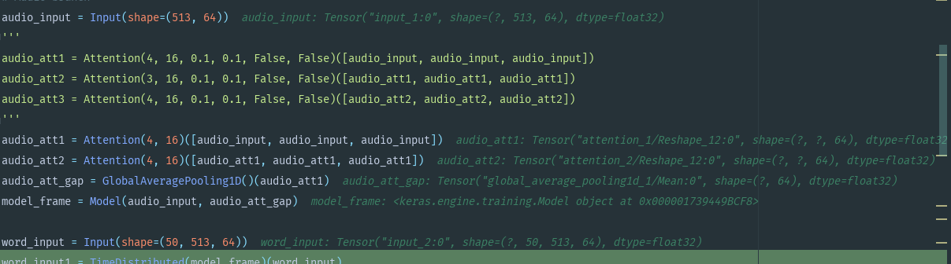

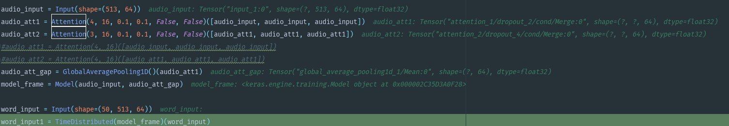\

loss_f 0.9328723096989544 acc_f 0.6631369954462007

final result:

text acc: 0.6538716082459329 audio acc: 0.5978835978835979 final acc: 0.6843150232423622

0 {'1': 6, '0': 104, '2': 5, '3': 115}

1 {'1': 190, '0': 9, '2': 5, '3': 124}

2 {'1': 12, '0': 1, '2': 106, '3': 81}

3 {'1': 49, '0': 43, '2': 27, '3': 634}

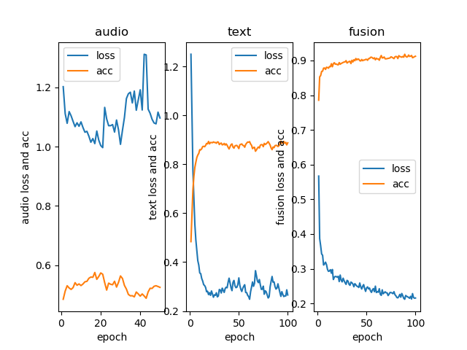

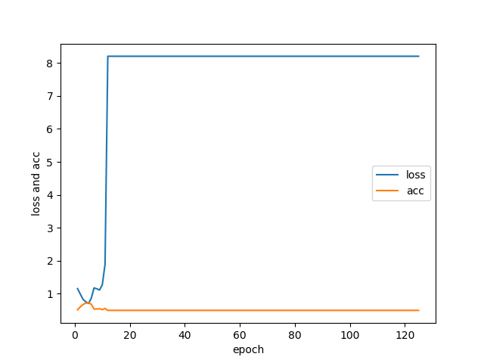

N_Head=4 d_k=16 adio 50 epoch

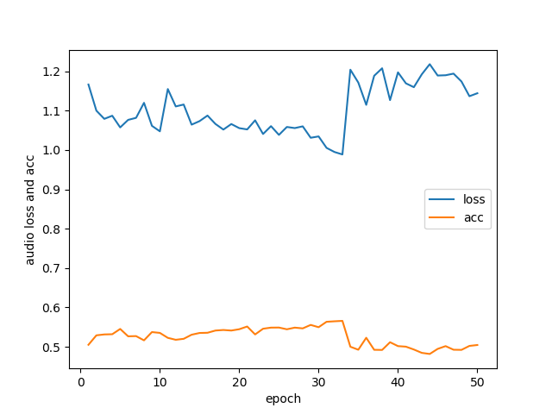

Best :Loss:0.9813419393481931 acc:0.5633074935400517

N_Head=4 d_k=16 audio 40 epoch

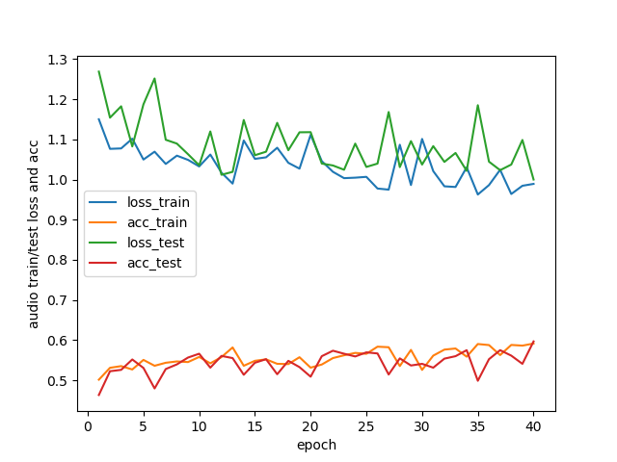

Best: Loss: 1.0000322514723692 acc: 0.5967302452316077

N_Head=4 d_k=16 audio epoch 100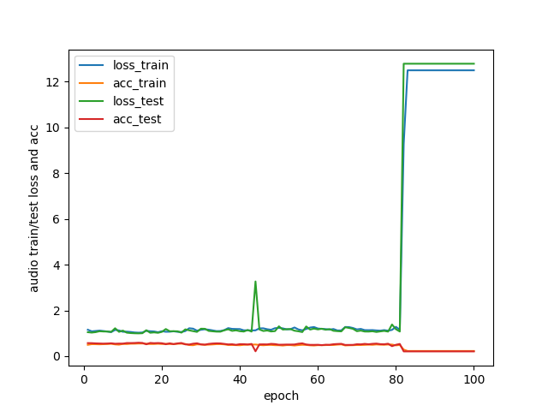 Best: 0.9953510132630666 0.5866666666666667