**HW1**

**Ruid: 182007396 Name: Xinyu Lyu**

1.

**Answer:**

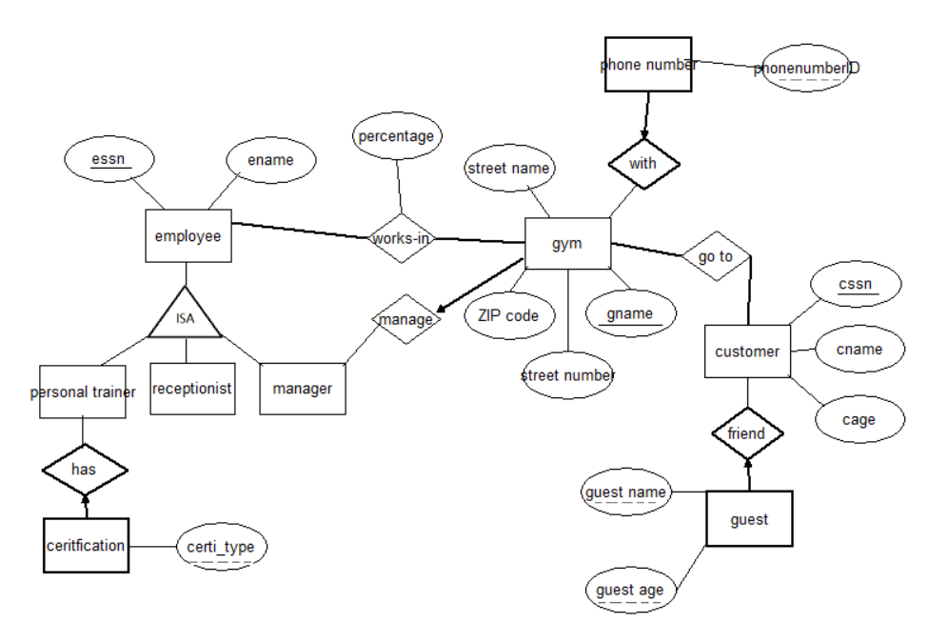

CREATE TABLE employee(

essn CHAR(11),

ename CHAR(20),

PRIMARY KEY (essn),

UNIQUE(essn)

);

CREATE TABLE works_in

(essn CHAR(11),

gname CHAR(20),

percentage CHAR(20),

PRIMARY KEY (essn,gname,percentage),

FOREIGN KEY (essn) REFERENCE employee,

FOREIGN KEY (gname) REFERENCE gym

);

CREATE TABLE customer

(cssn CHAR(11),

cname CHAR(20),

cage CHAR（11），

PRIMARY KEY (cssn),

UNIQUE(cssn)

);

CREATE TABLE cus_guest(

guestname CHAR(20)

guestage CHAR(11),

cssn CHAR(11) NOT NULL,

PRIMARY KEY (guestname,guestage ,cssn),

FOREIGN KEY (cssn) REFERENCE customer,

UNIQUE (guestname,guestage)

);

CREATE TABLE gym_manage(

gname CHAR(20),

streetnumber CHAR(20),

streetname CHAR(20),

ZIPcode CHAR(20),

essn CHAR(11) NOT NULL,

PRIMARY KEY (gname),

FOREIGN KEY (essn) REFERENCE manager,

UNIQUE (gname)

);

CREATE TABLE goto(

cssn CHAR(11) NOT NULL,

gname CHAR(20) NOT NULL,

PRIMARY KEY (cssn,gname),

FOREIGN KEY (cssn) REFERENCE customer,

FOREIGN KEY(gname) REFERENCE gym

);

CREATE TABLE gym_phonenumber(

gname CHAR(20) NOT NULL,

phonenumberID CHAR(20),

PRIMARY KEY (gname,phonenumberID),

FOREIGN KEY (gname) REFERENCE gym

);

CREATE TABLE personal trainer (

essn CHAR (11),

PRIMARY KEY (essn),

FOREIGN KEY (essn) REFERENCE employee

);

CREATE TABLE trainer_certification(

essn CHAR(11) NOT NULL,

certification CHAR (45),

PRIMARY KEY (essn,certi_type),

FOREIGN KEY (essn) REFERENCE trainer

);

CREATE TABLE receptionist(

essn CHAR (11),

PRIMARY KEY (essn),

FOREIGNER KEY(essn) REFERENCE employee

);

2.

**Answer:**

1. SELECT S.sname

FROM Suppliers S

WHERE NOT EXISTS

((SELECT P.pid

FROM Parts P)

EXCEPT

(SELECT C.pid

FROM Catalog C

WHERE C.sid =S.sid));

1. SELECT DISTINCT C.sid

FROM Catalog C

WHERE C.cost >(SELECT AVG(C2.cost)

FROM Catalog C2

WHERE C.pid=C2.pid);

1. SELECT P.pid,S.name

FROM Catalog C, Suppliers S,Parts P

WHERE C.pid=P.pid

AND C.sid=S.sid

WHERE C.cost=(SELECT MAX(C2.cost)

FROM Catalog C2

WHERE C2.pid=P.pid);

1. SELECT DISTINCT C.sid

FROM Catalog C

WHERE NOT EXISTS ( SELECT *

FROM Parts P

WHERE P.pid = C.pid AND P.color！=‘red’ );

1. SELECT DISTINCT S.sid

FROM Suppliers S ,Parts P, Catalog C

WHERE S.sid=C.sid

AND C.pid = P.pid

AND P.color =‘Red’

UNION

SELECT DISTINCT C1.sid

FROM Catalog C1, Parts P1

WHERE C1.pid = P1.pid

AND P1.color =‘Green’

1. SELECT S.sname, MAX(C.cost) as MaxCost

FROM Suppliers S, Parts P, Catalog C

WHERE P.pid = C.pid AND C.sid = S.sid

GROUP BY S.sname, S.sid

HAVING ANY ( P.color=’green’ ) AND ANY ( P.color = ’red’ )

3.

**Answer:**

1. SELECT M.MovieName

FROM Movie M ,MovieSuppiler MS ,Suppliers S

WHERE M.MovieID =MS.MovieID

AND MS.SupplierID =S.SupplierID

AND S.SupplierName=’Benis Video’

UNION

SELECT M.MovieName

FROM Movie M ,MovieSuppiler MS ,Suppliers S

WHERE M.MovieID =MS.MovieID

AND MS.SuppljerID =S.SupplierID

AND S.SupplierName=’Benis Video’ ;

1. SupplierName=’VideoClubhouse’;
2. SELECT M.MovieName

FROM Movie M,Inventory I,Rentals R

WHERE M.MovieID=I.MovieID

AND I.TapeID =R.TapeID

AND R.duration =(SELECT MAX(R2.duration)

FROM Rentals R2);

1. SELECT S.SupplierName

FROM Suppliers S

WHERE NOT EXISTS

((SELECT I.MovieID FROM Inventory I)

EXCEPT

(SELECT MS.MovieID

FROM MovieSupplier.MS

WHERE MS.SupplierID=SupplierID));

1. SELECT COUNT (DISTINCT MS.MovieID),S.SupplierName

FROM Suppliers, MovieSupplier MS. Movies M

WHERE S.SulplierID =MS.SupplierID

AND MS.MovieID=M.MovieID

GROUP BY S.SupplierName;

1. SELECT M.MovieName

FROM Orders O,Movies M

WHERE O.MovieID =M.MovieID

GROUP BY M.MovieName

HAVING SUM(O.Copies)>4;

1. SELECT C.LastName,C.FirstName

FROM Customer C,Inventory I,Rentals R, Movies M

WHERE C.CustomerID=R.CustomerID

AND R.TapeID =I.TapeID

AND I.MovieID=M.MovieID AND M.MovieName=’KungFu Panda’

UNION

SELECT C LastName , C FirstName

FROM Customer C,Inventory I,Rentals R,MovieSupplier MS,Suppliers S

WHERE C.CustomerID=R.CustomerID

AND R.TapeID=I.TapeID

AND I.MovieID=MS.MovieID

AND MS.SupplierID=S.Supplier ID AND S.SupplierName =’Palm Video’;

1. SELECT Movies.MovieName

FROM Movies M, Inventory I, Inventory I2

WHERE I.MovieID = I2.MovieID

AND I.TapeID !=I2.TapeID

AND M.MovieID=I.MovieID;

1. SELECT DISTINCT C.LastName ,C.FirstName

FROM Customer C ,Rentals R

WHERE R.CustomerID =C.CustomerID

AND (COUNT(R.Duration)>=5);

1. SELECT S.SupplierName

FROM MovieSupplier MS,Movies M,Suppliers S

WHERE S.SupplierID=MS.SupplierID

AND MS.MovieID=M.MovieID

AND MS.price=

(SELECT MIN(MS2.price)

FROM MovieSupplier MS2, Movie M2

WHERE M2.MovieName=’Cinderalla 2015’

AND M2.MovieID=MS2.MovieID);

(10) SELECT M.MovieName

FROM Movie M

WHERE EXISTS

(SELECT M2.MovieID

FROM Movie M2)

EXCEPT

(SELECT I.MovieID

FROM Inventory I

WHERE M.MovieID=I.MovieID );

4.

**Answer:**

1. (111,3) first judge the trigger condition in the clause ‘when’ , 4(OldTuple.price)>3(NewTuple.price) and 3(NewTuple.price)>1, so trigger the clauses from BEGIN to END to update purchase with new price set to be 1.5 where purchaseID=111, then update (111,3)
2. (111,1.5) first update (111,3) then judge the trigger condition, 4(OldTuple.price)>3(NewTuple.price) and 3(NewTuple.price)>1, so trigger the clauses from BEGIN to END to update the changed price=1.5 where purchaseID=111
3. (111,1.5) judge the trigger condition in ‘when’ clause, 4(OldTuple.price)>3(NewTuple.price) and 3(NewTuple.price)>1, so trigger the clauses from BEGIN to END to to update purchase with new price set to be 1.5 where purchaseID=111 and not update (111,3) because of the instead of trigger