class-4.R

xinyuwen

2025-01-16

x <- 1:50  
plot(x, sin(x))

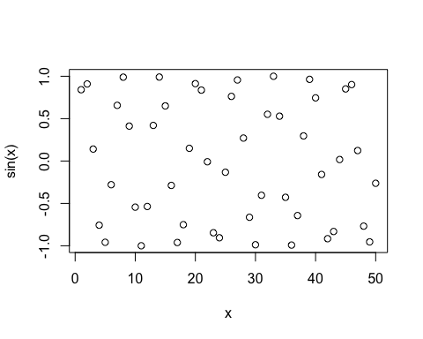

# make thi nicer  
plot(x, sin(x), col="pink", type = "l", lwd=4)

