ENGSCI 9510 Engineering Planning & Project Management
Assignment # 1

- Start Date: All course sections May 18 at midnight in the WebCT assignment area
- Due Date: All course sections June 8 at midnight in Owl Assignment box.
- Question 1 value = 2; Question 2 value = 1.5; Question 3 value = 1.5;

Question 1 – Vision, Mission, Objectives – Portfolio Management Decision Making

The following is an imaginary and theoretical vision, mission, and objectives exercise based on life at UWO. In life, managers are faced all the time with competing opportunities to either support or take a pass on interesting projects. Without a structured understanding of the organization’s priorities it is impossible to do a good job of keeping in alignment with what the university needs to be.

Your task: Read the vision, mission and objectives statements below as if you were an administrator with budgetary responsibility. Based upon their content evaluate the opportunities you are then presented with by various project managers. With the assistance of the evaluation sheet included below, as well as in WebCT, determine the correct ranking order for these opportunities. Hand back into WebCT your completed evaluation sheet as well as your conclusion.

UWO Vision – The University of Western Ontario desires to be a world class research university consistently ranked within the top 5 North American research universities that invest over $800 million in research annually. UWO envisions itself as a leader in contributing permanent solutions to the most difficult social, scientific, and business challenges facing mankind today and for centuries to come. UWO seeks strategic partners who can increase our likelihood of generating these solutions. In addition to the global role we assign to ourselves, UWO is a responsible neighbor and a leader in the local business community where we are committed to creating artistic, scientific, and commercial opportunities for our staff, our friends, and the community at large in London Ontario. UWO is a proponent of all things progressive. UWO seeks to be at the forefront in environmental management. Above all UWO is an environment where optimism reigns and where no restrictions are placed upon the possibilities of what each of us connected to the university might accomplish.

UWO Mission – The University as a whole is focused on growing by at least 10% as measured by full time faculty appointments. The Schuler School of Medicine and Dentistry targets gathering sufficient funding to break ground on Canada’s first Medical Research Hospital devoted exclusively to Orphan Illnesses. In addition to this, the medical school is committed to growing its faculty by 20% over the next 3 years. The faculty of Law is targeting gathering sufficient funding to build a Family Law research facility. The first of its kind in the English speaking world this organization would address creating low cost solutions for situations that truly are neither exclusively legal nor exclusively social in nature. The Ivey School of Business is looking to place UWO’s first international footprint on the world stage. Ivey is seeking partners to fund and build the West African School of Business in Lagos, Nigeria which will be jointly administered by the Nigerian Ministry of Education and UWO. Ivey is looking for $50 million over the next 3 years. Additionally Ivey is looking to increase its post graduate MBA placement rate from 95% to 100% over this period. The faculty of Engineering is looking to redesign all its facilities into buildings that are LEED gold certified over the next 7 years. To accomplish this both public and private funding will be investigated.

UWO “Must” Objectives – Every project must meet the must objectives as determined by the UWO Board of Control as well as the UWO Board of Directors. It is important that selected projects not violate such objectives of high strategic priority. There are three must objectives:

- All projects meets current legal, safety, and environmental standards
- All projects must be consistent with in some way adding to the body of knowledge at UWO.
- All projects should not have an adverse effect on current or planned operations within UWO.

UWO “Want” Objectives – want objectives are assigned weights for their relative importance. Executive administrators are responsible for formulating, ranking, and weighting objectives to ensure that projects support UWO’s vision and mission. The following is a list of UWO’s want objectives:

- Be in the top 10 for all categories in the annual MacLeans poll of Canadian university students
- Increase National Research council matching funds each year for the next 5 years.
- Create 5% more spinoff incubator companies through the Stiller Center each year.
- Raise Public consciousness about environmental issues and concerns.
- Will not apply pressure to increase tuition for undergraduate degrees.
- Enhance UWOs reputation as a leader in innovative technology implementation
- Provide the basis for the development of a new faculty at UWO
- Generate a return on investment of 14%. ROI calculations are somewhat difficult to calculate because the revenue stream is matching funds that are subject to government budgets so the prevailing matching system of today will be used.
- Require less than $1 million as a capital expenditure unless it is mission critical.

Project 1 – An anthropology study of native Canadians living in the London area at the time of European migration is proposed. The study will focus on native Canadian transportation methods. Additionally archaeological fly over mapping for earth features that show signs of pre-European modification will be undertaken. Capital expenditure: $330,000. Due to the Canadian nature of the project this project will be 50% funded by the NRC.

Probability 80% 50% 20%
ROI 14% 20% 30%

Project 2 – A study of family law practices in Ireland where until very recently divorce had been illegal in part of the island is proposed. Undertaken by the Faculty of Law, the study will trace the lives of a statistically significant number of Irish and Northern Irish families and examine the social impact of maintaining the family unit trending both positive and negative results. The project will create 3 full time jobs in London Ontario, 1 full time job in Belfast Northern Ireland, and will be supported by 15 grad students over the next 5 years. Capital expenditure: $550,000

Probability 80% 50% 20%
ROI 8% 13% 25%

Project 3 – A project is proposed to create a permanent home for the Team Canada economic mission at UWO. Sponsored by the Ivey School of Business, the project proposes building a permanent war room for Canadian scholars and politicians in the new Ivey building on the west side of Western Rd. Capital expenditure: $3.6 million. It is expected that this will enhance even further an already stellar reputation for Ivey within the business community and will contribute towards attracting even better students.

Probability 80% 50% 20%
ROI 3% 9% 18%

Project 4 – A project is proposed to lay 2000 sq ft of solar paneling on the roof of Spencer Hall. An additional 1000 sq ft is proposed to be laid on the roof of the Student Union Building. This project is a green initiative but will serve primarily as an advocacy for green building methods because the existing boilers and related mechanical services will not be removed because calculations show that winter loading less than -10 C will still require them. The capital expenditure is estimated at $1.1 million. Due to its ability to influence in the community, this project is eligible for 50% NRC funding.

Probability 80% 50% 20%
ROI 3% 6% 9%

Project 5 – A project to study the medicinal value of various West African tree barks for Creutzfeldt – Jacob disease is proposed. The project will be jointly run by the University of Lagos as well as the University of Western Ontario. It is expected that any findings resulting in commercial opportunities can be US patented and that development of a marketable product can occur in Canada. The project will be run by one UWO professor and will generate nearly 50 jobs in Nigeria. Capital expenditure: $900,000. This project is eligible for NRC funding. It is hoped that this project will be a flagship project for a proposed new Rare Illnesses research faculty for UWO. Additionally, it is expected that funding of such a project will be well received by students wishing to attend UWO.

Probability 80% 50% 20%
ROI 12% 20% 27%

Project 6 – A project to study the effects of vitamin D deficiency on the human body. It is now widely hypothesized that muscular dystrophy seems to have some sort of connection to vitamin D intake which is mostly from sunlight. It has been recorded that the incidence of this disease in nominally Anglo Saxon people has a direct correlation to the amount of sunlight in their country of residence be it Australia or England. While muscular dystrophy is a well funded illness, it makes sense that a Canadian university should contribute as our hours of sunlight per year in London Ontario are nearly mid way between those of London England and Sydney Australia and a significant percentage of the population is nominally Anglo Saxon in origin. The work will employ 4 full time researchers and one PhD in the school of medicine. The capital expenditure is $850,000

Probability 80% 50% 20%
ROI 12% 20% 27%

Project 7 - A project is proposed to build a new state of the art facility for the study of family law economics. Located on the main campus, this 15,000 square foot facility will be the workplace for 10 advanced degree law students, 4 law professors, and 25 sociologists. The building is to be LEED gold certified. The capital expenditure for this mission critical facility is $6.5 million.

Probability 80% 50% 20%
ROI 8% 14% 22%

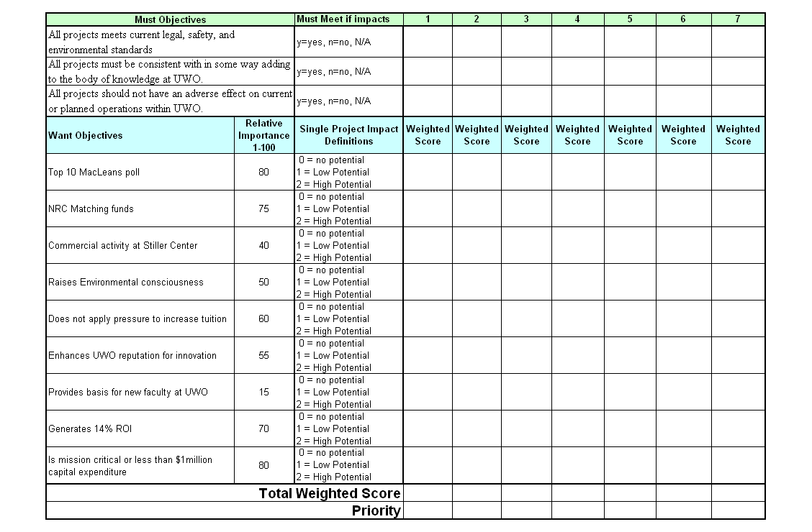

Question 2 – Network Diagrams
Using the following information relating to the development of “Harbourfront – the Great Canadian Boardwalk”, create an AON activity diagram, calculating TE, the total duration of the project, its early start, early finish, latest start, latest finish, and slack for each activity. Finally, show the project's critical path.

Activity | Preceding activity | Best | Likely | Worst | Time est.  (TE)
a | - | 12 | 15 | 25
b | a | 4 | 6 | 11
c | - | 12 | 12 | 30
d | b,c | 8 | 15 | 20
e | a | 7 | 12 | 15
f | e | 9 | 9 | 42
g | c,d,e | 13 | 17 | 19
h | e,f | 5 | 10 | 15
i | c,g | 11 | 13 | 20
j | g,h | 2 | 3 | 6
k | j,i | 8 | 12 | 22

a – dredge
b – boardwalk install
c – landscape
d – vendor area rough in
e – boat moors
f – shore line earth works
g – final micro restaurants installs
h – boat house assembly
I – walkway and bike path developments
J – life guard interviews and train
K – Harbour authority completes training

Question 3 – Work Breakdown Structure and the Three Little Pigs

Possibly UWO’s most famous project platform is the apparatus that goes by the formal name “The Insurance Research Laboratory for Better Homes”. You are more likely to have heard it referred to around campus as “the Three Little Pigs” project.

Here is the setup: You have been hired as a model maker. Your boss is the marketing group of the insurance company consortium. Their intention is to advertise the ongoing 3LP project as a means of getting the good word out regarding the home insurance industry. Specifically your job is to make an 8x8 straw house, an 8x8 wood house, and an 8x8 brick house that will each in turn be brought into the UWO wind Tunnel where of course only 2 out of 3 will come apart on camera. The ad is a comical parody of the children’s nursery fable “the Three Little Pigs”. In the first two scenes, straw, and wood, a man dressed as a pig is shown calmly trying to buttress his house against the growing winds. He is talking to the camera about his good luck and musing over having been able to spend so much money on food, and so little on taking out insurance. Each time despite his abundant confidence, his house is blown over exposing the infrastructure as flimsy and he is last seen chasing the materials down the road. In the third scene, the animated background is removed exposing the UWO control room. A more relaxed yet no less humble pig is now shown legs crossed in a lawn chair as he barbecue’s in front of the brick house and the winds build. He is bragging about the insurance industry and all the good works they have been able to accomplish at UWO. As the winds begin to peak this time the house is more robust than the pig. He is last heard claiming his role in all UWO has accomplished as he flips backwards and is blown down the through tunnel. The scene cuts and a voice over is heard to say: “The Canadian Insurance Industry is committed to building better homes for Canadians. You cannot plan for everything. With your support we can reduce your financial burden, and become one less faceless institution hogging your money. Support UWO, The Insurance Underwriters of Canada, and the Three Little Pigs Project. After all, it is your money.”

What you have to do for the CEE-9510 assignment: For the purpose of this assignment, don’t build the houses, just develop a work breakdown structure for each - maintaining the 8 to 80 hour rule for each activity. Stick to 40 activities maximum for each of the 3 houses. See the url below for further details. You will not be marked on the specific scientific accuracy or relevance of what you include in the WBS, but it may serve as a guideline.

http://www.eng.uwo.ca/irlbh/

Also in WebCT for this assignment, you will find a sample work breakdown structure (wbs) created for an unrelated hypothetical project at University Hospital. Use this as a guideline for creating your wbs, incorporating features such as a logical taxonomy, several worksheets hyperlinked together, sticky note looking wbs elements, and a summary sheet detailing the labor you expect for each.

All logical efforts for question 3 will receive full marks.

Submit your responses for this assignment in the dropbox. Please only one attachment each student. Xls, xlsx, or .pdf

