Self-Assessment of Periodic Table Project
Student Id:a1981985
Name: Xinyuan Liu

MATLAB programming concepts including
- Loops
I have used loops in various functions throughout my project. Such as in function main, queryElements and gamingElements, I used while loop with switch as the coordinator for sub module choice.
- Vectors
I used vector in my queryByPeriod function to store the ultimate result in the foundResult vector.

- Matrices
I used a string elementMatrix[maxPeriod,maxGroup] in loadElements function to store all the element symbols and display this matrix in command window.

- Conditional execution
I have used a massive number of conditional executions in different functions(queryByAtomicNumber,queryByPeriod). For example (if,else and switch).

- Function
I have built a series of functions with each functioning distinctly. (such as the queryByNumber function,the queryByName function and the gamingPeriod function.etc.)

Software Development Practices including:
- Commenting and code Style.
All the codes of functions and scripts in my project follows requirements in MatlabStyle2 book.pdf
- Testing
All the functions have the following test named XXXDriver.
- Incremental development of code
The project has already been uploaded in github,the project address is below：
https://github.com/XinyuanLiuSam/matlab_final/tree/main
my commit log reveals the development of incremental processing procedure
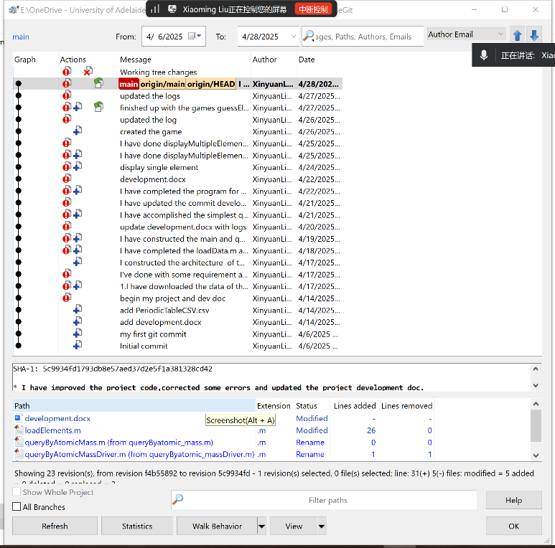

- Use of documentation to support self-learning
During the procedure of project development, I involved massive amount of knowledge that I have gained throughout the course such as: loop, statement, conditional execution, array , vector, 2D array ,matrix , photo load and show plot, and so on.
In addition to that，in order to develop the project，I have also gained some extra knowledge through online resources, for instance: read document readtable(), table2stuct(), struct and struct array,

Assessment
according to the Assessment rubric, I give the assessment for my project as bellow:
- Concept coverage
40 Pts.
My project code not only covered the concepts, but also for the project, I 还自己学习并应用了一些额外项目所必须的概念和知识点，如, readtable(), table2stuct(), struct and struct array.
- Value-add
20 Pts.
More than 400 lines of structured codes
The whole project has two upper modules, and each module has five or two sub modules.
Such as Github, git clone, git commit, tortoiesGit…
- Incremental development
15 Pts.

Git commit logs have proved my incremental development for this project in github.

https://github.com/XinyuanLiuSam/matlab_final
- Testing Strategy
15 Pts.
Each sub function has individual Driver test, and coordinators modules such as main(), queryElements(), gamingElemnts()
- Comments and styles
10 Pts
All my project code for functions and its test Drivers have followed the requirements in MatlabStyle2 on trying my best.
- Depth of understanding

