**EE450 – Lab3 Report**

**XINYUE LIU**

**1332044343**

**1. Screenshots of lab3:**

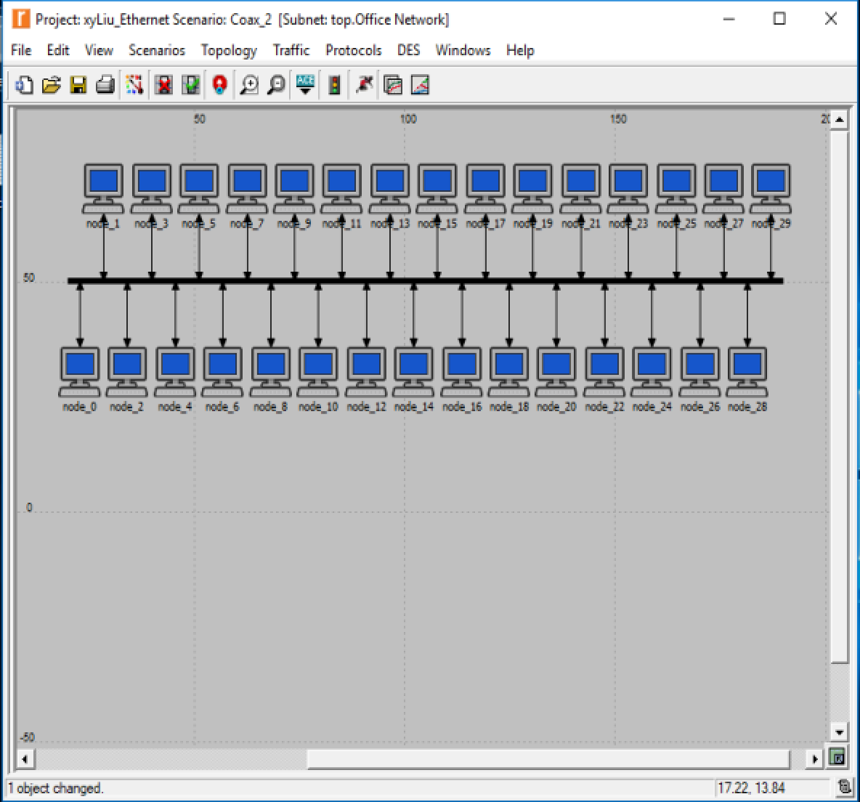

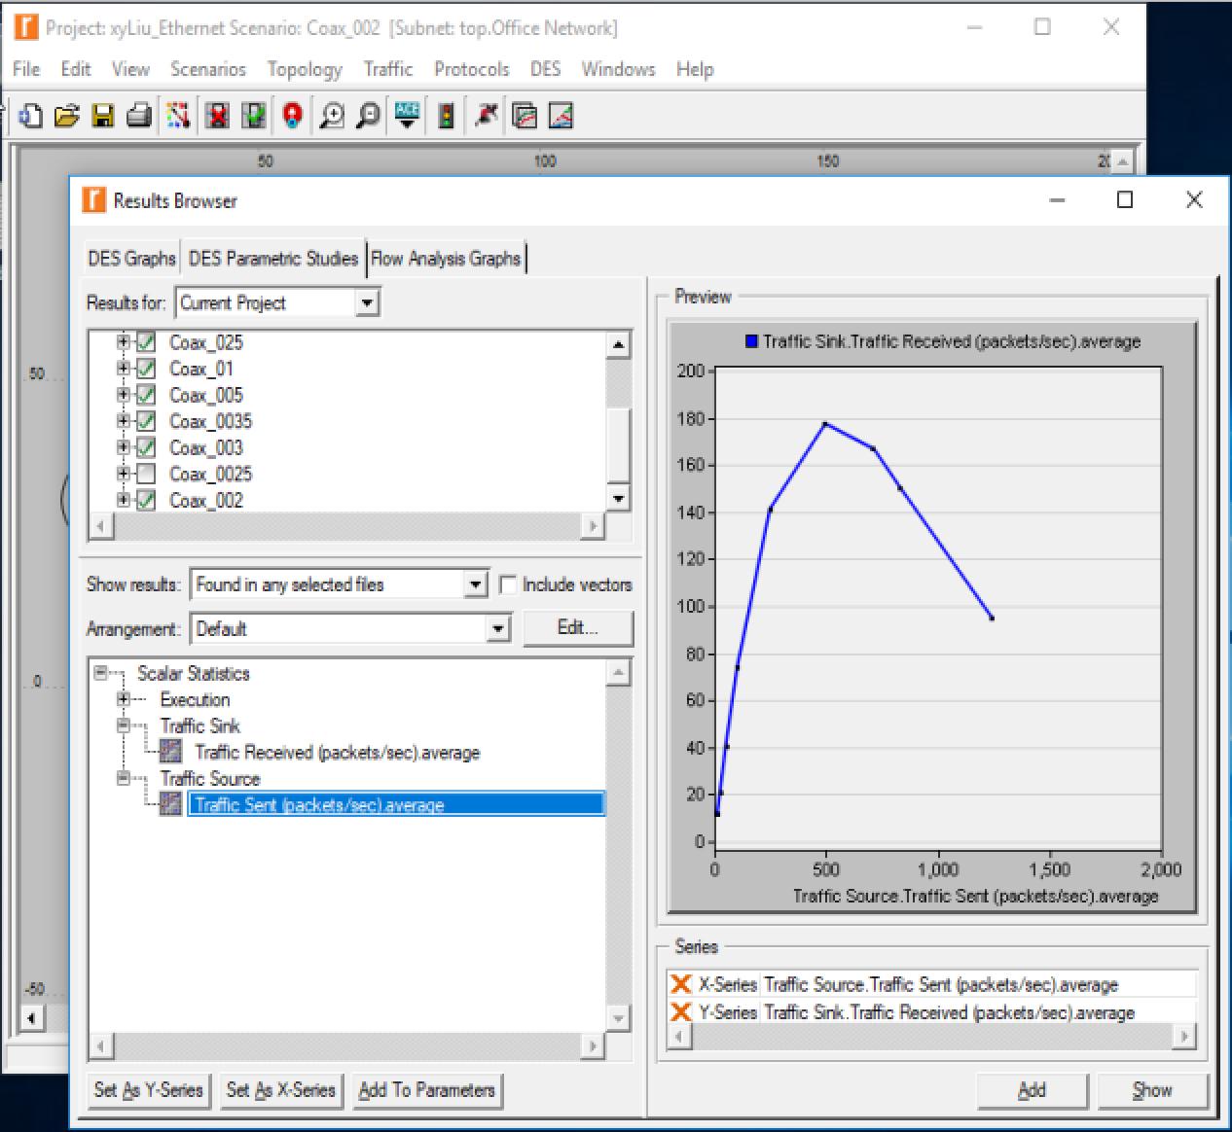

1) Explain the graph we received in the simulation that shows the relationship between the received (throughput) and sent (load) packets. Why does the throughput drop when the load is either very low or very high?

**Answer:**

**When the received packets are less than 500, the received packets and the sent packets are positive related, the sent packets will increase according to the sent packets. And then this relation will become less. When it is over 500, number of the received packets will decrease when the sent packets keep increasing.**

2) Use three duplicates of the simulation scenario implemented in this lab named Coax_01, Coax_005, and Coax_0025. Make sure that the Interarrival Time attribute of the Packet Generation Arguments for all nodes in the scenarios are as follows:

- Coax_01 scenario: exponential(0.1)

- Coax_005 scenario: exponential(0.05)

- Coax_0025 scenario: exponential(0.025)

Choose the following statistic for node 0: Node Statistics →Ethcoax →Collision Count. Make sure that the following global statistic is chosen: Global Statistics→Traffic Sink→Traffic Received (packet/sec). (Refer to the Choose the Statistics section in the lab.)

Run the simulation for all three scenarios. Get two graphs: one to compare node 0’s collision counts in these three scenarios and the other graph to compare the received traffic from the three scenarios. Explain the graphs and comment on the results. (Note: To compare results you need to select Compare Results from Results in the DES menu after the simulation runs is done.)

**Screenshots:**

**1. Collision Count graph:**

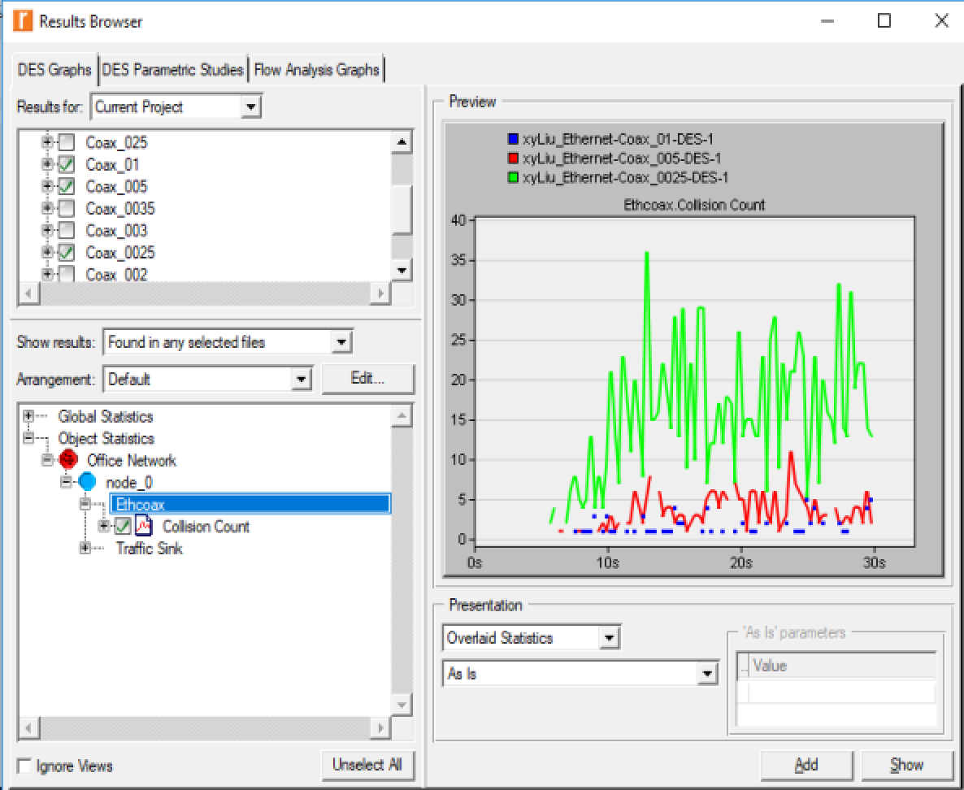

**The above figure shows the conditions of the smaller number of exponential with the larger number of collision count. As the exponential is smaller, the times of sending packets are larger than before. At the same time, numerous other machines try to send their own packets, as a result, more conflicts happen.**

**2. Traffic Received graph:**

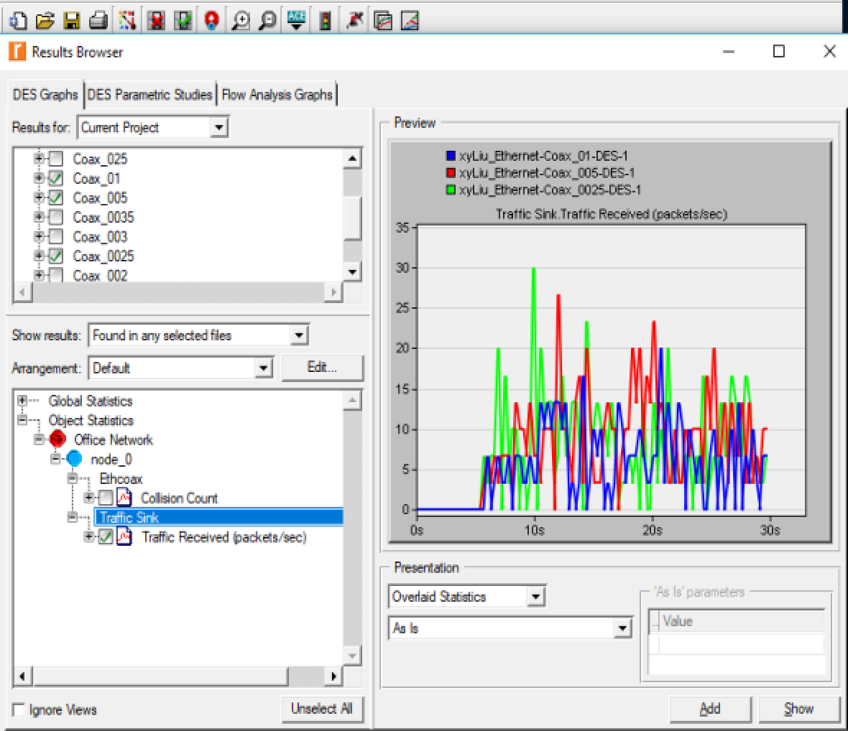

**The above figure shows that at the beginning, Coax_01 (exponential = 0.1) has the lowest traffic received speed. However, when the load becomes heavier, the speed goes up. And the highest point of curve Coax_0025 (exponential = 0.025) is at the beginning. But the speed drops a little as the traffic load becomes heavier. The curve of Coax_005 (exponential = 0.05) keeps rising all the time, and it reaches its highest point at the time when the traffic load is heavy. These three curves show that different exponential will affect the efficiency of the networks. In another word, an appropriate value of exponential is required.**

3) To study the effect of the number of stations on Ethernet segment performance, create a duplicate of the Coax_0025 scenario. Name the new scenario Coax_Q3. In the new scenario, remove the odd- numbered nodes, a total of 15 nodes (node 1, node 3, ..., and node 29). Run the simulation for the new scenario. Create a graph that compares node 0’s collision counts in scenarios Coax_0025 and Coax_Q3. Explain the graph and comment on the results.

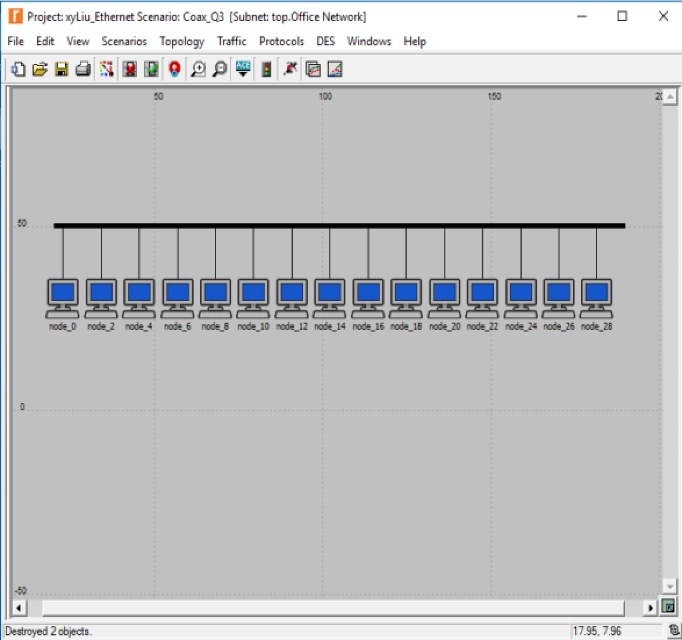

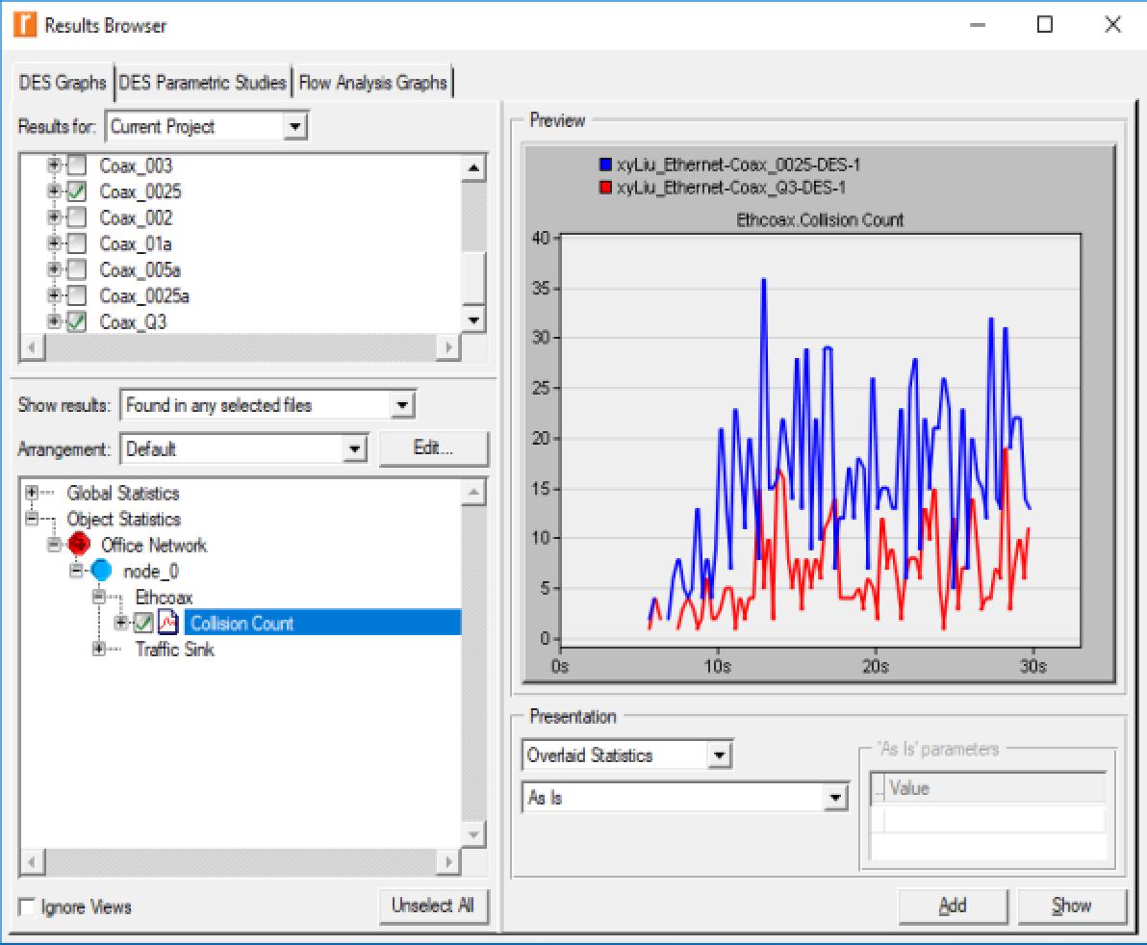

**The first figure shows that the number of Coax_Q3 nodes is half of Coax_0025. As fewer computers will make fewer collisions, so we can see that the collision count with more nodes is larger in the second figure.**

4) In the simulation a packet size of 1024 bytes is used (Note: Each Ethernet packet can contain up to 1500 bytes of data). To study the effect of the packet size on the throughput of the created Ethernet network, create a duplicate of the Coax_0025 scenario. Name the new scenario Coax_Q4. In the new scenario use a packet size of 512 bytes (for all nodes). For both Coax_0025 and Coax_Q4 scenarios, choose the following global statistic:

Global Statistics→Traffic Sink→Traffic Received (bits/sec). Rerun simulation of **Coax_0025** and **Coax_Q4** scenarios. Create a graph that compares the throughput as packets/sec and another graph that compares the throughput as bits/sec in **Coax_0025** and **Coax_Q4** scenarios. Explain the graphs and comment on the results.

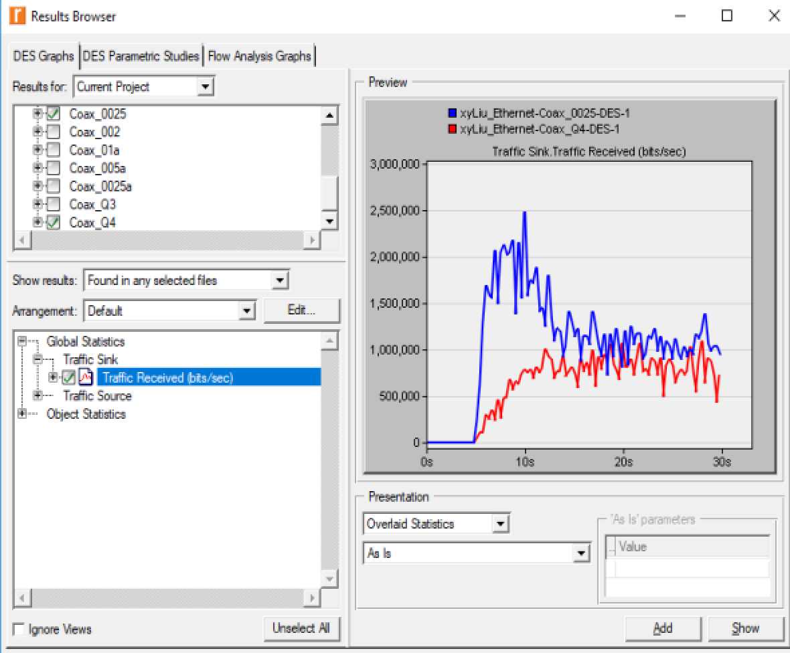

**The above figure shows the traffic received speed. The network with smaller packets (constant 512 bytes) has smaller speed at the beginning. However, with the time goes by, the speed maintains a certain value. This is because of the difference of the packet number. With more packets to be sent, the time efficiency becomes worse. Therefore, it is smaller when the load of network is light. As the network load is rising, the network with more sending packets will be more efficient. It is because the smaller size packet will make the collision count drop.**