To download the software on Android phone using the installation package file we uploaded on GitHub, you can follow the following steps:

1. Open a web browser app on your Android phone and sign into your GitHub account.
2. Visit the repository page where you download the ZIP file in your browser.
3. After the download is complete, install on your mobile phone.
4. The ZIP file contains an APK file (Android application file), you can find the file in the file Manager and click on it, then select the "Install" option to install the software.
5. If you have downloaded the installation package from us, you need ignore the security risk of downloading and installing APK files from unknown sources that may appear on your phone, click to continue installing.

Briefly introduce how to use the software to calculatethe concentration of sodium chloride and the volume percentage of oil of two methods. The first way is to click the drop-down box to select the desired tissue, and the interface pops up to select the tissue. Input the frequency first, and click "OK" after selecting the tissue, and the software outputs the required concentration of sodium chloride and the volume percentage of oil. The second method is to manually input the frequency, permittivity, and conductivity. Click "Calculate" next, and the software outputs the required concentration of sodium chloride and the volume percentage of oil (Figure 1).

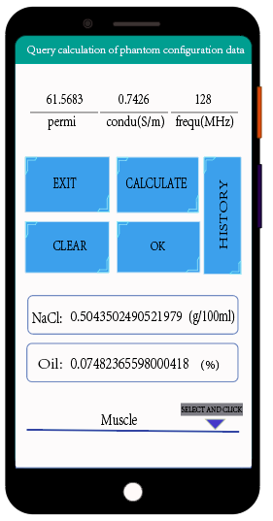

Figure 1