CPE 314 — Software Design
University of Cebu
Computer Engineering Department

UC-B Campus Marketplace
with Reviews
Project Design Document
Table 1: Group information
Group Name / No.: | Group 1 / Team 01 | BSCPE 3B | EDP 69323
Members: | John Benedict Alaiza
 | Acexion B. Mahigugmaon
 | Glyde V. Arreglado
 | Tristan Dominic Urot
 | Joshua Brian S. Enovero
 | Eman De Paz
Instructor: | Richyll Son
Term: | First Semester, S.Y. 2026–2027
Document Version / Date: | 0.3 / 23 October 2026 — Week 8 draft

Table of Contents

Revision History 3
Formatting Guidelines 3
1. Introduction & Project Overview 4
2. Preliminary ER Sketch & Team Roles 4
2.1 Key Attributes and Relationships 5
2.2 Team Roles 5
3. System Architecture & Object-Oriented Design 6
4. Data Model & Database Design 6
5. API Integration Design 6
6. Concurrency Design 6
7. Data Mining & Visualization Design 6
8. Testing Summary 6
9. Individual Contributions 6
Appendix 7
Project References 7
Document Status 7

Revision History
Table 2: Document revisions
Version | Date | Author | Changes
0.1 | 17 Oct 2026 | Group 1 | Initial planning draft.
0.2 | 18 Oct 2026 | Group 1 | Working title, roster and assigned theme updated.
0.3 | 23 Oct 2026 | Group 1 | Week 8 template draft with introduction, ER sketch and roles.

Formatting Guidelines
Maintain these template rules as the same document develops through the later milestones.
Table 3: Formatting rules from the template
Element | Rule
Body font | Calibri, 11 pt.
Headings | Use Word Heading 1, Heading 2 and Heading 3 styles so the table of contents can update.
Margins | One inch on all sides.
Line spacing | Body: 1.15–1.5. Tables: single spacing.
Table captions | Table N: short description, directly above each table.
Figure/chart captions | Figure N: short description, directly below each figure.
Code snippets | Consolas or Courier New, 9–10 pt; fewer than about 20 lines; link to full repository files.
Page numbers | Use automatic page-number fields in the footer.
Alignment | Body text left aligned or justified; headings left aligned.

1. Introduction & Project Overview
UC-B Campus Marketplace with Reviews is a proposed Java desktop application for students, faculty, school units, and department committees to post and browse campus goods. Our assigned theme is Option J, retaining Textbook, Electronics, and Furniture listing types with different condition-grading rules, nested category search, buyer-interest waitlists, recently viewed listings, and reviews. We plan to use JavaFX, SQLite through JDBC, a background sales-history CSV import, FakeStoreAPI product suggestions, and category price and rating bar charts. Uniforms and department merchandise are proposed additions for instructor review; the initial application uses local storage, with online payments outside its scope.

2. Preliminary ER Sketch & Team Roles
The preliminary model carries forward the entities, key attributes and relationships from the proposal. The sketch below shows the core listing relationships; Table 4 lists all seven proposed records and their foreign keys.
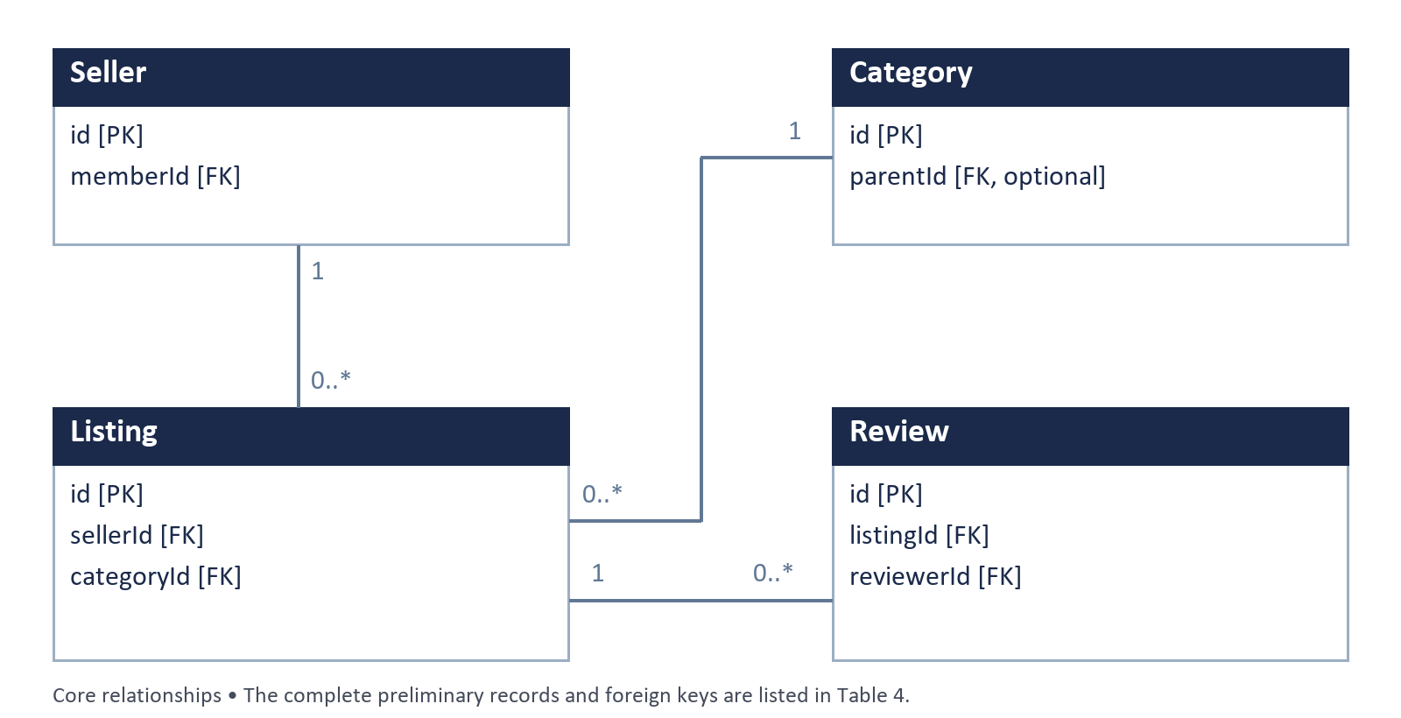
Figure 1: Core preliminary entity relationships
Each Seller and Category can relate to many Listings; each Listing can receive many Reviews. The 1 and 0..* labels mean one parent and zero or more related records. This is a proposal sketch; the final ERD and actual schema will be documented in Section 4.

2.1 Key Attributes and Relationships
PK identifies a record uniquely. FK refers to a related record. Category.parentId may be empty for a root category.
Table 4: Preliminary entities and key attributes
Entity | Key attributes
Member | id PK; name
Seller | id PK; memberId FK → Member.id; displayName; sellerKind
Category | id PK; parentId FK → Category.id; name
Listing | id PK; sellerId FK → Seller.id; categoryId FK → Category.id; type; title; priceMinor; currency; status
Review | id PK; listingId FK → Listing.id; reviewerId FK → Member.id; rating; comment
BuyerInterest | id PK; listingId FK → Listing.id; buyerId FK → Member.id; joiningOrder
HistoricalSale | id PK; categoryId FK → Category.id; sourceRecordId; priceMinor; currency; soldAt
Member relates to many Seller profiles, Reviews and BuyerInterest entries. Category relates to many Listings, child Categories and HistoricalSale records. Listing relates to many Reviews and BuyerInterest entries. Each listing is proposed to have one matching subtype-details record; its fields are not finalized.

2.2 Team Roles
Table 5: Proposed primary responsibilities for Week 8
Member | Primary responsibility
John Benedict Alaiza | Sample listings, categories and condition examples.
Acexion B. Mahigugmaon | Architecture, implementation planning and integration.
Glyde V. Arreglado | ER sketch, attributes and relationship review.
Tristan Dominic Urot | GUI sketches, control labels and user steps.
Joshua Brian S. Enovero | Sample CSV and API/import validation cases.
Eman De Paz | Test cases and expected analytics calculations.
These are proposed responsibilities for member confirmation. Actual contributions and supporting commits will be recorded in Section 9.

3. System Architecture & Object-Oriented Design
Reserved for a later milestone. Add the class hierarchy, responsibilities and design rationale after the proposal is approved and the implementation is developed.

4. Data Model & Database Design
Reserved for a later milestone. Finalize the ERD, SQL types, constraints and SQLite schema. Section 2 contains the preliminary proposal model only.

5. API Integration Design
Reserved for a later milestone. Document the actual endpoint response, parsing, comparable-product matching, currency policy and failure handling after verification.

6. Concurrency Design
Reserved for a later milestone. Record the implemented background import/API work, UI update approach, cancellation and error handling.

7. Data Mining & Visualization Design
Reserved for a later milestone. Document the implemented category calculations, sample counts, currency handling and labeled charts.

8. Testing Summary
Reserved for a later milestone. No application test suite or execution results are recorded in this Week 8 draft. Add actual JUnit coverage, edge cases and results when available.

9. Individual Contributions
Contribution records will be added with verified commit references. The roles in Section 2 describe proposed responsibilities and do not claim completed implementation.

Appendix
This Week 8 draft contains the title page, written overview, preliminary ER sketch and six-member role list. Later sections will be completed in this same cumulative document as evidence becomes available.

Project References
Project repository
https://github.com/XionAce/cpe314-69323-capstone-team-01
Project proposal
https://github.com/XionAce/cpe314-69323-capstone-team-01/blob/project/proposal/docs/proposal.md
Student Guide — Group Capstone Project
https://drive.google.com/file/d/195Y8cNaHnd0M7FpIwmKDYzfok5pbKZti/view
Week 8 design-document checklist
https://drive.google.com/file/d/1wb9xb2nd7RDowEEbSMx-M-l58qnO9gMM/view
Project design-document template
https://drive.google.com/file/d/1sRJ5rjciHBeYgBQmUbpJB12kWyD_sCkO/view
FakeStoreAPI documentation
https://fakestoreapi.com/docs

Document Status
Instructor approval, final implementation ownership, API behavior and currency decisions remain to be confirmed. This draft contains no claim of a working application or completed tests.

