《编译原理》

实
验
报
告

实验名称： 词法分析程序实验
专业班级： 大数据2001班
姓 名： 王昊宇
学 号： 20855018
日 期： 2023.5.24

- 实验目的
自己编程实现对C语言的词法分析程序，加深对词法分析原理的理解。
- 实验要求
- C语言分为关键字、标识符、数字、运算符、界符五类。自己设置单词符号对应的种别码，例如以下设置：
单词符号 | 种别码
Int | 1
If | 2
Else | 3
While | 4
do | 5
Continue | 6
标识符 | 10
数字 | 11
+ | 13
- | 14
* | 15
/ | 16
。。。。。。 | 。。。。。。
2、要求能够识别以下代码：
int main()
{
char c=56;
int a=1;
int bb_b1=7;
if(a>bb_b1)c=9;
else c=90;
while(1){;}
return 67;
}
- 实验参考代码
#include<stdio.h>
#include<string.h>

char token[20];
char *keywords[]={"int","char","if","else","while"};
void scanner(FILE *fp)
{
char ch;
int i,c;
ch=fgetc(fp);
if((ch>='a'&&ch<='z') || (ch>='A'&&ch<='Z') || (ch=='_')){
token[0]=ch;
ch=fgetc(fp);
i = 1;
while((ch>='a'&&ch<='z') || (ch>='A'&&ch<='Z') || (ch>='0'&&ch<='9') || (ch=='_')){
token[i]=ch;
i++;
ch=fgetc(fp);
}
token[i]='\0';
fseek(fp, -1, 1);
for(i=0;i<sizeof(keywords)/sizeof(keywords[0]);i++){
if(strcmp(keywords[i],token)==0) {printf("%d,%s\n", i+1, token);break;}
}
if(sizeof(keywords)/sizeof(keywords[0]) == i) printf("%d,%s\n", 6, token);
}else if(ch>='0'&&ch<='9'){
token[0] = ch;
ch=fgetc(fp);
i = 1;
while(ch>='0'&&ch<='9'){
token[i]=ch;
i++;
ch=fgetc(fp);
}
token[i]='\0';
fseek(fp, -1, 1);
printf("%d,%s\n", 11, token);
}else switch(ch){
case '>':
ch=fgetc(fp);
if(ch == '=') printf("%d,%s\n", 9, "");
else {
fseek(fp, -1, 1);
printf("%d,%s\n", 7, "");
}
break;
case '=':
ch=fgetc(fp);
if(ch == '=') printf("%d,%s\n", 10, "");
else {
fseek(fp, -1, 1);
printf("%d,%s\n", 8, "");
}
break;
case ';':
printf("%d,%s\n", 12, "");
break;
case '}':
printf("%d,%s\n", 13, "");
break;
case '{':
printf("%d,%s\n", 14, "");
break;
case '(':
printf("%d,%s\n", 15, "");
break;
case ')':
printf("%d,%s\n", 16, "");
break;
default:
;
//printf("error!\n");
}
}
int main()
{
FILE *fp=NULL;
fp = fopen("data.c","r");
while(!feof(fp)){
scanner(fp);
}
}
- 实验代码
#include<string.h>
#include<stdio.h>
#define MAX 22
#define RES_MAX 10
#define MAXBUF 255
char ch =' ';
int Line_NO;
struct keywords
{
char lexptr[MAXBUF];
int token;
};
struct keywords symtable[MAX];
char str[MAX][10]={"int","char","float","main","double","case", "for","if","auto","else","do","while","void","static", "return","break","struct","const","union","switch","typedef","enum"};

void init()
{
int j;
for(j=0; j<MAX; j++)
{
strcpy(symtable[j].lexptr,str[j]);
symtable[j].token=j+3;
}
}

int Iskeyword(char * is_res){
int i;
for(i=0;i<MAX;i++){
if((strcmp(symtable[i].lexptr,is_res))==0) break;
}
if(i<MAX) return symtable[i].token;
else return 0;
}

int IsLetter(char c)
{
if(((c<='z')&&(c>='a'))||((c<='Z')&&(c>='A'))) return 1;
else return 0;
}
int IsDigit(char c){
if(c>='0'&&c<='9') return 1;
else return 0;
}
void analyse(FILE *fpin,FILE *fpout){

char arr[MAXBUF];
int j=0;
while((ch=fgetc(fpin))!=EOF){

if(ch==' '||ch=='\t'){}
else if(ch=='\n'){Line_NO++;}

else if(IsLetter(ch)){
while(IsLetter(ch)|IsDigit(ch)|ch=='_'){
if((ch<='Z')&&(ch>='A'))
ch=ch+32; /*忽略大小写*/
arr[j]=ch;
j++;
ch=fgetc(fpin);
}
fseek(fpin,-1L,SEEK_CUR);
arr[j]='\0';
j=0;
if (Iskeyword(arr)){ /*如果是关键字*/
fprintf(fpout,"%s\t\t%d\t\t关键字\n",arr,Iskeyword(arr));
}else
fprintf(fpout,"%s\t\t%d\t\t标识符\n",arr,1);
}else if(IsDigit(ch)){
int s=0;
while(IsDigit(ch)|IsLetter(ch)){
if(IsLetter(ch)){
arr[j]=ch;
j++;
ch=fgetc(fpin);
s=1;
}
else if(IsDigit(ch)){
arr[j]=ch;
j++;
ch=fgetc(fpin);
}
}
fseek(fpin,-1L,SEEK_CUR);
arr[j]='\0';
j=0;
if(s==0)
fprintf(fpout,"%s\t\t%d\t\t无符号整数\n",arr,2) ;
else if(s==1)
fprintf(fpout,"%s\t\t%d\t\t错误\n",arr,3) ;
}else switch(ch){
case'+' :
ch=fgetc(fpin);
if(ch=='+'){
fprintf(fpout,"%s\t\t%d\t\t自加运算符\n","++",41);
break;
}
else if(ch=='='){
fprintf(fpout,"%s\t\t%d\t\t运算符\n","+=",42);
break;
}
else
fseek(fpin,-1L,SEEK_CUR);
fprintf(fpout,"%s\t\t%d\t\t运算符\n","+",43);
break;
case'-' :
ch=fgetc(fpin);
if(ch=='-'){
fprintf(fpout,"%s\t\t%d\t\t自减运算符\n","--",44);
break;
}
else if(ch=='='){
fprintf(fpout,"%s\t\t%d\t\t运算符\n","-=",45);
break;
}
else
fseek(fpin,-1L,SEEK_CUR);
fprintf(fpout,"%s\t\t%d\t\t运算符\n","-",46);
break;
case'*' :fprintf(fpout,"%s\t\t%d\t\t运算符\n","*",47);break;
case'(' :fprintf(fpout,"%s\t\t%d\t\t分界符\n","(",25);break;
case')' :fprintf(fpout,"%s\t\t%d\t\t分界符\n",")",26);break;
case'[' :fprintf(fpout,"%s\t\t%d\t\t分界符\n","[",27);break;
case']' :fprintf(fpout,"%s\t\t%d\t\t分界符\n","]",28);break;
case';' :fprintf(fpout,"%s\t\t%d\t\t分界符\n",";",29);break;
case'=' :fprintf(fpout,"%s\t\t%d\t\t运算符\n","=",48);break;
case'.' :fprintf(fpout,"%s\t\t%d\t\t分界符\n",".",30);break;
case',' :fprintf(fpout,"%s\t\t%d\t\t分界符\n",",",31);break;
case':' :fprintf(fpout,"%s\t\t%d\t\t分界符\n",":",32);break;
case'{' :fprintf(fpout,"%s\t\t%d\t\t分界符\n","{",33);break;
case'}' :fprintf(fpout,"%s\t\t%d\t\t分界符\n","}",34);break;
case'%' :fprintf(fpout,"%s\t\t%d\t\t分界符\n","%",35);break;
case'\"' :fprintf(fpout,"%s\t\t%d\t\t分界符\n","\"",36);break;
case'\\' :fprintf(fpout,"%s\t\t%d\t\t分界符\n","\\",37);break;
case'#' :fprintf(fpout,"%s\t\t%d\t\t分界符\n","#",38);break;
case'>' :{
ch=fgetc(fpin);
if(ch=='=')
fprintf(fpout,"%s\t\t%d\t\t运算符\n",">=",49);
else {
fprintf(fpout,"%s\t\t%d\t\t运算符\n",">",50);
fseek(fpin,-1L,SEEK_CUR);
}
}break;

case'<' :{
ch=fgetc(fpin);
if(ch=='=')
fprintf(fpout,"%s\t\t%d\t\t运算符\n","<=",51);
else if(ch=='>')
fprintf(fpout,"%s\t\t%d\n","<>",52);
else{
fprintf(fpout,"%s\t\t%d\t\t运算符\n","<",53);
fseek(fpin,-1L,SEEK_CUR);}
}break;
case'/' :{
ch=fgetc(fpin);
if(ch=='/'){
while(ch!='\n'){
ch=fgetc(fpin);
}
}
else if(ch=='*'){
while(ch!='/'&&ch!=EOF){
ch=fgetc(fpin);
}
if(ch==EOF)
fprintf(fpout,"缺少一个'/'");}
else {
fprintf(fpout,"%s\t\t%d\t\t运算符\n","/",39);
fseek(fpin,-1L,SEEK_CUR);
}
break;
}
default :fprintf(fpout,"在第%d行无法识别的字符\t%c\n",Line_NO,ch);
}
}
}
int main(){
char in_fn[25],out_fn[25];
FILE * fpin,* fpout; printf("<<<<<<<<<<<<<<<<<<WELCOME>>>>>>>>>>>>>>>>>>>>>>>>>>>\n");
printf("..............词法分析程序实验......................\n");
printf("\n");
printf(".....目前共有词法程序范例： 1个 \n");
printf(".....程序范例1：data.txt \n");
printf(".....输入一个已有的程序:\n");
scanf("%s",in_fn);
printf(".....输入你想要保存分析的目标文件名:\n");
scanf("%s",out_fn);
fpin=fopen(in_fn,"r");
fpout=fopen(out_fn,"w");
fprintf(fpout,"单词符\t\t种类编码\t\t种类\n");
init();
analyse(fpin,fpout);
fclose(fpin);
fclose(fpout);
printf(".....程序已分析完成分析并保存至目标文件\n");
printf("........<谢谢使用>......\n");
return 0;
}
- 实验验证
实验结果如图所示：
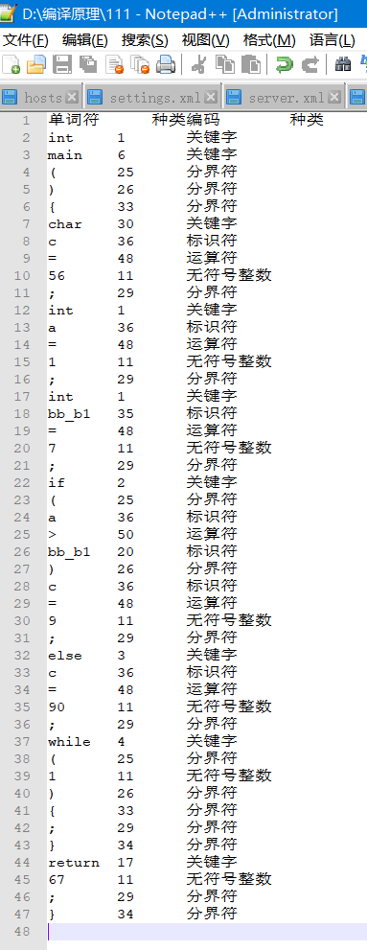
- 实验中遇到的问题和解决办法
无
- 实验体会
通过本次实验我深刻体会到了词法分析在编译原理中的重要性。我学习到了识别关键字、标识符、常量、运算符和界符等不同类型的单词，并将其转化为记号流。同时，我还使用有限自动机和正则表达式来构造词法分析器，了解了如何处理诸如注释、错误输入等特殊情况，培养了我分析和解决问题的能力。这对于我的编程能力和实践来说都是非常有益的。

