**Linxu basic test**

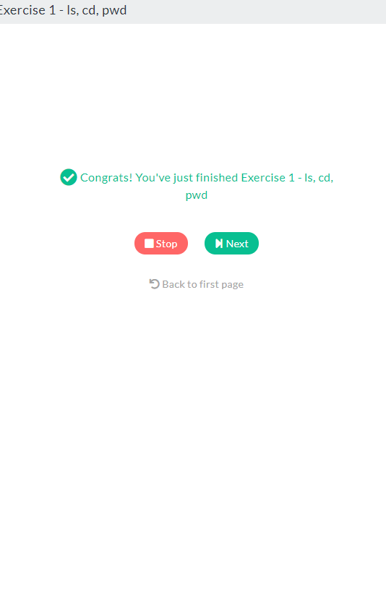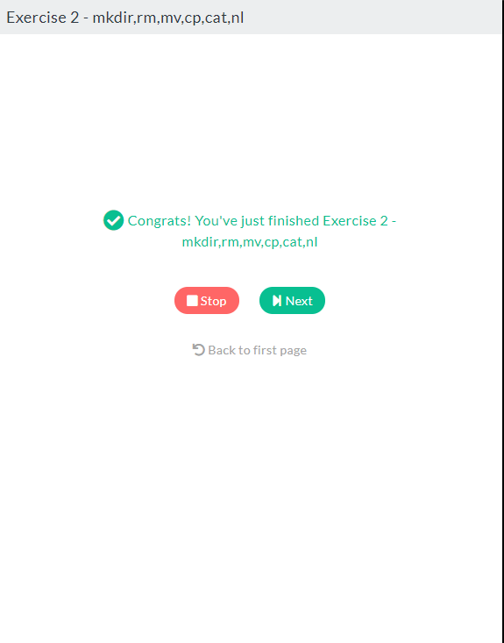

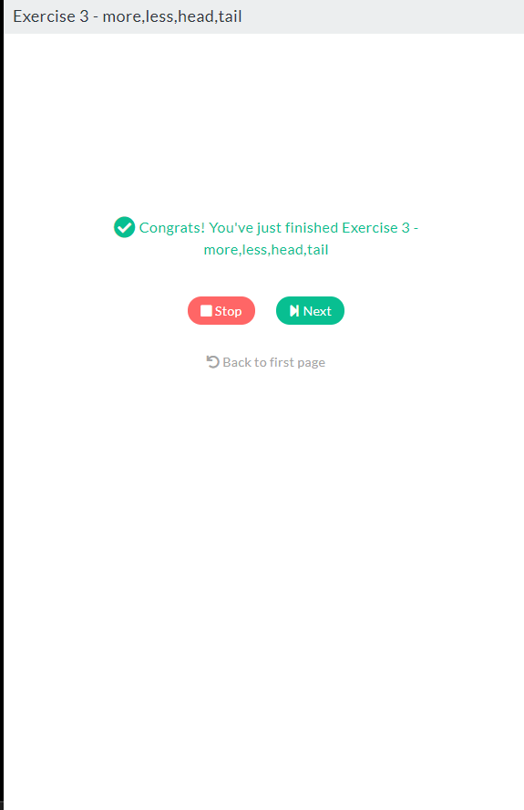

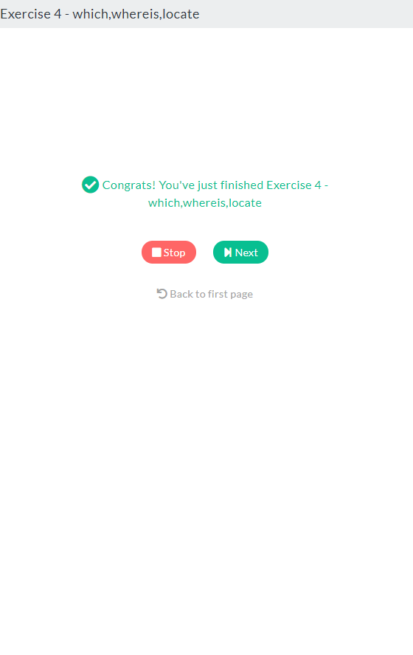

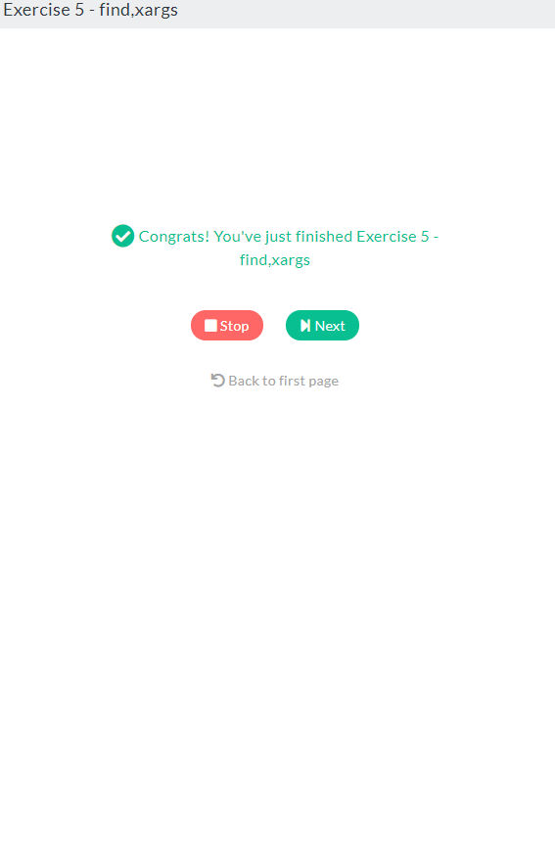

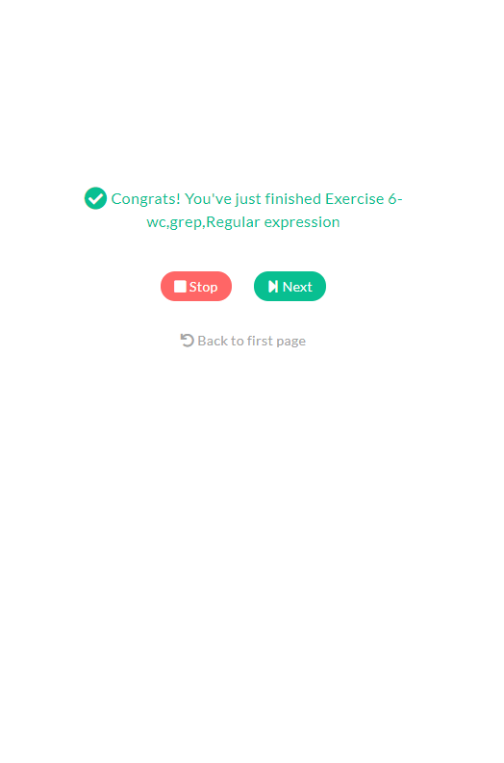

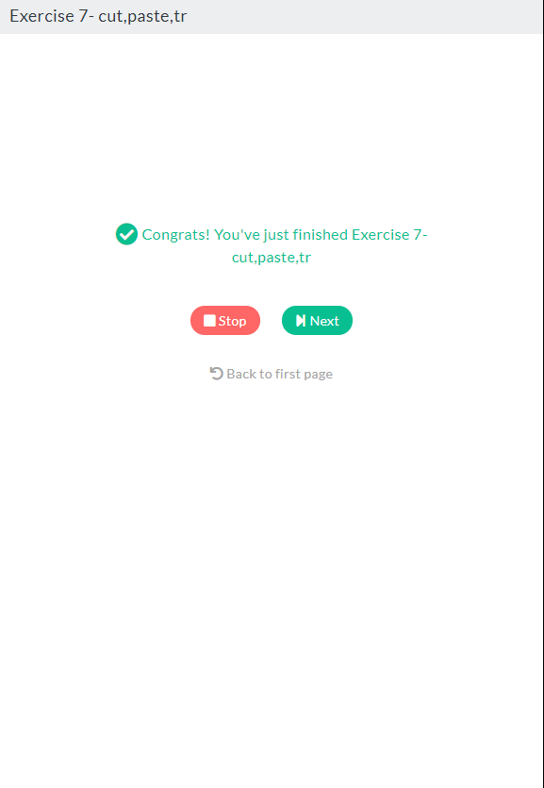

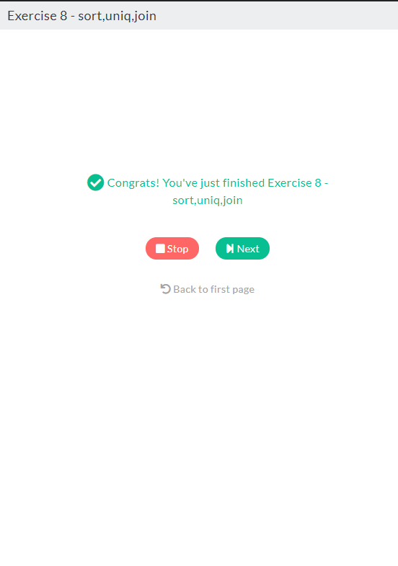

1. mkdir cli-practice
2. touch readme.md
3. echo 'Hi there, this is a readme file' > ~/cli-practice/readme.md
4. echo 'This is the second line of the readme file' >> ~/cli-practice/readme.md
5. mv ~/cli-practice/readme.md ~/cli-practice/readme.txt
6. mkdir ~/cli-practice/document
7. mv ~/cli-practice/readme.txt ~/cli-practice/document/introduction.txt
8. cp ~/cli-practice/document/introduction.txt ~/cli-practice/document/readme.tx
9. echo 'The quick brown for jumps over a lazy dog' > ~/cli-practice/document/readme.txt
10. cp -r ~/cli-practice/document ~/cli-practice/docs
11. rm -rf ~/cli-practice/document/
12. mkdir -p ~/cli-practice/parent/child/docs
13. cp ~/cli-practice/docs/introduction.txt ~/cli-practice/parent/child/docs/