**SOUTHWESTERN STATE COLLEGE**

**TRIBHUVAN UNIVERSITY**

**FACULTY OF HUMANITIES AND SOCIAL SCIENCE**

**A Project Report on :**

**Task Management System**

**Submitted to :**

**Department of Computer Application**

**Southwestern State College, Basundhara, Kathmandu**

***In partial fulfillment of the requirements for the Bachelor in Computer Application.***

***Submitted By***

Name: Manik lama

TU Reg. No:

Name : Chiran thapa

TU Reg. No:

**SOUTHWESTERN STATE COLLEGE**

**TRIBHUVAN UNIVERSITY**

**FACULTY OF HUMANITIES AND SOCIAL SCIENCE**



# SUPERVISOR’S RECOMMENDATION

We hereby recommend that this project is prepared by Chiran Raj Thapa and Manik lama under supervision by Mr. Bijay Babu Regmi entitled “**PROJECT TITLE IN BLOCK LETTERS**” in partial fulfillment of the requirements for the degree of Bachelor of Computer Application be processed for the evaluation.

Supervisor Name

Designation

# LETTER OF APPROVAL

This is to certify that this project is prepared by Name (TU Reg No.) and Name (TU Reg No.) entitled “**Task Management System**” in partial fulfillment of the requirements for the degree of Bachelor in Computer Application has been evaluated. In our opinion it is satisfactory in the scope and quality as a project for the required degree.

NAME Kiran Ghimire

Project Supervisor HOD

BCA Department BCA Department

SWSC SWSC

Dhurba Prasad Timalsina External Examiner

Academic Head Tribhuvan University

SWSC

# ACKNOWLEDGMENT

First and foremost, we would like to express our sincere gratitude to [Name] for serving as our supervisor and providing us with invaluable advice, knowledge, and unwavering support throughout the entire course of this project. Their perceptive suggestions and leadership have greatly influenced the Task Management System's functionality and overall effectiveness.

We also want to thank our friends, peers and internet sources for their encouragement and feedback. Their feedback and recommendations have been instrumental in improving the system's usability and efficacy.

# ABSTRACT

Our project Task Management System is a centralized software solution that simplifies task assignment, view task progression, set task priority and also add and delete staffs account within organizations. With an intuitive interface, it streamlines task coordination and facilitates effective communication among team members. By enhancing productivity and optimizing workflow management.

Key abstractions of the Task Management System include task assignment based on specific skills and availability staffs, as well as real-time task updates and deadlines. These abstractions streamline collaboration, minimize manual follow-ups, and ensure efficient utilization of resources. The system's user-friendly easy to use feature abstract the complexities of task management, empowering organizations to achieve streamlined workflows and improved productivity.

**Keywords: *4 -5 keywords in Italic separated by semicolon***

TABLE OF CONTENTS

SUPERVISOR’S RECOMMENDATION 2

LETTER OF APPROVAL 3

ACKNOWLEDGMENT 4

ABSTRACT 5

TABLE OF CONTENTS 6

LIST OF FIGURES 8

LIST OF TABLES 9

LIST OF ABBREVATIONS 10

CHAPTER 1: INTRODUCTION 11

1.1. Introduction 11

1.2. Problem Statement 11

1.3. Objectives 13

1.4. Scope and Limitation 13

1.5. Report Organization 15

CHAPTER 2: BACKGROUND STUDY AND LITERATURE REVIEW 16

2.1. Background Study 16

2.2. Literature Review 17

CHAPTER 3: SYSTEM ANALYSIS AND DESIGN 18

3.1. System Analysis 18

3.1.1. Requirement Analysis 18

I. Functional Requirements 18

II. Non-Functional Requirements 19

3.1.2. Feasibility Analysis 20

I. Technical 20

ii. Operational 20

iii. Economic 20

iv. Schedule (Illustrated using Gantt Chart) 21

21

3.1.2 Data Modeling (ER Diagram) 22

3.1.4. Process Modeling (DFD Make 2 level DFD) 22

3.2. System Design 22

3.2.1. Architectural Design 22

3.2.2. Database Schema Design 22

3.2.3. Interface Design (UI Interface/ Interface Structure Diagram) 22

3.2.4. Physical DFD 22

CHAPTER 4: IMPLEMENTATION AND TESTING 24

4.1. Implementation 24

4.1.1. Tools Used 24

4.1.2. Implementation Details of Modules 26

4.2. Testing 27

4.2.1. Test Cases for Unit Testing 27

4.2.2. Test Cases for System Testing 27

CHAPTER 5: CONCLUSION AND FUTURE RECOMMENDATION 29

5.1. Lesson Learnt / Outcome 29

5.2. Conclusion 29

5.3. Future Recommendation 30

REFERENCES 31

Bibliography 31

APPENDIX 33

# 

# LIST OF FIGURES

Figure 1: Gantt chart 9

Figure 2: Waterfall Model 10

Figure 3: Use case diagram 11

Figure 4: Er-diagram 12

# LIST OF TABLES

Table 1: Software Requirements 7

Table 2: Hardware Requirements 7

# LIST OF ABBREVATIONS

**CSS:** Cascading Style Sheet

**CV:** Curriculum Vitae

**ER:** Entity Relationship

**HTML:** Hypertext Markup Language

**PHP:** Hypertext Preprocessor

**SQL:** Structured Query Language

**UI:** User Interface

|  |  |  |
| --- | --- | --- |
|  |  |  |
|  |  |  |
|  |  |  |
|  |  |  |
|  |  |  |
|  |  |  |
|  |  |  |
|  |  |  |
|  |  |  |
|  |  |  |
|  |  |  |
|  |  |  |

# CHAPTER 1: INTRODUCTION

## 1.1. Introduction

In today's fast-paced business environment, managing office tasks and staffs can be a daunting challenge. That's where a Task Management System (TMS) comes in handy. The Task Management System (TMS) is a digital platform designed to help organizations manage their day-to-day operations efficiently and effectively. The primary objective of this project is to develop an interface that can manage tasks, oversee progress, monitor employee data, and improve collaboration among team members. The proposed system will include features such as task management, task scheduling, user management.

* Setting up user accounts according to the company policy.
* Digitally Assign and track tasks for employees, set deadlines, and monitor progress.
* Supervise user authentication within the system and oversee user data within the system.
* Dashboard providing an overview of task counts, employee details, and distinct staff dashboards tailored to their individual task count.

## 1.2. Problem Statement

The "Task Management System" project addresses key challenges faced in the office environment, including:

* Lack of clarity in office tasks and responsibilities.
* Inadequate implementation of time management practices and coordination among staff.
* Issues related to staff absenteeism and lack of attention to work.
* Insufficient focus on the implementation and maintenance process.

The project aims to tackle these challenges by developing a comprehensive software solution that provides clear task assignments, enhances time management practices, improves coordination among staff members, and promotes accountability. The system will facilitate efficient task allocation, set clear deadlines, and enable real-time tracking of task progress. By providing automated notifications and reminders, it will promote better attendance and attention to tasks. Additionally, the project will emphasize the importance of proper implementation and ongoing maintenance to ensure the system's effectiveness in addressing these challenges.

## 1.3. Objectives

The primary objectives of the Task Management System project are to enhance task management efficiency, facilitate effective communication, and improve productivity within the organization. The system aims to provide the following key functionalities:

* To simplify User Account Setup: The system will allow the creation of user accounts according to the company's policy, ensuring secure access for authorized employees.
* To streamline Task Assignment and Tracking: The system will enable digital task assignment, allowing managers to assign tasks to employees, set deadlines, and track their progress in real-time.
* To being coordination in team: The system will provide platform for easing their specific task assignment which could help on task progress, employee approval, and other relevant metrics providing healthy valuable insights for decision-making among team. .

With these objectives in mind, the Task Management System project aims to revolutionize the way tasks are managed within the organization, promoting efficient task allocation, effective coordination , and improved overall productivity.

**Bottom of Form**

## 1.4. Scope and Limitation

Scope:

* User Account Setup: The system will allow the creation of user accounts according to the company's policy, ensuring secure access for authorized employees.
* Task Assignment and Tracking: The system will provide a digital platform for assigning tasks to employees, setting deadlines, and monitoring their progress in real-time.
* Reporting and Analytics: The system will generate reports on task progress, employee productivity, and other relevant metrics to provide valuable insights for decision-making and performance evaluation.

Limitations:

* Integration with Existing Systems: The project's scope does not include full integration with existing software systems within the organization. The system will function as a standalone application.
* Limited Customization: While the system will provide essential task management features, it may have limitations in terms of customization options to align with specific organizational workflows.
* Hardware and Software Requirements: The system's functionality may be subject to hardware and software limitations, requiring compatible devices and operating systems for optimal performance.

It is important to acknowledge these scopes and limitations to ensure realistic expectations and effective project management during the development and implementation of the Task Management System.

## 1.5. Report Organization

Write down in a paragraph about the Chapters you included in the report i.e. what that Chapter is all about.

# CHAPTER 2: BACKGROUND STUDY AND LITERATURE REVIEW

## 2.1. Background Study

1. Task Management: Task management refers to the process of planning, organizing, assigning, tracking, and monitoring tasks within an organization. It involves allocating tasks, setting deadlines, and ensuring that tasks are completed efficiently and effectively [1].
2. Project Management: Project management is the discipline of planning, organizing, and controlling resources to achieve specific goals and objectives within a defined timeframe. It includes tasks such as defining project scope, scheduling, risk management, and communication.
3. Workflow Management: Workflow management involves the design, execution, and monitoring of work processes within an organization. It focuses on optimizing the flow of tasks and information, ensuring smooth collaboration and coordination among team members.
4. Task Assignment: Task assignment involves assigning specific tasks to individuals or teams based on their skills, availability, and workload. It ensures that responsibilities are clearly defined and distributed among employees.
5. Deadline: A deadline is a predetermined date or time by which a task or project must be completed. Deadlines play a crucial role in task management, as they provide a sense of urgency and help prioritize work.
6. Progress Tracking: Progress tracking involves monitoring and measuring the progress of tasks or projects against set milestones and deadlines. It enables stakeholders to stay updated on task status and identify any delays or bottlenecks.
7. Collaboration: Collaboration refers to the process of working together towards a common goal. In the context of task management, collaboration involves effective communication, sharing of information, and joint effort among team members to accomplish tasks.
8. Reporting and Analytics: Reporting and analytics involve generating reports and analyzing data to gain insights into task progress, employee productivity, and other performance metrics. It helps in decision-making, identifying areas for improvement, and evaluating project outcomes.

Understanding these fundamental theories, general concepts, and terminologies will provide a solid foundation for developing and implementing the Task Management System.

## 2.2. Literature Review

Here are a few web applications similar to our "Task Management System" project, along with a brief literature review for each:

1. Trello: Trello is a popular web-based project management tool that provides a visual approach to task management. It offers features such as task boards, lists, and cards that allow users to create, assign, and track tasks. Literature reviews highlight Trello's user-friendly interface, flexibility, and ease of use, making it suitable for both personal and professional task management (Bhatti et al., 2019).
2. Asana: Asana is a comprehensive task management software that focuses on collaboration and workflow management. It offers features like task assignment, deadline setting, progress tracking, and team communication. Literature reviews emphasize Asana's ability to improve team coordination, productivity, and project visibility, making it a popular choice among organizations (Nasir et al., 2020).
3. Jira: Jira is a widely used web-based software for project management and issue tracking, primarily in software development teams. Literature reviews highlight Jira's robust features for task assignment, progress tracking, and agile project management. It is known for its flexibility, customization options, and integration capabilities (Mahajan et al., 2018).
4. Monday.com: Monday.com is a versatile project management platform that offers customizable task boards, timelines, and collaboration tools. Literature reviews emphasize its intuitive interface, visual appeal, and ease of use. It is particularly appreciated for its flexibility and adaptability to different project management methodologies (Choudhary et al., 2021).
5. Basecamp: Basecamp is a web-based project management and team collaboration tool. Literature reviews highlight its simplicity, straightforwardness, and emphasis on communication and collaboration. It is often praised for its intuitive design, file sharing capabilities, and ease of onboarding for new users (Seo et al., 2019).

# CHAPTER 3: SYSTEM ANALYSIS AND DESIGN

## 3.1. System Analysis

Well, from here the real work begins, development of the proposed system is analyzed into details. It will analyze the tools and technologies used, data sources and programming languages used and why. Dataflow diagrams, flowcharts, use-case diagrams, relationship and entity diagrams, and many more will be used to explain the project and it starts from now here on.

### 3.1.1. Requirement Analysis

Requirement analysis is the systematic process of gathering, documenting, and analyzing the needs and expectations of stakeholders for a software system or project. It involves understanding and defining the functional and non-functional requirements that the system should meet to satisfy the desired objectives.

The purpose of requirement analysis is to establish a clear understanding of what the system should do, how it should behave, and what constraints or limitations it should adhere to. It involves identifying and documenting the goals, features, functionalities, and performance criteria that the system should possess.

### I. Functional Requirements

* + - * The system shall allow the creation, management, and authentication of user accounts, including user registration, login, and password management.
      * The system shall provide functionality for creating tasks, assigning tasks to specific users or teams, and setting task priorities, deadlines, and dependencies.
      * The system shall enable users to track the progress of assigned tasks, update task status, and provide real-time visibility into task completion.
      * The system shall generate reports and provide analytics on task progress, employee productivity, task completion times, and other relevant metrics.

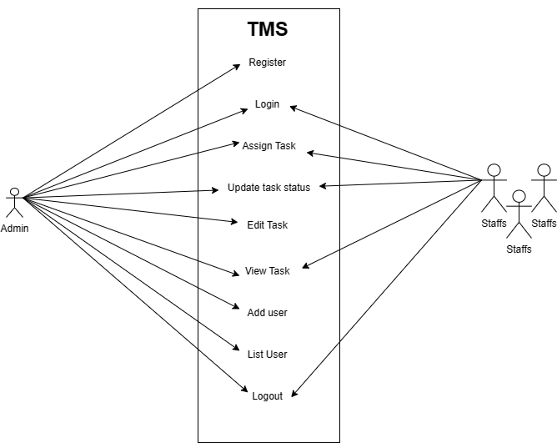

*Fig1: use case diagram*

### II. Non-Functional Requirements

* The system must have an intuitive and user-friendly interface that is easy to navigate, ensuring a positive user experience and minimizing the learning curve.
* The system must implement appropriate security measures, such as user authentication to ensure authorized access and protect sensitive information of staffs.
* The system must perform efficiently, with minimal response times and the ability to handle a growing number of users and tasks without significant performance degradation.
* The system must be reliable, ensuring that tasks and data are not lost or corrupted. It should also have high availability, minimizing downtime and ensuring access to the system when needed.
* The system must be compatible with different operating systems, web browsers, and devices, and should support integration with other existing software systems

within the organization, if required.

### 3.1.2. Feasibility Analysis

### I. Technical

* From a technical standpoint, the project is feasible as it leverages commonly used technologies and frameworks for web application development. The required programming languages, such as HTML, CSS, and JavaScript, along with backend technologies like PHP, are widely available. Additionally, databases like MySQL us being utilized for data storage. The project's technical requirements can be met using existing tools, libraries, and development environments, making it technically feasible to implement.

### ii. Operational

* In terms of operational feasibility, the project offers significant advantages. It streamlines task management processes, enhances communication and collaboration, and improves overall productivity. The system can be easily integrated into existing workflows, allowing for seamless adoption by staff members. Conducting small training sessions and providing user-friendly interfaces will further facilitate smooth operations and user acceptance. Therefore, the project demonstrates strong operational feasibility.

### iii. Economic

* The "Task Management System" project demonstrates strong feasibility in terms of learning and gaining knowledge without significant monetary costs. By investing time and effort into developing and implementing the system, the college and project team can acquire valuable skills in software development, project management, and problem-solving. This non-monetary value derived from learning and skill development makes the project economically feasible

### iv. Schedule (Illustrated using Gantt Chart)

### 

*fig2:Gantt chart*

### Data Modeling (ER Diagram)

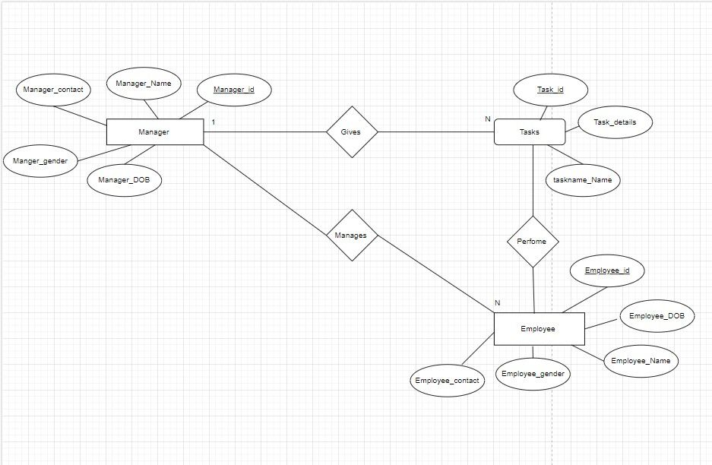

*Fig3:ER diagram*

### 3.1.4. Process Modeling (DFD Make 2 level DFD)

## 3.2. System Design

### 3.2.1. Architectural Design

### 3.2.2. Database Schema Design

### 3.2.3. Interface Design (UI Interface/ Interface Structure Diagram)

### 3.2.4. Physical DFD

# CHAPTER 4: IMPLEMENTATION AND TESTING

## 4.1. Implementation

### 4.1.1. Tools Used

|  |  |  |
| --- | --- | --- |
| **SN** | **Software** | **Purpose** |
| 1 | Visual Studio Code | Code Editor |
| 2 | MySQL | DBMS to store data and information |
| 3 | Microsoft Word | Documentation |
| 4 | Snipping Tool | Screenshots |

Table 2: Hardware Requirements

|  |  |  |
| --- | --- | --- |
| **SN** | **Hardware Requirements** | **Specification** |
| 1 | Processor | Intel Core i3 2.0 GHz or higher |
| 2 | RAM | 2 GB or higher |
| 3 | Internet Speed | 3-5 Mbps |

### 4.1.2. Implementation Details of Modules

To implement the project, we are going to follow the waterfall model (output for one is input for another). It is the first SDLC model to be widely used in Software Engineering to ensure the success of the project.

The following illustration is a representation of the different phases of the Waterfall Model.

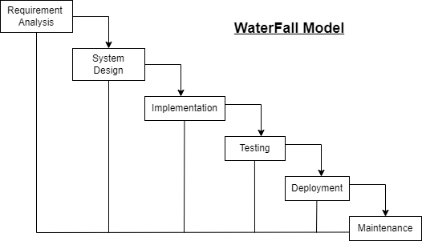

*Figure 4: Waterfall Model*

Technology is clearly understandable. Our project definition is stable. Since we have well known, clean and fixed requirements therefore its best suits for the software development. This model is simple, easy to understand and user friendly. In this model phases are processed and completed one at a time and the phases don’t overlap. Waterfall model works well for smaller projects where sequence is very well understood.

## 4.2. Testing

### 4.2.1. Test Cases for Unit Testing

### 4.2.2. Test Cases for System Testing

# CHAPTER 5: CONCLUSION AND FUTURE RECOMMENDATION

## 5.1. Lesson Learnt / Outcome

Our project provides integrate knowledge and it analyses, evaluates and manage the designed project based on JavaScript language associated with Database Management System (DBMS). It provides the capacity to perform the designed project theoretically and practically which is based on GUI interface. And as an we individuals can use this system easily, quickly, and accurately as it is user friendly, so that required information can be easily generated. This system enables users to create an account in accordance with their company policy, and effortlessly access information regarding their task working, and encompasses the overview of their tasks within the company.

The admin has complete control over the entire system, including updating task, managing staff information privacy, and tracking staff progress. This system saves time and simplifies the process for both the user and the admin in the company. In future, this system has the potential to be utilized for other management purposes, such as sports team management, student management, and various other similar platforms.

## 5.2. Conclusion

On the basis of development of this project, this project assists organizations in optimizing their task operations by automating staff tasks. by implementing an task Management System, an organization can significantly enhance its productivity, efficiency, and communication through the centralization of information, and improved collaboration of staff members. The main motive to design this project is to make the task management system more technical and easier for many organizations out there. With regards to this, we the project team member Chiran raj Thapa and Manik lama would like to express a true appreciation who have given their kind assistance, encouragement and support for the completion of this project work. First and foremost, we would like to thank Southwestern State College affiliated with Tribhuvan University for providing this opportunity to carry out this project as a partial fulfillment for the requirement of Bachelor of Arts in Computer Application (BCA). Last but not the least we would like to gratitude all the well-wisher who had helped as directly or indirectly during this project development phases.

## 5.3. Future Recommendation

Future Recommendations for the "Task Management System" Project:

1. Mobile App: Develop a mobile application for on-the-go task management.
2. Calendar and Email Integration: Sync tasks with popular calendar and email applications.
3. Collaboration Features: Enhance communication and collaboration with real-time messaging and file sharing.
4. Advanced Task Analytics: Provide in-depth insights into task performance and resource utilization.
5. Integration with Project Management Tools: Integrate with popular project management platforms for seamless data exchange.
6. Customization Options: Allow users to personalize the system's interface and notifications.
7. Continuous Improvement: Gather user feedback and regularly update the system based on user needs.

s

# REFERENCES

1. "Task management system: Benefits, Features, and Providers of office system

Software," researchgate,01 march 2018. [Online]. Available: [(PDF) Office Management (researchgate.net)](https://www.researchgate.net/publication/323731787_Office_Management)

# Bibliography

|  |  |
| --- | --- |
| [1] | C. Thapa, "Task Management System," [Online]. Available: https://www.taskmanagement.com. [Accessed 20 08 2023]. |

|  |  |
| --- | --- |
|  |  |
|  |  |
|  |  |
|  |  |
|  |  |
|  |  |
|  |  |

# APPENDIX

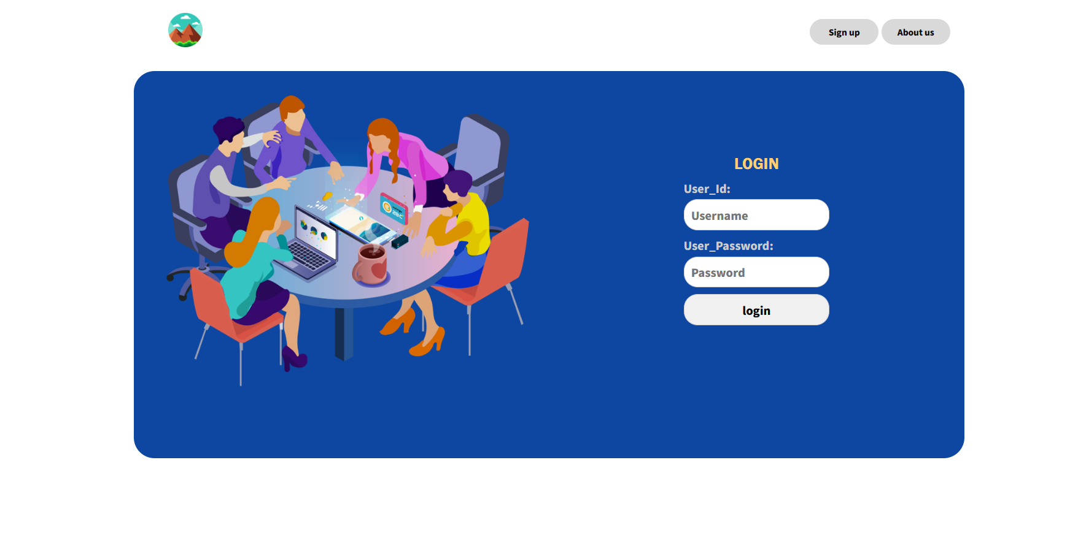

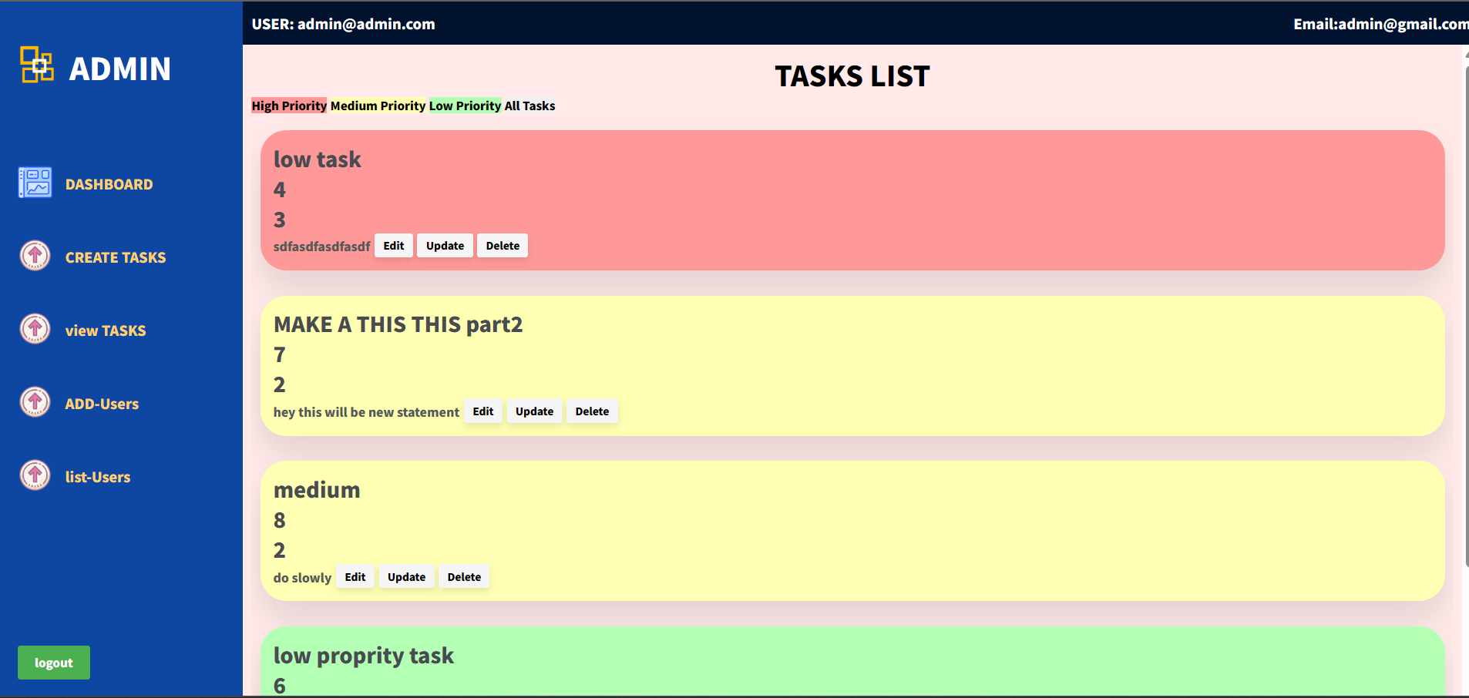

**Report Format Standards**

A. Page Number

The pages from certificate page to the list of tables/figures should be numbered in roman starting from i. The pages from chapter 1 onwards should be numbered in numeric starting from 1. The page number should be inserted at bottom, aligned center.

B. Page Size and Margin

The paper size must be a page size corresponding to A4. The margins must be set as

Top = 1; Bottom = 1; Right = 1; Left = 1.25

C. Paragraph Style

• All paragraphs must be justified and have spacing of 1.5.

D. Text Font of Document

• The contents in the document should be in Times New Roman font

• The font size in the paragraphs of document should be 12

E. Section Headings

• Font size for the headings should be 16 for chapter title, 14 for section headings, 12 for the sub-section headings. All the headings should be bold faced.

F. Figures and Tables

• Position of figures and tables should be aligned center. The figure caption should be centred below the figure and table captions should be centered above the table. All the captions should be of bold face with 12 font size.