Marie Leung (mcleung)

**TP1**

**Project Description:**

My project, named “I Can’t Sleep”, will be a first person shooter game with a 112 theme. It will basically progress through a story, having levels based on topics we have learned throughout the year, and each level will have enemies to shoot that are ideas from those topics. For example, level one may have enemies that are numbers, called “Ints”, to shoot, whereas the final boss would be “Recursion”. If possible, there will be a little bit of narrative text in an overlay during levels to take the player through the journey of a year in 112.

**Competitive Analysis:**

Similar 112 projects include any shooter game that has been made in the past, such as a “2.5D FPS” (<https://www.youtube.com/watch?v=aGD918JzFoo>) I found that drew a “fake 3D” world, which was actually meticulously drawn out without additional 3D support like Blender. However, I believe that the 3D used in this 2.5D shooter is not the same fake 3D that my mentor suggested; she said to use 3D images and create fake depth as well as simulated scrolling from area to area instead of making a character model walk through actual 3D levels. The techniques in the 2.5D shooter are likely beyond my initial plans.

Another project, “Sniper Shooter” (<https://www.youtube.com/watch?v=0w1aEcN7SbA>), is clearly a 2D shooter, but that is similar to what I will actually be coding with the exception of my game having the arm and gun within view. Sniper Shooter has shaking effects of wind that I am not planning on using, but all other aspects, such as different levels and shooting targets that will move around and die, are pretty basic in shooters that I will also have.

**Structural Plan:**

For my standard enemies, they have their own classes like the monster demo from lab. Players, which are basically different characters with different weapons, also currently have a class, just because not much changes between players in terms of how health, armour, attacking, etc works. Only their damage dealing is different.

For each item in the game, there will be a helper function to draw them, which is then called in redrawAll() for data.mode == “gameMode”. There will also be another mode for a boss level if I reach VIP status first.

To save scores or even the state of a game, there will be files written to the folder the game is in with information regarding the scores/game state.

A lot of things I talked about in TP meetings, I’m not sure if I can remember every structural detail right now.

**Algorithmic Plan:**

I think the two hardest parts of my game is the trajectory of bullets and taking damage when they impact, and creating enemy AI. While I think AI is okay because it is just randomized movement and shooting, the bullets may take more effort. Perhaps they are fired from the “gun” origin point, then travel as a circle across the screen, and when a bullet hits an enemy, it will deal damage to the enemy and disappear. There is also the question as to what happens when an enemy dies; I’m not sure if I want it to disappear or be replaced by a body.

**Timeline Plan:**

I aim to have everything functioning at its most basic level by next Sunday, when we have a “middle” checkpoint, and then fix problems between the checkpoint and TP2. Graphical improvements will also be after the checkpoint, and aren’t as important. They are easily replaced, anyways.

**Version Control Plan:**

For version control, I will be keeping the code files on my laptop of course, but I will also be using GitHub for a more complete record. Since I can access any previous commits in my project’s repository, it will be easier to check what happened when and how the code differed.

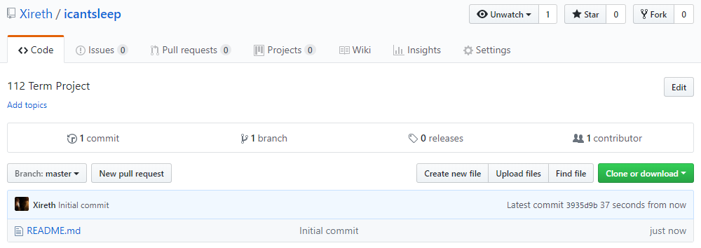

**Module List:**

I am not planning on using any external modules/hardware/technologies in my project, at least before MVP. I have discussed trying 3D modelling software after reaching MVP status, but for now, I will be using what my mentor calls “fake 3D” in Python.