Development and Evaluation of a Domain-Specific RAG Chatbot for the National Building Code of the Philippines: A Comparison of Gemma 2B IT and Qwen2.5-1.5B-Instruct

Patricia Mae G. Dela Cruz ^{a1}, Nathaniel H. Dumayas ^{a2}
^{a2}School of Information Technology, Mapua University
Makati, Philippines
Email: ¹ pmgdelacruz@mymail.mapua.edu.ph, ² nhdumayas@mymail.mapua.edu.ph

Abstract— Accessing complex regulatory documents such as the National Building Code of the Philippines (NBCP) is challenging because of their technical language and dispersed requirements. Although Large Language Models (LLMs) enable natural-language querying of documents, general-purpose models often struggle to provide accurate, evidence-grounded responses required in compliance-oriented applications. This study developed a retrieval-augmented generation (RAG) chatbot for NBCP question answering and compared two instruction-tuned, open-weight models—Gemma 2B IT and Qwen2.5-1.5B-Instruct—as generation backends under identical retrieval conditions using 21 unseen user-style questions. Both models achieved perfect retrieval recall (Recall@k = 1.0), indicating that the retrieval pipeline consistently surfaced at least one relevant chunk for every query. However, the quality of answer generation differed across models. Gemma outperformed Qwen in overall answer quality, achieving a higher Token F1 score (0.6078 vs. 0.5637), higher token recall (0.5963 vs. 0.5354), and stronger preservation of numeric values and units, with numeric recall and unit recall both at 0.9048 compared with Qwen’s 0.7143 and 0.7619, respectively. Although Qwen showed slightly higher token precision (0.6786 vs. 0.6405), Gemma produced more complete and more consistent answers overall. The findings suggest that in regulatory RAG systems, effectiveness depends not only on retrieval quality but also on the generator’s ability to accurately recover precise technical details from noisy retrieved context, establishing Gemma as the more suitable model for NBCP-focused question answering in the current setup.
Keywords— Retrieval-Augmented Generation, Large Language Models, Dense Retrieval

Introduction
The National Building Code of the Philippines (NBCP), enacted as Presidential Decree No. 1096, establishes minimum requirements governing building design, construction, occupancy, and maintenance to safeguard life, health, property, and public welfare [1]. In practice, the NBCP is frequently consulted by students and professionals in architecture and civil engineering, as well as by local government offices involved in permitting and compliance checks. However, the NBCP is a lengthy and technical legal document, and users often need to locate precise requirements (e.g., minimum heights, clearances, or procedural timelines) under time constraints and without knowing the exact chapter or section where the relevant clause appears.
Manual consultation of the NBCP PDF can be inefficient and error-prone because requirements are distributed across multiple chapters and frequently include conditional statements (e.g., exceptions, “provided that” clauses, or differing rules depending on building conditions). Regulatory questions are often phrased in practical terms rather than legal language, which makes keyword-based searching insufficient. In addition, many NBCP provisions depend on exact numeric thresholds and measurement units; therefore, any paraphrasing, rounding, or omission of units can reduce the reliability of an answer for compliance-oriented tasks.
Large language models (LLMs) enable natural-language question answering and conversational access to complex documents. Still, general-purpose LLMs may produce plausible responses that are not explicitly supported by the source text. This limitation is particularly important in regulatory settings where factual grounding and traceability are necessary. Retrieval-augmented generation (RAG) addresses this issue by combining passage retrieval from a trusted corpus with conditioned response generation, improving factual accuracy by constraining the model to retrieved context rather than relying solely on parametric knowledge [2].
In this study, we develop a domain-specific chatbot for the National Building Code of the Philippines (NBCP) using a retrieval-augmented generation (RAG) pipeline constructed from the NBCP PDF. The document is parsed into page-level text and segmented into overlapping chunks to preserve clause continuity, then encoded using dense sentence embeddings and indexed in a FAISS vector store for efficient semantic similarity search [3], [4]. For each user query, the system retrieves the top-ranked chunks and injects them into a constrained prompt that enforces document grounding and strict preservation of numeric values and measurement units, returning “Not specified in the document” when evidence is insufficient [2]. We then compare two instruction-tuned open-weight LLMs as generation backends—Gemma 2b IT and Qwen2.5 1.5B Instruct—to assess response quality and quantitative fidelity under the same retrieval and prompting conditions [6], [7]. Performance is measured using overlap-based metrics such as token-level precision/recall/F1, complemented by compliance-oriented metrics that explicitly evaluate numeric and unit preservation to reflect the correctness requirements of regulatory question answering.

Review of Related Literature

Chatbots for Laws, Regulations, and Standards
The integration of chatbot technology within the legal and regulatory sectors has shifted from basic information retrieval to advanced Legal Question Answering (LQA). As noted by Hassan and Le, the construction industry faces persistent challenges regarding "inadequate drafting, review, and management of legal documents," which often result in costly disputes [8]. Their research demonstrates that Natural Language Processing (NLP) can automate the processing of these dense statutes, achieving an accuracy range of 80% to 96% in identifying specific project requirements. Furthermore, Shamshiri et al. posit that Large Language Model (LLM)-based systems act as "augmented intelligence," allowing multidisciplinary teams to synthesize complex regulatory insights into natural language, thereby significantly reducing the manual effort traditionally required for compliance verification [9].
- Natural Language Processing for Technical Documents
Technical standards, such as building codes, present unique NLP challenges due to their semi-structured layouts and complex clause dependencies. Shamshiri et al. emphasize that while traditional text mining focuses on information extraction without semantic context, modern NLP methodologies enable Knowledge Representation (KRep) and reasoning in a human-centric manner [9]. A critical development in this domain is Automated Compliance Checking (ACC), which utilizes NLP to translate natural language building codes into machine-readable formats. This allows for the seamless integration of regulatory requirements into Building Information Modeling (BIM) workflows [9]. Moreover, classification models are now capable of extracting both "explicit and implicit requirements" from construction documents, mitigating the "significant burden" on practitioners to restructure technical text manually [8].

Open-Source Large Language Models (Gemma-B 1-5 Instruct and Qwen-2B IT)
Open-Source Large Language Models (Gemma-2B-Instruct and Qwen2.5-1.5B-Instruct)
Selecting a base model is a critical architectural decision for domain-specific applications. The Qwen2.5 model family, developed by Alibaba Cloud, is trained on a large multilingual corpus and incorporates architectural features such as Grouped Query Attention (GQA) and Rotary Positional Embeddings (RoPE), which improve efficiency and long-context reasoning capabilities [10]. These features are particularly useful for processing lengthy regulatory documents such as the National Building Code of the Philippines.
In this study, we utilize Gemma-2B-Instruct, a lightweight open-weight language model released by Google DeepMind and trained using techniques derived from the Gemini research framework [7]. Gemma models are designed to provide strong instruction-following capabilities while remaining computationally efficient for research and deployment on limited hardware.
Prior research suggests that integrating open-source language models with Retrieval-Augmented Generation (RAG) can significantly improve factual grounding and reliability, allowing smaller models to perform competitively with larger proprietary systems when provided with relevant contextual evidence [9].
- Retrieval-Augmented Generation for Regulatory Document QA
Retrieval-Augmented Generation (RAG) has become a standard framework for improving the factual grounding of LLM-based question answering systems, particularly in domains where authoritative documents must be followed. RAG pipelines retrieve relevant passages from a knowledge source and condition the language model’s response on the retrieved context, reducing reliance on the model’s parametric memory and mitigating hallucinations [11]. This approach is especially appropriate for regulatory documents such as building codes, where requirements must be traceable to source clauses, and answers often depend on conditional language (e.g., exceptions and “provided that” statements). In practical implementations, RAG typically includes document chunking, dense embedding generation, vector indexing, top-k retrieval, and prompt construction for controlled response generation [11].
- Dense Retrieval Using Sentence Embeddings and Vector Search (FAISS)
Unlike keyword matching, dense retrieval supports semantic search by representing both queries and document chunks in a shared embedding space. Sentence-BERT (SBERT) introduced an efficient method for generating sentence-level embeddings optimized for similarity search, enabling retrieval even when user questions are paraphrased or use non-legal wording [12]. For scalability and efficiency, vector databases and similarity search libraries such as FAISS are widely used to perform nearest-neighbor retrieval over high-dimensional embeddings [13]. These tools allow low-latency retrieval over large corpora and are commonly paired with RAG systems for document-grounded QA.
- Prompting and Grounding Strategies for Compliance-Oriented Chatbots
Even with retrieval, generation quality depends on prompting strategies that constrain the model to the retrieved evidence. For compliance-oriented assistants, prompts often enforce short responses, prohibit unsupported claims, and require preserving numeric values and units exactly as written in the source. Such constraints improve usability and reduce the risk of errors in measurement-sensitive requirements. In addition, providing explicit fallbacks (e.g., “Not specified in the document”) can prevent the model from guessing when evidence is insufficient, aligning system behavior with regulatory expectations.
- Evaluation Metrics for Document-Grounded Question Answering
Automatic evaluation of QA systems often relies on lexical overlap measures, such as ROUGE, which quantifies similarity between generated answers and references using n-gram overlap and longest common subsequences [14]. While useful, overlap-based metrics may penalize correct paraphrases or alternative phrasing, particularly in natural-language responses. For building-code QA, correctness also depends on preserving quantitative constraints; therefore, domain-specific evaluation benefits from additional measures such as numeric recall and unit recall to verify whether answers reproduce the required thresholds and measurement units. Combining overlap-based metrics with compliance-oriented checks yields a more accurate assessment of a regulatory chatbot’s practical performance.

Methodology
The proposed system combines a domain-specific language model with a retrieval pipeline to answer queries on the Philippine Building Code. We follow a retrieve-then-read paradigm: first, ingest and index the code corpus, then for each query, retrieve relevant passages and pass them to a language model to generate an answer. This mirrors recent domain-specific RAG systems that ground LLM outputs in external knowledge [16], [17].
- Data Sourcing and Preprocessing
We first obtained the complete text of the National Building Code (Republic Act 1096, PD 1096 of 1977) from the official DPWH website [1]. We extract text from each page (tracking page numbers for traceability) and then apply sliding-window chunking (chunk size ≈900 tokens, overlap ≈150 tokens). This ensures that clauses and conditions spanning page breaks remain intact. Each chunk retains a reference to its original page. (This is similar to chunking strategies in other RAG pipelines to preserve context.)
The extracted text was preprocessed to increase consistency and retrieval quality prior to chunking. Formatting artefacts like page headers, footers, irregular spacing, and non-text elements were eliminated during this phase. To guarantee that the extracted content remained machine-readable while maintaining the original wording of the legal document, punctuation normalisation and whitespace cleaning were also carried out. Because legal and regulatory texts frequently rely on precise terminology, it was crucial to preserve the NBCP's exact wording.
Additionally, each chunk was linked to and preserved with metadata like page numbers and section identifiers. This allows the system to maintain traceability between generated answers and the original source document. By retaining this metadata, the system can later provide evidence references that enable users to verify the correctness of the generated responses directly from the official NBCP document.
- Embedding and Indexing
Each text chunk is encoded into a dense vector using a pretrained SentenceTransformer model (all-MiniLM-L6-v2). These vectors are indexed with FAISS (a fast nearest-neighbor search library) [18]. In our FAISS setup, we normalize embeddings and use an L2 index, which enables efficient semantic retrieval. This approach of combining semantic embeddings with FAISS-based search has been applied in prior RAG systems for context retrieval [18].
Dense vector embeddings can identify semantically similar text passages that may not use the same words as the user’s query. This is because dense vector embeddings can understand the contextual meaning of words within sentences or paragraphs. This is particularly advantageous when working with regulatory texts like the NBCP, as the same concept may be written differently across different sections.
The FAISS index stores the vectors and allows the system to conduct similarity searches over the entire document corpus. After indexing the vectors, the system can then quickly compare the user query vector with all the vectors to identify the most relevant passage to the user query. This method greatly improves the speed of the system while maintaining high accuracy to process user queries almost in real-time.
- Retrieval
For the query, we use the same embedding model to encode the user query and then use k-nearest neighbors search on the FAISS index to retrieve the top k most relevant chunks (we choose k ≈ 20). Optionally, we also apply keyword matching on the retrieved chunks to guarantee the presence of important words (e.g., numerical values and units). Finally, the retrieved context, which is a small set of chunks from the NBCP, is used to generate the answer. This approach to retrieve and then read the context is similar to the pipelines adopted by other legal and domain-specific QA systems, known as “retrieve-then-read” or RAG models [16], [17].
The retrieval stage is critical to guarantee the accuracy of the generated response by the generative model. Indeed, by restricting the input to the language model to the most relevant information contained in the NBCP, the system reduces the risk of hallucination and favors the generation of answers grounded in the actual information contained in the code.
Finally, the retrieval of multiple chunks of context allows the system to gather information on the surrounding context of the regulation. Some NBCP provisions may span multiple paragraphs or pages, and retrieving several relevant chunks increases the probability that the complete regulatory condition is included in the context. This improves both the accuracy and reliability of the final generated answer.
- Generative Models and Prompting
We compare two LLM backends under identical retrieval conditions: Google’s Gemma 2b and Qwen 2.5-1.5B model. Both models are accessed via HuggingFace Transformers. We use a carefully crafted prompt that instructs the model to use only the provided context and to output exactly one sentence containing the answer or “Not specified in the document” if the answer isn’t found. In particular, the prompt directs the model to copy verbatim from the context when possible and disallows any extra explanation. This strict prompting effectively constrains the models to be factual and grounded in the retrieved text. In other words, we enforce an extractive QA style even from these generative models.
The prompt design is critical in controlling the behavior of large language models. In the absence of such instructions, the generative models may generate lengthy explanations or, worse still, invent information that is not present in the source document. By enforcing the use of strict instructions that restrict the output to a single concise sentence, the system facilitates consistency and comparability of the two evaluated models.
Additionally, the prompt structure emphasizes the importance of using only the retrieved NBCP context. This constraint encourages the models to treat the retrieved passages as authoritative references, effectively turning the generative models into context-aware question answering systems. As a result, the system behaves more like a retrieval-based legal assistant rather than a general-purpose conversational model.
- Answer Generation
For each model, we generate the answer with beam or greedy decoding (we set temperature and beam parameters to favor deterministic output). We ensure the model is returned to evaluation mode between questions to avoid state carry-over. Any extraneous tokens (e.g., partial words or stop sequences) are trimmed from the model’s output to produce a clean answer string.
The decoding configuration was chosen to prioritize stability and reproducibility of results. Lower temperature values reduce randomness in the generated text, ensuring that the models produce consistent answers when presented with identical inputs. This is especially relevant with respect to comparing various models, as this helps to ensure that the performance variance can be accounted for with respect to the model’s ability rather than the generation variance.
A post-processing step follows the generation. This step removes unnecessary whitespace, incomplete tokens, or formatting artifacts that may appear during generation. The final output is then formatted as a single sentence answer that can be directly compared with the reference answer during evaluation.
- Evaluation Dataset
We evaluate on a held-out set of user-style NBCP questions (unseen during any setup) with annotated gold answers and evidence pages. Each test item has the following components: a natural language question, a reference answer (extracted from the NBCP), and the ground truth page where the answer is found. This is similar to the general approach adopted for domain QA, where a small test set is used to evaluate the performance of the system.
The test questions for the evaluation set were designed to mimic the types of queries users might ask while using the NBCP. This includes queries such as height, occupancy, setback, etc. Using practical questions is more relevant for the evaluation of the system, as it is more applicable to the real world.
Each test question has been manually associated with the corresponding reference answer, which is extracted directly from the NBCP document. The ground-truth evidence pages were also recorded to verify whether the retrieval stage successfully identifies the correct portions of the document. This structured dataset enables both answer-level evaluation and retrieval-level analysis.
- Metrics
We use multiple metrics to analyze performance. For correctness, we compute token-level precision, recall, and F1 scores between the predicted and gold answers. (Extractive QA often uses token-F1 and exact-match metrics [19] .) In our case, we focus on token-F1 (considering answer tokenization that normalizes numbers and units). We also define compliance metrics for numeric values: we extract numerical magnitudes (normalizing formats) and units from the predicted and gold answers and compute the fraction of gold numbers/units that were correctly recovered (numeric-recall and unit-recall). These measure how well the model captures quantitative compliance details. Finally, we assess retrieval performance by computing the fraction of true evidence pages retrieved; specifically, we measure recall@k for page-level evidence (i.e., how many of the annotated pages appear among the top-k retrieved pages).
These metrics allow the evaluation to capture both linguistic accuracy and regulatory correctness. Token-level F1 measures the textual similarity between predicted and reference answers, while the numeric and unit compliance metrics ensure that critical regulatory values such as measurements, distances, and quantities are correctly captured. Since many building regulations depend on precise numerical limits, these compliance metrics are particularly important in assessing system reliability.
In addition to answer-level metrics, the retrieval recall@k metric evaluates the effectiveness of the document retrieval stage. High retrieval recall indicates that the system is successfully locating the relevant sections of the NBCP before answer generation. Together, these evaluation metrics provide a comprehensive assessment of the system’s performance across retrieval accuracy, answer correctness, and regulatory compliance.
- System Architecture
The overall system architecture for our RAG chatbot is illustrated in Figure 1. The pipeline consists of two main stages: (i) an offline data ingestion and embedding phase, and (ii) an online query phase. As described by Wolff et al., a typical RAG pipeline has an offline “ingestion” pipeline that preprocesses and embeds documents, and a separate “inference” pipeline that handles user queries and generates answers [20].
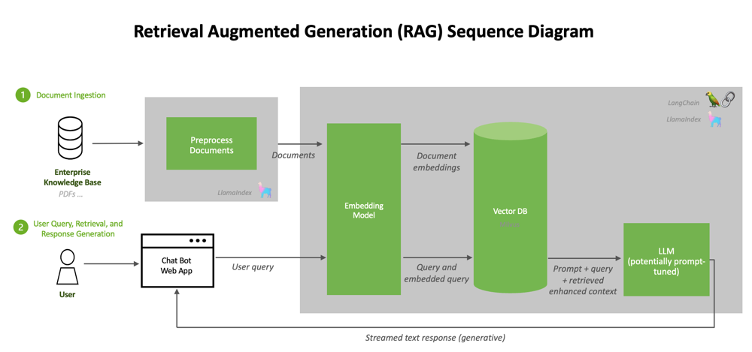
Figure 1. Pipeline architecture of the RAG chatbot for the NBCP.
The offline pipeline (left) involves ingesting the NBCP document, splitting it into chunks, embedding the chunks using a sentence transformer, and storing the embeddings in a FAISS index, a vector database. At runtime (right), the user’s query is embedded and searched against the FAISS index to retrieve the most relevant text chunks. The retrieved text is then combined with the query and processed through a large language model (either Gemma 2b or Qwen 2.5B) using the Hugging Face Transformers library. A short answer is generated, which is then returned to the user through a web interface.
Each component uses standard NLP and ML tools. In the document ingestion phase, Python code (running on CPU) reads the NBCP PDF (using PyMuPDF), cleans the text (removing headers/footers), and applies the sliding-window chunking described earlier [20]. Each chunk’s text and page metadata are passed to the embedding stage. Here, we use a pretrained all-MiniLM-L6-v2 sentence transformer (PyTorch) to convert each chunk into a fixed-size vector. These vectors are then normalized and added to a FAISS index (e.g., using an L2/flat index) for fast similarity search [20]. FAISS is a CPU-optimized (and optionally GPU-accelerated) library that supports billion-scale nearest-neighbor search; storing our document embeddings in FAISS creates a vector database akin to the “specialized vector databases” described in the literature [20].
When a user query is received (via our Gradio web interface on the inference server), it is handled by the online retrieval pipeline. The query text is first embedded with the same sentence-transformer, and FAISS is queried to find the top-k most similar chunk vectors. Optionally, a simple keyword match filter is applied to ensure critical terms are present. The resulting text chunks (and their page sources) form the contextual evidence. As shown in Fig. 1, the query and retrieved passages are then concatenated and sent to the LLM. The LLM inference component uses HuggingFace Transformers to call either Gemma 2b or Qwen 2.5B. These models generate the final answer sentence, conditioned on both the user query and the retrieved context [20]. In this way, the LLM serves as the generative component of the RAG pipeline, producing responses grounded in the retrieved knowledge [20].
Finally, the answer is returned to the user through the front-end interface. We implemented this interface using Gradio (Python), which allows users to enter questions and see answers along with the relevant NBCP page citations. All these pieces are run on the same server, with document processing and indexing running on CPU threads and LLM inference running on a GPU. The tech stack is Python 3, HuggingFace Transformers, Sentence Transformers, FAISS, and web-serving libraries. This modular architecture – with separate services for ingestion vs. query – follows best practices for RAG systems [20].
- Deployment
In the deployment stage, the developed Retrieval-Augmented Generation (RAG) system was integrated with an interactive web interface developed using Gradio to facilitate real-time user interaction with the chatbot. This was based on the fact that Gradio is compatible with Python-based machine learning environments and can easily integrate with the Hugging Face Transformers library to create a user-friendly interface without extensive coding expertise. This enabled the creation of a user interface that can be used to interact with the chatbot through a web interface to input questions based on the National Building Code of the Philippines (NBCP).
The process of deploying the RAG model involved loading the pre-built FAISS vector index containing the embedded NBCP document chunks and the pre-trained Gemma 2B and Qwen 2.5-1.5B language models. Once the user submits a query to the chatbot using the interface, the query is converted into a semantic embedding using the same sentence transformer model as was used during the indexing process. This query embedding is then used to retrieve the most relevant text chunks from the FAISS vector database. These text chunks form the input to the language model.
The language model subsequently generates an answer using a constrained prompt that instructs the model to rely solely on the retrieved NBCP context. The generated response is returned to the user in the interface together with the supporting context passages, enabling transparency and allowing users to verify the source of the information. This design ensures that the system remains grounded in the official NBCP document while minimizing hallucinated responses.
The deployed interface provides an accessible platform for evaluating the chatbot’s ability to answer regulatory and compliance-related questions based on the NBCP. Although the system is intended primarily for research and educational purposes, the successful deployment of the RAG pipeline demonstrates the feasibility of integrating large language models with structured document retrieval systems to support regulatory information access and assist users in navigating complex legal or technical documents.
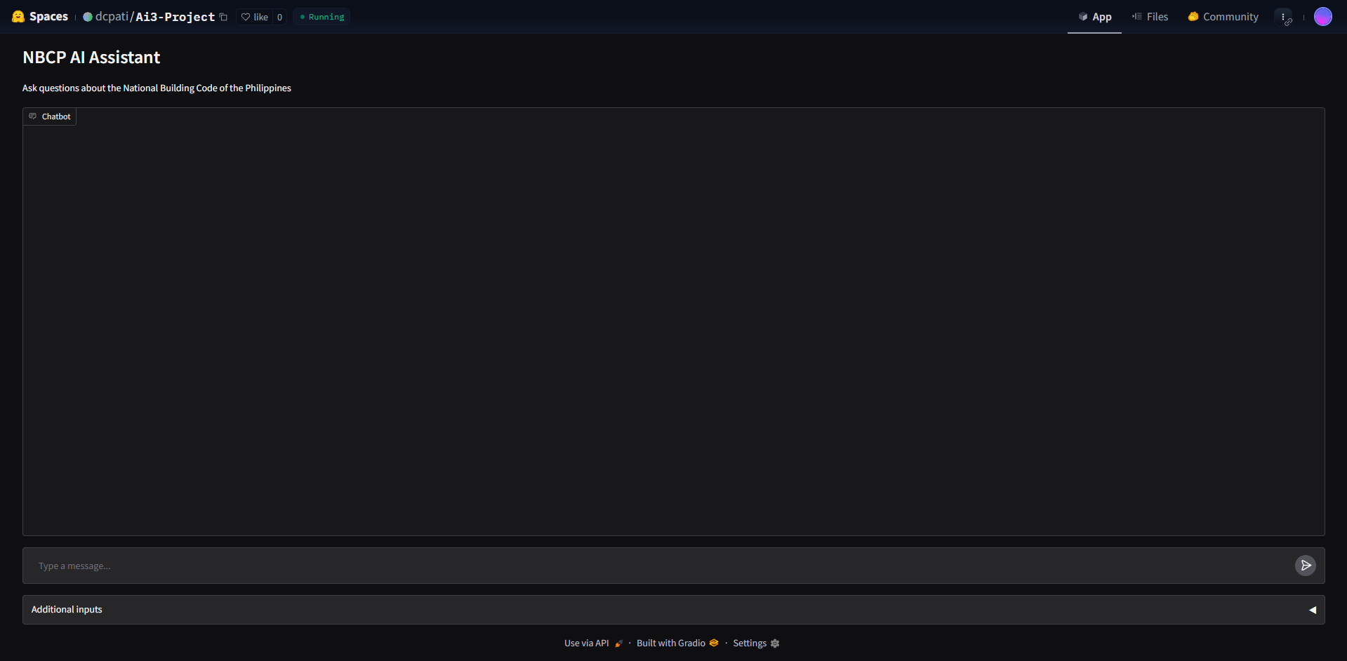
Figure 2. Gradio Deployment
- Reproducibility
All experiments are run with fixed random seeds where applicable, and we document software versions to ensure results can be replicated. We list all code dependencies (PyPDF for PDF parsing, SentenceTransformers and FAISS for indexing, HuggingFace Transformers for LLMs, etc.) and provide our code and test data.

Results and discussion
The performance evaluation of the proposed NBCP-based retrieval-augmented generation chatbot revealed clear differences between Qwen and Gemma, even though both models were tested under the same retrieval setup and evaluated on the same set of 21 unseen questions. The results show that the system was generally effective at locating relevant provisions from the National Building Code of the Philippines, but the final quality of the responses depended mainly on the generation model. This distinction is important because the study was not only concerned with whether the system could retrieve relevant code sections, but also whether it could generate answers that were accurate, concise, and consistent with the retrieved legal and technical evidence.
In terms of retrieval performance, Table 1 shows that both models achieved identical results, with a mean Recall@k of 1.0 and a mean Precision@k of 0.2. The perfect Recall@k indicates that for every evaluation question, the retriever successfully included at least one relevant chunk among the returned results. This suggests that the document chunking, embedding, and FAISS-based retrieval pipeline used in the study was effective for navigating the NBCP corpus. However, the Precision@k value of 0.2 also shows that only a small proportion of the retrieved chunks were directly relevant to the question. In other words, the retriever was highly successful in finding relevant evidence, but it also returned additional non-essential text, leaving the generator to identify the most useful information from a relatively noisy context.

model | qwen | gemma
count | 21 | 21
recall@k | 1 | 1
precision@k | 0.20 | 0.20
token_f1 | 0.5636869084479761 | 0.607775623
token_precision | 0.6785703419493777 | 0.6404842943283297
token_recall | 0.535444373499967 | 0.5963332899435198
numeric_recall_mean | 0.7142857142857143 | 0.9047619047619048
unit_recall_mean | 0.7619047619047619 | 0.9047619047619048
Table 1. Summary_df
Although retrieval performance was identical, the two models differed in answer generation quality. Based on the updated results in Table 1, Gemma achieved a higher mean Token F1 score (0.6078) than Qwen (0.5637), indicating better overall overlap between its generated answers and the gold reference answers. Gemma also obtained a higher token recall (0.5963 vs. 0.5354), which suggests that it captured more of the expected answer content across the evaluation set. By contrast, Qwen achieved slightly higher token precision (0.6786 vs. 0.6405), meaning its answers were generally more focused and contained fewer extra or irrelevant tokens. These results suggest that Gemma was more effective overall at recovering the required answer content, while Qwen tended to be more concise but less complete.
The differences become more significant when examining the compliance-oriented metrics, particularly numeric recall and unit recall. Gemma achieved a numeric recall of 0.9048, substantially higher than Qwen’s 0.7143, and a unit recall of 0.9048, also higher than Qwen’s 0.7619. These metrics are especially important in NBCP question answering because many provisions depend on exact measurements, dimensions, heights, widths, clearances, and validity periods. A response may appear generally correct, yet still be unusable if it omits the required number or fails to reproduce the correct unit. The stronger numeric and unit recall of Gemma, therefore, suggests that it is more reliable in preserving the precise technical details required in code-based question answering. This comparison is also reflected in Figure 3, which visually summarizes the mean performance of the two models across the main evaluation metrics.
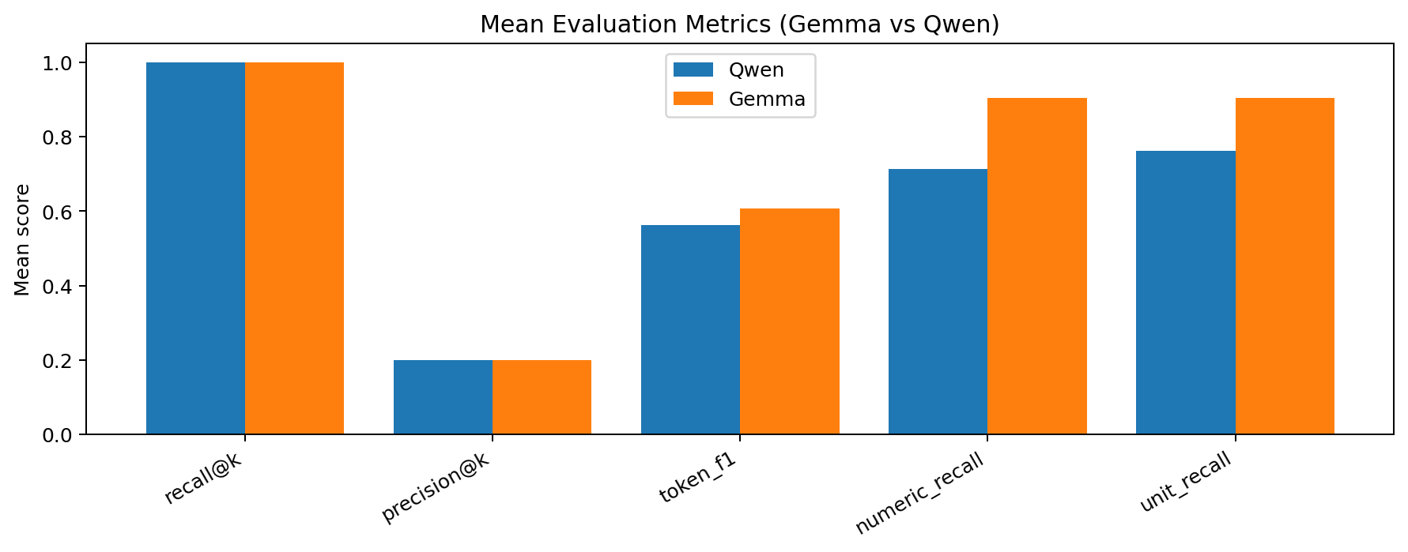
Figure 3. Mean Metrics Bar
Another important finding is the consistency of model performance across questions. The per-question Token F1 plot shows that Qwen’s performance varies more sharply, with several very strong results but also some large drops on individual questions. In contrast, Gemma shows a smoother and more consistent pattern across the evaluation set. This suggests that although Qwen can perform very well on certain questions, Gemma is more dependable overall. Stability is an important consideration in evaluating an information-support chatbot, especially in legal or technical domains, because users are more likely to trust a system that performs consistently rather than one that alternates between very strong and very weak outputs.
The failure analysis further clarifies where the limitations of the system originated. Using a threshold of Token F1 < 0.30 to define a failed response, Gemma recorded 2 generation failures and 19 acceptable responses, while Qwen recorded 3 generation failures and 18 acceptable responses. No retrieval failures were observed for either model. The absence of retrieval failures strongly suggests that the retrieval component was not the main source of error. Instead, the main challenge lies in the model’s ability to interpret the retrieved context and generate the correct answer from it. This distinction is important because it shows that improving the retriever alone may not significantly improve end-to-end performance, since the current retrieval system is already sufficient for surfacing relevant evidence.

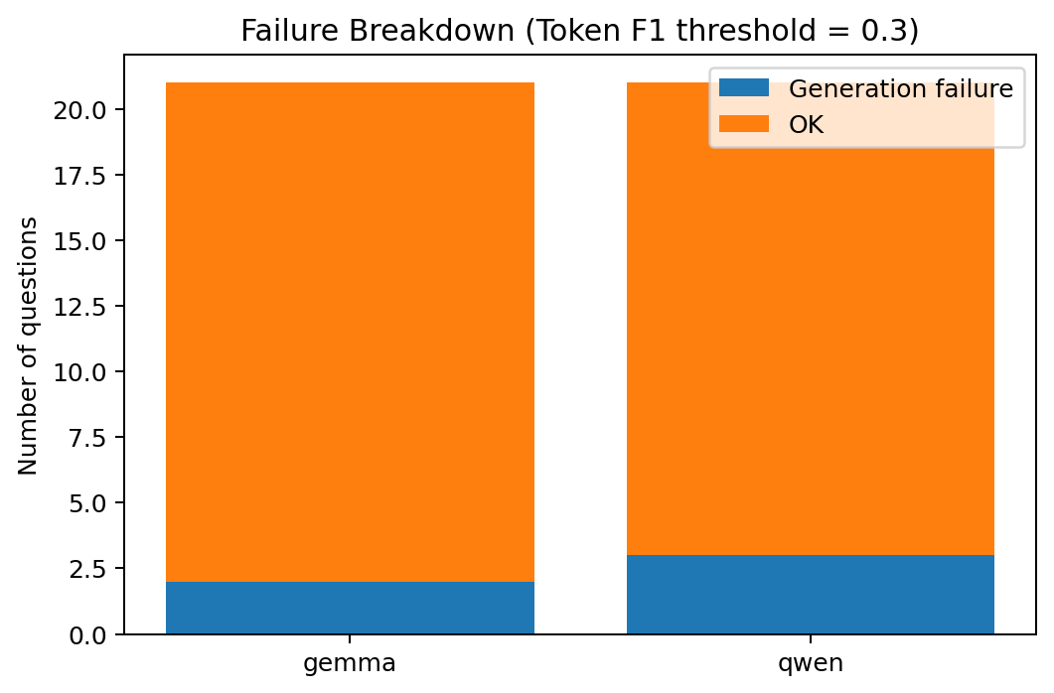
Figure 4. Failure Breakdown
The qualitative examples provide a clearer view of how the two models differ in practice. In the best cases, Qwen achieved some higher peak scores, including one exact-match answer with Token F1 = 1.00, showing that it can closely reproduce the expected wording when the evidence is clear and direct. However, Qwen’s worst cases were more severe, including responses such as “Not specified in the document,” even when the correct answer was present in the retrieved context. This suggests that Qwen sometimes fails conservatively at the generation stage, not because the evidence is missing, but because it does not successfully extract the needed detail. By contrast, Gemma’s best examples were slightly lower in peak score, but its worst cases were generally less extreme and more often reflected incomplete or loosely phrased answers rather than total extraction failure. This pattern supports the view that Gemma is more stable overall, even if Qwen occasionally performs better on individual questions.
These results imply that the major bottleneck of the proposed RAG chatbot is not evidence retrieval, but answer generation under domain-specific constraints. Since the retriever already performs strongly in terms of Recall@k, future improvements should focus on helping the model make better use of the evidence it receives. This may involve stronger prompt engineering, stricter answer-format instructions, reranking or compressing retrieved chunks before generation, or adding post-processing steps that explicitly verify numeric values and units in the final response. The results also suggest that model suitability in RAG systems is not determined only by concise phrasing or occasional high-scoring answers, but by consistent ability to recover the exact technical details required by the task.
Overall, the findings demonstrate that the proposed NBCP RAG chatbot is capable of retrieving relevant legal and technical evidence with high reliability, but the final usefulness of its answers depends strongly on the generation model. Between the two evaluated models, Gemma emerged as the stronger overall option under the updated evaluation, achieving better Token F1, higher token recall, stronger numeric recall, stronger unit recall, fewer generation failures, and more stable performance across questions. Qwen still showed slightly higher token precision and stronger peak performance in some individual cases, but Gemma was more reliable across the full evaluation set. These results support the conclusion that Gemma is currently the more suitable model for this NBCP-focused RAG chatbot, while also highlighting that generator selection remains a critical design decision in regulatory and code-based question answering systems.

Conclusion and Future Work
This study presented a Retrieval-Augmented Generation (RAG) chatbot designed to support question answering for the National Building Code of the Philippines (NBCP). The system integrates semantic retrieval using sentence embeddings and FAISS with instruction-tuned large language models to generate document-grounded responses. Two models, Gemma 2B IT and Qwen2.5-1.5B-Instruct, were evaluated under the same retrieval pipeline.
Experimental results showed that the retrieval component achieved perfect Recall@k, demonstrating effective identification of relevant NBCP passages. However, answer quality varied depending on the generation model. Gemma achieved better overall performance in Token F1, token recall, numeric recall, and unit recall, indicating a stronger ability to recover complete and technically accurate answers. Qwen showed slightly higher token precision and performed very well in some individual cases, but Gemma was more consistent across the evaluation set and recorded fewer generation failures. These findings indicate that the main limitation of the system lies not in retrieval, but in the generator’s ability to extract and present the correct answer from the retrieved evidence.
Future work may focus on improving answer generation through stronger prompt constraints, retrieval reranking, context compression, and post-generation verification of numeric values and units. Expanding the evaluation dataset and testing additional domain-adapted models may further improve system reliability for regulatory information access. Overall, the study shows that a domain-specific RAG chatbot can provide reliable access to NBCP provisions, but generator selection remains a critical design factor in regulatory and code-based question answering.

References
- Senate of the Philippines Legislative Reference Bureau, "Presidential Decree No. 1096, s. 1977," ldr.senate.gov.ph. https://ldr.senate.gov.ph/legislative%2Bissuances/Presidential%20Decree%20No.%201096%2C%20s.%201977 (accessed Mar. 3, 2026).
- P. Lewis et al., “Retrieval-Augmented Generation for Knowledge-Intensive NLP tasks,” arXiv.org, May 22, 2020. https://arxiv.org/abs/2005.11401
- N. Reimers and I. Gurevych, “Sentence-BERT: Sentence Embeddings using Siamese BERT-Networks,” arXiv.org, Aug. 27, 2019. https://arxiv.org/abs/1908.10084
- J. Johnson, M. Douze, and H. Jégou, “Billion-scale similarity search with GPUs,” arXiv.org, Feb. 28, 2017. https://arxiv.org/abs/1702.08734
- C.-Y. Lin, “ROUGE: a package for automatic evaluation of summaries,” ACL Anthology, Jul. 01, 2004. https://aclanthology.org/W04-1013
- Google DeepMind, “Gemma: Open Models Based on Gemini Research and Technology,” Google DeepMind 2024. Available: https://ai.google.dev/gemma.
- Alibaba Cloud, "Qwen2.5-1.5B-Instruct," Hugging Face, 2024. [Online]. Available: https://huggingface.co/Qwen/Qwen2.5-1.5B-Instruct. Accessed: Mar. 3, 2026.
- Z. Dan et al., “EduChat: A Large-Scale Language Model-based Chatbot System for Intelligent Education,” arXiv preprint arXiv:2308.02773, Aug. 2023. Available: https://arxiv.org/pdf/2308.02773
- K. G. Yager, “Domain-specific chatbots for science using embeddings,” Digital Discovery, vol. 2, no. 6, pp. 1850–1861, Jan. 2023, doi: 10.1039/d3dd00112a.
- Alibaba Cloud, "Qwen2.5-1.5B-Instruct," Hugging Face, 2024. [Online]. Available: https://huggingface.co/Qwen/Qwen2.5-1.5B-Instruct. Accessed: Mar. 3, 2026.
- H. Kim et al., “Small Language Models Learn Enhanced Reasoning Skills from Medical Textbooks,” arXiv (Cornell University), Mar. 2024, doi: 10.48550/arxiv.2404.00376.
- P. Lewis et al., “Retrieval-Augmented Generation for Knowledge-Intensive NLP Tasks,” in Advances in Neural Information Processing Systems (NeurIPS), 2020.
- N. Reimers and I. Gurevych, “Sentence-BERT: Sentence Embeddings using Siamese BERT-Networks,” in Proc. EMNLP-IJCNLP, 2019.
- J. Johnson, M. Douze, and H. Jégou, “Billion-Scale Similarity Search with GPUs,” arXiv:1702.08734, 2017.
- C.-Y. Lin, “ROUGE: A Package for Automatic Evaluation of Summaries,” in Text Summarization Branches Out, ACL, 2004.
- R. C. Barron et al., “Domain-Specific Retrieval-Augmented generation using vector stores, knowledge graphs, and tensor factorization,” arXiv.org, Oct. 03, 2024. https://arxiv.org/abs/2410.02721#:~:text=is%20an%20expensive%20and%20time,It%20was%20shown%20that
- A. Louis, V. D. Gijs, and G. Spanakis, “Interpretable Long-Form Legal Question Answering with Retrieval-Augmented Large Language Models,” arXiv.org, Sep. 29, 2023. https://arxiv.org/abs/2309.17050#:~:text=In%20this%20work%2C%20we%20propose,with%20detailed%20answers%20rooted%20in
- M. Baqar, “RAG4Tickets: AI-Powered ticket resolution via Retrieval-Augmented Generation on JIRA and GitHub data,” arXiv.org, Oct. 09, 2025. https://arxiv.org/abs/2510.08667#:~:text=challenge%2C%20we%20propose%20a%20Retrieval,JIRA%20and%20GitHub%20data%2C%20an
- S. Kumar, “Measuring Meaning: Practical Techniques for Assessing LLM Output (Part II),” Medium, May 13, 2025. https://medium.com/@satyam.k/measuring-meaning-practical-techniques-for-assessing-llm-output-part-ii-114f6cdf19c9
- H. Wolff and H. Wolff, “RAG 101: Demystifying Retrieval-Augmented Generation Pipelines,” NVIDIA Technical Blog, Aug. 22, 2024. [Online]. Available: https://developer.nvidia.com/blog/rag-101-demystifying-retrieval-augmented-generation-pipelines/

