青 岛 理 工 大 学
课程实验报告
课程名称 | Web前端基础及框架 | 班级 | 软件213 | 实验日期 | 2022.12.9
姓名 | 白鹏飞 | 学号 | 202111050676 | 实验成绩
实验名称 | 实验5 Vue.js路由应用实验
实验目  及要求 | 熟练掌握采用Vue Router创建前端路由的步骤、动态路由匹配的方法、创建嵌套路由的步骤。
实验环境 | Vs code
实验内容 | 1、创建如下前端路由页面。    2、采用动态路由匹配的方法，创建如下前端路由页面。    3、创建如下嵌套路由页面。  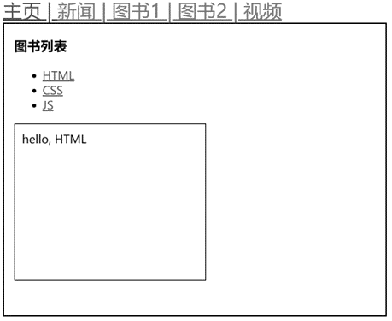
实  验  步  骤 | 1、创建html文件  2、vue.js标记查询与掌握  3、前端路由的使用  4、网站实现
调  试  过  程  及  实  验  结  果 |   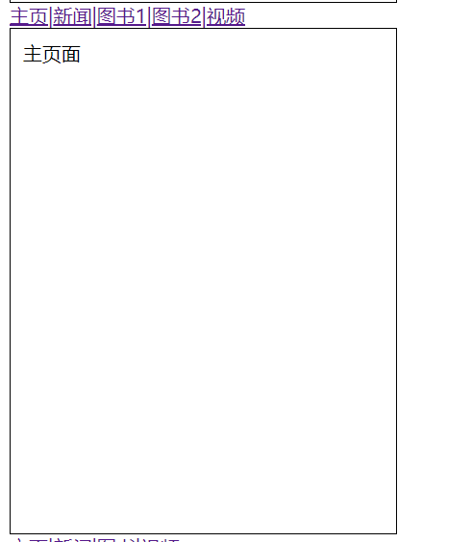
总  结 | 了解并掌握了前端路由的使用方法，但还并不熟练，需要多多练习
源程序 | <!DOCTYPE html>  <html lang="en">  <head>  <meta charset="UTF-8">  <meta http-equiv="X-UA-Compatible" content="IE=edge">  <meta name="viewport" content="width=device-width, initial-scale=1.0">  <title>Document</title>  <script src="https://unpkg.com/vue@3/dist/vue.global.js"></script>  <script src="https://unpkg.com/vue-router@4"></script>  </head>  <style>  .content{  border: 1px solid black;  width:300px;  height: 400px;  padding:10px;  }  </style>  <body>  <div id="app1">  <div>  <router-link to="/">主页|</router-link>  <router-link to="/news">新闻|</router-link>  <router-link to="/books">图书|</router-link>  <router-link to="/videos">视频</router-link>  </div>  <router-view></router-view>  </div>  <div id="app2">  <div>  <router-link to="/">主页|</router-link>  <router-link to="/news">新闻|</router-link>  <router-link to="/books/1">图书1|</router-link>  <router-link to="/books/2">图书2|</router-link>  <router-link to="/videos">视频</router-link>  </div>  <router-view></router-view>  </div>  <div id="app3">  <div>  <router-link to="/">主页|</router-link>  <router-link to="/news">新闻|</router-link>  <router-link to="/books">图书|</router-link>  <router-link to="/videos">视频</router-link>  </div>  <router-view></router-view>  </div>  <script>  const Home={template:'<div class="content">主页面</div>'};  const News={template:'<div class="content">新闻页面</div>'};  const Books={template:'<div class="content">图书页面</div>'};  const Videos={template:'<div class="content">视频页面</div>'};  const routes=[  {path:'/',component:Home},  {path:'/news',component:News},  {path:'/books',component:Books},  {path:'/videos',component:Videos},  ];  const router=VueRouter.createRouter({  history:VueRouter.createWebHashHistory(),  routes  });  const app=Vue.createApp({});  app.use(router);  app.mount('#app1');  </script>  <script>  const Home2={template:'<div class="content">主页面</div>'};  const News2={template:'<div class="content">新闻页面</div>'};  const Books2={template:'<div class="content">图书页面{{$route.param.id}}</div>'};  const Videos2={template:'<div class="content">主页面</div>'};  const routes2=[  {path:'/',component:Home2},  {path:'/news',component:News2},  {path:'/books/:id',component:Books2},  {path:'/videos',component:Videos2},  ];  const router2=VueRouter.createRouter({  history:VueRouter.createWebHashHistory(),  routes  });  const app1=Vue.createApp({});  app1.use(router2);  app1.mount('#app2');  </script>  <script>  const Home3={template:'<div class="content">主页面<div>'};  const News3={template:'<div class="content">新闻页面</div>'};  const Books3={  data(){  return{  books:[  {id:1,title:'HTML',desc:'hello,HTML'},  {id:2,title:'CSS',desc:'hello,css'},  {id:3,title:'JS',desc:'hello,js'}  ]  }  },  template:`<div class="content">  <h3>图书列表</h3>  <ul>  <li v-for="book in books":key="book.id">  <router-link:to="'/books/book/'+book.id">{{book.title}}</router-link>  </li>  </ul>  <router-view></router-view>  </div>`  };  const Book={  date(){  return{  books:[  {id:1,title:'HTML',desc:'hello,HTML'},  {id:2,title:'CSS',desc:'hello,css'},  {id:3,title:'JS',desc:'hello,js'},  ]  }  },  template:'<div class="content">{{book.desc}}</div>',  created(){  this.book=this.books[this.Sroute.params.id-1];  this.$watch(()=>this.$route.params,(toParams)=>{this.book=this.book[toParams.id-1]});  }  };  const Videos3={template:'<div class="content">视频</div>'};  const routes3=[  {path:'/',component:Home3},  {path:'/news',component:News3},  {path:'/books',component:Books3,children:[{path:'book/:id',component:Book}]},  {path:'/videos',component:Videos3},  ];  const router3=VueRouter.createRouter({  history:VueRouter.createWebHashHistory(),  routes  });  const app2=Vue.createApp({});  app2.use(router3);  app2.mount('#app3');  </script>  </body>  </html>

