青 岛 理 工 大 学
课程实验报告
课程名称 | Web前端基础及框架 | 班级 | 软件213 | 实验日期 | 2022.12.16
姓名 | 白鹏飞 | 学号 | 202111050676 | 实验成绩
实验名称 | 实验6 Vue CLI应用
实验目  及要求 | 掌握Vue CLI的安装与使用，掌握单文件组件的语法
实验环境 | Vscode
实验内容 | 1、下载并安装VS Code。  2、下载并安装Vue CLI（Vue脚手架工具，用于辅助创建和配置Vue项目）。  3、使用Vue CLI创建一个Vue项目。  4、采用VS Code打开上一步创建的Vue项目。  5、根据自己设计的页面，在VS Code中修改public文件夹下的index.html(主页面)；在component文件夹中修改已有的组件或创建新的组件；根据需要修改根组件文件App.vue；根据需要修改main.js文件，实现自己的web页面。
实  验  步  骤 | - 根据实验内容完成调试。
调  试  过  程  及  实  验  结  果 | 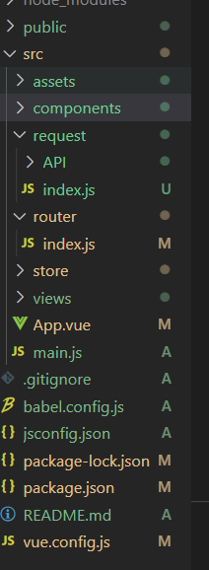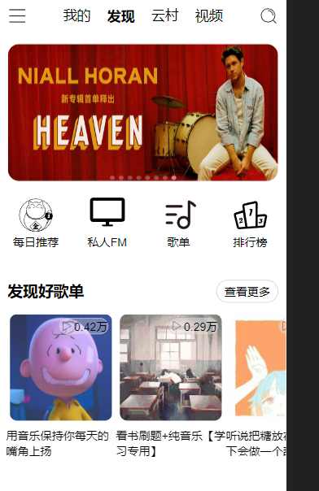
总  结 | 通过脚手架可以快速搭建项目，节省大量时间。Cli今年停止维护，应该转用vite.  安装脚手架基本上需要node.js。
源程序 | //项目是web课程设计大作业，文件部分展示  Index.html  <!DOCTYPE html>  <html lang="">  <head>  <meta charset="utf-8">  <meta http-equiv="X-UA-Compatible" content="IE=edge">  <meta name="viewport" content="width=device-width,initial-scale=1.0">  <link rel="icon" href="<%= BASE_URL %>favicon.ico">  <!-- 链接图标 -->  <script src="//at.alicdn.com/t/c/font_3838365_l6v7ezcweq.js"></script>  <title><%= htmlWebpackPlugin.options.title %></title>  </head>  <body>  <noscript>  <strong>We're sorry but <%= htmlWebpackPlugin.options.title %> doesn't work properly without JavaScript enabled. Please enable it to continue.</strong>  </noscript>  <div id="app"></div>  <script src="<%= BASE_URL %>js/rem.js"></script>  <!-- built files will be auto injected -->  </body>  </html>  App.vue:  <template>  <router-view/>  <FooterPlayer></FooterPlayer>  </template>  <script setup>  import FooterPlayer from './components/FooterPlayer.vue';//播放器为全局组件  </script>  <style lang="less">  *{//整体调整  margin: 0;  padding: 0;  box-sizing: border-box;//元素的总高度和宽度包含内边距和边框,设置内边距不会撑开盒子  }  .icon{  width:.5rem;  height:.5rem;  }  a{  color:black;  }  </style>  iconList.vue  <template>  <div class="iconList">  <!----------------------------------->  <div class="iconItem">  <svg class="icon" aria-hidden="true">  <use xlink:href="#icon-iconlogo"></use>  </svg>  <span>每日推荐</span>  </div>  <!----------------------------------->  <div class="iconItem">  <svg class="icon" aria-hidden="true">  <use xlink:href="#icon-dianshiji"></use>  </svg>  <span>私人FM</span>  </div>  <!----------------------------------->  <div class="iconItem">  <svg class="icon" aria-hidden="true">  <use xlink:href="#icon-gedan"></use>  </svg>  <span>歌单</span>  </div>  <!----------------------------------->  <div class="iconItem">  <svg class="icon" aria-hidden="true">  <use xlink:href="#icon-paihangbang"></use>  </svg>  <span>排行榜</span>  </div>  <!----------------------------------->  </div>  </template>  <style lang="less" scoped>  .iconList{  margin-top: .2rem;  width: 100%;  height: 2rem;  display: flex;  justify-content: space-around;  align-items: center;  .iconItem{  width: 25%;  height: 100%;  display: flex;  flex-direction: column;  align-items: center;  .icon{  width: 1rem;  height: 1rem;  }  }  }  </style>  MusicList.vue  <template>  <div class="musicList">  <div class="musicTop">  <div class="title">发现好歌单</div>  <div class="more">查看更多</div>  </div>  </div>  <div class="musicContent">  <van-swipe :loop="false" :width="150" class="my-swipe" :show-indicators="false"><!--动态绑定-->  <van-swipe-item v-for="item in state.musicList" :key="item.id" class="oneSwipe">  <RouterLink :to="{path:'/songsheet' ,query:{id:item.id}}">  <img :src="item.picUrl" />  <span class="playCount">  <svg class="icon" aria-hidden="true">  <use xlink:href="#icon-24gl-play"></use>  </svg>  <!--播放量-->  {{changeCount(item.playCount) }}  </span>  </RouterLink>  <!--图片下方字-->  <span class="name">{{ item.name }}</span>  </van-swipe-item>  </van-swipe>  </div>  </template>  <script setup>  import {getMusicaList}from "@/request/API/home.js"  import { reactive,onMounted } from "vue";  const state=reactive({  musicList:[],  })  function changeCount(num){  if(num>=100000000){  return (num/100000000).toFixed(2)+'亿'  }  else if(num>=10000)  return (num/100000000).toFixed(2)+'万'  }  onMounted(async()=>{  let res=await getMusicaList();  state.musicList=res.data.result;  })  </script>  <!--lang=“less” 可以敲层级关系的样式  scoped 使style内的样式只作用于当前的界面-->  <style lang="less" scoped>  .musicList{  width: 100%;  height:1rem;  padding: 0.2rem;  .musicTop{  width:100%;  height: 0.6rem;  display: flex;  justify-content: space-between;  .title{  font-size: 0.4rem;  font-weight: 900;  }  .more{  border:1px solid #ccc;  text-align: center;  line-height: 0.6rem;  padding: 0 0.2rem;  border-radius: 0.4rem;//添加圆角边框  }  }  }  .musicContent{  width:100%;  height:4rem;  .my-swipe{  height: 100%;  padding-left: .16rem;  .oneSwipe{  img{  width: 100%;  height: 3rem;  padding: .1rem;  border-radius: 0.3rem;//添加圆角边框  }  .playCount{//播放量  position: absolute;  top: .2rem;  right: .2rem;  border:1px solid rgb(204, 204, 204);  background-color: rgba(255,255,255,0.3);  border-radius: 0.5rem;  text-align: center;  display: flex;  justify-content:center ;  .icon{  margin: 2px;  height: .3rem;  width: .3rem;  }  }  }  }  }  </style>  SwiperTop.vue  <template>  <div id="swiperTop">  <!--懒加载-->  <van-swipe :autoplay="3000" lazy-render >  <van-swipe-item v-for="image in state.images" :key="image">  <img :src="image.pic" />  </van-swipe-item>  </van-swipe>  </div>  </template>  <script>  //import axios from 'axios'  import { reactive,onMounted } from 'vue';  import {getBanner} from '@/request/API/home.js'  export default{  setup() {  const state =reactive({  images: [  ]});  onMounted(async()=>{  // axios.get('http://localhost:3000/banner?type=2').then((res)=>{  // console.log(res);  // state.iamges=res.data.pic;  let res=await getBanner();// async 用于申明一个 function 是异步的，而 await 用于等待一个异步方法执行完成。  state.images=res.data.banners;  });  return { state }  }  }  </script>  <style lang="less" >  #swiperTop{  .van-swipe{  width: 100%;  height: 4rem;  .van-swipe__track{  .van-swipe-item{  padding:0.2rem;  img{  width: 100%;  height: 100%;  border-radius: 0.3rem;//添加圆角边距  }  }  }  .van-swipe__indicator--active{  background-color: rgb(219,130,130);  }  }  }  </style>  TopNav.vue:  <!--导航组件-->  <template>  <div class="topNav">  <div class="topLeft">  <svg class="icon" aria-hidden="true">  <use xlink:href="#icon-liebiao2"></use>  </svg>  </div>  <div class="topContent">  <span>我的</span>  <span class="active">发现</span>  <span>云村</span>  <span>视频</span>  </div>  <div class="topRight">  <svg class="icon" aria-hidden="true">  <use xlink:href="#icon-fangdajing"></use>  </svg>  </div>  </div>  </template>  <style lang="less" scoped>  .topNav{  width:100%;  padding: .2rem;  height: 1rem;  display:flex;//弹性布局  justify-content: space-between;//两端对齐  align-items: center;  .topContent{  width:65%;  height: 100%;  display: flex;  justify-content: space-around;  //align-items: center;  font-size: .36rem;  .active{  font-weight: 900;  }  }  }  </style>

