青 岛 理 工 大 学
课程实验报告
课程名称 | Android开发技术 | 班级 | 软件213 | 实验日期 | 2023.11.28
姓名 | 白鹏飞 | 学号 | 202111050676 | 实验成绩
实验名称 | SQLite编程
实验目的  及要求 | （1）掌握SQLite数据库的增删改查等基本操作；  （2）掌握SQLiteOpenHelper的使用方法；
实验环境 | Win10, Android Studio
实验内容 | 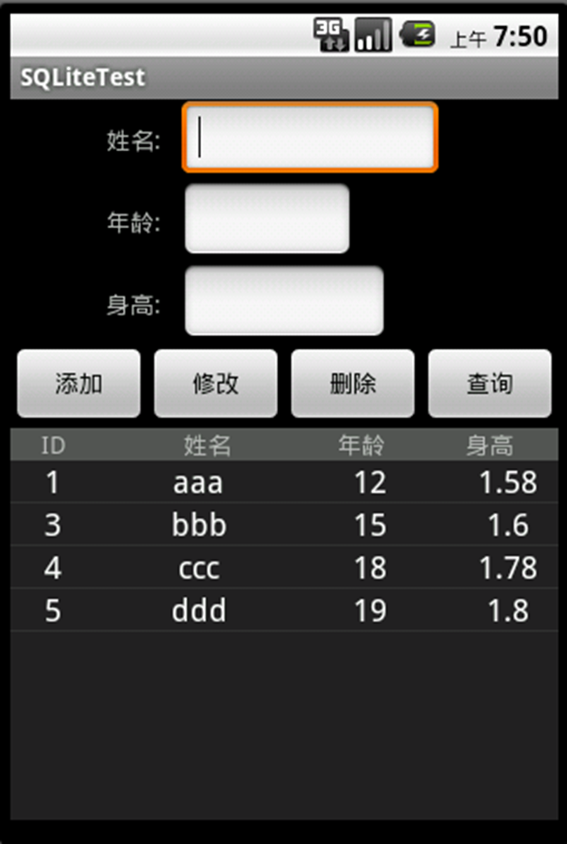  1. 创建一个SQLiteOpenHelper子类  （1）实现数据库创建功能；  （2）实现升级管理功能；  2. 实现数据库的增删改查操作  （1）上方控件中输入数值，点击添加，则将数据存入数据库中，同时下方的ListView添加一行；  （2）点击下方的一行，则该行内容显示到上方的的控件中，修改其内容，然后点击修改按钮，则更新数据库和ListView；  （3）先用（2）中操作选择一行，然后点击删除按钮，则从数据库和界面中删除选中的数据；  （4）上方输入年龄值，点击查询按钮，则将大于等于该年龄值的查询结果（可能多行）用AlertDialog显示出来。例如：输入18，则显示：  4 ccc 18 1.78  5 ddd 19 1.8
算法描述及实验步骤 | 步骤 1: 创建 SQLiteOpenHelper 子类  步骤 2: 实现数据库的增删改查操作  步骤 3: 在 Activity 中使用 DataOperations 类
调试过程及实验结果 | 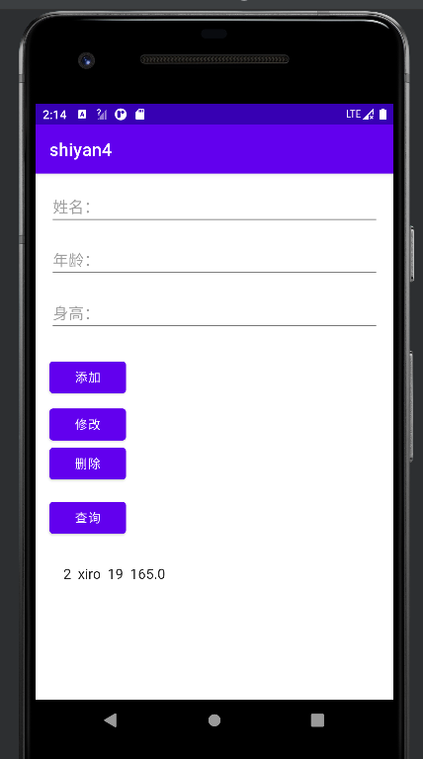  添加：  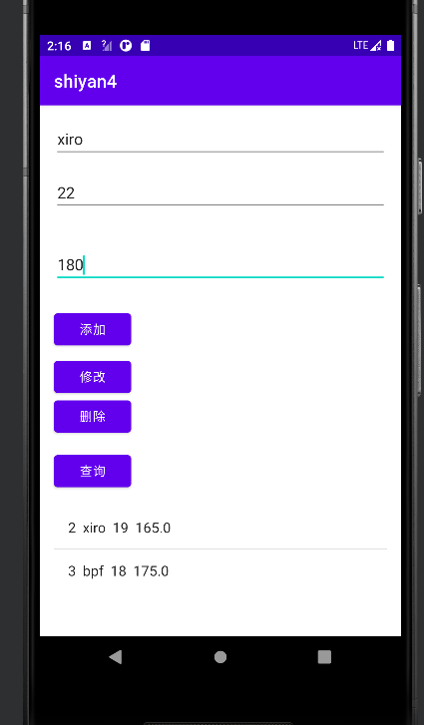  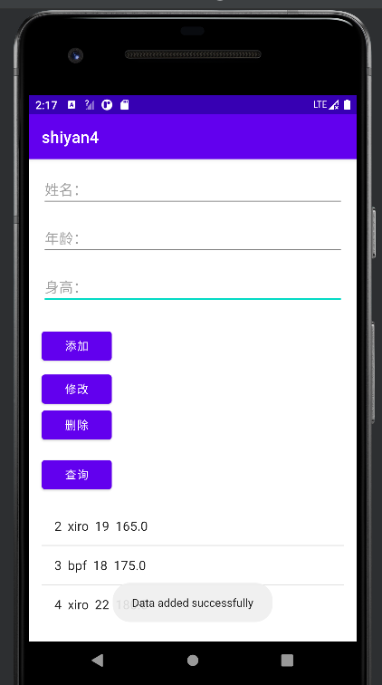  修改  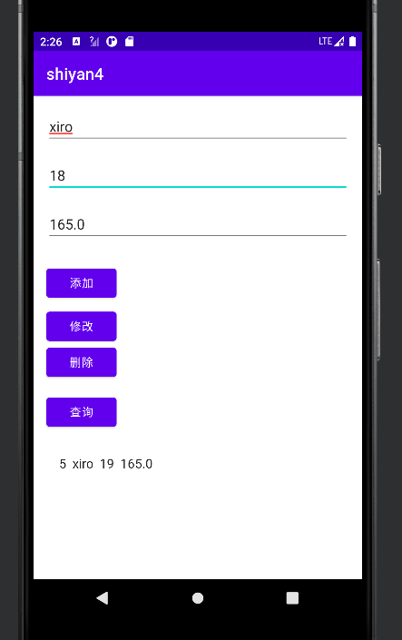  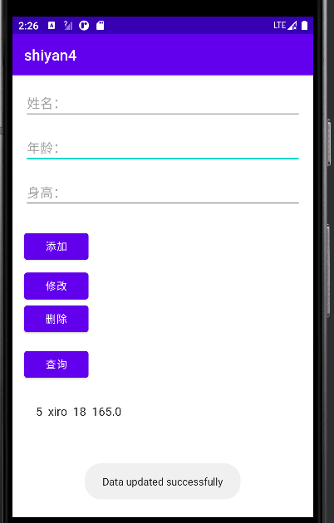  删除  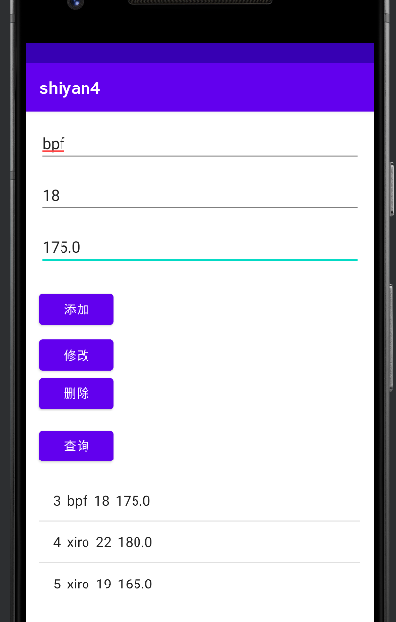  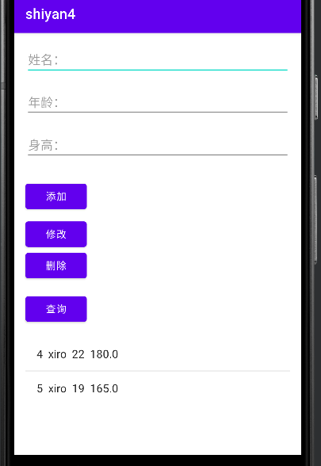  查询  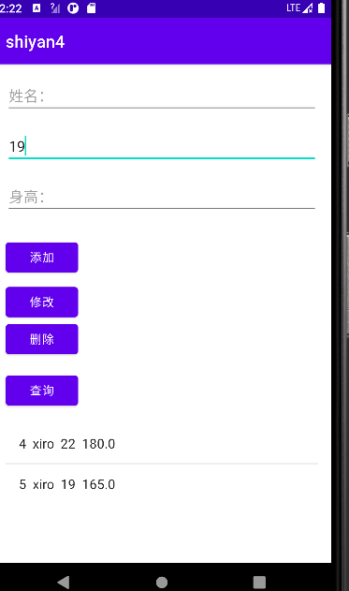  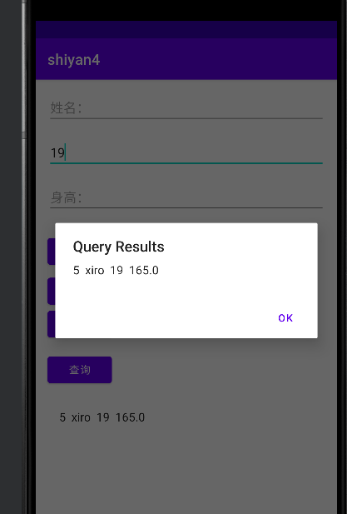
总结 | SQLiteOpenHelper 的作用：  管理数据库的创建和版本升级。  提供数据库读写的权限。  数据库操作：  添加数据：使用 insert 方法。  查询数据：使用 query 方法，返回一个 Cursor 对象。  更新数据：使用 update 方法。  删除数据：使用 delete 方法。  注意事项：  使用 try-catch 块确保数据库连接的正确关闭，避免资源泄漏。  数据库的表结构变更需要在 onUpgrade 方法中处理，避免出现版本冲突。  建议：  尽量将数据库操作放在独立的线程中，以避免在主线程中执行耗时操作导致界面卡顿。  在需要进行数据库操作的地方加入适当的错误处理机制，以便更好地处理异常情况。
附  录 | protected void onCreate(Bundle savedInstanceState) {  super.onCreate(savedInstanceState);  setContentView(R.layout.activity_main);  nameEditText = findViewById(R.id.nameEditText);  ageEditText = findViewById(R.id.ageEditText);  heightEditText = findViewById(R.id.heightEditText);  addButton = findViewById(R.id.addButton);  updateButton = findViewById(R.id.updateButton);  deleteButton = findViewById(R.id.deleteButton);  queryButton = findViewById(R.id.queryButton);  listView = findViewById(R.id.listView);  dbHelper = new MyDatabaseHelper(this);  db = dbHelper.getWritableDatabase();  idList = new ArrayList<>();  adapter = new ArrayAdapter<>(this, android.R.layout.simple_list_item_1);  listView.setAdapter(adapter);  addButton.setOnClickListener(new View.OnClickListener() {  @Override  public void onClick(View v) {  addData();  }  });  updateButton.setOnClickListener(new View.OnClickListener() {  @Override  public void onClick(View v) {  updateData();  }  });  deleteButton.setOnClickListener(new View.OnClickListener() {  @Override  public void onClick(View v) {  deleteData();  }  });  queryButton.setOnClickListener(new View.OnClickListener() {  @Override  public void onClick(View v) {  queryData();  }  });  listView.setOnItemClickListener(new AdapterView.OnItemClickListener() {  @Override  public void onItemClick(AdapterView<?> parent, View view, int position, long id) {  // Set the item as checked  listView.setItemChecked(position, true);  showSelectedData(position);  }  });  refreshListView();  }  private void addData() {  ContentValues values = new ContentValues();  values.put(MyDatabaseHelper.COLUMN_NAME, nameEditText.getText().toString());  values.put(MyDatabaseHelper.COLUMN_AGE, Integer.parseInt(ageEditText.getText().toString()));  values.put(MyDatabaseHelper.COLUMN_HEIGHT, Double.parseDouble(heightEditText.getText().toString()));  long newRowId = db.insert(MyDatabaseHelper.TABLE_NAME, null, values);  if (newRowId != -1) {  Toast.makeText(this, "Data added successfully", Toast.LENGTH_SHORT).show();  refreshListView();  clearInputFields();  } else {  Toast.makeText(this, "Error adding data", Toast.LENGTH_SHORT).show();  }  }  private void updateData() {  int position = listView.getCheckedItemPosition();  if (position != AdapterView.INVALID_POSITION) {  ContentValues values = new ContentValues();  values.put(MyDatabaseHelper.COLUMN_NAME, nameEditText.getText().toString());  values.put(MyDatabaseHelper.COLUMN_AGE, Integer.parseInt(ageEditText.getText().toString()));  values.put(MyDatabaseHelper.COLUMN_HEIGHT, Double.parseDouble(heightEditText.getText().toString()));  int selectedId = idList.get(position);  String selection = MyDatabaseHelper.COLUMN_ID + "=?";  String[] selectionArgs = {String.valueOf(selectedId)};  int updatedRows = db.update(MyDatabaseHelper.TABLE_NAME, values, selection, selectionArgs);  if (updatedRows > 0) {  Toast.makeText(this, "Data updated successfully", Toast.LENGTH_SHORT).show();  refreshListView();  clearInputFields();  } else {  Toast.makeText(this, "Error updating data", Toast.LENGTH_SHORT).show();  }  } else {  Toast.makeText(this, "Please select a row to update", Toast.LENGTH_SHORT).show();  }  }  private void deleteData() {  int position = listView.getCheckedItemPosition();  Log.d("delete",position+"");  if (position != AdapterView.INVALID_POSITION) {  int selectedId = idList.get(position);  String selection = MyDatabaseHelper.COLUMN_ID + "=?";  String[] selectionArgs = {String.valueOf(selectedId)};  int deletedRows = db.delete(MyDatabaseHelper.TABLE_NAME, selection, selectionArgs);  if (deletedRows > 0) {  Toast.makeText(this, "Data deleted successfully", Toast.LENGTH_SHORT).show();  refreshListView();  clearInputFields();  } else {  Toast.makeText(this, "Error deleting data", Toast.LENGTH_SHORT).show();  }  } else {  Toast.makeText(this, "Please select a row to delete", Toast.LENGTH_SHORT).show();  }  }  private void queryData() {  int ageThreshold = Integer.parseInt(ageEditText.getText().toString());  String[] projection = {  MyDatabaseHelper.COLUMN_ID,  MyDatabaseHelper.COLUMN_NAME,  MyDatabaseHelper.COLUMN_AGE,  MyDatabaseHelper.COLUMN_HEIGHT  };  String selection = MyDatabaseHelper.COLUMN_AGE + ">=?";  String[] selectionArgs = {String.valueOf(ageThreshold)};  Cursor cursor = db.query(  MyDatabaseHelper.TABLE_NAME,  projection,  selection,  selectionArgs,  null,  null,  null  );  showQueryResults(cursor);  }  private void showQueryResults(Cursor cursor) {  AlertDialog.Builder builder = new AlertDialog.Builder(this);  builder.setTitle("Query Results");  StringBuilder result = new StringBuilder();  while (cursor.moveToNext()) {  int id = cursor.getInt(cursor.getColumnIndex(MyDatabaseHelper.COLUMN_ID));  String name = cursor.getString(cursor.getColumnIndex(MyDatabaseHelper.COLUMN_NAME));  int age = cursor.getInt(cursor.getColumnIndex(MyDatabaseHelper.COLUMN_AGE));  double height = cursor.getDouble(cursor.getColumnIndex(MyDatabaseHelper.COLUMN_HEIGHT));  result.append(id).append(" ").append(name).append(" ").append(age).append(" ").append(height).append("\n");  }  if (result.length() > 0) {  builder.setMessage(result.toString());  } else {  builder.setMessage("No matching records found.");  }  builder.setPositiveButton("OK", null);  builder.show();  cursor.close();  }  private void showSelectedData(int position) {  int selectedId = idList.get(position);  String selection = MyDatabaseHelper.COLUMN_ID + "=?";  String[] selectionArgs = {String.valueOf(selectedId)};  Cursor cursor = db.query(  MyDatabaseHelper.TABLE_NAME,  null,  selection,  selectionArgs,  null,  null,  null  );  if (cursor.moveToFirst()) {  nameEditText.setText(cursor.getString(cursor.getColumnIndex(MyDatabaseHelper.COLUMN_NAME)));  ageEditText.setText(String.valueOf(cursor.getInt(cursor.getColumnIndex(MyDatabaseHelper.COLUMN_AGE))));  heightEditText.setText(String.valueOf(cursor.getDouble(cursor.getColumnIndex(MyDatabaseHelper.COLUMN_HEIGHT))));  }  cursor.close();  }  private void refreshListView() {  adapter.clear();  idList.clear();  Cursor cursor = db.query(  MyDatabaseHelper.TABLE_NAME,  null,  null,  null,  null,  null,  null  );  while (cursor.moveToNext()) {  int id = cursor.getInt(cursor.getColumnIndex(MyDatabaseHelper.COLUMN_ID));  String name = cursor.getString(cursor.getColumnIndex(MyDatabaseHelper.COLUMN_NAME));  int age = cursor.getInt(cursor.getColumnIndex(MyDatabaseHelper.COLUMN_AGE));  double height = cursor.getDouble(cursor.getColumnIndex(MyDatabaseHelper.COLUMN_HEIGHT));  idList.add(id);  adapter.add(id + " " + name + " " + age + " " + height);  }  cursor.close();  adapter.notifyDataSetChanged();  }  private void clearInputFields() {  nameEditText.getText().clear();  ageEditText.getText().clear();  heightEditText.getText().clear();  }  }  private static final String CREATE_TABLE =  "CREATE TABLE " + TABLE_NAME + "(" +  COLUMN_ID + " INTEGER PRIMARY KEY AUTOINCREMENT, " +  COLUMN_NAME + " TEXT, " +  COLUMN_AGE + " INTEGER, " +  COLUMN_HEIGHT + " REAL)";  public MyDatabaseHelper(Context context) {  super(context, DATABASE_NAME, null, DATABASE_VERSION);  }  @Override  public void onCreate(SQLiteDatabase db) {  db.execSQL(CREATE_TABLE);  }  @Override  public void onUpgrade(SQLiteDatabase db, int oldVersion, int newVersion) {  // 简单示例，升级时直接删除表重新创建  db.execSQL("DROP TABLE IF EXISTS " + TABLE_NAME);  onCreate(db);  }

