Pwd : print working directory

Ls : lists (ls –a)

Cd : change directory

Clear

Mkdir : make directory

Q or esc  or ctrl + C: quit

Configuration : git config user.name "TXLe" user.email [lexiutb@gmail.com](mailto:lexiutb@gmail.com) (--global)

Git init (only once)

Git status

Git clone : clone a remote repository

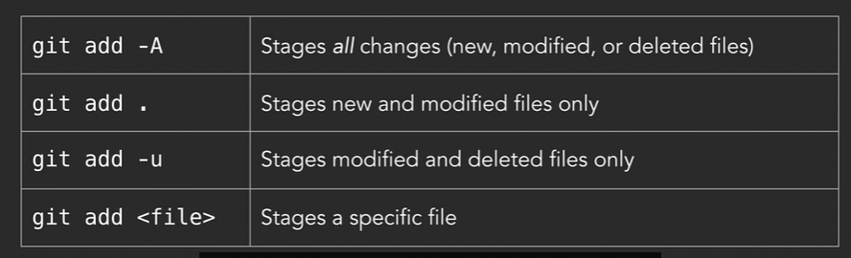

Git commit –m "Description …"

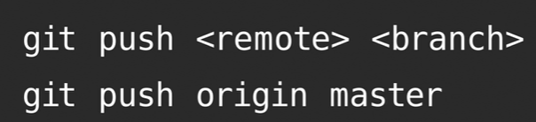

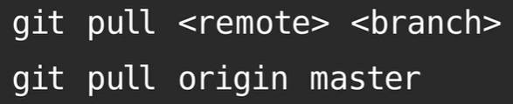

Git help branch

Git branch : local branches

Git branch -a : all branches

Git branch -r : remote branches

[**git remote**](https://www.atlassian.com/fr/git/tutorials/syncing/git-fetch) [**git fetch**](https://www.atlassian.com/fr/git/tutorials/syncing/git-fetch) [**git push**](https://www.atlassian.com/fr/git/tutorials/syncing/git-fetch) [**git pull**](https://www.atlassian.com/fr/git/tutorials/syncing/git-fetch)

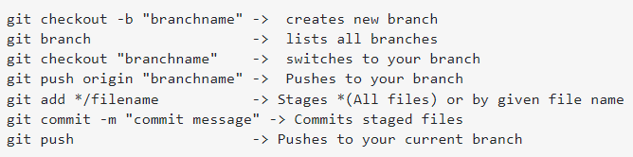

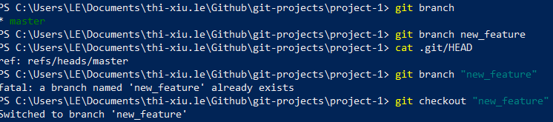

Git log –oneline

Git diff master..new

Git branch merged/no-merged : check wich bracnch contains all changes

Get branch –m « new_name » : rename

Get branch –d « branch_to_delete » : delete

Git merge « branch_to_metge » : on receiving branch