**Assignment1 report**

Student name: Xiuyuan Lu. Student ID:53786454

My program structure:

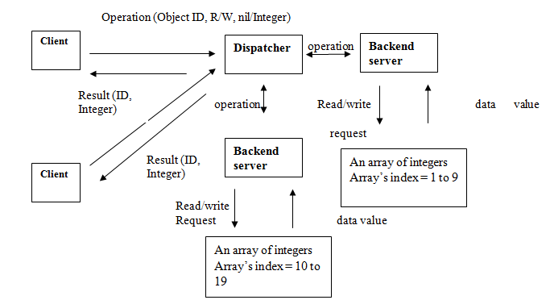

And my java code content:

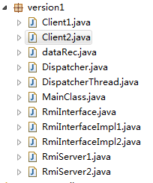

I created two independent clients called Client1 and Client2 to connect to the Dispatcher Server. The Dispatcher Server then ran multiple threads to handle the socket connection from multiple clients. The Dispathcer Server invoked the RMI method(index 0-9 invoke server1 10-19 invode server 2). And every dataRec Object will be synchronized when they are accessed which means it’s impossible that two different clients can access one particular object simultaneously.

My execution results are shown below:

First I start up 2 backend servers and the Dispatcher Server, I initiate the object list in the server side, then start up 2 independent clients.

Two clients read different objects by their own, and the execution time is simulated as 8000 minisecs:

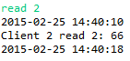

Two clients read the same object simultaneously:

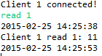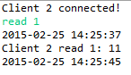

One writes and the other reads the same object:

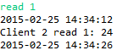

One writes and the other also writes the same object then read the result:

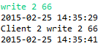

And if access different indexes from different servers, the client will not be aware:

the output is as ordinary as before.