# AustoSalesReport

ADSR Technologies was founded by Hendrik Dreyer and Jon Heap. The company’s existence was brought about by the creation of its main product, AustoSalesReports (ASR).



The idea behind ASR was to create an amalgamated CRM/Sales Reporting system for the Australian automotive industry. Ultimately, ASR would support the average dealership in its day-to-day running and management. ASR is fully functional in the cloud and is hosted in Caspio, which runs in AWS. ASR scales seamlessly and is deployable at any site that houses an internet connection.

The functionality behind ASR caters for easy deployment and setup. No installations had to be performed in order to get ASR operational. Once, a client has signed up for ASR, a dealership account was created the dealership would be immediately able to go live.

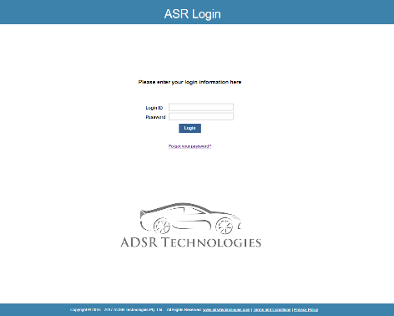

ASR facilitate multiple views into the operations of a dealership. Different user levels present different views of operational dealership data. This enables different users to concentrate on only the data that is relevant to their jobs. ASR showcased a pinpoint directed CRM system. Capture of customer data is intuitive and easy