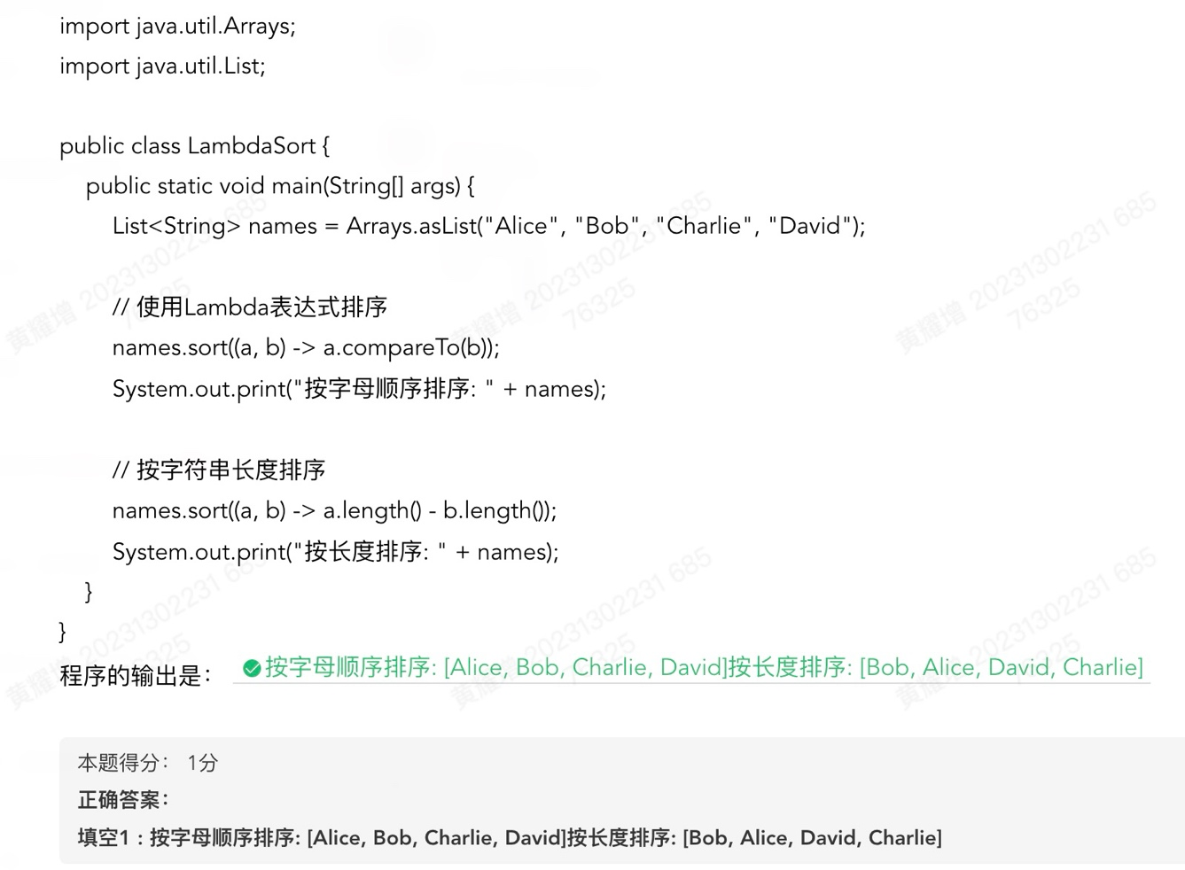
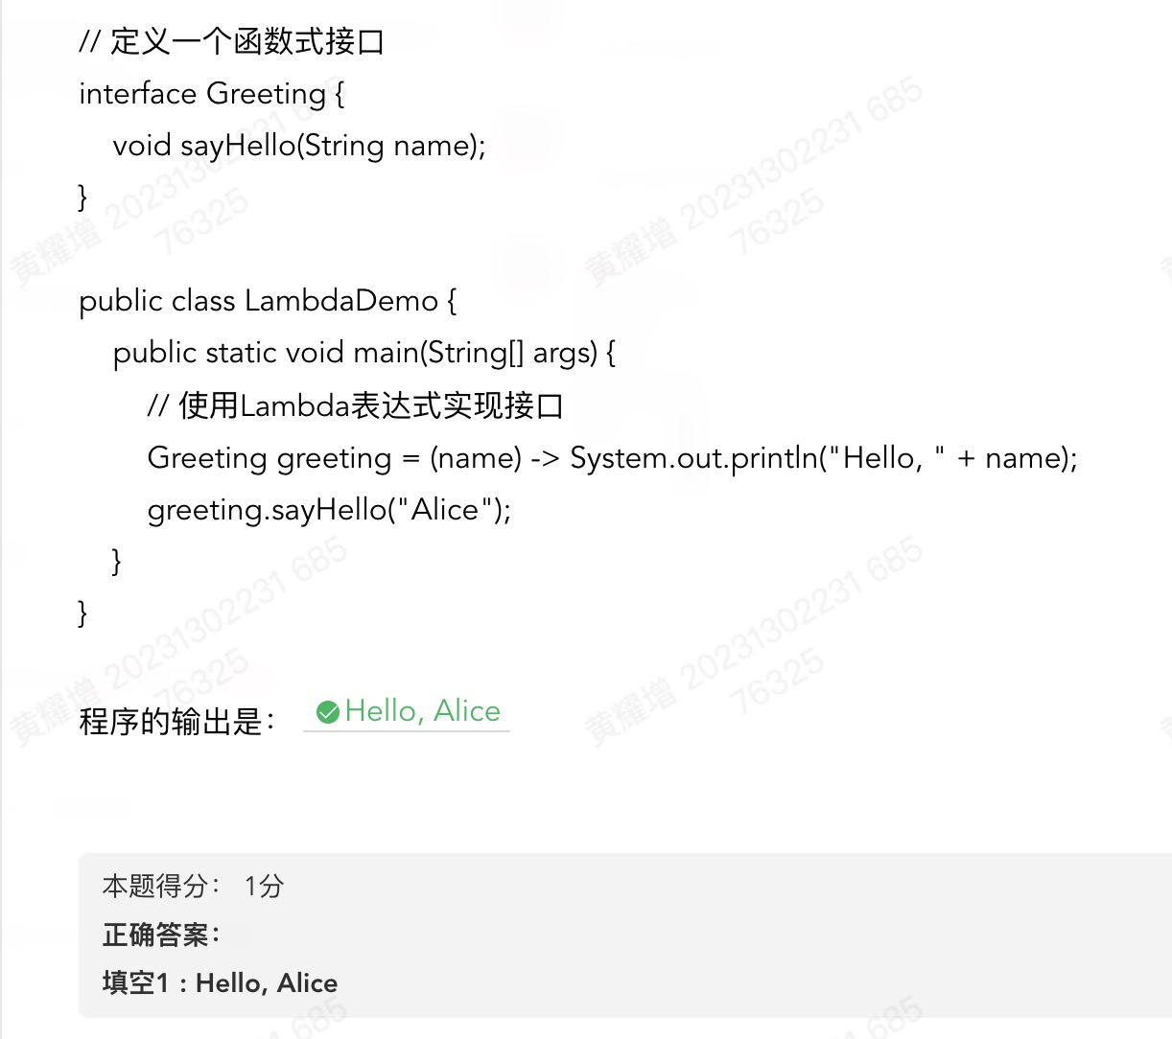
lambda表达式用法练习
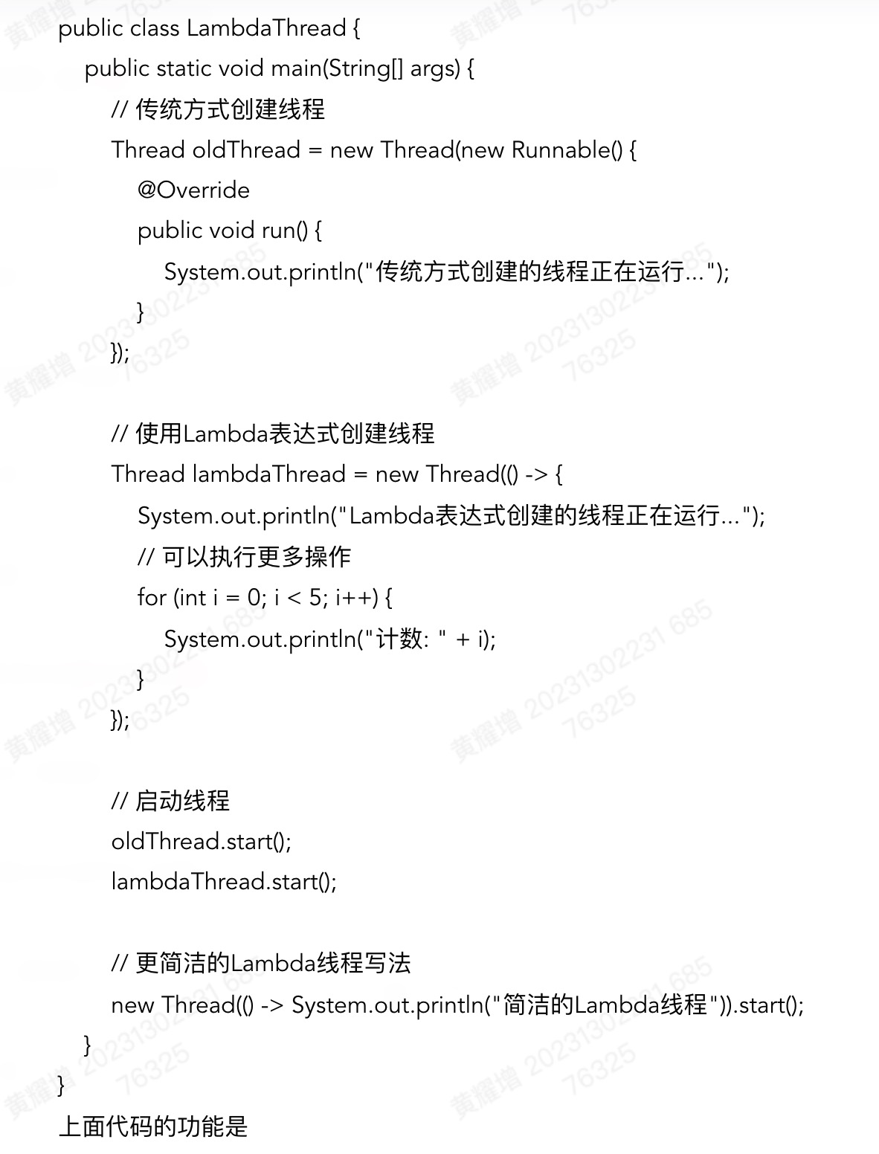

import javax.swing.*;
import java.awt.*;
import java.awt.event.ActionEvent;
import java.awt.event.ActionListener;
import java.util.Random;

public class AdditionPractice {
private JFrame frame;
private JLabel questionLabel;
private JTextField answerField;
private JButton verifyButton;
private JLabel resultLabel;

// 当前随机生成的 a 和 b
private int a;
private int b;

private Random random = new Random();

public AdditionPractice() {
// 初始化 UI
frame = new JFrame("加法练习");
frame.setDefaultCloseOperation(JFrame.EXIT_ON_CLOSE);
frame.setSize(300, 180);
frame.setLocationRelativeTo(null); // 居中显示

// 主面板使用垂直布局
JPanel panel = new JPanel();
panel.setLayout(new BoxLayout(panel, BoxLayout.Y_AXIS));
panel.setBorder(BorderFactory.createEmptyBorder(10, 10, 10, 10));

questionLabel = new JLabel();
questionLabel.setFont(new Font("SansSerif", Font.PLAIN, 18));
questionLabel.setAlignmentX(Component.CENTER_ALIGNMENT);

// 生成初始题目
generateNewQuestion();

// 输入框
answerField = new JTextField();
answerField.setMaximumSize(new Dimension(Integer.MAX_VALUE, 30)); // 限高
answerField.setAlignmentX(Component.CENTER_ALIGNMENT);

// 验证按钮
verifyButton = new JButton("验证");
verifyButton.setAlignmentX(Component.CENTER_ALIGNMENT);

// 结果标签
resultLabel = new JLabel(" ");
resultLabel.setFont(new Font("SansSerif", Font.PLAIN, 16));
resultLabel.setAlignmentX(Component.CENTER_ALIGNMENT);

// 添加组件到面板
panel.add(questionLabel);
panel.add(Box.createRigidArea(new Dimension(0, 10)));
panel.add(answerField);
panel.add(Box.createRigidArea(new Dimension(0, 10)));
panel.add(verifyButton);
panel.add(Box.createRigidArea(new Dimension(0, 10)));
panel.add(resultLabel);

// 注册按钮点击事件
verifyButton.addActionListener(new ActionListener() {
@Override
public void actionPerformed(ActionEvent e) {
onVerify();
}
});

frame.getContentPane().add(panel);
frame.setVisible(true);
}

// 生成新的随机题目，并更新 questionLabel，清空输入框和结果
private void generateNewQuestion() {
// 这里随机生成 0~100 之间的整数；可自行改范围
a = random.nextInt(101);
b = random.nextInt(101);
questionLabel.setText(a + " + " + b + " = ");
answerField.setText("");
resultLabel.setText(" ");
}

// 验证逻辑
private void onVerify() {
String text = answerField.getText().trim();
if (text.isEmpty()) {
resultLabel.setText("请输入答案~");
return;
}
try {
int userAns = Integer.parseInt(text);
if (userAns == a + b) {
resultLabel.setText("正确");
// 如果想在正确后直接生成下一题，可以取消下面注释
// JOptionPane.showMessageDialog(frame, "回答正确，进入下一题！");
// generateNewQuestion();
} else {
resultLabel.setText("错误");
}
} catch (NumberFormatException ex) {
resultLabel.setText("请输入有效整数");
}
}

public static void main(String[] args) {
// 确保在 EDT 中创建 UI
SwingUtilities.invokeLater(new Runnable() {
@Override
public void run() {
new AdditionPractice();
}
});
}
}

import java.sql.*;

public class ScoreQuery {
// 请根据实际地址、端口和时区调整 URL
private static final String URL = "jdbc:mysql://localhost:3306/mmis?useSSL=false&serverTimezone=UTC";
private static final String USER = "root";
private static final String PASSWORD = "root";

public static void main(String[] args) {
// 加载驱动（可选，对于新版驱动通常不需要，但写上更保险）
try {
Class.forName("com.mysql.cj.jdbc.Driver");
} catch (ClassNotFoundException e) {
System.err.println("找不到 MySQL JDBC 驱动，请检查依赖：" + e.getMessage());
return;
}

String sql = "SELECT uid, score FROM score_t";

// try-with-resources 自动关闭 Connection、Statement、ResultSet
try (Connection conn = DriverManager.getConnection(URL, USER, PASSWORD);
Statement stmt = conn.createStatement();
ResultSet rs = stmt.executeQuery(sql)) {

System.out.println("遍历 score_t 表，输出 uid;score：");
while (rs.next()) {
// 假设 uid 字段是字符串类型或整数类型均可用 getString，score 也可改为适合的类型
String uid = rs.getString("uid");
String score = rs.getString("score");
System.out.println(uid + ";" + score);
}
} catch (SQLException e) {
System.err.println("数据库操作异常：" + e.getMessage());
// e.printStackTrace();
}
}
}

import java.sql.*;

public class ScoreUpdate {
private static final String URL = "jdbc:mysql://localhost:3306/mmis?useSSL=false&serverTimezone=UTC";
private static final String USER = "root";
private static final String PASSWORD = "root";

public static void main(String[] args) {
// 加载驱动（可选）
try {
Class.forName("com.mysql.cj.jdbc.Driver");
} catch (ClassNotFoundException e) {
System.err.println("找不到 MySQL JDBC 驱动，请检查依赖：" + e.getMessage());
return;
}

String updateSql = "UPDATE score_t SET score = ? WHERE uid = ?";

try (Connection conn = DriverManager.getConnection(URL, USER, PASSWORD);
PreparedStatement ps = conn.prepareStatement(updateSql)) {

// 设置参数：score=98，uid="1001"
ps.setInt(1, 98);
ps.setString(2, "1001");

int affected = ps.executeUpdate();
if (affected > 0) {
System.out.println("更新正确，影响行数：" + affected);
} else {
System.out.println("更新失败，没有找到 uid=1001 的记录或未发生修改");
}

} catch (SQLException e) {
System.err.println("数据库操作异常：" + e.getMessage());
// e.printStackTrace();
}
}
}

